Opening remarks: | Ms. Nada Al-Nashif, United Nations Deputy High Commissioner for Human Rights  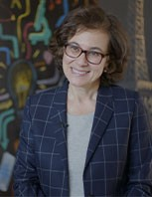  Nada Al-Nashif was appointed United Nations Deputy High Commissioner for Human Rights on 6 December 2019, assuming the position in 10 February 2020.  She brings to the role close to 30 years of experience within the United Nations system around the world. As an economist and development practitioner, Ms. Al-Nashif has taken on increasingly complex management roles during her career within the United Nations, including leading strategic organisational transformation processes.  Ms. Brigitte Strobel-Shaw, Chief, Corruption and Economic Crime Branch, United Nations Office on Drugs and Crime  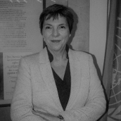  Brigitte Strobel-Shaw is the Chief of the Corruption and Economic Crime Branch at the United Nations Office on Drugs and Crime. The Branch is responsible for providing policy, normative and substantive support to States for the implementation of the United Nations Convention against Corruption, the only global anti-corruption instrument. The Branch delivers technical assistance in various corruption-related thematic areas, such as prevention, education, asset recovery, international cooperation, integrity in the criminal justice system and sports. Prior to this post, Brigitte held several positions in the UN system, both at headquarters and in the field, on issues related to crime prevention and criminal justice, including on organized crime, counterterrorism, juvenile justice and violence against women. Brigitte is a lawyer by training.
Chair: | H.E. Mr. Federico Villegas, President of the Human Rights Council  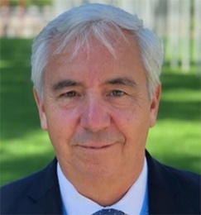  Mr. Federico Villegas is the President of Human Rights Council and Ambassador and Permanent Representative of Argentina to the United Nations Office at Geneva.  Prior to his arrival in Geneva, Mr. Villegas had been serving as Argentina’s Ambassador to Mozambique since 2016. He served as the Director General of Human Rights at the Ministry of Foreign Affairs of Argentina from 2012 to 2016, and from 2005 to 2007. He was Argentina’s Alternate Representative to the Southern Common Market MERCOSUR and the Association for Latin-American Integration (ALADI) in Montevideo, Uruguay from 2008 to 2011.
Moderator: | Mr. Thomas STELZER, Dean of International Anti-Corruption Academy  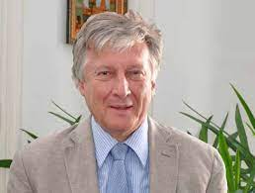  Mr. Stelzer has been a member of the foreign service of the Republic of Austria. He has served as Permanent Representative of Austria to the United Nations Office in Vienna, the International Atomic Energy Agency, the United Nations Industrial Development Organization, and the Comprehensive Nuclear-Test-Ban Treaty Organization Preparatory Commission; and more recently as Ambassador to Portugal. He also served as Assistant Secretary-General for Policy Coordination and Inter-Agency Affairs at the United Nations, and as the Secretary of the United Nations Chief Executives Board.
Panellists: | Ms. Anita RAMASASTRY, Working Group on the issue of human rights and transnational corporations and other business enterprises  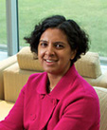  Ms. Anita Ramasastry is the Roland L. Hjorth Professor of Law and the Director of the Graduate Program in Sustainable International Development at the University of Washington School Of Law. She researches and teaches in the fields of law and development, anti-corruption, international commercial law and business and human rights. Ramasastry is a recurring visiting professor at the Irish Centre for Human Rights as well as the Central European University in Budapest. She is a founding co editor in chief of the Business and Human Rights Journal (Cambridge). Ramasastry is a graduate of Harvard College, Harvard Law School and the University of Sydney.  Mr. David Clarke, Unit Head a.i., Health System’s Governance and Policy  David is a senior public health lawyer and a health policy and governance specialist. David currently works at WHO HQ in Geneva as a Unit Head on health law and governance. Before joining WHO he worked as a senior official in the New Zealand Ministry of Health, and as an advisor to global health and international development agencies and an advisor to Ministries of Health in over fifty different countries across four continents. At WHO HQ, David is the global lead for the institutions and law theme at WHO HQ. In this capacity, he leads on private sector engagement for UHC, anticorruption accountability and transparency in health, UHC law and working with parliamentarians to achieve UHC.  Ms. Beatriz Elena Londoño, Secretary for Transparency of the Presidency of the Republic of Colombia  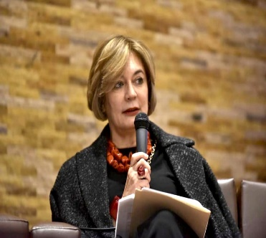  Beatriz Elena Londoño is a lawyer, specialist in Financial Law. She has experience in financial supervision and investigation, with an emphasis on control of money laundering and financing of terrorism, as well as the illegal exercise of financial activity and financial and securities market conduct. During her tenure at the Financial Superintendence of Colombia, she was Deputy Superintendent for Financial Consumer Protection, Deputy Superintendent for Risk of Money Laundering (E), Director of Prevention and Control of Money Laundering, Intendant of Foreign Exchange Market Intermediaries and Head of Division of Banco Republica Y Cambios.​​  Ms. Gillian Dell, Head of Conventions, Transparency International  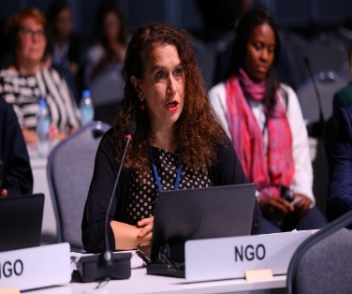  Gillian Dell is Head of Conventions at Transparency International (TI) and works on issues relating to grand corruption impunity, foreign bribery enforcement, asset recovery, victims’ compensation and implementation of international anti-corruption conventions. She has co-authored eleven editions of the Exporting Corruption Report, about OECD Convention enforcement, including the most recent edition in 2020. In 2006, as part of her TI work she co-founded the UNCAC Coalition, a global civil society network dedicated to implementation of the UN Convention against Corruption, and until 2018 she led the TI team providing its secretariat.

