Register for an Event and Manage your Registration
V.2
April 2021

Table of Contents

Register for an event 1
What is profile update?
What if the event requires you to have an account but you don’t have to be logged in
What if a non-user tries to register?
Email notifications
Check the status of my registration 4
Modify my registration 5
There is no Modify button!
Withdraw my registration 6
There is no Withdraw button!
Sync events to my calendar 7

Register for an event
On the event page click Apply now.

If you are not already logged in, you will be prompted to do so.

Proceed to complete the form in full and when finished, click Apply.

A message appears on-screen in an orange status bar acknowledging that the registration is awaiting approval. You may modify or withdraw your registration whilst it is still pending approval.

What is profile update?

Normally, if you are logged in to register, personal data will be pulled from your profile and added to the form automatically. If you update any of this data on the form at the time of registering, then at the bottom of the form in the Profile update section, if you toggle Update profile to YES, then whatever data you updated on the form will also be updated automatically on your profile. If you don’t want this data updated on your profile, toggle the Profile update button to NO.

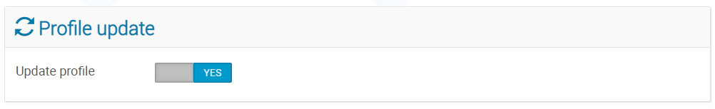

What if the event requires you to have an account but you don’t have to be logged in

On the event page click Apply now. The registration form will open immediately.

Proceed to complete the form in full.

When entering an email address, it must be the one that your account is registered to. It will be recognized as existing in the system and in that way, the registration will be associated with your account.

When finished, click Apply. The button will be active since the email will be recognized as existing in the system.
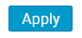

What if a non-user tries to register?

If the event allows non-users to register, when Apply now is clicked, the registration form will open immediately.

Proceed to complete the form in full.

When entering an email address, a message appears indicating that the registration will not be associated with an account. So, while the registration may be submitted, no user account is actually being created. (See ** below).

When finished, click Apply. The button will be active to permit the registration.

** Since a non-user does not have an account, in order to be able to access the registration to modify or withdraw it at a later date, the user should take note of the registration URL which is generated when the form is submitted. The registration URL is located at the bottom of the screen below the form.

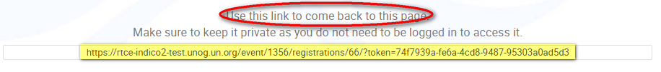

If the event does not allow non-users to register, then when entering an email address, a message indicating that there is no Indico user associated with this email address is displayed and the Apply button will not be active.

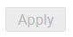

Email notifications

Normally, registrants receive notifications automatically from indico when they register to an event and when a decision has been made (i.e. it has been approved or rejected). Users should check their spam or junk folders if in doubt or contact the event organizer directly.

Check the status of my registration
Log in to Indico and go to the page of the event you are registered to.

In the blue Application status bar, click See details.

The status of the registration is displayed either in:

- an orange status bar (if it is still pending)
- a green status bar (if it has been approved) or
- a red status bar (if it has been rejected)

Modify my registration
You may modify your registration while it is pending approval and/or if the organizer permits it.

Log in to Indico. Go to the page of the event you have registered for. In the blue Application status bar, click See details.

A summary of your registration opens.

If the registration is pending and modifications are permitted, click Modify.

If the registration is approved and modifications are still permitted, click Modify.

If the registration is rejected, you may no longer modify it.

Once you have modified the form, to save the changes click Modify located at the bottom of the form.

There is no Modify button!

Contact the organizer. It has not permitted modifications.

Withdraw my registration
You may withdraw your registration while it is pending approval and/or if the organizer permits it.

Log in to Indico. Go to the page of the event you have registered for. In the blue Application status bar, click See details.

A summary of your registration opens.

If the registration is pending, click Withdraw.

If the registration is approved, click Withdraw.

If the registration is rejected, you may no longer withdraw it.

A message appears on-screen. Confirm the withdrawal by clicking OK.

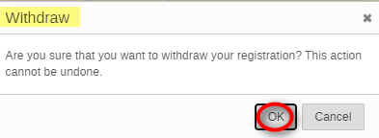

There is no Withdraw button!

Contact the organizer. It has not permitted modifications.

Sync events to my calendar
It is possible to synchronize events you are registered to and/or events in your favourite categories with your own personal calendar from your dashboard. Any updates that are made, will automatically be reflected in your calendar.

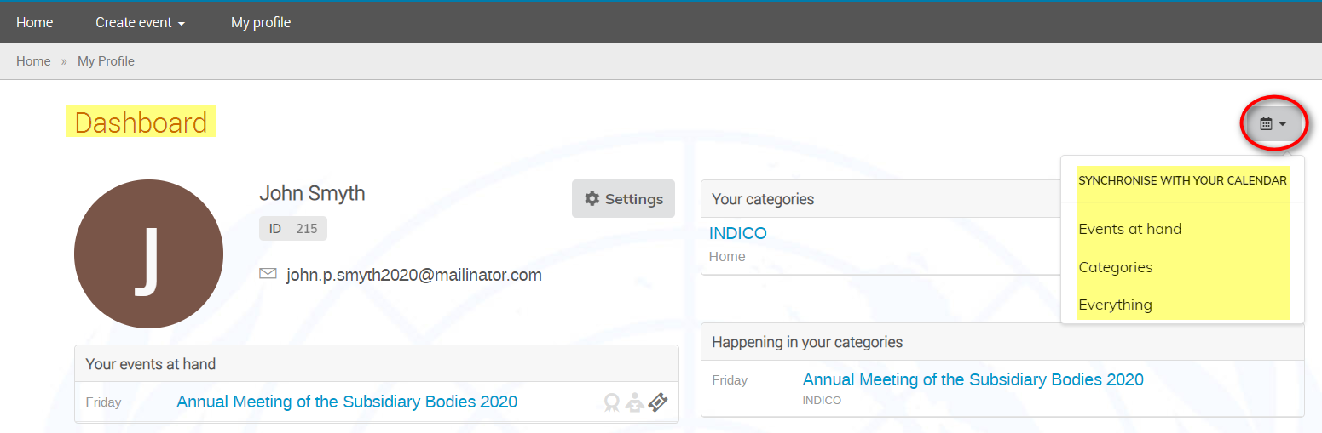

In your dashboard, click the calendar icon on the right of the screen. The options are:

Events at hand – sync events you are registered to with your calendar.
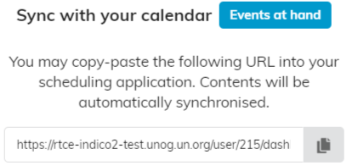

Categories – sync events in your favourite categories with your calendar.
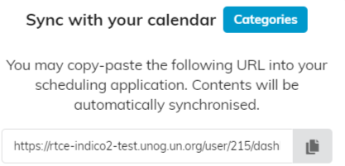

Everything – sync events you are registered to and events in your favourite categories with your calendar.
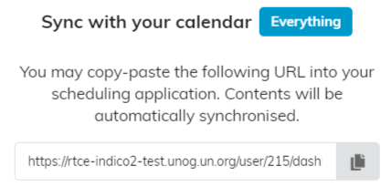
Click and a URL is copied for you to paste in your scheduling application.

