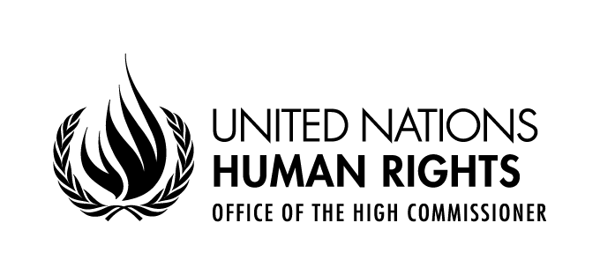
Seminar
THE CONTRIBUTION OF DEVELOPMENT
TO THE ENJOYMENT OF ALL HUMAN RIGHTS

28 May 2021
Virtual meeting, Central European Summer Time (CEST)

PROGRAMME OF WORK
11h00-11h15 Opening
Chair: Mr. Todd Howland, Chief of the Development, Economic and Social Issues Branch, OHCHR
- H. E. Ms. Nazhat Shameen Khan, President of the Human Rights Council
- Ms. Michelle Bachelet, United Nations High Commissioner for Human Rights
- H. E. Mr. Chen Xu, Permanent Representative of the People's Republic of China to the United Nations Office at Geneva and other International Organizations in Switzerland
11h15-12h00 Panel I: General perspectives on the contribution of development to the enjoyment of all human rights
Moderator: Mr. Todd Howland, Chief of the Development, Economic and Social Issues Branch, OHCHR
- Mr. Wang Xigen, Dean of Law School, Huazhong University of Science and Technology (HUST), China
A study on the contribution of development to the enjoyment of human rights
- Mr. Richard Kozul-Wright, Director of Division on Globalization and Development Strategies, UNCTAD
The role of globalization and development strategies in promoting and protecting human rights
- Ms. Rabia Akhtar, Director of the Centre for Security & Strategy and Policy Research, University of Lahore, Pakistan
The contribution of inter-connectivity to the enjoyment of human rights
- Mr. Hassan Njifon Njoya, Lecturer at the Department of Political Science, University of Buea, Cameroon
Contribution of education and of the elimination of digital gap to the enjoyment of human rights
12h00-13h00 Interactive dialogue

15h00-15h45 Panel II: The contribution of development to the enjoyment of human rights in the Decade of Action and in recovering better from COVID-19
Moderator: Ms. Jyoti Sanghera, Independent consultant, former Chief of the Human Rights and Economic and Social Issues Section, OHCHR
- Mr. Jeffrey Sachs, Director of the Center for Sustainable Development, Columbia University, USA
Addressing inequalities in the Decade of Action for the Sustainable Development Goals
- Ms. Sabina Alkire, Director of the Oxford Poverty and Human Development Initiative
The contribution of poverty alleviation to the enjoyment of human rights
- Ms. Adriana Abdenur, member of the United Nations Committee for Development Policy and Executive Director of Plataforma CIPÓ, Brazil
The contribution of international development cooperation to the enjoyment of human rights
- Mr. Hossam Badrawi, Chairman of Badrawi Foundation for Development
Challenges to secure the human right to health in pandemics
15h45-16h45 Interactive dialogue
16h45-17h00 Closing
Mr. Ayush Bat-Erdene, Chief of the Right to Development Section, OHCHR

