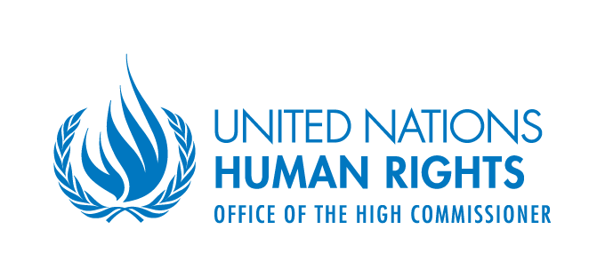
Human Rights Council Resolution 41/19

The Contribution of Development to the Enjoyment of All Human Rights

28th May 2021
(virtual meeting)
CONCEPT NOTE

- INTRODUCTION

- On 12 July 2019, the Human Rights Council adopted resolution 41/19 on “The contribution of development to the enjoyment of all human rights”. In this resolution, the Council requested “the United Nations High Commissioner for Human Rights to organize a one-day intersessional seminar, before the forty-seventh session of the Human Rights Council, on the contribution of development to the enjoyment of all human rights, in order to allow Member States, relevant United Nations agencies, funds and programmes, international organizations, national human rights institutions, civil society organizations and other stakeholders to identify challenges and gaps and share good practices and experiences in this regard.” In its decision 45/113, the Council decided that the intersessional seminar would be held before the forty-eighth session according to the new timeline for implementation of resolution 41/19.
- The present concept note details the content, methodology and expected outcome of the seminar that will take place on 28th May 2021.

- BACKGROUND

- In its resolution 35/21, Human Rights Council affirmed that development contributes significantly to the enjoyment of all human rights by all. It called upon all countries to realize people-centred development of the people, by the people and for the people; and to spare no effort to promote sustainable development, in particular while implementing the 2030 Agenda for Sustainable Development, as it is conducive to the overall enjoyment of human rights. The Council also invited relevant bodies of the United Nations system to mobilize resources to assist States, as requested, in realizing sustainable and inclusive development and requested the Advisory Committee to conduct a study on the ways in which development contributes to the enjoyment of all human rights by all. Consequently, the Advisory Committee produced a report (A/HRC/41/50) which contained a set of conclusions and recommendations on this matter.
- In its resolution 41/19, the Human Rights Council reiterated points made in resolution 35/21, and further invited relevant United Nations human rights mechanisms and procedures to continue to take into account the role of development in promoting and protecting human rights when fulfilling their mandates. The Council also invited the Office of the United Nations High Commissioner for Human Rights (OHCHR) to strengthen its work relevant to sustainable development, including studies on the role of development in the enjoyment of human rights. Pursuant to this request the OHCHR has commissioned a consultancy study aimed at unpacking the concept of contribution of development to the enjoyment of all human rights. The outcome of the study will be presented during the seminar.
- In its resolution 41/19, the Human Rights Council requested the United Nations High Commissioner for Human Rights to organize a one-day intersessional seminar on the contribution of development to the enjoyment of all human rights, in order to allow Member States, relevant United Nations agencies, funds and programmes, international organizations, national human rights institutions, civil society organizations and other stakeholders to identify challenges and gaps and share good practices and experiences in this regard. This event is organized pursuant to the latter request.

- ONE-DAY INTERSSESSIONAL SEMINAR
Overall Theme
- As requested by resolution 41/19, the seminar will focus on the contribution of development to the enjoyment of all human rights, in order to allow Member States, relevant United Nations agencies, funds and programmes, international organizations, national human rights institutions, civil society organizations and other stakeholders to identify challenges and gaps and share good practices and experiences in this regard.
Date and Venue
- The one-day intersessional seminar will take place on Friday, 28 May 2021, from 11:00 to 13:00 and from 15:00 to 17:00 (CEST). Due to the COVID-19 situation, this meeting will be held virtually through “Interprefy” and webcast at http://webtv.un.org/. The Secretariat will be in the Palais des Nations, in Room XVIII. Further details will be communicated to participants that register at https://indico.un.org/event/35807.
Participants
- As requested by resolution 41/19, the seminar will engage “Member States, relevant United Nations agencies, funds and programmes, international organizations, national human rights institutions, civil society organizations and other stakeholders.”
Methodology and Programme of Work
- The seminar will be divided in introductory remarks, two panels and closing remarks. More specifically, the meeting will be structured as follows.
11:00 – 11:15: Opening
- The remarks will be delivered by the President of the Human Rights Council, the High Commissioner for Human Rights and the Permanent Representative of the People's Republic of China to the United Nations Office at Geneva.
11:15 – 13:00: Panel I: General perspectives on the contribution of development to the enjoyment of all human rights
- The presentations during the first panel will identify challenges and gaps and share good practices and experiences relating to the contribution of development to the enjoyment of all human rights. In particular, panelists will elaborate on the concept of the “contribution of development to the enjoyment of human rights” and share different examples of how development contributes to the enjoyment of all human rights including the right to development. Panelists will present examples of the contribution international development strategies, poverty alleviation policies, inter-connectivity, education and closing the digital gap to the enjoyment of human rights. Panelists will have 7 to 10 minutes for their presentations.
- After statements by panelists, the moderator will open the floor to participants registered in the speakers’ list to make interventions with questions and comments on the presentations. Each participant will have two minutes to make their intervention.
- Following the interventions from the floor, panelists will have the opportunity to answer questions and present concluding observations.
15:00 – 16:45: Panel II: The contribution of development to the enjoyment of human rights in the Decade of Action and in recovering better from COVID-19
- The second panel will focus on the role of development on the enjoyment of human rights taking into account specific challenges towards the Decade of Action for the Sustainable Development Goals and in recovering better from the COVID-19 pandemic. Topics that will be addressed by panelists will include the contribution to the enjoyment of human rights of addressing inequalities, promoting international solidarity and development cooperation – including South-South cooperation and challenges to secure the human right to health in pandemics.
- The second panel will follow the same methodology of the first panel, including 7 to 10 minutes presentations by panelists, followed by interventions from the floor of participants registered in the list of speakers, each for two minutes, and concluding observations by panelists.
16:45 – 17:00: Closing
- The chief of the Right to Development Section of the Office of the United Nations High Commissioner for Human Rights will present closing remarks, summarizing the main points of the discussion.

- OUTCOME

- Resolution 41/19 requested “the High Commissioner to prepare a summary report on the discussions held at the seminar for presentation to the Human Rights Council at its forty-seventh session”. In accordance to Human Rights Council decision 45/113, the report of the one-day seminar will be submitted to the forty-eight session of the Council.

