General user guides
Support.accreditation@un.org

Create and Activate an Indico Account 1
Create an Indico Account 1
Activate an Indico Account 4
No Activation eMail Received 5
Modify Your Personal Details 6
Modify Your eMail 7
Modify Your Password/Forgotten Password 9
Modify Your Password 9
Forgotten Your Password 10
Register for an Event 13
eMail Notifications 15
Registration Acknowledgement 15
Approval (or Rejected) 15
Modify or Cancel Your Registration 17
Modify Your Pending Registration 17
Cancel Your Pending Registration 18
Cancel your pending registration 18
Modify or Cancel your Approved Registration 18
Print Your Approval eMail/Print UN Event Pass 19
Print Your Approval eMail 19
Print UN Event Pass 19

Create and Activate an Indico Account

Create an Indico Account

- Navigate to https://indico.un.org/user/login. Click create a new account.

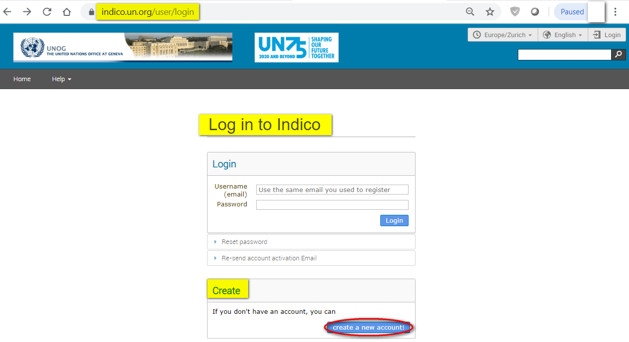

- The below screen appears. Complete all fields marked * - they are mandatory.

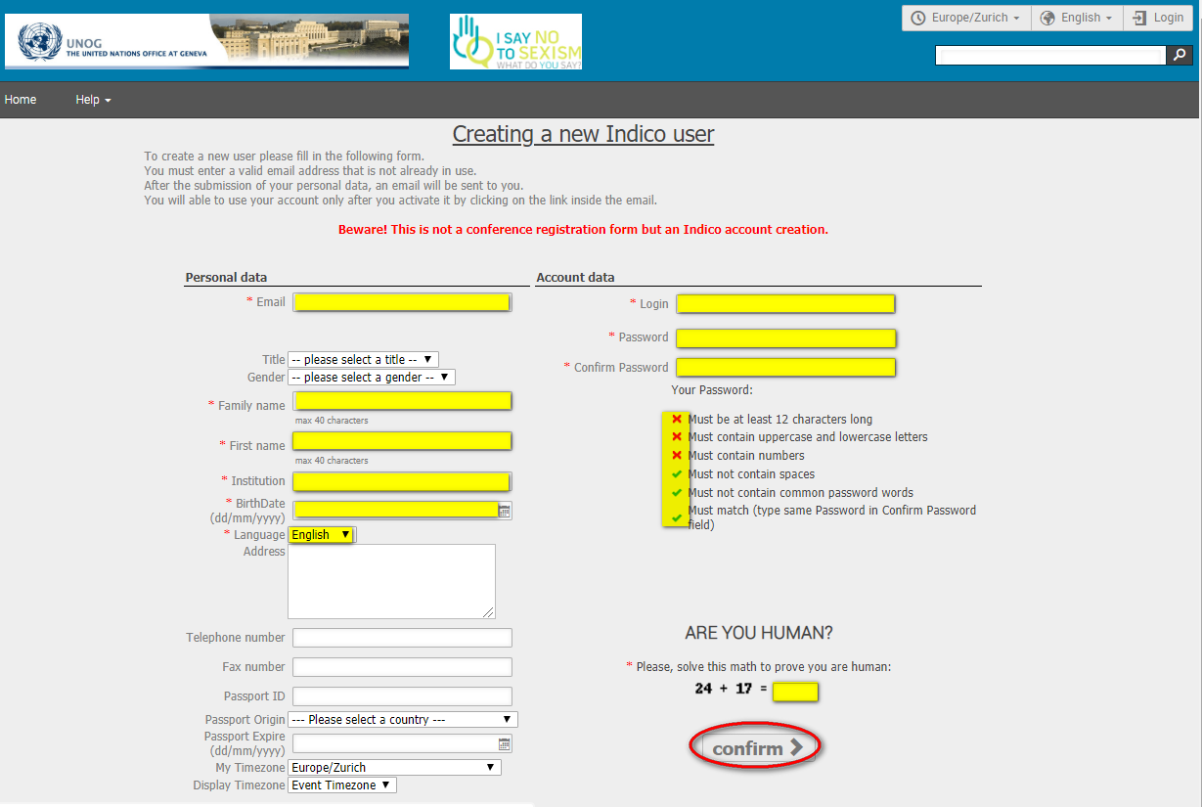

- The email address entered serves as the user ID for the newly created account.
- Ensure that all 6 criteria for establishing a password are met – you should achieve 6 green check marks (If the criteria for setting the password is not visible, it is probably due to an incompatible browser being used - switch to Chrome or Firefox).
- Solve the math sum under ARE YOU HUMAN? and click confirm.
- A message appears on-screen (below) confirming the successful creation of the account and advising you to check your email to activate the account.

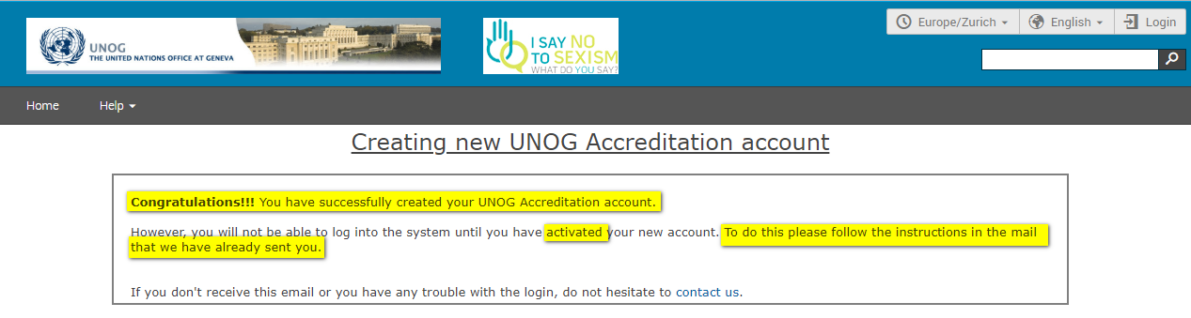

---END---

Activate an Indico Account
- In your email, find the Indico account activation email from noreply.accreditations@unog.ch – it will feature the following text in the subject line “Accreditation account confirmation”.
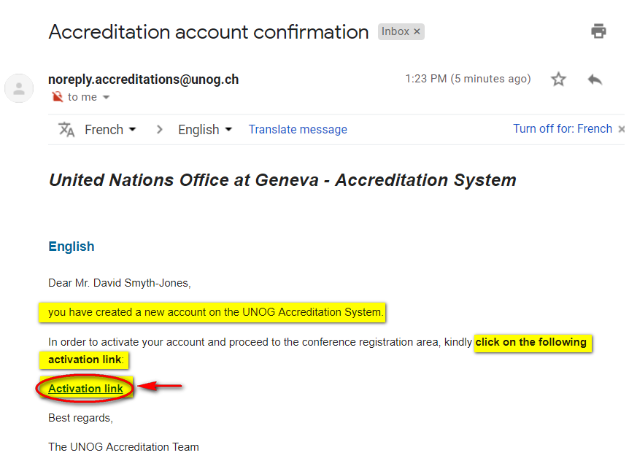
- Open the email and click the Activation link.

- A message appears on-screen (below) confirming the account is activated.

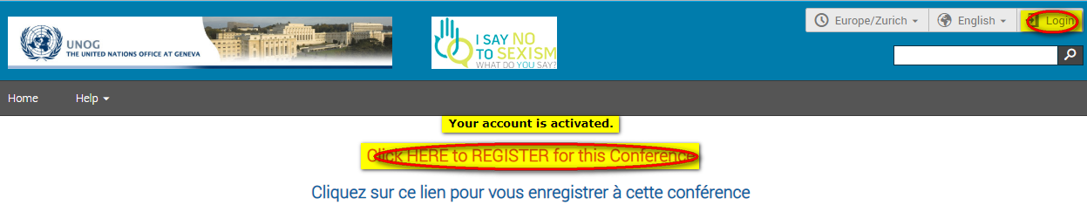

- Proceed to log in to Indico – click either Login (top-right corner of the screen) or Click HERE to Register for this Conference.

---END---

No Activation eMail Received
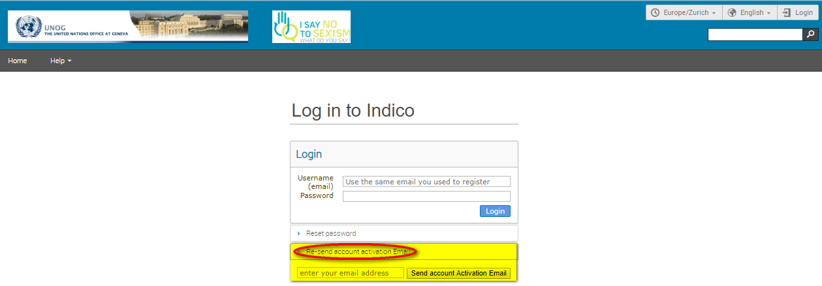
- If you fail to find the activation email, check your Spam or Junk folder. Alternatively, click the Re-send account activation Email link on the Indico log in page, enter the email address under which you created your Indico account and click Send account Activation Email. Check your email account again.

- Failing that, send an email to support.accreditation@un.org

---END---

Modify Your Personal Details
- Log in to Indico and follow My profile.

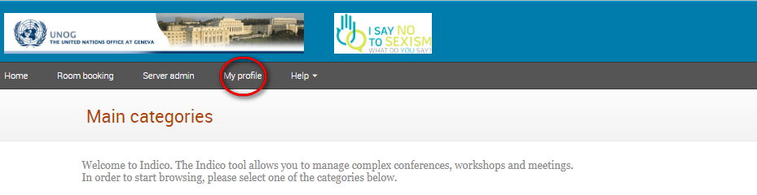

- In the Personal Area, select the Account Details tab.

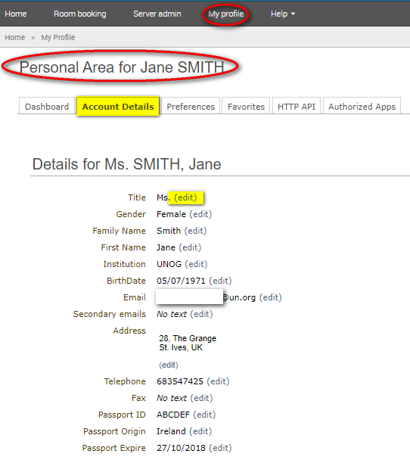

- Click (edit) beside the fields you wish to change.

- Click Save after each change to save the edits.

---END---

Modify Your eMail
- Log in to Indico and follow My profile.

- In the Personal Area, select the Account Details tab.

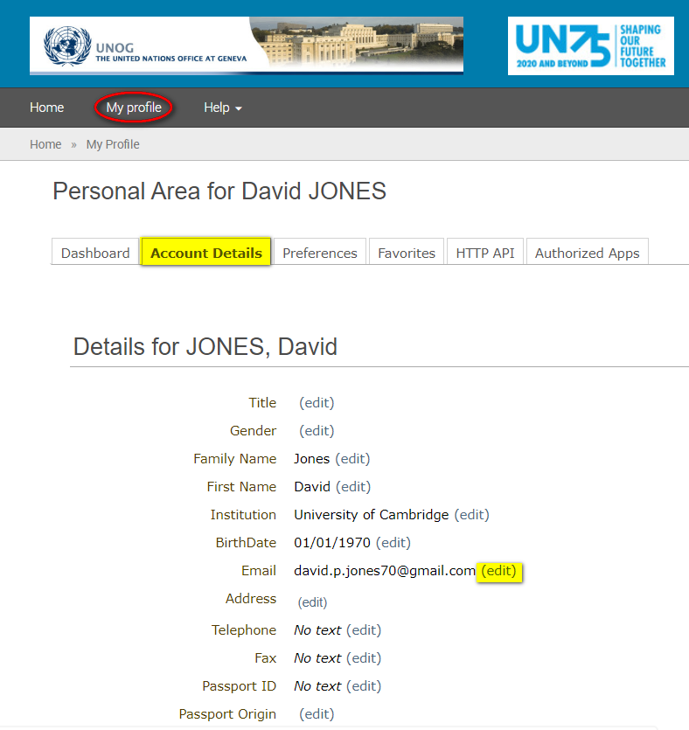

- Click (edit) beside the email field to modify it.
- After entering the new address, a message appears on-screen telling you that an email has been sent to the new email account to verify the change of email.

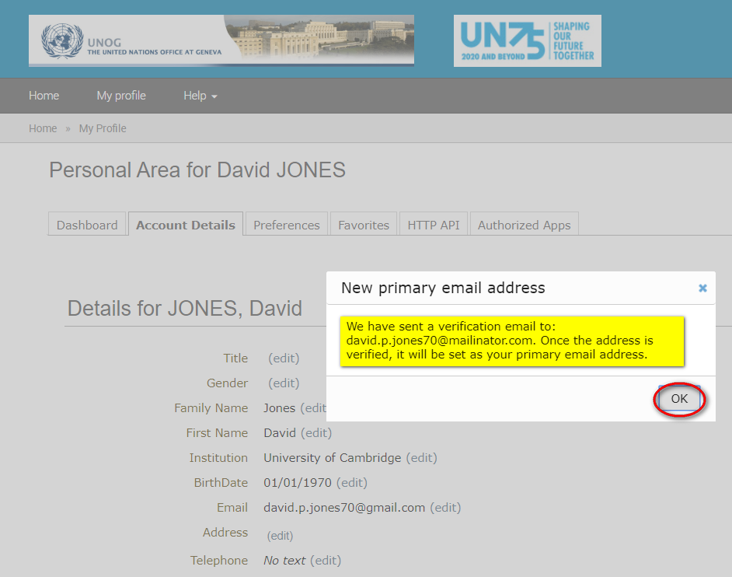

- WITHOUT logging out of Indico, go to the new email account and find the email from noreply.accreditation@unog.ch requesting you to verify the new email address.
- Click the link in the email to confirm the change.

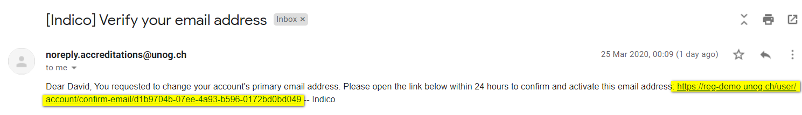

- At this point you will be redirected back to the account details tab in Indico.
- A green message appears at the top of the screen confirming that the new email address has been set as the primary address. It is also the new user ID.

- Alternatively, if you are logged out of Indico when you click the change of email link, then the next time you log in to Indico you will need to still use the OLD email address as your user ID - but only for the first time. Then once logged in you will see the same green message appear on the top of the screen.

---END---

Modify Your Password/Forgotten Password

Modify Your Password
- Log in to Indico and follow My profile.

- In the Personal Area, select the Account Details tab and at the bottom click Change password.

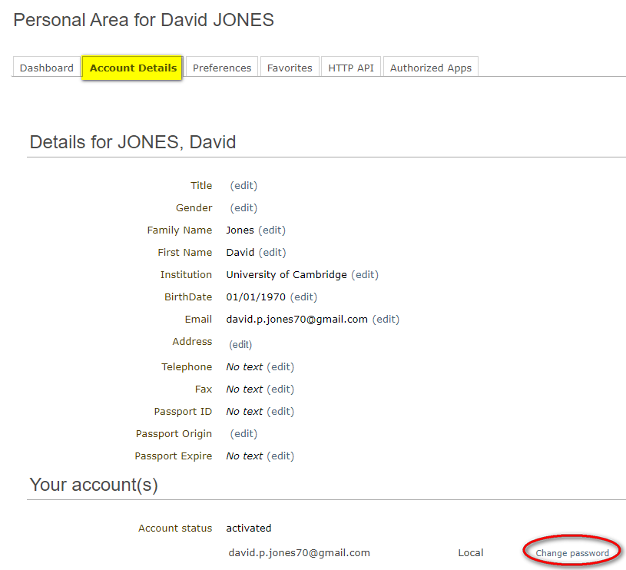

- In the Change password dialogue pane, enter a new password respecting the criteria laid out. Ensure to achieve 6 green check marks . Click Ok to save.

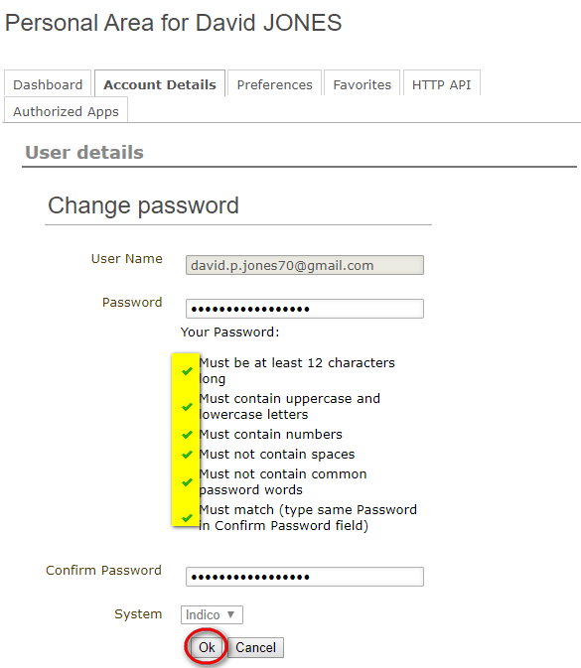

Forgotten Your Password
- Click Reset my password on the log in screen.

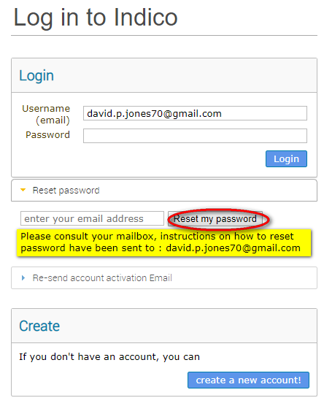

- Enter your email address and click Reset my password.

- A message appears on-screen “Please consult your mailbox, instructions on how to reset password have been sent to xxxxxx”.
- Go to your email account and find the email from noreply.accreditations@unog.ch. Click on the link in the email.

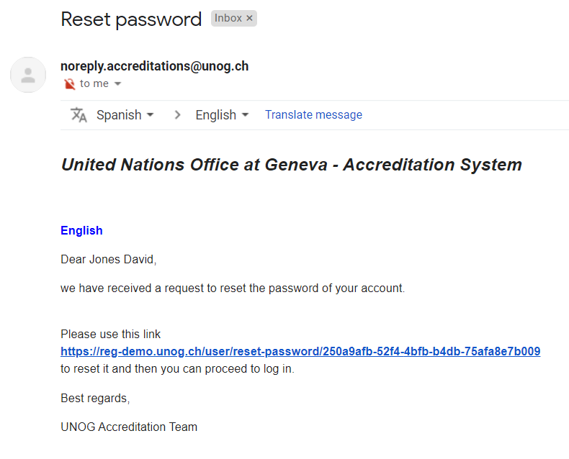

- In the Reset your Indico password dialogue pane, enter a new password respecting the criteria laid out. Ensure to achieve 6 green check marks . Click Change password to save. The new password can be used to log in.
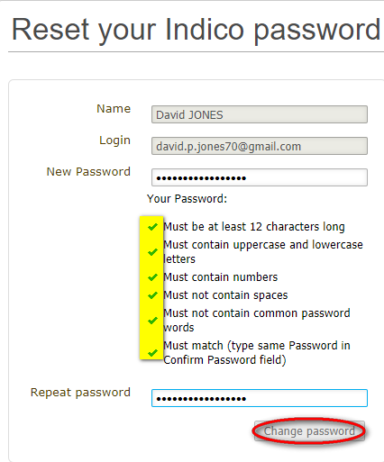

---END---

Register for an Event
- Log in to Indico and go to the main page of the event.
- Click Register now and the registration form opens.

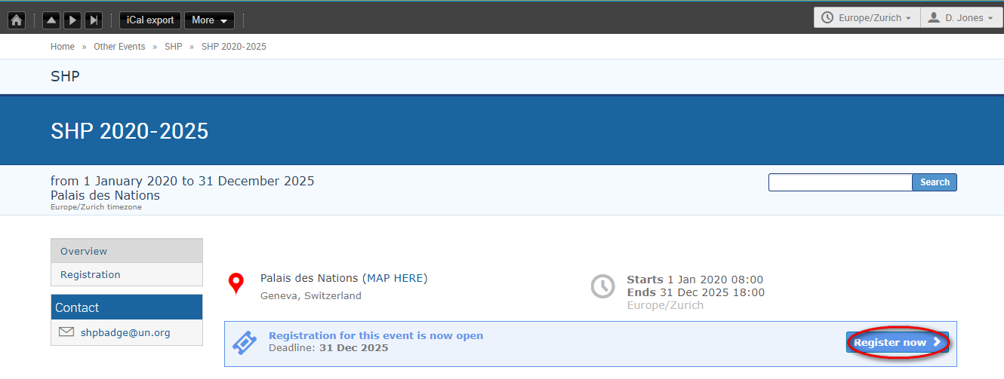

- When the registration form opens, read it carefully. Note, some personal data will already be replicated from your profile.
- Complete ALL mandatory fields marked with “*” (this includes uploading any documents that are deemed mandatory). Failing to complete the mandatory requirements will result in the form being blocked from submission.
- Ensure that a picture is included that meets the picture criteria. (If you have successfully registered for an event previously, the last picture used will be added to the registration form automatically).
- Once satisfied that all requirements have been completed/uploaded, click Register.
- A confirmation message appears on screen.

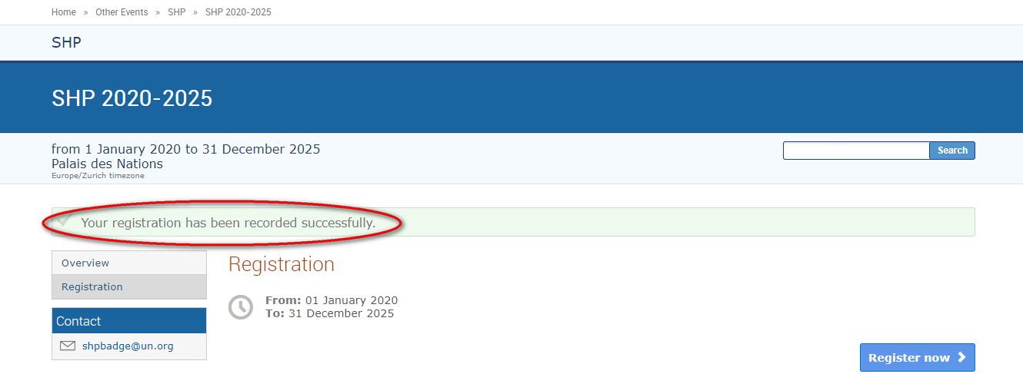

- At this point your registration will be in a pending approval status with the organizer.

Sample Registration Form

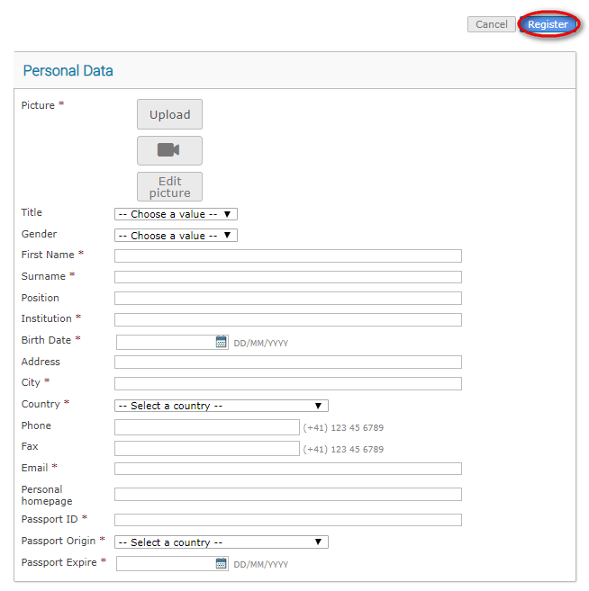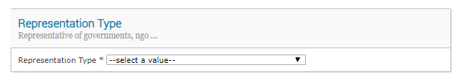

---END---

eMail Notifications

Registration Acknowledgement
- Within minutes of submitting the registration form, an email notification is sent acknowledging receipt of your registration and confirming its pending status. Remember to check spam or junk folders for this email.

Sample acknowledgement of receipt of a registration form
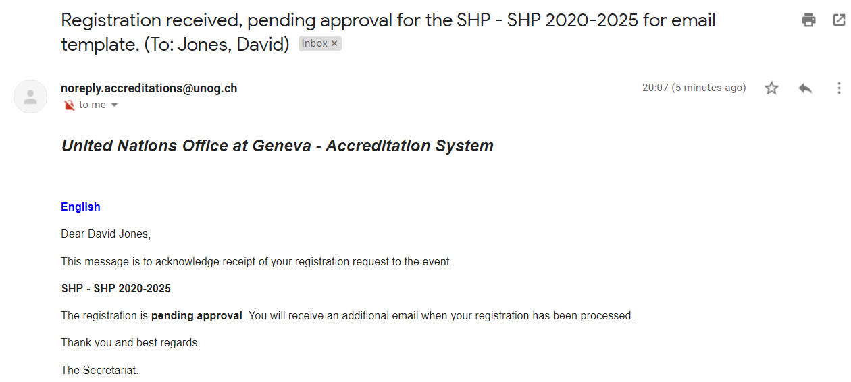

Approval (or Rejected)
- Once an organizer has processed your registration, an email notification is sent indicating whether your registration has been Approved or Rejected.
- If the registration request has been Approved, an approval email is sent to the registrant which includes, amongst other details, a QR code. This email should be printed and presented at the entrance to the event in order to gain access.
- If an event has been configured by the organizer to also issue UN Event Passes, then one will be attached to the email as a PDF. This too should be printed and presented upon entry to the event.

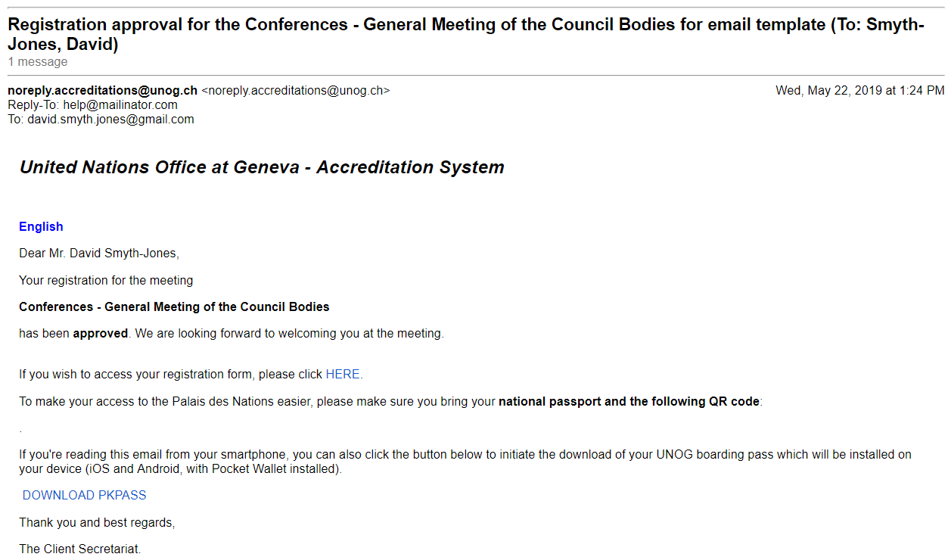
Sample confirmation of approval email

Sample UN Event Pass

Modify or Cancel Your Registration
You can only modify or cancel your registration when it is PENDING approval.

- Log in to Indico and go to the main page of the event.
- On the event page a registration status bar “Your request for participation is pending” is visible with the options to either Cancel or Modify.

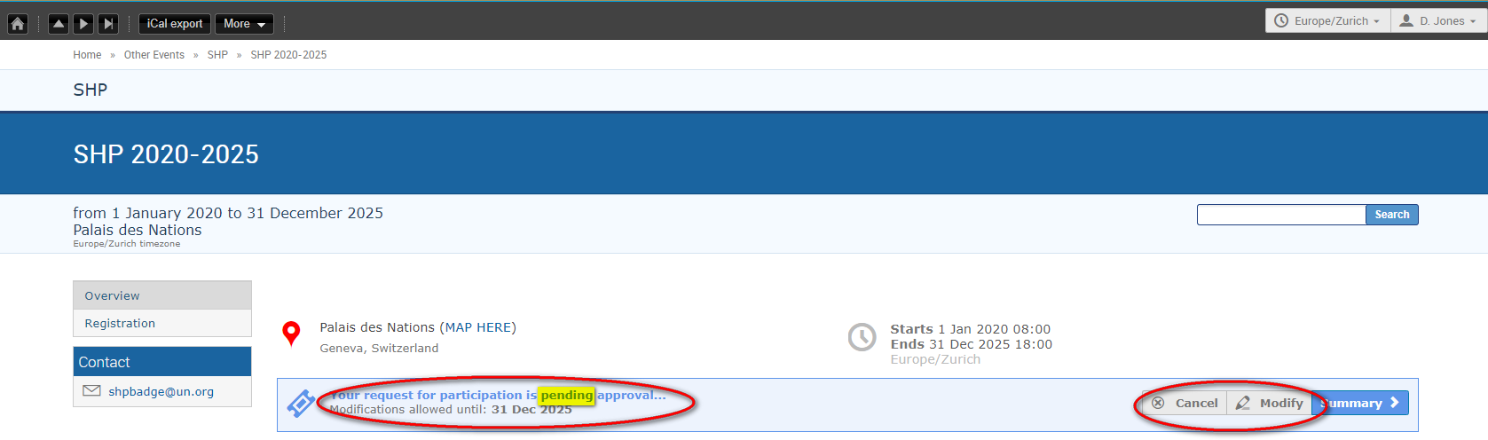

Modify Your Pending Registration
- Click Modify in the status bar. The Modify Registration form opens. Make the changes and then click Modify again to save the changes.

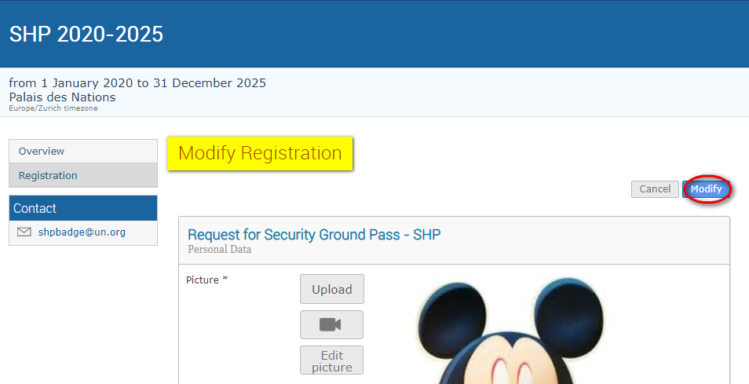

- The following message appears on screen to confirm the changes:

Cancel Your Pending Registration

Cancel your pending registration
- Click Cancel on the registration status bar.

Modify or Cancel your Approved Registration
- Neither option (Cancel or Modify) is available on the registration status bar and you will have to contact the organizer in both these situations.

- For modifications, upon request the organizer can make the changes on your behalf OR reset the registration to pending. When it is back to pending you can make the changes as previously described and resubmit for approval.
- For cancellation, you should contact the organizer to cancel the registration on your behalf.

--- END ---

Print Your Approval eMail/Print UN Event Pass

Print Your Approval eMail
- Log in to Indico and follow My profile.

- In the Personal Area select the Dashboard tab.
- There, clicking the envelope icon beside the events you are registered for will open emails sent to you by the organizer.

Dashboard tab
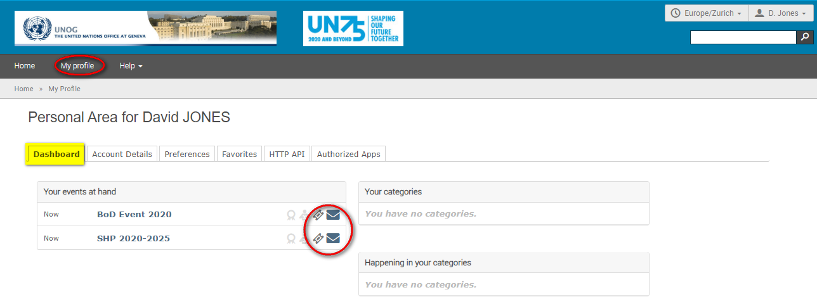

Print UN Event Pass
- If it has been enabled for an event, the UN Event Pass can be downloaded from the event page by clicking on the Get UN Event Pass link in the registration status bar. (Clicking the ticket icon beside the event on the dashboard tab redirects you to the event page).

---END---

For cases where registrations are Rejected, the registrant should contact the event organizer directly should he/she wish to query the decision.

