INDICO

Create and Activate an Account /
Edit Profile, eMail, Password

Contents

Create an Indico account 2
Activate an account 4
No activation eMail received 5

Edit profile (incl. email) 6
Change password (incl. reset password) 7

KEY POINTS TO REMEMBER

WHY CREATE AN INDICO ACCOUNT?
An Indico account is required in order to register for events managed in Indico.
BROWSER COMPATIBILITY
Indico performs better with the following browsers:
Firefox – Chrome
PASSPORT / ID CARD
Have passport/ID card to hand while completing an Indico profile. Personal data must correspond with details contained in passports/on ID cards.
PICTURE
When submitting a registration form, upload a recent picture to it from your hard drive or take one with a webcam if your PC has a lens (registration forms contain an active camera function). A guide on picture standards is available.
EMAIL ADDRESS
The email address used when creating an Indico account must not already be in use by another Indico user. Email addresses are used as a unique identifier of users.

NO ACCOUNT ACTIVATION EMAIL
Before seeking assistance, check your SPAM folder or click on the resend account activation email option on the Indico log in page.
CHILDREN
Children 13 and under are not required to register in Indico for an event if they accompany an adult who is registered and approved for the event. Children 14+ must register for an event.

Create an Indico account

- Navigate to https://indico.un.org/user/login and click create a new account.
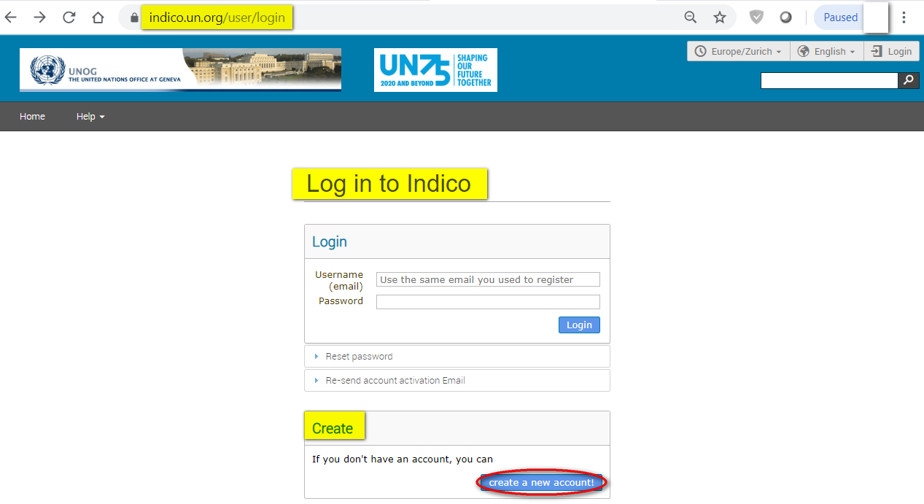

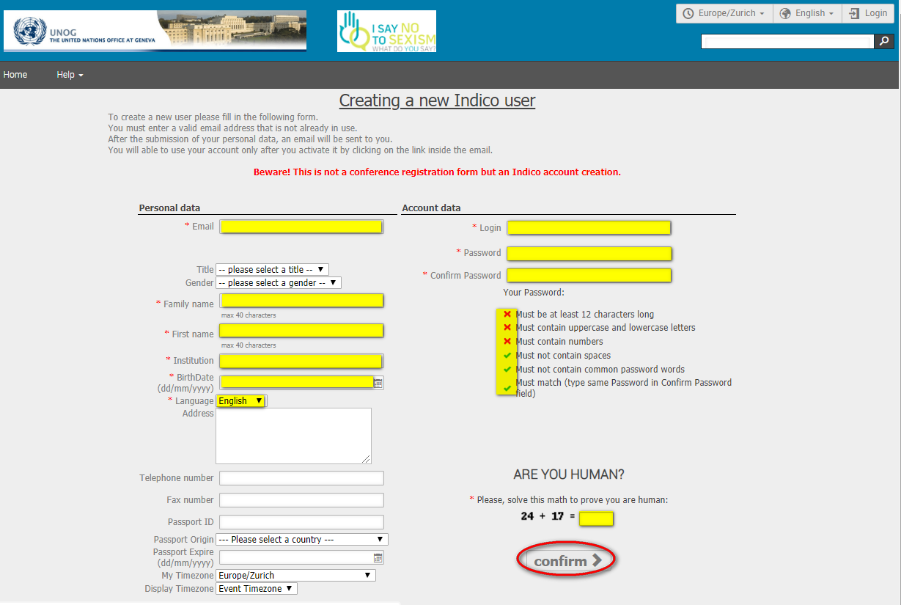
- The below screen appears.

- Complete all fields marked “*” – they are mandatory.

- The email address entered serves as the user ID for the newly created account.

- Ensure that all 6 criteria for establishing a password are met – you should achieve 6 green check marks (If the criteria for setting the password is not visible, it is probably due to an incompatible browser being used - switch to Chrome or Firefox).

- Solve the math sum under ARE YOU HUMAN? and click confirm.

- A message appears on-screen confirming the successful creation of the account and advising you to check your email to activate the account.

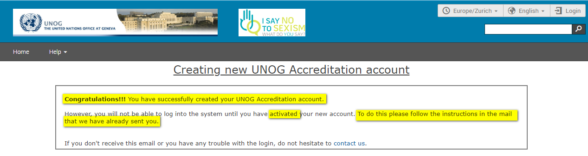

Activate an account

- In your in box, find the Indico account activation email – it will feature the following text in the subject line “Accreditation account confirmation”.

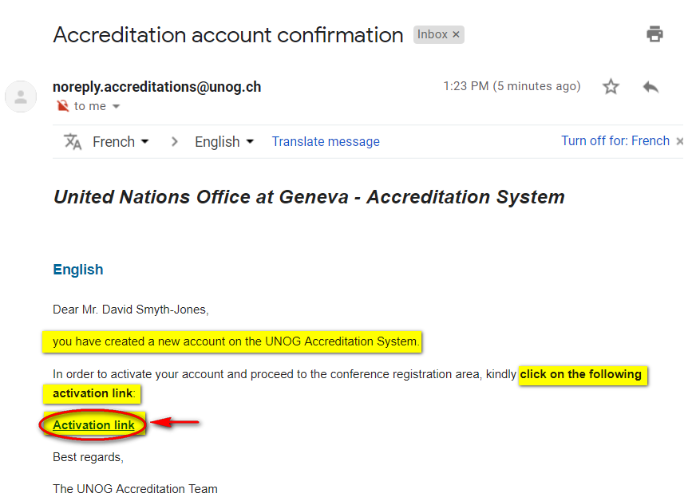
- Open the email and click the activation link.

- A message appears on-screen confirming your account is activated.

- Proceed to log in to Indico – click Login (top-right corner of the screen) or on Click HERE on the page.

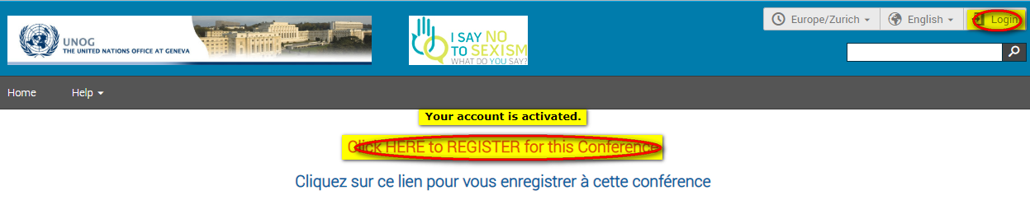

No activation eMail received

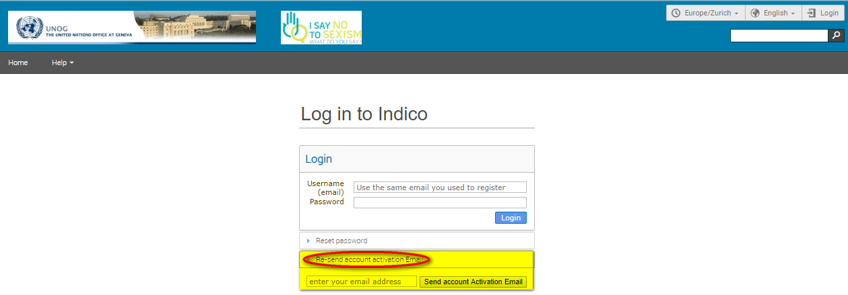
If you fail to find the activation email, check your Spam or Junk folder. Alternatively, click the Re-send account activation Email link on the Indico log in page, enter the email address under which you created your Indico account and click Send account Activation Email. Check your email account again.

Edit profile (incl. email)
(Log in first)

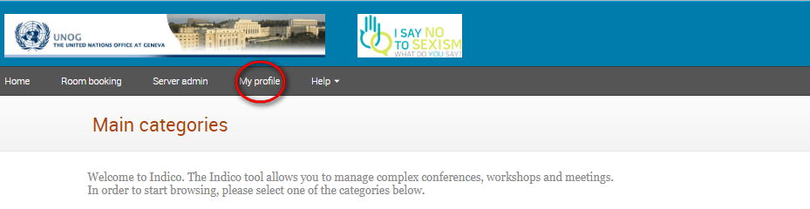
- Follow My profile.

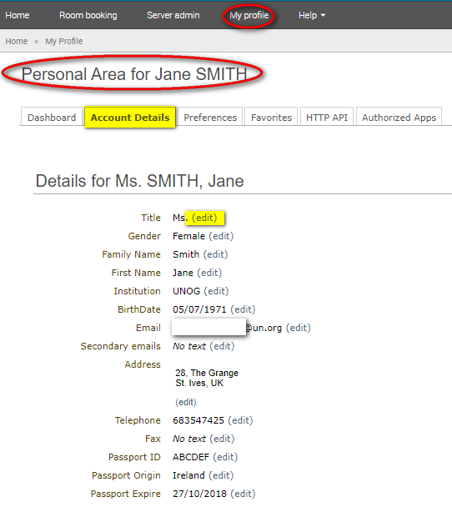
- In the Personal Area, select the Account Details tab.

- Click (edit) beside the fields you wish to change.

- Click Save after each change to save the edits.

Edit email

- When you update your email address, you will receive a message on-screen telling you that an email has been sent to the new email account to confirm the change of email.
- Log out of Indico.
- Go to the new email account and find the email from Indico.
- Click the link in that email to confirm the change.
- Go back to Indico to log in – use your OLD email address as your user iD.
- At this point the NEW email address will be registered on your account and will be your NEW user iD.

Change password (incl. reset password)
(Log in first)

Change password

- Follow My profile.

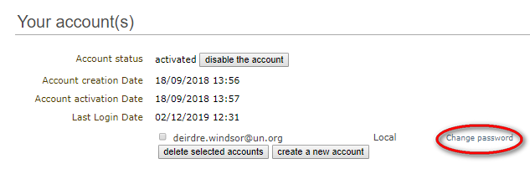
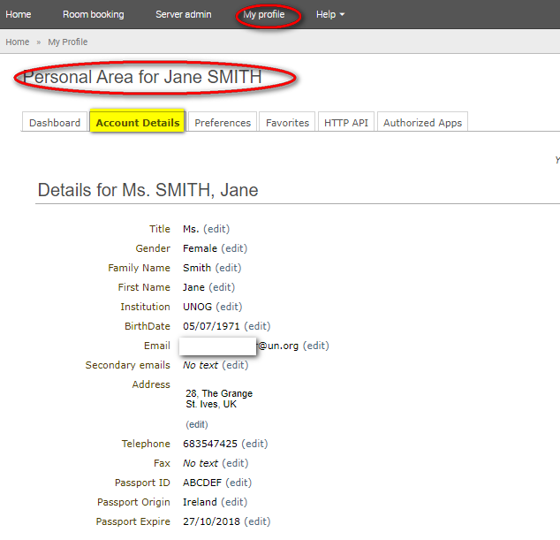
- In the Personal Area, select the Account Details tab.

- Click Change password.

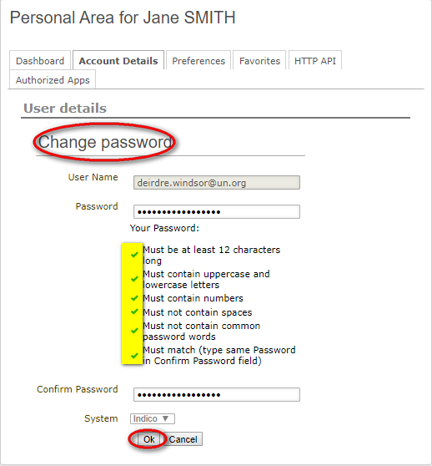
- Enter a new password applying all the 6 password criteria. You MUST obtain 6 green check marks =

- Click Ok. The password is reset.

Reset password (forgotten)

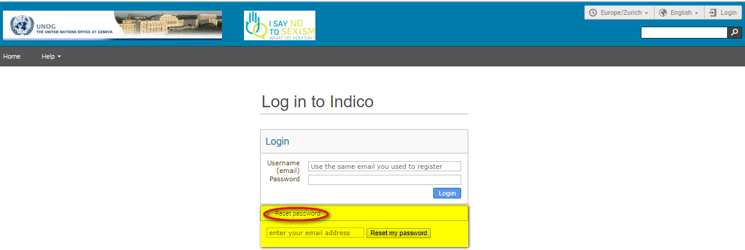
A user who has an active account and forgotten the password may use the reset password link on the log in page to reset it. Enter the user ID/email address against which the account was created and click Reset my password. A message appears on-screen “Please consult your mailbox, instructions on how to reset password have been sent to xxxxxx”.

If the account is not yet active, if you click Reset password an account activation email is sent instead of the password reset message.

--- END ---

