Access Your eMail - Access your UN Event Pass

Access your eMail

- Log in to Indico and follow My profile.

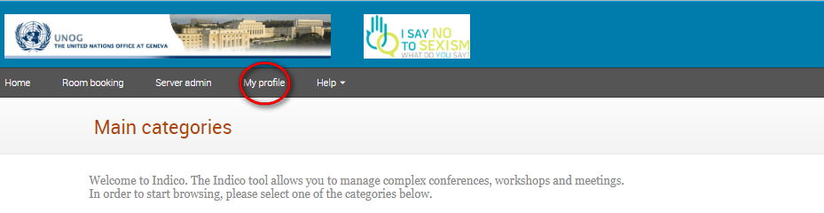

- In the Personal Area select the Dashboard tab.

- Click the envelope icon beside events you are registered to in order to open emails sent to you by the organizer.

Dashboard tab
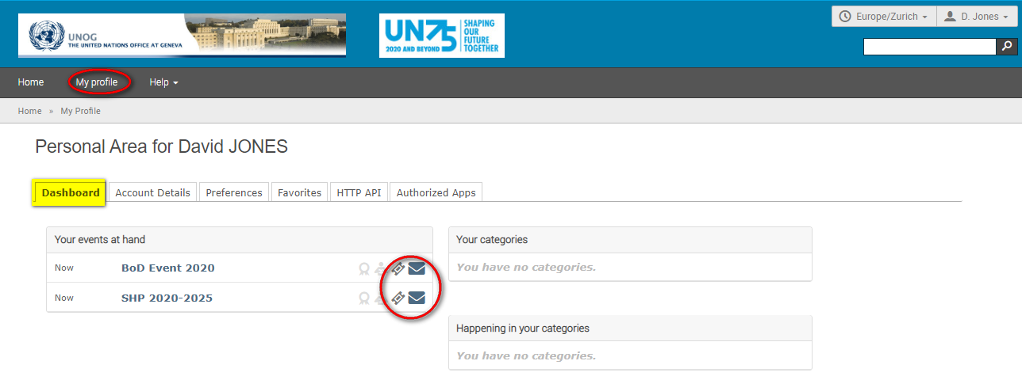

Access Your UN Event Pass

- The UN Event Pass can be downloaded and printed from the event page by clicking on the Get UN Event Pass link in the registration status bar. (Clicking the ticket icon beside the event on the dashboard tab redirects you to the event page).

---END---

If this feature has been enabled for the event.

