Modify or Cancel your Registration

You may only modify or cancel your registration when it is PENDING approval.

- Log in to Indico and go to the event page.

- On the event page a registration status bar “Your request for participation is pending” is visible with the options to either Cancel or Modify.

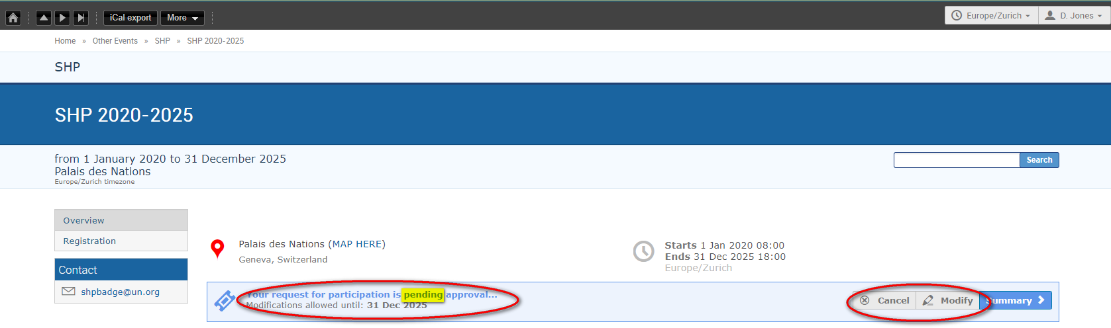

Modify Your Registration
- Click Modify in the status bar. The Modify Registration form opens. Make the changes and then click Modify again to save the changes.

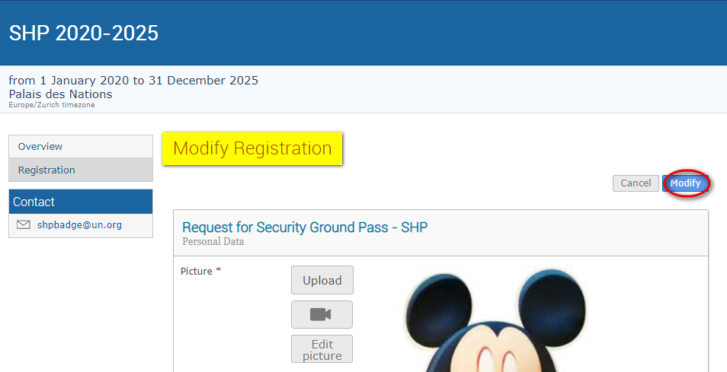

- The following message appears on screen to confirm the changes:

To Cancel Your Registration

- Click Cancel on the registration status bar.

To Modify or Cancel Your Approved Registration

- Neither option (Cancel or Modify) is available on the registration status bar and you will have to contact the organizer in both these situations.

- For modifications, upon request the organizer can make the changes on your behalf OR reset the registration to pending. When it is back to pending you can make the changes as previously described and resubmit for approval.

- For cancellation, you should contact the organizer to cancel the registration on your behalf.

--- END ---

