Register for an Event

- Click Register now on the event page. If you are an Indico account holder and not logged in, you will be prompted to log in. Otherwise the registration form will open.
- For existing account holders, the registration form will contain some of your personal data replicated from your profile.

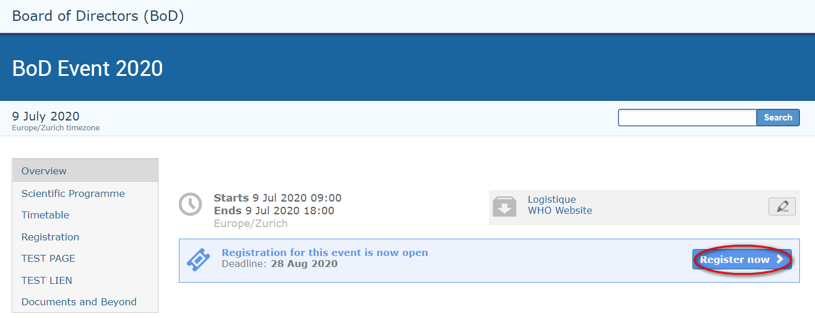

Registration Form
- Read the registration form carefully as it may contain instructions for you to follow.
- Complete ALL mandatory fields marked with “*” (this includes uploading any documents that are deemed mandatory). Failing to complete the mandatory requirements will result in the form being blocked from submission.
- Ensure that a picture is included that meets the picture criteria. (If you have successfully registered for an event previously, the last picture used will be added to the registration form automatically).
- Once satisfied that all requirements have been completed/uploaded, click Register. A confirmation message appears on screen.

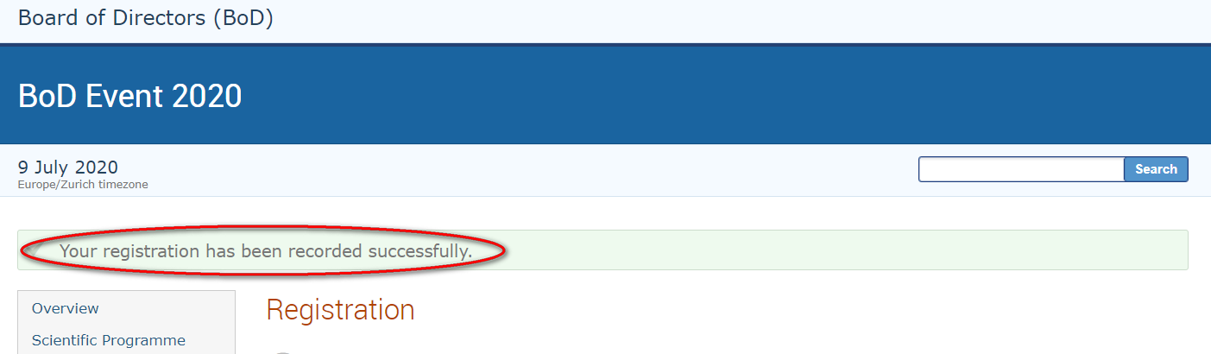

- At this point your registration will be in a pending approval status with the organizer.
Sample Registration Form

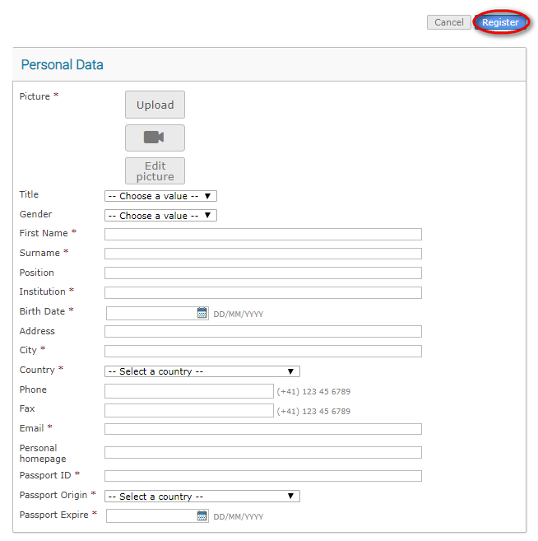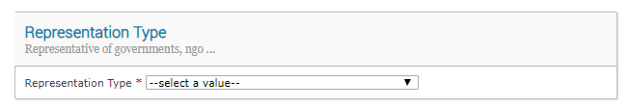

Acknowledgement Email
- Within minutes of submitting the registration form, an email notification is sent acknowledging receipt of your registration and confirming its pending status. Remember to check spam or junk folders for this email.

Sample acknowledgement of receipt of a registration form
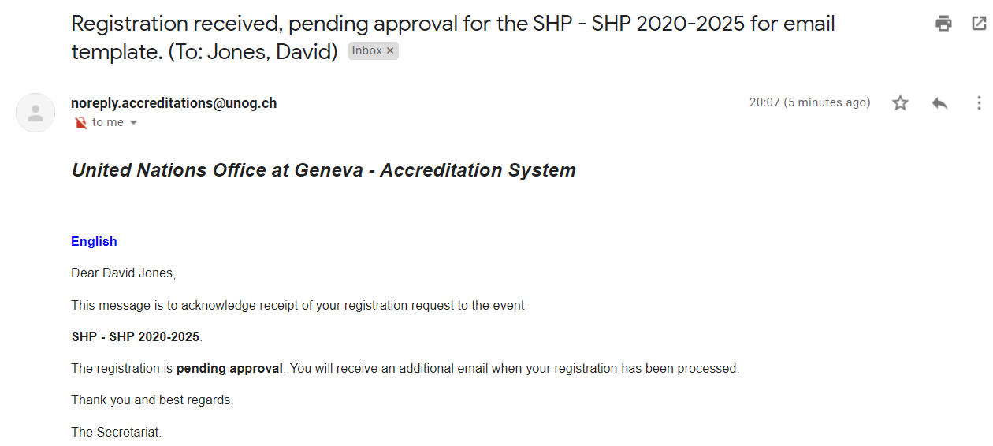

Notification of an Approved Registration (or Rejected)
- Once an organizer has processed your registration, an email notification is sent indicating whether your registration has been Approved or Rejected.
- If the registration request has been Approved, an approval email is sent to the registrant which includes, amongst other details, a QR code. This email should be printed and presented at the entrance to the event in order to gain access.
- If an event has been configured by the organizer to also issue UN Event Passes, then one will be attached to the email as a PDF. This too should be printed and presented upon entry to the event.

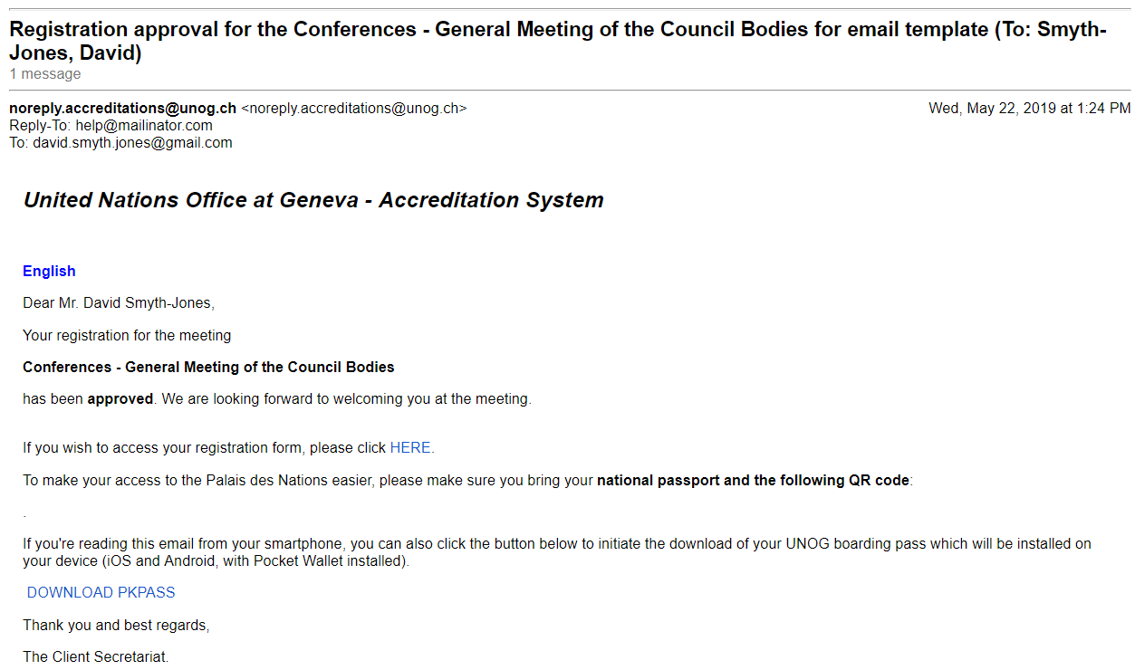
Sample confirmation of approval email

Sample UN Event Pass

If you are NOT an Indico account holder, you will be prompted to create one first before you may register to the event.
Picture standards are here: https://indico.un.org/ihelp/pdf/unog/UNOG%20Indico%20picture%20standards.pdf

