Modify YOUR Password - Forgotten password

Modify Your Password

- Log in to Indico and follow My profile.

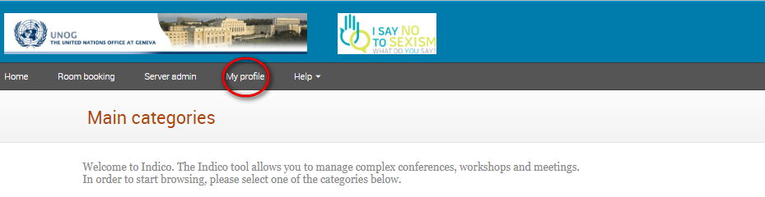

- In the Personal Area, select the Account Details tab and at the bottom click Change password.

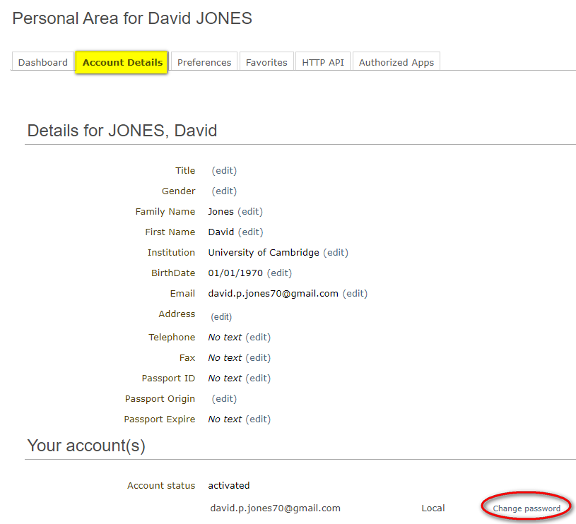

- In the Change password window enter a new password respecting the criteria laid out. Ensure to achieve 6 green check marks . Click Ok to save.

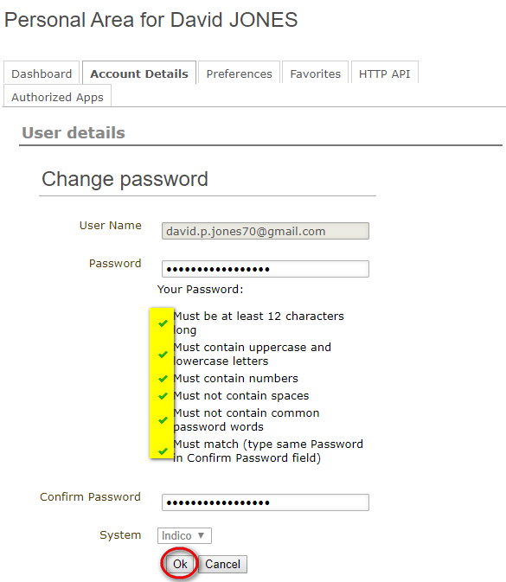

Forgotten Password

- On the Indico log in page click Reset my password.

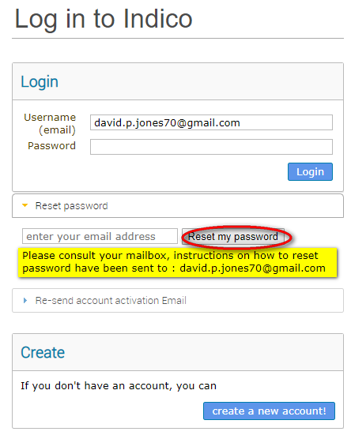

- Enter your email address and click Reset my password.

- A message appears on-screen “Please consult your mailbox, instructions on how to reset password have been sent to xxxxxx”.

- Go to your email account and find the email from noreply.accreditations@unog.ch. Click on the link in the email.

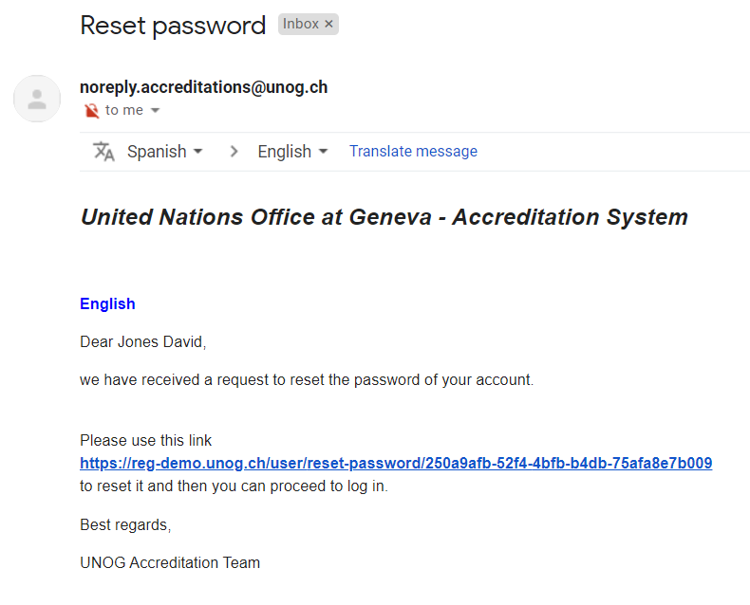

- In the Reset your Indico password window enter a new password respecting the criteria laid out. Ensure to achieve 6 green check marks . Click Change password to save. The new password can be used to log in.

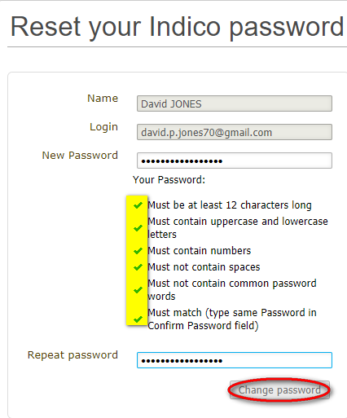

---END---

