Modify your eMail address

- Log in to Indico and follow My profile.

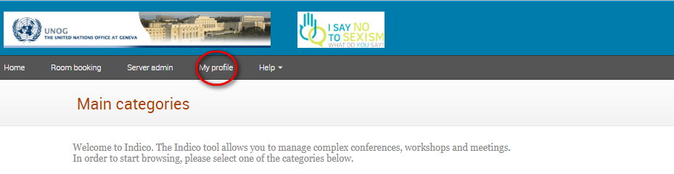

- In the Personal Area, select the Account Details tab.

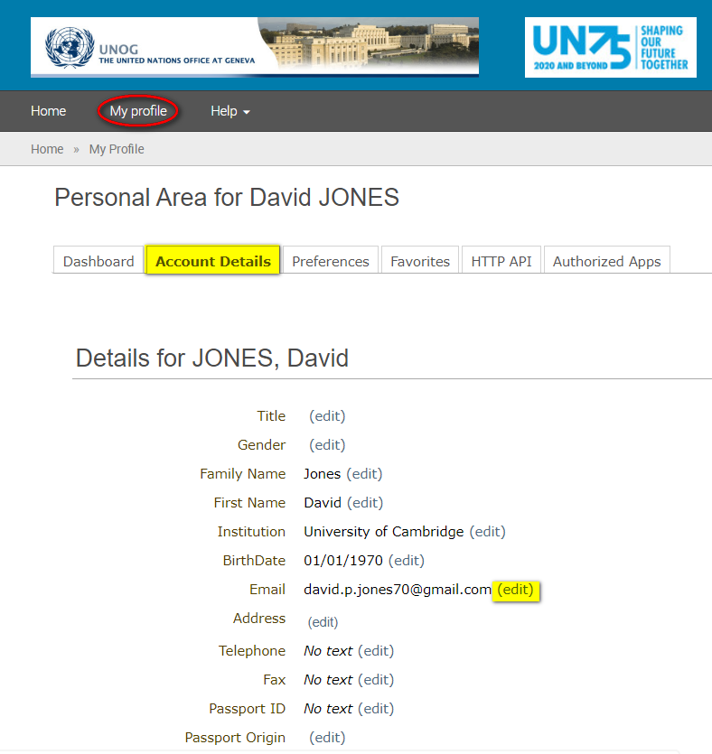

- Click (edit) beside the email field to modify it.

- After entering the new address, a message appears on-screen telling you that an email has been sent to the new email account to verify the change of email.

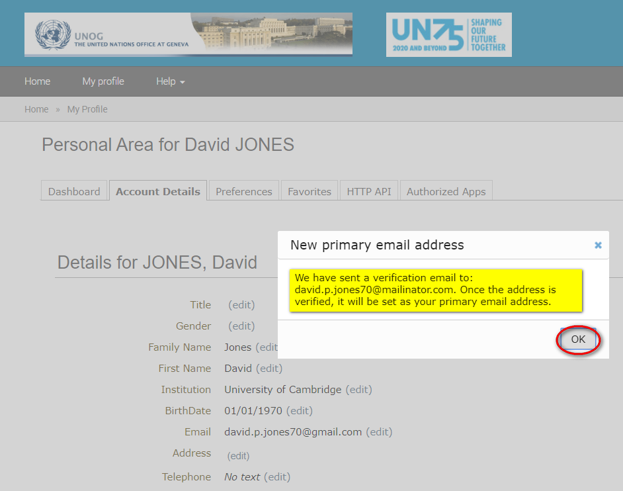

- DO NOT LOG OUT OF INDICO. Go to the new email account and find the email from noreply.accreditation@unog.ch requesting you to verify the new email address.
- Click the link in the email to confirm the change.

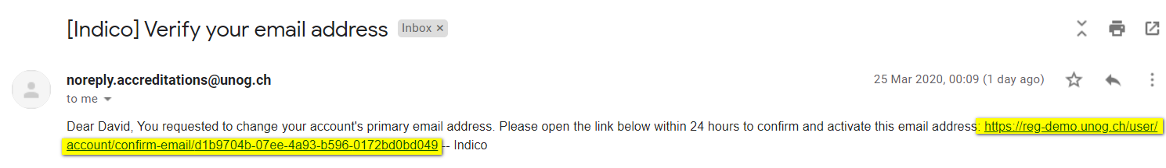

- At this point you will be redirected back to the account details tab in Indico.
- A green message appears at the top of the screen confirming that the new email address has been set as the primary address. It is also the new user ID.

If you are logged out of Indico when you click the change of email link, then the next
time you log in to Indico you will need to still use the OLD email address as your
user ID - but only for the first time. Then once logged in you will see the same green
message appear on the top of the screen.

---END---

