Create and activate an Indico account

Create an Account

- Navigate to https://indico.un.org/user/login and click create a new account.

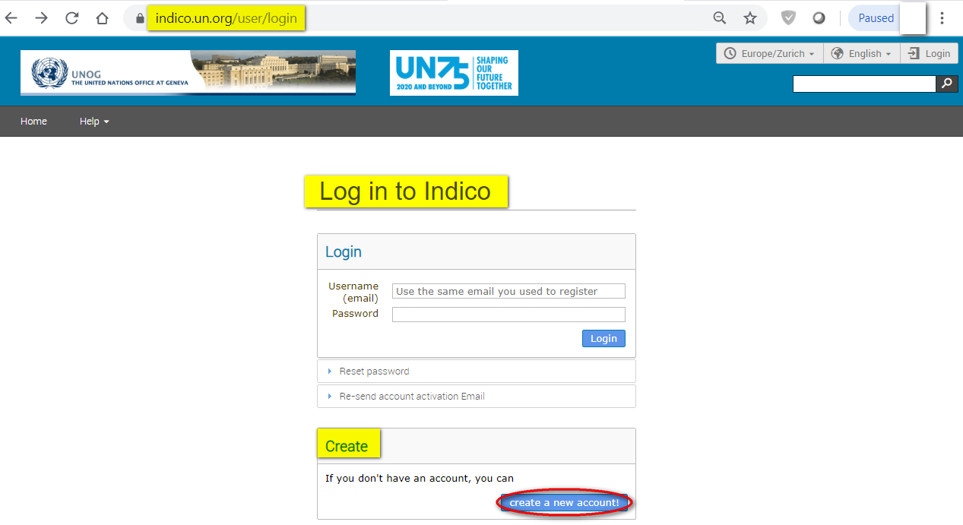

- The below screen appears. Complete all fields marked *. They are mandatory.

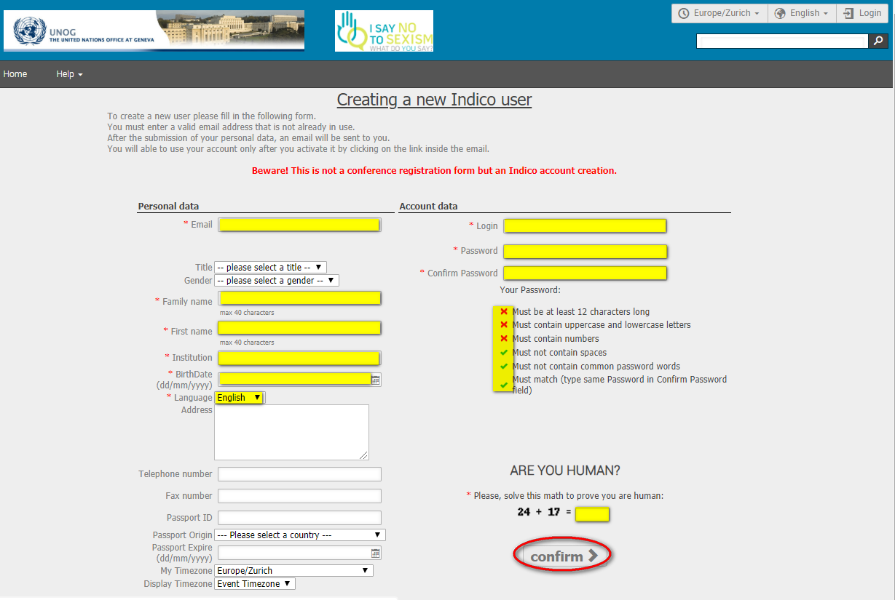
- The email address entered serves as the user ID for the newly created account.

- Ensure that all 6 criteria for establishing a password are met – you should achieve 6 green check marks (If the criteria for setting the password is not visible, it is probably due to an incompatible browser being used - switch to Chrome or Firefox).

- Solve the math sum under ARE YOU HUMAN? and click confirm.

- A message appears on-screen (sample below) confirming the successful creation of the account and advising you to check your email to activate the account.

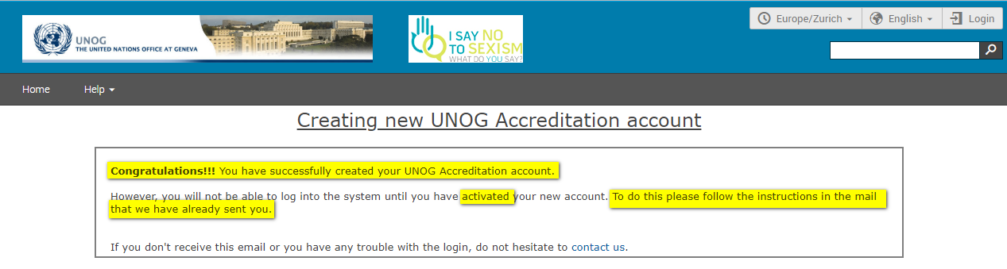

Activate an Indico Account

- In your in box, find the Indico account activation email from noreply.accreditations@unog.ch – it will feature the following text in the subject line “Accreditation account confirmation”.

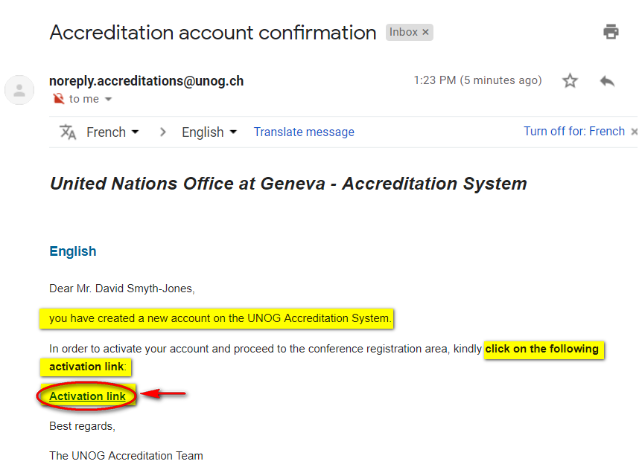
- Open the email and click the activation link.

- A message appears on-screen (sample below) confirming the account is activated.

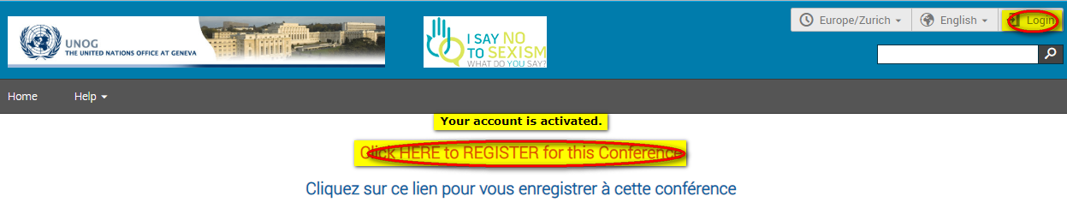

- Proceed to log in to Indico – click either Login (top-right corner of the screen) or Click HERE to Register for this Conference.

No Activation eMail Received

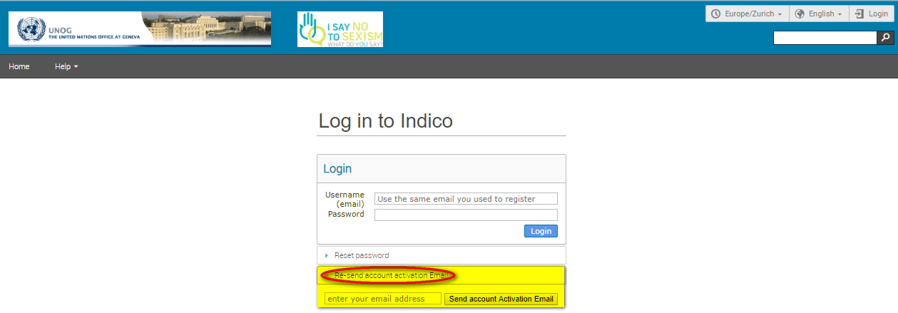
- If you fail to find the activation email, check your Spam or Junk folder. Alternatively, click the Re-send account activation Email link on the Indico log in page, enter the email address under which you created your Indico account and click Send account Activation Email. Check your email account again.

- Failing that, send an email to support.accreditation@un.org

---END---

