CREATE USER PROFILE

STEP 1: Validate my eMail Address 2
STEP 2: Register my Indico Profile 3
STEP 3: Add Personal Data to My Indico Profile 4
My profile: Personal data 5
My profile: Emails 6
Add an additional email address 6
Set a new primary email address 7

My profile: Preferences 8
My profile: Favourites 8
My profile: Accounts (change password) 9
Update my Personal Data 9
Forgotten Password 9

STEP 1: Validate my eMail Address
- Go to xxxxxx and enter your email address in the Email address field.
- Click Send me a verification email.

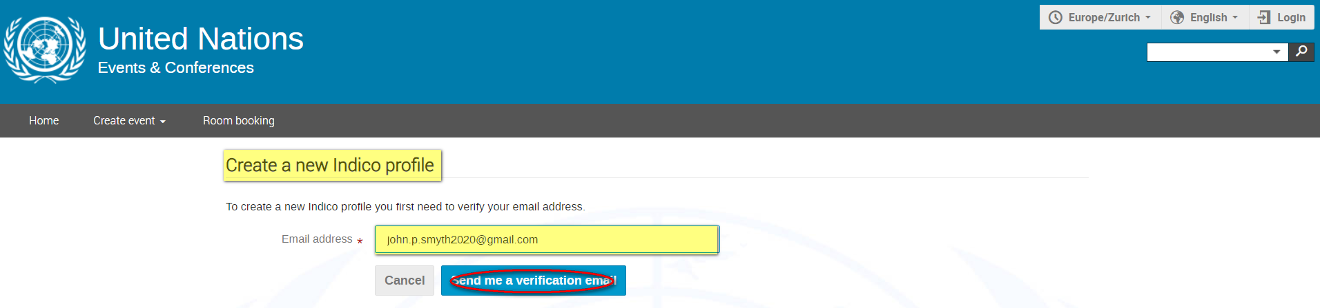

- A message appears on-screen - you have 1 hour within which to go to your email account and find the Indico verification email.

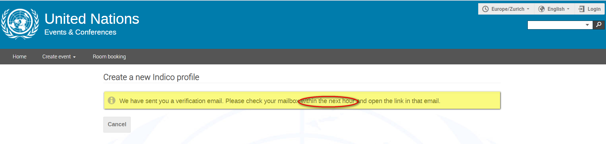

- In the message click the email verification link.

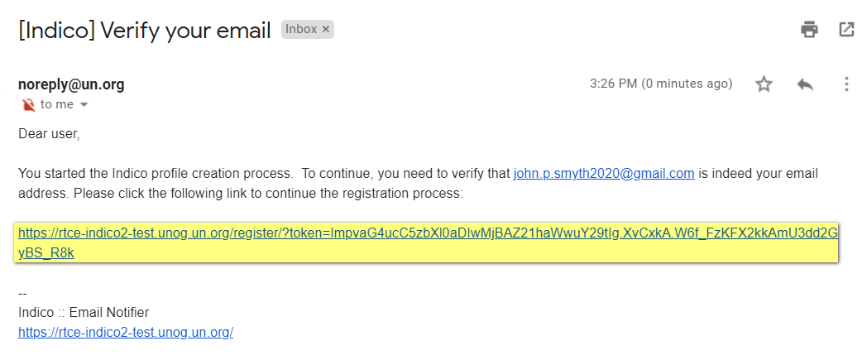

- The link directs you to the page Create a new Indico profile. A message appears on-screen You have successfully validated your email address and can now proceed with the registration.

STEP 2: Register my Indico Profile
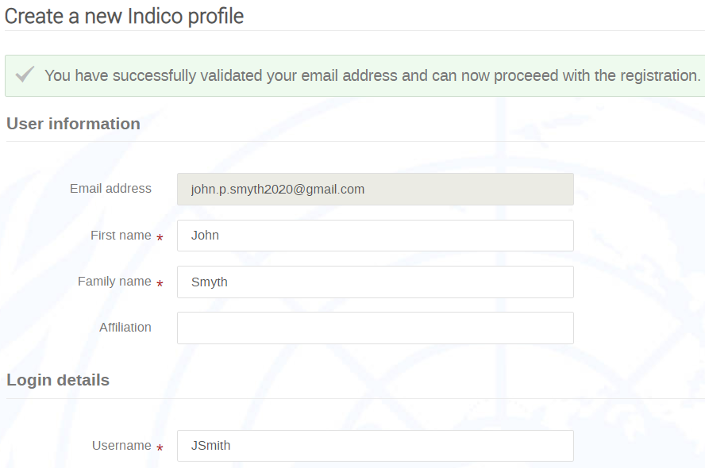
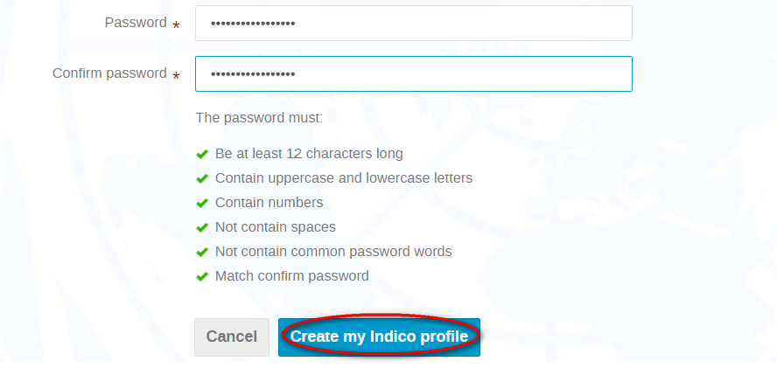

- Complete the form paying attention that:
- You pick a username that is easy to remember;
- fields marked * are mandatory;
- you must achieve 6 green check marks when setting your password.

- Click Create my Indico profile when finished.
- A message appears on-screen You have successfully registered your Indico profile.

STEP 3: Add Personal Data to My Indico Profile
- After successfully registering your Indico profile, click your profile in the on-screen message.

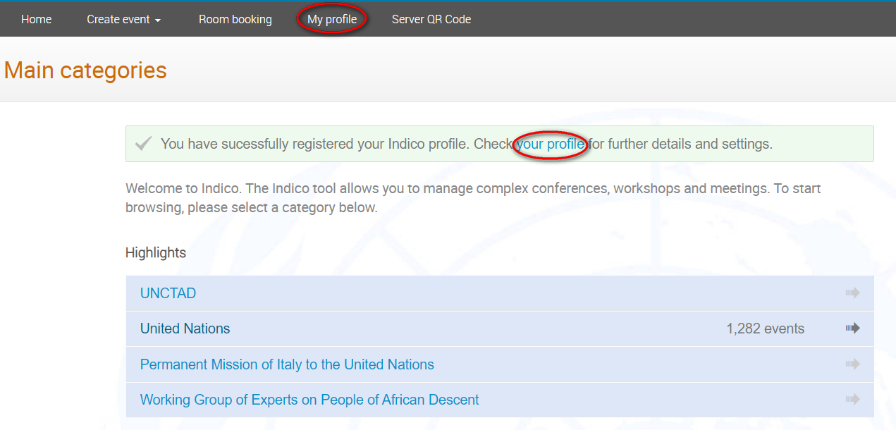

- You may also get to your profile by clicking My profile in the menu bar and then clicking Settings.

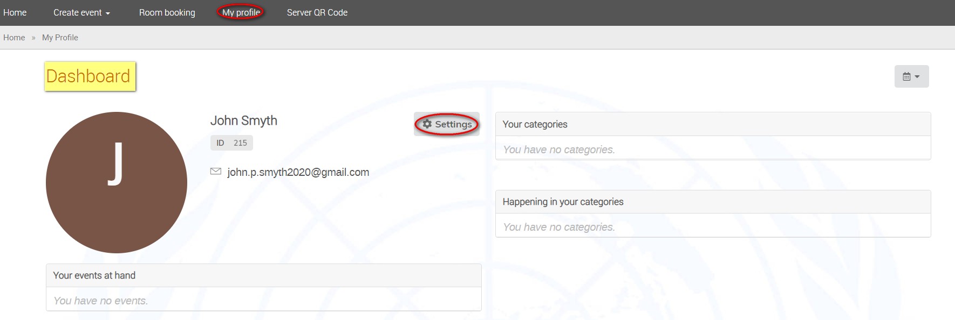

My profile: Personal data
- Click Personal data. Enter your data. All fields marked * are mandatory.
- Click Save when finished.

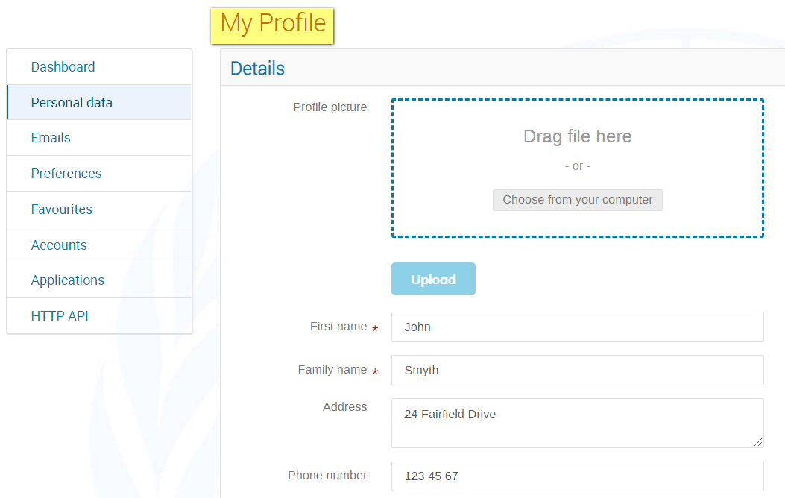
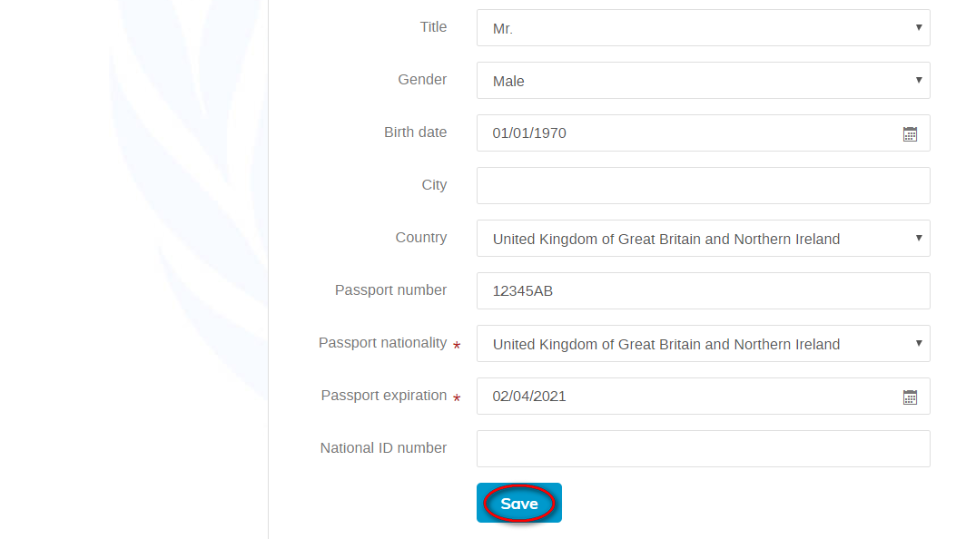

My profile: Emails
The email address used when creating the Indico account is by default the PRIMARY email to which all your notifications from Indico are sent.

Add an additional email address

- Click Emails.
- Enter a new email address in the Add new email address field.
- Click Add.

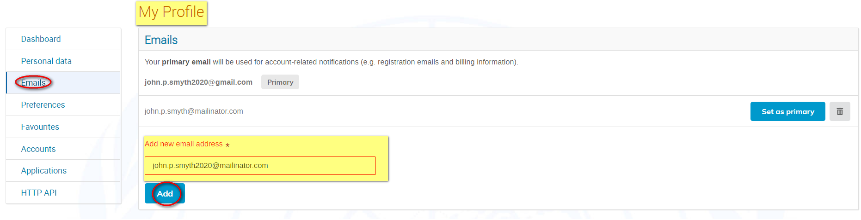

- A message appears on-screen telling you that you have 24hrs to confirm the additional email address as yours.

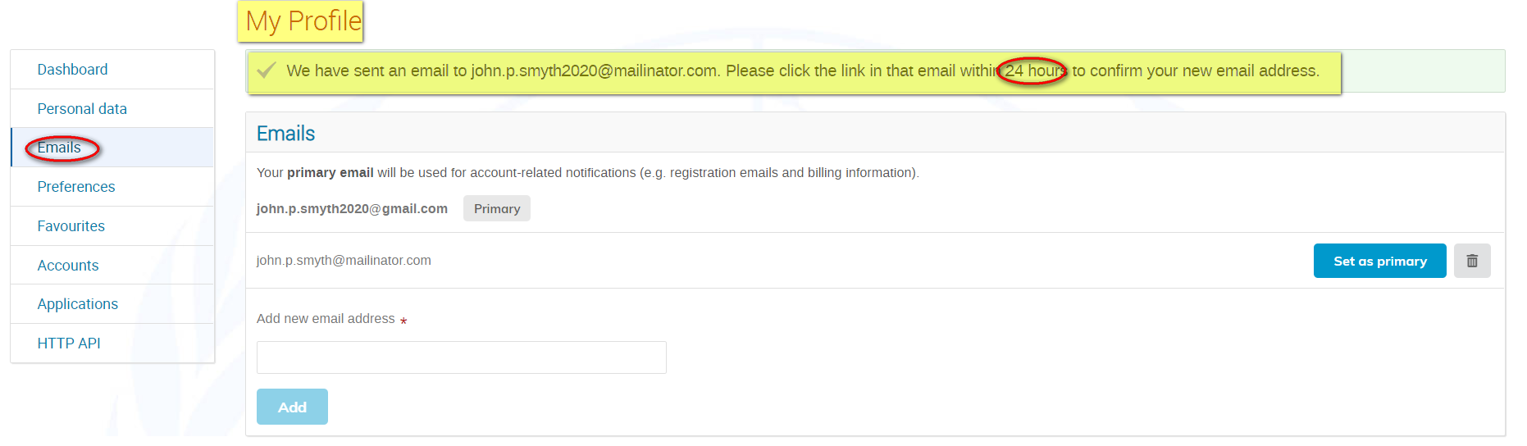

- To confirm the additional email as yours, click the link in an email you receive from Indico.

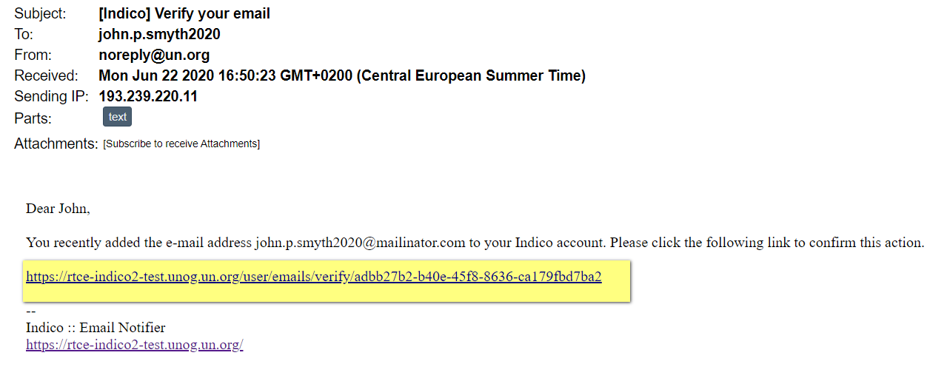
- A confirmation message appears on-screen confirming the email address has been added to your account.

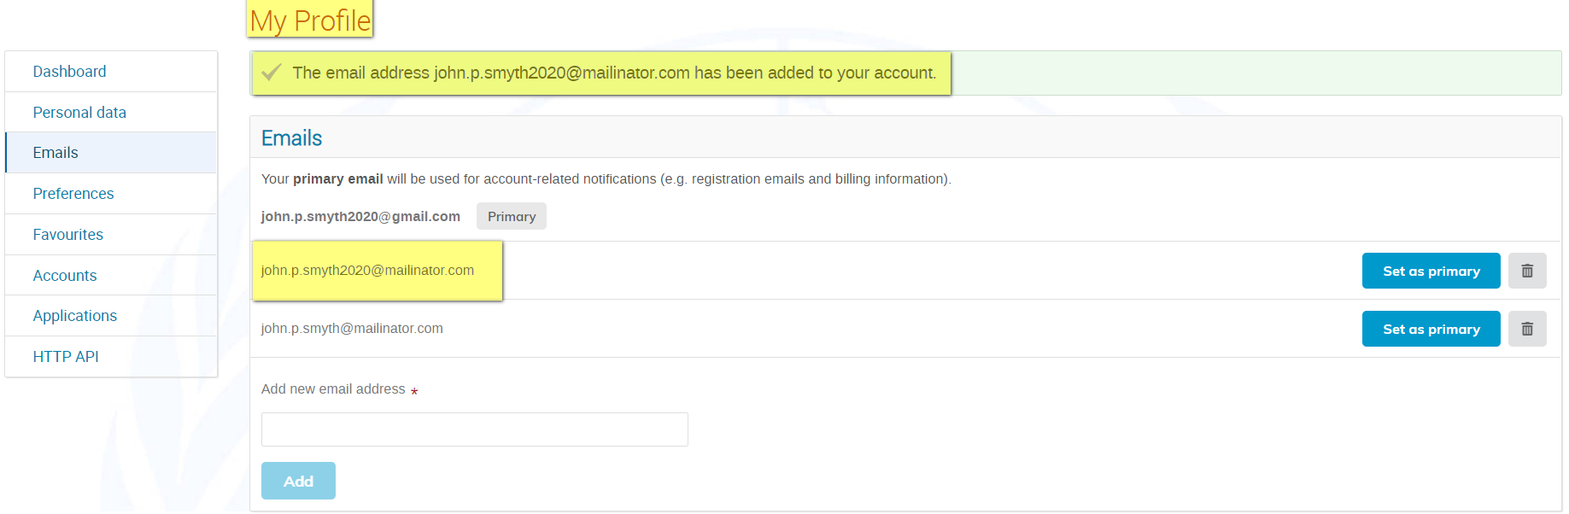

Set a new primary email address

- Click Set as primary beside the email address you want to switch to.

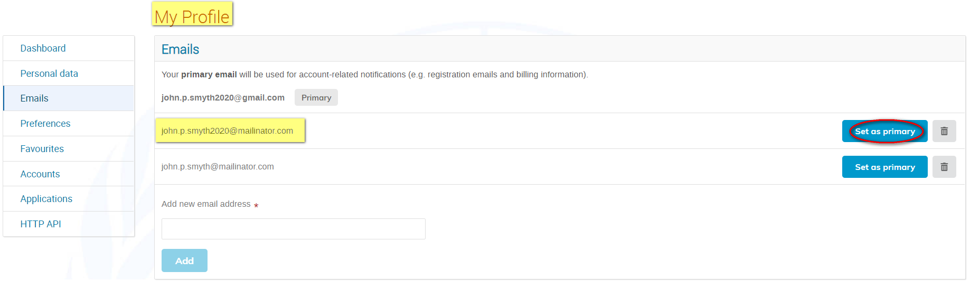

- A message appears on-screen confirming that the primary email has been updated successfully.

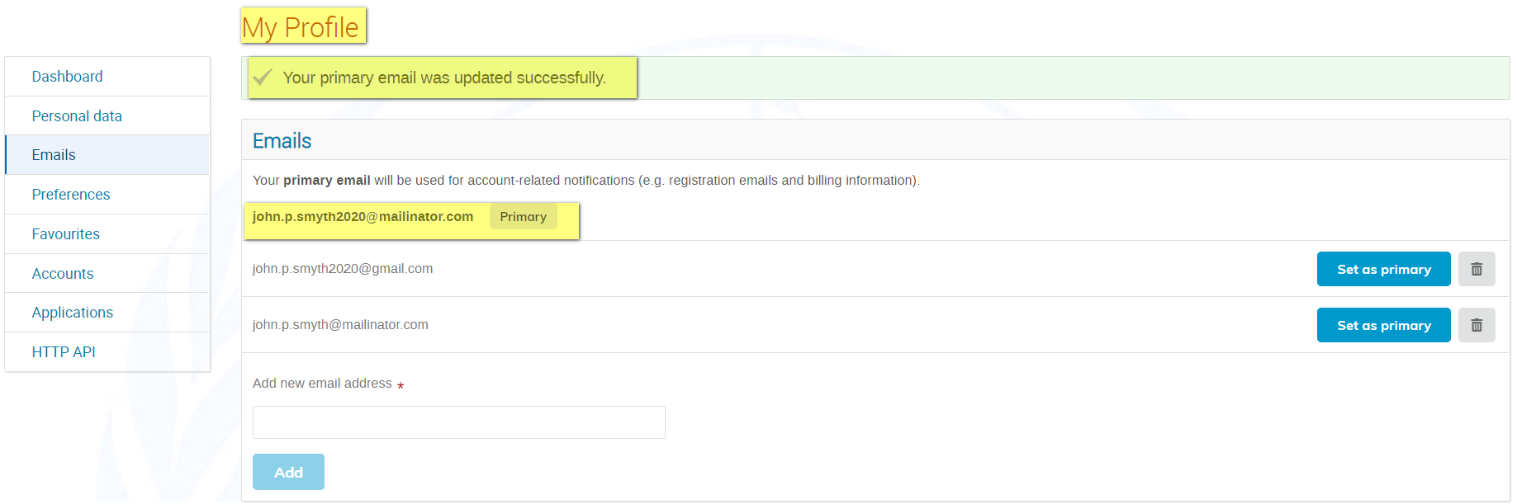

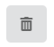
- Use to remove unwanted email addresses on your profile.

My profile: Preferences

Under Preferences, you can:

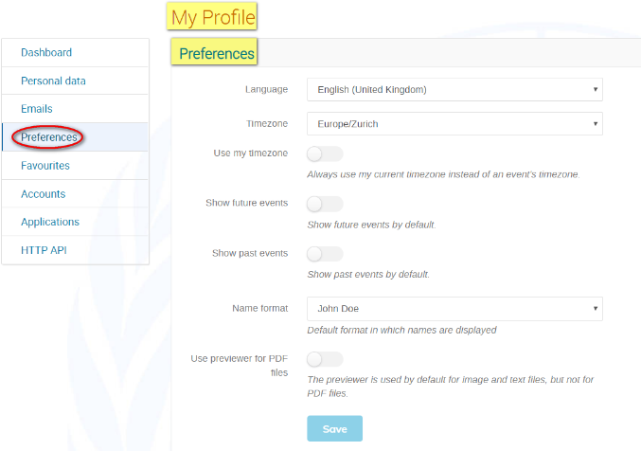
- Select your display language.
- Set your timezone.
- Elect to have events displayed according to your timezone and not that of the events.
- Elect to have future events displayed by default.
- Elect to have past events displayed by default.
- Determine the format names are displayed of persons.
- Use previewer for PDF (not sure).

My profile: Favourites

Under Favourites, you can:

- Search for other Indico users and add them to a favourite users list.
- Bookmark your favourite categories (i.e. entities) for easy navigation to their event pages.

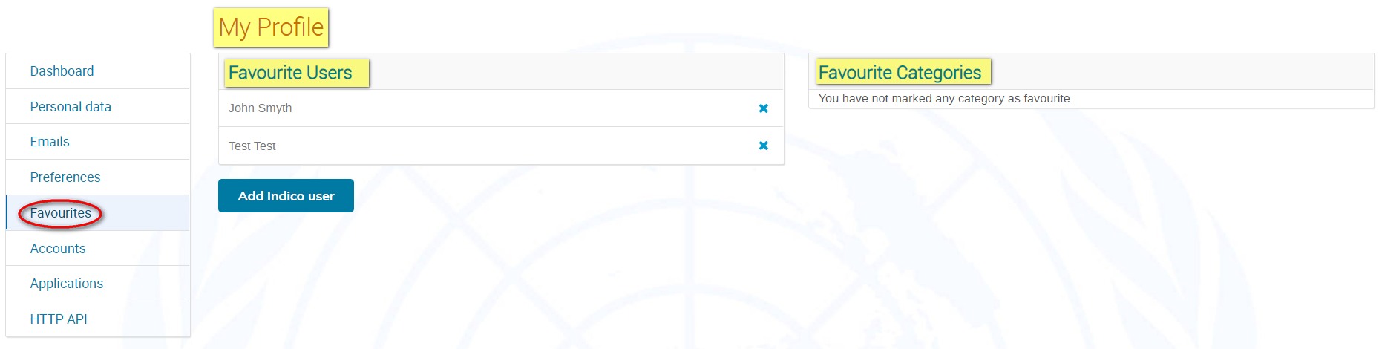

My profile: Accounts (change password)

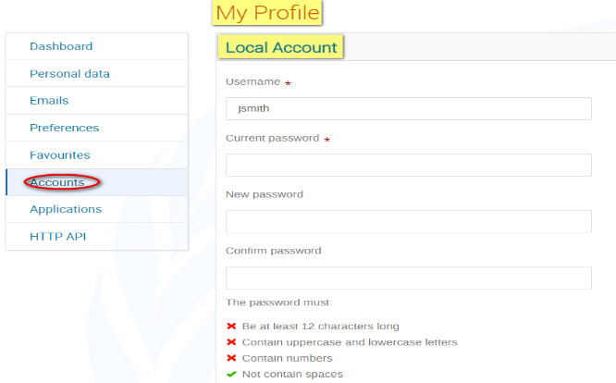
- The fields marked * are mandatory.
- Ensure that you achieve 6 green check marks when setting the password.
- Click Modify credentials to save.

Update my Personal Data
(problems with Indico and can’t test this)

Forgotten Password
- Click Forgot my password on the log in page.

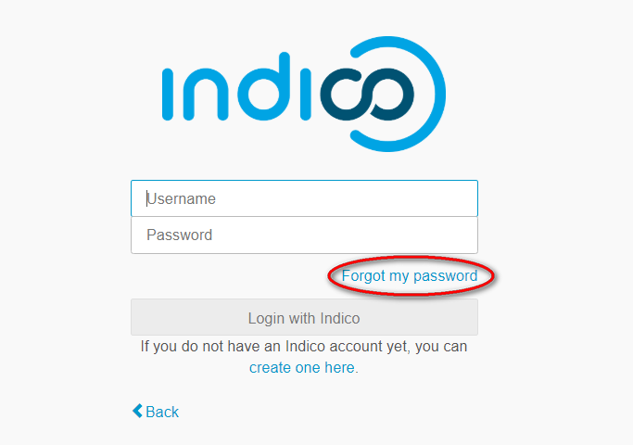

- Enter your email address in the Email address field.
- Click Submit.

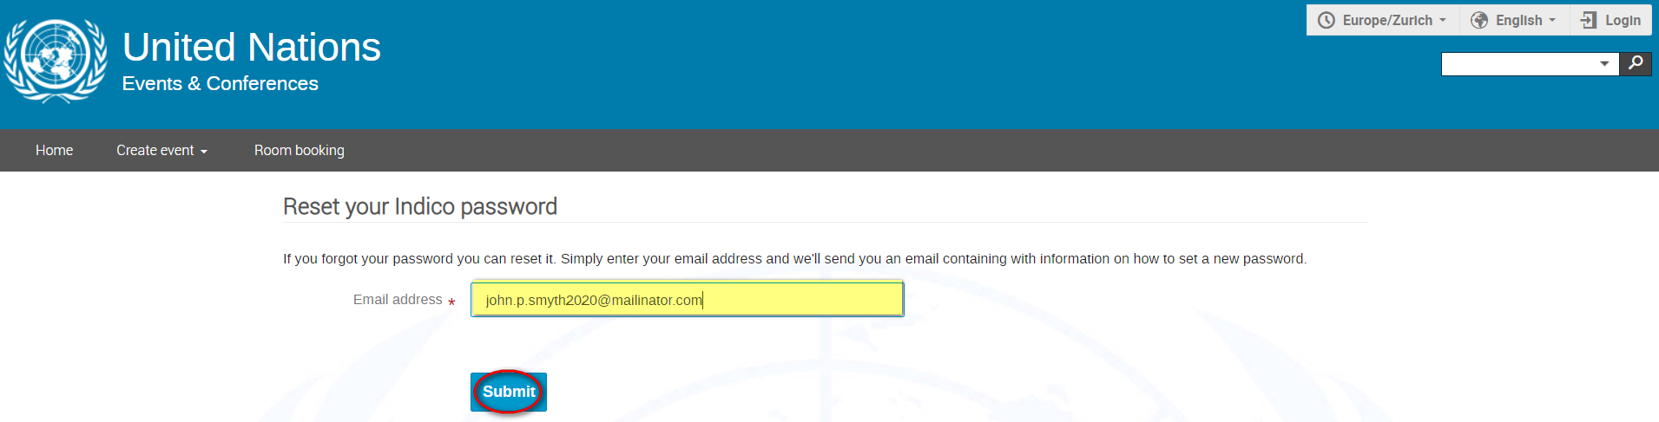

- A message appears on-screen – you have 1 hr. to check your email account for a password reset email from Indico.

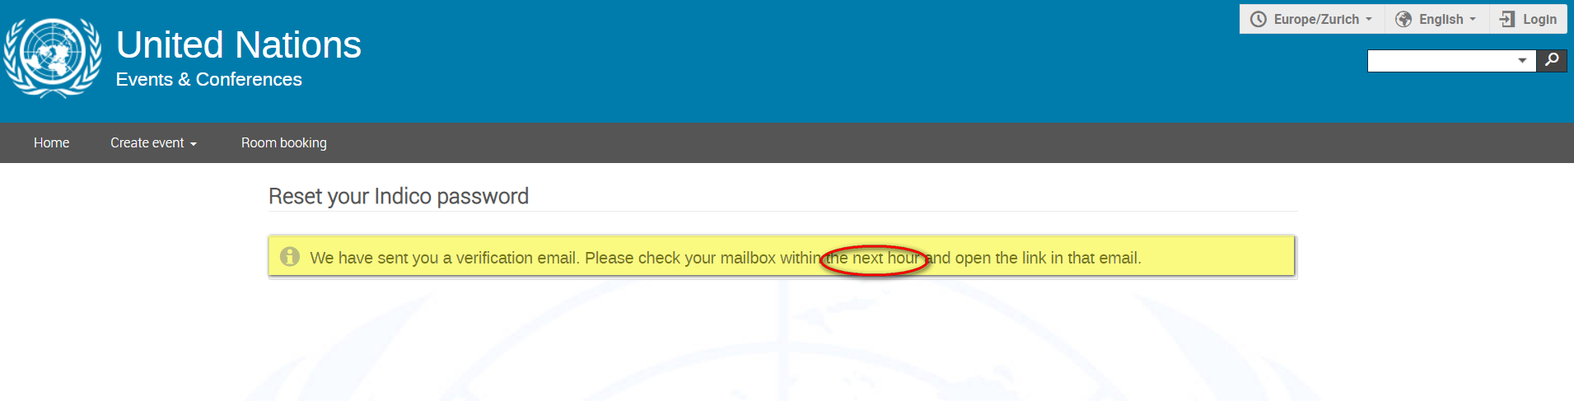

- Click the link in the email.

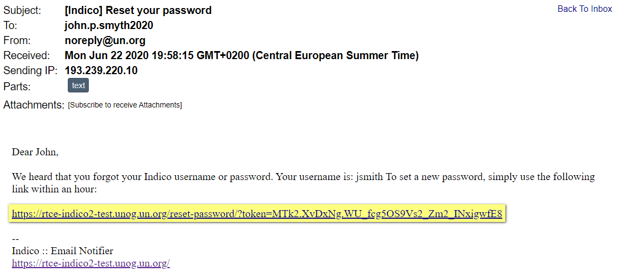

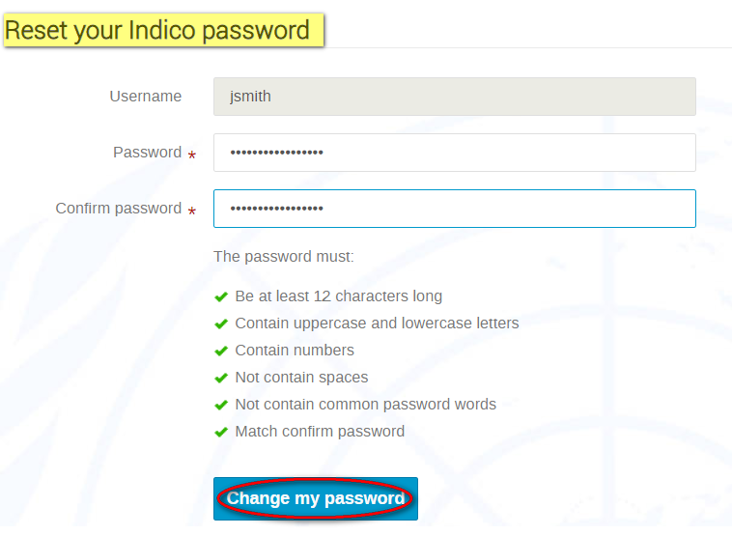
- Upon being redirected back to Indico, enter a new password and ensure you achieve 6 green check marks .
- Click Change my password.

- Your dashboard opens with an on-screen message confirming that the password has been changed successfully.

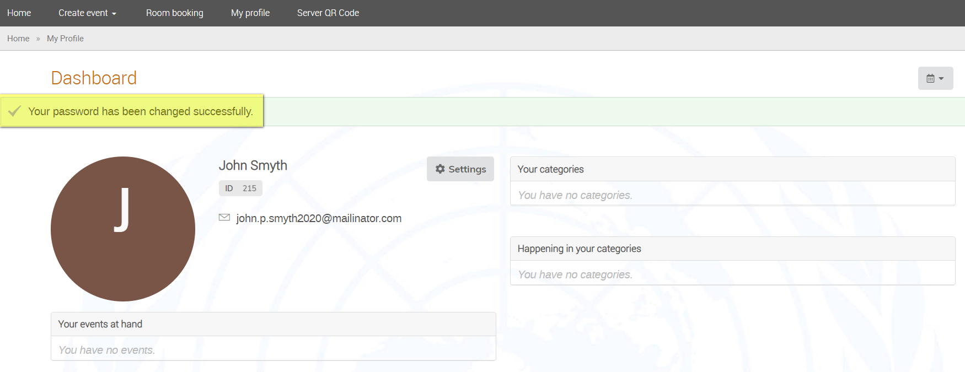

___END___

