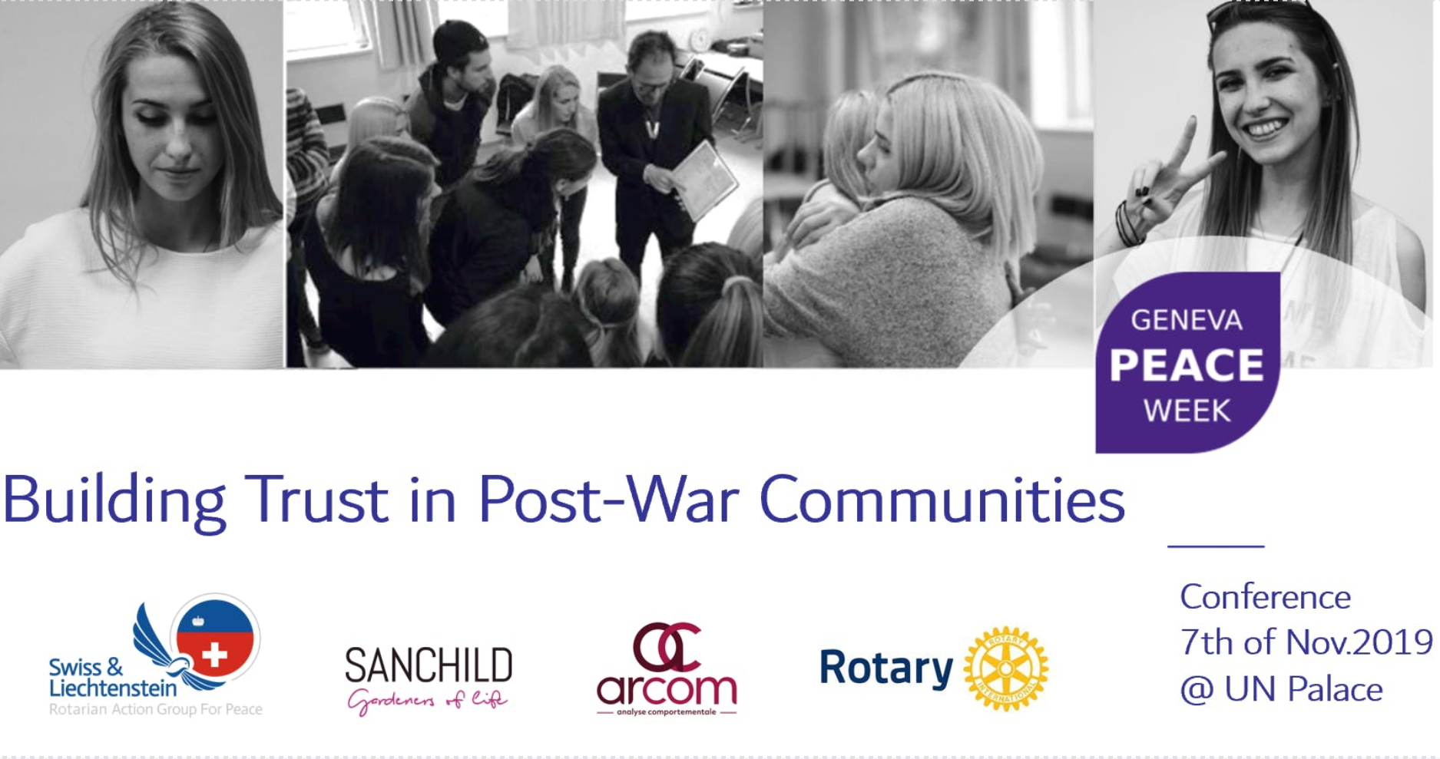

At the heart of Europe, the Balkan region is the closest post-war and conflict zone to Geneva. This conference proposes to uncover the challenges to overcoming prevailing traumatic experiences of post-war communities in former conflict zones.
Together with multiple local and international actors, SANCHILD association, Rotary Clubs from Switzerland and the Balkan regions with the support of Peace Fellows, professional peace building moderators and local NGO’s have put together long-term educational support programs to train teachers, social workers and peace advocates in peace-building and conflict resolution.
These programs aim to contribute to the reconciliation of diverse communities experiencing post-war trauma by building trust and cooperation to create sustainable and lasting peace.
Participants at this event are invited to interact with main experts of this project approach, to share life experiences and modalities used.
An interactive conference will help the audience to understand the difficulties to overcome.
The event will address the following goals:
- uncover the challenges that must be addressed to overcome the perpetual violence, hatred and mistrust that continues despite the concluded civil war.
- visionaries from the Balkan region that will speak on this topic include Ena Rajic, a young psychologiste, artist and poet from Croatia, and project facilitators Sanela Music President of SanChild NGO and Jelena Stojanovic member of Rotary working together from Bosnia and Serbia, who will present their visions of peace.
- dynamically showcase the teaching methodology by the expert Stephanie Armangau working on the project from ArCom that will include audience interaction.
- bring awareness to the challenges peace makers are facing even 25 years after the end of the war & an interactive discussion on the overarching "From Inner to Outer Peace" approach and curriculum for the Harmony Project, the upcoming long term educational training program.

