**WHO Technical Guidance Notes on Sendai Framework reporting**

**for Ministries of Health**

**OVERVIEW**

**Policy context – the Sendai Framework and 2030 Sustainable Development Agenda**

Ministries of Health hold vital information that can support the national reporting on the 7 Targets and associated 38 indicators of the Sendai Framework for Disaster Risk Reduction 2015-2030. Some of these indicators are included in the Sustainable Development Goals, the 100 WHO Global Health Indicators and the 13th WHO General Programme of Work.

The Sendai Framework was adopted by the 187 United Nations member states in 20151, and provides direction to countries to enhance their capacities to reduce risks and consequences of hazardous events at all scales and across all sectors. It covers small-scale and large-scale, frequent and infrequent, sudden and slow-onset events associated with natural, biological, environmental, technological and biological hazards. On 2 February 2017, the UN General Assembly adopted resolution A/71/644, which describes the indicators for the 7 Sendai Framework Targets2.

Along with complementary instruments of the United Nations’ 2030 agenda, such as the Sustainable Development Goals (SDGs) and the Paris Climate Agreement, the Sendai Framework offers UN Member States targets and indicators to enable monitoring and reporting of progress3.

Health is woven throughout the Sendai Framework: it is central to the Framework outcome of a “substantial reduction of disaster risk and losses in live, livelihoods and health” and the goal to “prevent new and reduce existing disaster risk through the implementation of integrated and inclusive economic, structural, legal, social, health, cultural, educational, environmental, technological, political and institutional measures that prevent and reduce hazard exposure and vulnerability to disaster, increase preparedness for response and recovery, and thus strengthen resilience.”1

Figure 1 shows the links between the two UN adopted agreements.

Figure 1: Link between Sendai Framework and Sustainable Development Goals

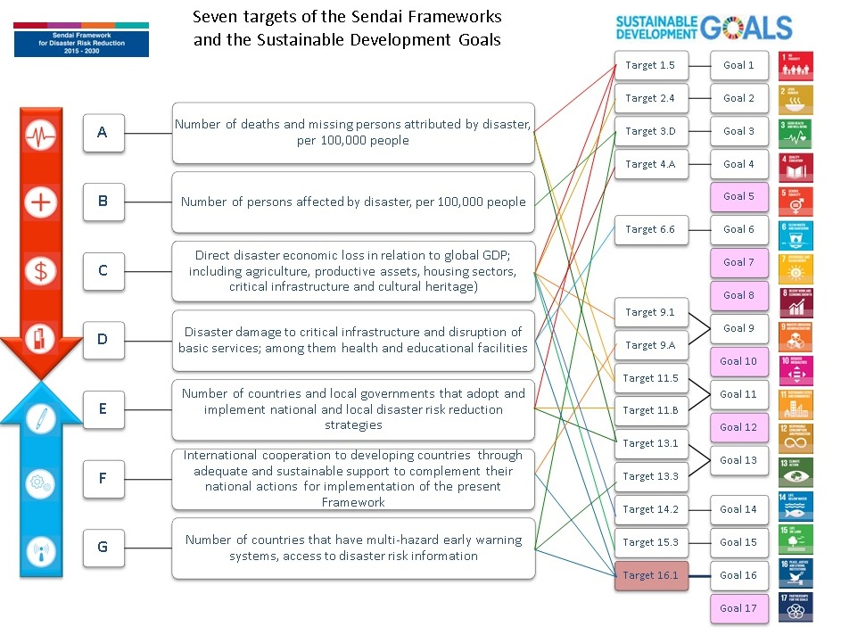

**Why it is important**

The Sendai Framework Targets are directly or indirectly related to health in terms of reducing mortality, morbidity, damage and disruption to health services attributed to emergencies and disasters, as well as strengthening of national and local strategies for disaster risk reduction, international cooperation, and accessibility and availability of early warning and risk information It is therefore important the Ministries of Health and other health authorities are actively involved in working with other government agencies, including the Sendai Framework Monitoring Focal Point, to ensure that health data is accurately reported in national reporting for the Sendai Framework and in reporting for other related frameworks (e.g. the SDGs).

Data is central to designing, implementing and evaluating health emergency and disaster risk management (Health-EDRM) which refers to the systematic analysis and management of health risks, posed by potential and actual hazardous events, including emergencies and disasters, through a combination of:

* hazard, exposure and vulnerability reduction to prevent and mitigate risks,
* preparedness,
* response, and
* recovery.

Understanding to what extent health is affected by emergencies and disasters is a complex task but essential to reducing risks and mitigating the effects of future events through effective and efficient health EDRM4. On the other hand, changes in capacities in health and other sectors are important to measuring progress in implementing health EDRM, Sendai Framework and other related frameworks, such as the International Health Regulations.

Improving access and availability of health data will inform understanding and decision-making around current and future risks. Health data is vital to risk and capacity assessments, planning and implementation of measures to reduce the health risks and consequences of different types of emergencies and disasters, and to build the resilience of communities and countries. Health data is essential to monitor and evaluate the impacts of action taken by health and other sectors at all levels of society, identify good practice and improve future action. Improving access and availability of health data will inform.

**The purpose of the guidance notes**

These technical guidance notes aim to guide the health sector, in particular Ministries of Health, on their role in collecting and reporting relevant data for the Sendai Framework targets. They seek to simplify and standardise reporting through the application of common language and methods. They provide information on the key issues to take into account in the collection of health data, types of data that should be collated, potential stakeholders to engage with, and templates to enable efficient transfer of data. They adapt and complement the *Technical guidance for monitoring and reporting on progress in achieving the global targets of the Sendai Framework for Disaster Risk Reduction* **5** which have a multisectoral target audience.

These notes seek to provide support and to help operationalise the gathering of data for Ministries of Health to report against the Sendai Framework.

# The guidance notes also make reference to indicators that will enable countries to monitor health effects, such as indirect losses, that are relevant to the Sendai Framework but outside the scope of the targets. Furthermore, the health sector also has a strong interest and role in reporting on societal hazards which are outside the scope of the Sendai Framework, and to indicators related to capacities required to implement the Sendai Framework and reduce risks and consequences of all types of emergencies and disasters.

Ultimately, they aim to support the measurement of progress towards the achievement of the global targets of the Sendai Framework and relevant targets of the Sustainable Development Goals.

**Sendai Framework Monitoring and Reporting process**

The Sendai Framework calls for country self-monitoring to assess progress against the Targets and Indicators. This implies that internationally comparative methods are not required and disaster loss data recording can take place using existing databases. This can ensure country capacities for recording and reporting are not overstretched and there is a focus on progress at the country level. Assessing the impact of hazardous events requires collaboration across national governments. Ministries devoted to health, business and the environment are a sample of those who will be key to accurately the extent and impact of natural, biological and technological hazards.

Accountability is one of the corner stones of the Sendai Framework. To support Member States in reporting against the Sendai Framework a reporting tool was developed, the Sendai Framework Monitor - <https://sendaimonitor.unisdr.org/>. The Sendai Framework Monitor will also function as a management tool to help countries develop disaster risk reduction strategies, make risk-informed policy decisions and allocate resources to prevent new disaster risks. As of March 1, 2018, Member States have to report against the indicators for measuring the global targets of the Sendai Framework, and disaster risk reduction-related indicators of the SDGs, using the online Sendai Framework Monitor.

Reporting is an important element of the Sendai Framework. It is important for Ministries of Health to identify and work with the National Focal point for reporting and ensure that staff who collect data relevant to the Targets are given access to report this data onto the Sendai Framework Monitor – either directly or via the National focal point.

**Data and indicators**

These guidance notes provide advice on what data to collect and how to collect it for each of the seven Sendai Targets, however, collecting and monitoring this data can be challenging.

The Sendai Framework seeks to collect data that is available without asking for Member States to develop specialised reporting tools. This means that there are limits to comparisons geographically and through time. In terms of disaster losses, the main focus of Sendai is on the direct impact of disasters to populations, infrastructure, etc. While the Sendai Targets do not provide a full picture of the impact of all hazards or the capacities required for health EDRM, it provides a good basis for developing monitoring and measurement of the impact of hazardous events in a more systematic manner. More work will be needed to develop more sophisticated systems if there is a desire to collect data on the full impact of communities and countries, including the indirect impacts across a longer time frame, e.g. ongoing mental health impacts, building back better and ensuring resilience is in place to protect and prevent from future disasters.

Numerous countries do not have access to reliable disaster loss data. In 2014, the WHO demonstrated that ‘cause of death’ data varied significantly across the globe with some countries recording cause of mortality in less than 25% of cases (Figure 2). The strengthening of civil registration and vital statistics capacities would assist the ability of countries to report against Targets A and B. The Sendai Framework recommends “case registry and a database of mortality caused by disaster in order to improve the prevention of morbidity and mortality”.1

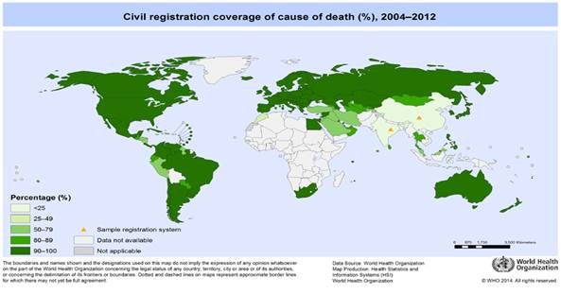

**Figure 2. Civil Registration Coverage of Cause of Death (%) 2004-2012**

Some of the common challenges countries may come across when monitoring and reporting data following a hazardous event are demonstrated in Table 1.

Table 1: Common Challenges

|  |  |  |
| --- | --- | --- |
| CHALLENGE | PROBLEM | SOLUTION |
| Temporal Dimension | Defining the time period to monitor and measure data following a hazardous event can be challenging and will vary dependent on the nature of the event. | For sudden-impact natural hazards, the UNISDR / DesInventar method suggests the date of appearance of first reports of damage can mark the beginning of the event and the date of the last report of physical damage associated with the event be taken as the end date. It also recommends annual reporting as a minimum for slow-onset disasters that span for more than one year.  In the case of biological hazards, an “event” is determined when the number of cases exceeds the agreed threshold of cases for the hazard, which is often context specific. Deaths must meet the case definition for the disease, and the end date is when the outbreak is declared over5. |
| Thresholds | Deciding on set thresholds for monitoring following a hazardous event, classifying what is a hazardous event and determining categories of people or assets at risk of loss. | For example, 1) Determine the number of cases of an infectious disease that class as a ‘hazardous event’.  2) Decide age categories for aggregation of data. The most important recommendation to countries is to emphasise that criteria should be fixed for the entire time span of data collection (2005-2030). |
| Attribution | Deciding what to attribute to a hazardous event and determining what to class as both a direct and indirect effect. | Facilitate statistical analysis to determine issues around attribution issues, consider working with resources such as academic partners as well as Offices of National Statistics to test attribution related issues and developing methods to capture the right information |
| Data Coverage | Not all countries systematically collect disaster loss and damage data. | Consider undertaking archival work to recover records of disaster loss and damage since 2005 and then begin the systematic recording of all new loss. |
| Validity and Bias | Does the data measure the issues identified accurately? | Engagement with data production process, its sources, caveats and limitations of data reported is important to improve management |
| Precision and Uncertainty | Does the sample size permit statistical inference and are there rigorous to measure/quantify uncertainty? | Facilitate statistical analysis to determine issues around precision and uncertainty issues, consider working with resources such as academic partners as well as Offices of National Statistics to test these issues |
| Double Counting | Double counting is inevitable when monitoring certain targets. E.g. Target B – Affected people – People are likely to be counted twice if their property is damaged, and they are injured. | Using the suggested method and indicators will provide a robust and verifiable proxy of total number of affected |
| Timeliness | There is often a lag between when a hazardous event happens and when it is possible to submit data. | Routine data collection in a timely fashion facilitates early reporting but will require statistical analysis to determine issues around timeliness, consider working with resources such as academic partners as well as Offices of National Statistics to test these issues |

The main challenge for damage and loss data sharing and comparison is the lack of agreed technical standards6.

Nonetheless, it is important to emphasise that no indicator will provide an absolutely precise, accurate and exhaustive measure disaster losses. It would be impossible to remove a level of uncertainty or inaccuracy from loss estimations, for which the sourcing of data is subject to the legal procedures and timeframe criteria of a specific country, as well as the exhaustiveness of data collection.

Table 2 outlines some further challenges that can be associated with monitoring and reporting disaster data. It explains some key criteria for disaggregation of data that should be considered when recording data, to ensure completeness.

Table 2: Further Challenges for Monitoring & Reporting Disaster Data

|  |  |  |
| --- | --- | --- |
| Criteria | Challenges | Possible Solutions |
| Hazard | Different taxonomies in use. | Refer to WHO Hazard Classification for guidance or Sendai Framework Monitoring National Focal points.  Classification defined in the [United Nations General Assembly resolution A\71\644.](http://reliefweb.int/report/world/report-open-ended-intergovernmental-expert-working-group-indicators-and-terminology) |
| Geography | Geographical boundaries are not always static. | Ideally by sub-national administrative unit, similar or equivalent to municipality. [See Results of informal consultation on indicators for global targets](http://www.preventionweb.net/files/50683_resultsoftheinformalconsultationsof.pdf).  Example: INSPIRE Administrative Units Theme (<http://inspire-regadmin.jrc.ec.europa.eu/dataspecification/ThemeOverview.action?themeId1=au>) |
| Income | Treatment of non-monetary transactions such as services of housewives to families. Difficult to record impact on informal economy. | Use of the **international poverty line.**[1] **and other means of disaggregating levels of income.** |
| Sex | Vulnerability, exposure and consequence data should be disaggregated by sex. There are genders which do not fall directly into either category. | Disaggregation by **women/men**  **Example:** [ECLAC](http://www.cepal.org/publicaciones/xml/0/47330/olainvernalcolombia2010-2011.pdf) |
| Age | Many different age classifications are in use. | Disaggregation by **children, adults and older people.**  Children – 0 to 14 years; Adults – 15 to 64 years; Older People – 65+ years.  **Example:** [ECLAC](http://www.cepal.org/publicaciones/xml/0/47330/olainvernalcolombia2010-2011.pdf) |
| Disability | Wide spectrum of disabilities so difficult to sub-classify for reporting. | Propose the category: **People with disabilities**. |

I World bank (2017) Poverty headcount ratio at $1.90 a day (2011 PPP) (% of population). Available at <http://data.worldbank.org/topic/poverty> [Retrieved 22 February 2017]

An overview of the qualities of good data can be seen in Appendix B.

**Key steps in monitoring and reporting of health data for the Sendai Framework**

Process

* Identify and engage with the Sendai Framework Monitor National Focal Point Obtaining and complying with timetables for reporting…
* Identify a health focal point for Sendai Framework monitoring and reporting
* Agree the methods to be used in health related Sendai Framework monitoring and reporting
* Develop, implement and review plans for Sendai Framework monitoring and reporting by the health sector
* Where possible, engage in the process of SDG reporting with the national office for statistics

Capacity development

* Raise awareness of Sendai Framework targets and indicators within the health sector and the monitoring and reporting requirements
* Conduct national and sub-national training on methods to improve monitoring and reporting on Sendai targets in the health sector
* Strengthen national and sub-national capacities for civil registration and vital statistics
* Develop national case registries
* Develop methods to attribute health-related mortality and morbidity to hazardous events

**References**

1. UNISDR (United Nations International Strategy for Disaster Reduction). 2015b. Sendai framework for disaster risk reduction 2015–2030. Available at: <http://www.unisdr.org/files/43291_sendaiframeworkfordrren.pdf> [Accessed 21st February 2017]
2. General Assembly resolution 71/644, Report of the open-ended intergovernmental expert working group on indicators and terminology relating to disaster risk reduction, A/71/644 (1 December 2016) Available at: <http://www.preventionweb.net/files/50683_oiewgreportenglish.pdf>

Clarke, L., Blanchard, K., Maini, R., Radu A., Zaidi, A., & Murray, V. (2018) “Knowing What we Know – Reflections on the development of Technical Guidance for Loss Data for the Sendai Framework for Disaster Risk Reduction” *PLOS Current Disasters* Available at: <http://currents.plos.org/disasters/index.html%3Fp=36974.html> [Accessed 13 November 2018]

1. Green Paper. Increasing Availability, Quality, and Accessibility of Common and Fundamental Operational Datasets to Support Disaster Risk Reduction and Emergency Management in the Philippines (2014) Available at: <http://www.gaia-geosystems.org/PROJECTS/SIIEM/PHL/Green_Paper_DSWD-SIIEM_305014.pdf> [Accessed 22nd February 2017]

UNISDR Technical Guidance for Monitoring and Reporting on Progress in Achieving the Global Targets of the Sendai Framework for Disaster Risk ReductionCollection of Technical Notes on Data and Methodology (2017) Available <https://www.unisdr.org/files/54970_techguidancefdigitalhr.pdf> [Accessed 15 November 2018]

JRC: Guidance for Recording and Sharing Disaster Damage and Loss Data. Available at: <http://publications.jrc.ec.europa.eu/repository/bitstream/JRC95505/lbna27192enn.pdf> [Accessed 22nd February 2017]

The technical guidance notes have been developed by Public Health England and WHO. They were developed in preparation for the **Technical workshop on Concepts and Technical Guidance for Health Emergency and Disaster Risk Management** in Geneva (21-23 November 2018) and have benefitted from review by many experts.

Development team: Public Health England: Virginia Murray, Tanith Palmer; Helen Green, Megan Harris. Ministry of Health Malaysia: Rohaida Ismail; WHO: Jonathan Abrahams …

Other Contributors: Canterbury District Health Board, New Zealand Alistair Humphrey; Public Health England: Ashley Sharp; Tristana Perez, xxx

Reviewers: xxx

**Appendix A**



Sources:

1. Terminology of disaster risk reduction. Geneva: United Nations International Strategy for Disaster Reduction; 2009 (http://www.unisdr.org/files/7817_UNISDRTerminologyEnglish.pdf, accessed 10 February 2015).

2. Global focus model. Bangkok: United Nations Office for the Coordination of Humanitarian Affairs; 2013 (http://www.earlyrecovery.info/wp-content/uploads/2013/10/17.-DRR-GFM-2013.pdf, accessed 10 February 2015).

3. Types of disasters: definition of hazard [website]. Geneva: International Federation of Red Cross and Red Crescent; 2014 (http://www.ifrc.org/en/what-we-do/disaster-management/about-disasters/definition-of-hazard/, accessed 10 February 2015).

4. Em-DAT: classification of disasters [website]. Brussels: Centre for Research on the Epidemiology of Disasters; 2014 (www.emdat.be/new-classification, accessed 10 February 2015).

5. International health regulations, 2nd edition. Geneva: World Health Organization; 2005 (http://www.who.int/ihr/publications/9789241596664/en/, accessed 10 February 2015).

6. Dzud national report 2009-2010. Mongolia: United Nations Development Programme and Swiss Agency for Development and Cooperation; 2010 (https://www.academia.edu/2426652/How_Mongolian_herders_affected_by_Dzud_natural_phenomena_2009-2010_government_and_pastoralists_disaster_management, accessed 10 February 2015).

7. Jaykus L, Woolridge M, Frank J, Miraglia M, McQuatters-Gollop A, Tirado C. Climate change implications for food safety. Rome: Food and Agriculture Organization of the United Nations; 2008 (http://ftp.fao.org/docrep/fao/010/i0195e00.pdf, accessed 10 February 2015).

8. Em-DAT: technological disasters trends [website]. Brussels: Centre for Research on the epidemiology of Disasters; 2009 (http://www.emdat.be/technological-disasters-trends, accessed 10 February 2015). 9. Global environmental outlook 3 : air pollution and air quality [website]. UK and US: United Nations Environment Programme; 2002 (http://www.unep.org/geo/geo3/english/366.htm, accessed 10 February 2015).

10. Hicks K, Kuylenstierna J, Mills R. Air pollution at the global and hemispheric scales-emerging trends. Tunis: Global Atmospheric Pollution Forum; 2009 (http://www.unep.org/transport/pcfv/PDF/Tunis-KevinHicksNAEmergingTrends.pdf, accessed 10 February 2015).

11. Coppola D. Introduction to international disaster management, 2nd edition. UK: Butterworth-Heinemann; 2011.

12. Recommendations for the transport of dangerous goods, 7th edition. New York and Geneva: United Nations; 2011 (http://www.unece.org/fileadmin/DAM/trans/danger/publi/unrec/rev17/English/Rev17_Volume1.pdf, accessed 10 February 2015).

13. IHR core capacity and monitoring framework. Geneva: World Health Organization; 2013 (http://apps.who.int/iris/bitstream/10665/84933/1/WHO_HSE_GCR_2013.2_eng.pdf, accessed 10 February 2015).

14. The protocol additional to the Geneva conventions for 12 August 1949, and relating to the protection of victims of international armed conflicts (Protocol I) of 8 June 1977. Geneva: International Committee of the Red Cross; 1977 (https://www.icrc.org/ihl/INTRO/470, accessed 10 February 2015).

15. National strategy for chemical, biological, radiological, nuclear, and explosives (CBRNE) standards [website]. US: U.S. Department of Homeland Security; 2010 (http://www.dhs.gov/national-strategy-chemical-biological-radiological-nuclear-and-explosives-cbrne-standards, accessed 10 February 2015).

16. Treaty on the non-proliferation of nuclear weapons [website]. US: United Nations Office for Disarmament Affairs; 2012 (http://www.un.org/disarmament/WMD/Nuclear/NPT.shtml, accessed 11 February 2015).

17. Technical Guidance for Monitoring and Reporting on Progress in Achieving the Global Targets of the Sendai Framework for Disaster Risk Reduction https://www.unisdr.org/we/inform/publications/54970, UNISDR; 2017, accessed 1 November 2018)

**Appendix B**

Data to measure indicators should conform as far as possible to the following principles:

* **USEFUL** - Data collected must be applicable to any country in the world and, to where possible, allow comparison among countries or regions
* **FEASIBLE** - Data should be easy to collect regardless of the level of development or income of each country.
* **TRANSPARENT** - The method used for collecting data should be well established, with any caveats or limitations declared
* **CONSISTENT -** Data must be recorded and reported in a consistent way
* **PRECISE –** Data must have a measure of dispersion
* **VERIFIABLE -** Data should be traceable back to the original sources
* **RELEVANT –** Data should meet users’ needs
* **COMPLETE –** Data should serve users’ needs as much as possible
* **TIMELY –** Time between recording and publication of data should be minimised
* **ACCESSIBLE -** All data on public matters and/ or funded by public funds, including those data produced by the private sector, should be made public and “open by default”, with narrow exemptions for genuine security or privacy concerns.
* **DATA GOVERNANCE -** Data quality should be protected and improved by strengthening NSOs, and ensuring they are functionally autonomous, independent of sector ministries and political influence.

1.