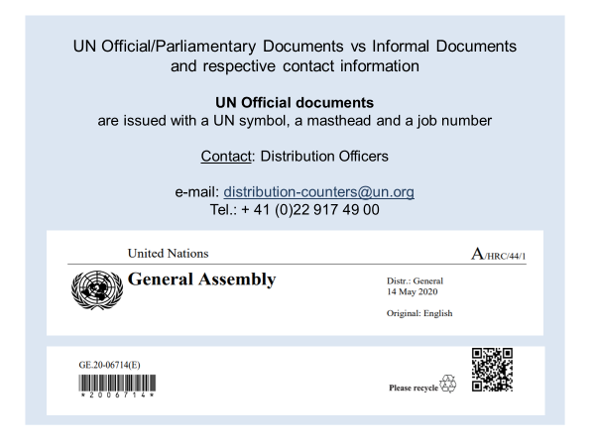

Informal Documents
Statements, speeches, materials provided by the secretariat, etc.

Contact: Meetings Services Assistant
in charge of distribution of informal documentation
in close cooperation with the relevant secretariat

e-mail: msu2@un.org & speeches@un.org
Tel.: +41 (0)22 917 18 11

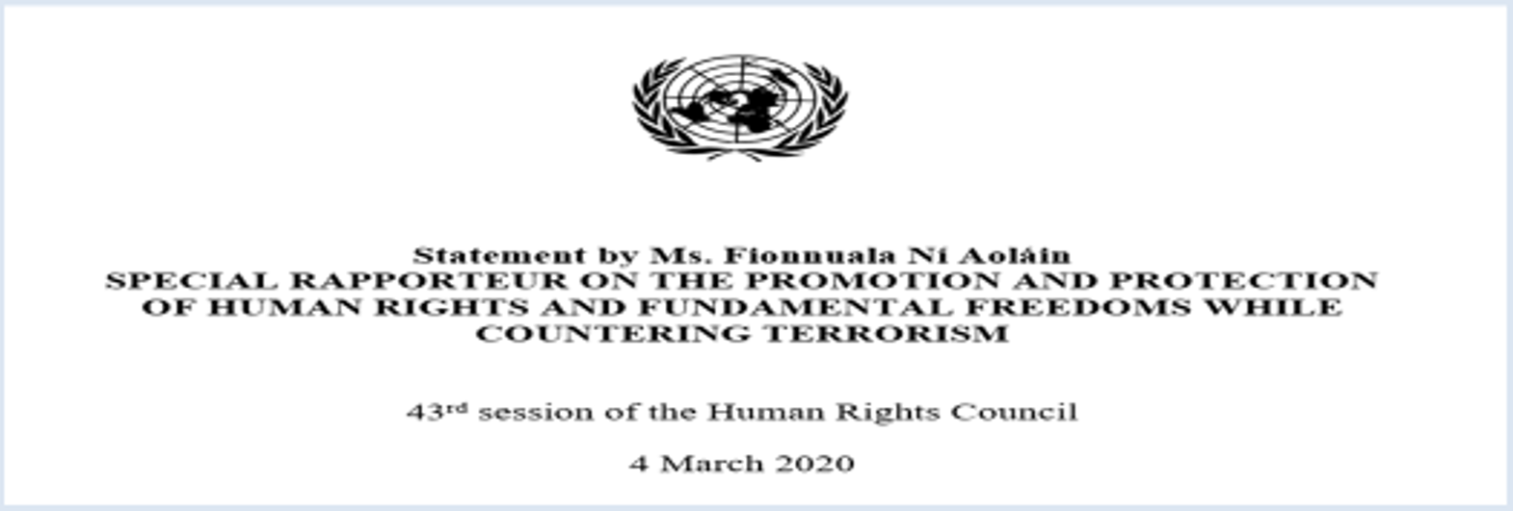

Main symbols of the UN Official Documents for the Council on Human Rights
Root symbol: A/HRC/44/…
Reports: A/HRC/44/1 (2, 3…)
CRP - Conference Room Paper
L – Draft resolutions (all resolutions that have not yet been voted on)
INF - Informational document
N.B. Documents issued as “Advance copy” or “Advance unedited/edited copy” are not available for official simultaneous distribution in all UN official languages; the available language versions are uploaded on the secretariat’s website.

