The 17th General Cooperation Meeting between
The Organization of Islamic Cooperation and United Nations Systems
Geneva, 22-24 July 2026

United Nations Office at Geneva
Palais des Nations
Geneva, Switzerland

Logistics Note

Venue

The UN-LAS general cooperation meeting will take place from 22-24 July 2026 at the United Nations Office at Geneva (the Palais des Nations), in Building A, Conference Room V.

Registration

For UN Staff with ID cards issued at UNOG, no registration is needed. Please report to Conference Room V (Building A) before the start of the meeting.

For UN Staff with ID cards issued at UNHQ (New York), please send your Travel Authorization in .pdf format (this can be downloaded from Umoja) as well as photos of the front and back of your ID to Brian Pozun (pozun@un.org) and Johnette Mannato (mannato@un.org) before Monday, 13 July and arrangements will be made with DSS to activate your card to allow access to the Palais des Nations. No other registration is required.

For all others, including all non-UN staff members and UN staff members without UNHQ ID cards, you must register for the event in INDICO before Wednesday, 15 July. To do so you must first create an account at this link: https://indico.un.org/register. You will receive an activation email from INDICO (if you do not receive the email, please check your junk/spam folder). Follow the instructions in the email to activate your account. Once your account is successfully activated, you must log into INDICO and register for the event at this link: https://indico.un.org/event/1024770/registrations/27229/?form_token=3a5ce6a4-c0f2-4242-b7e5-c133fc6d6e1a

NOTE: Staff attending both the UN-OIC and UN-LAS General Cooperation Meetings must register for each one in INDICO separately. Each event has its own unique URL.

For more information, please refer to this how-to video. If you require any assistance with this procedure, please contact support.accreditation@un.org.

Once you have registered, you will receive an approval email with a digital badge. Please report by 9:00 a.m. on 22 July to the Palais des Nations, Pregny Gate, and present the digital badge on your device, together with valid ID, to UNOG security personnel to receive access to the complex.

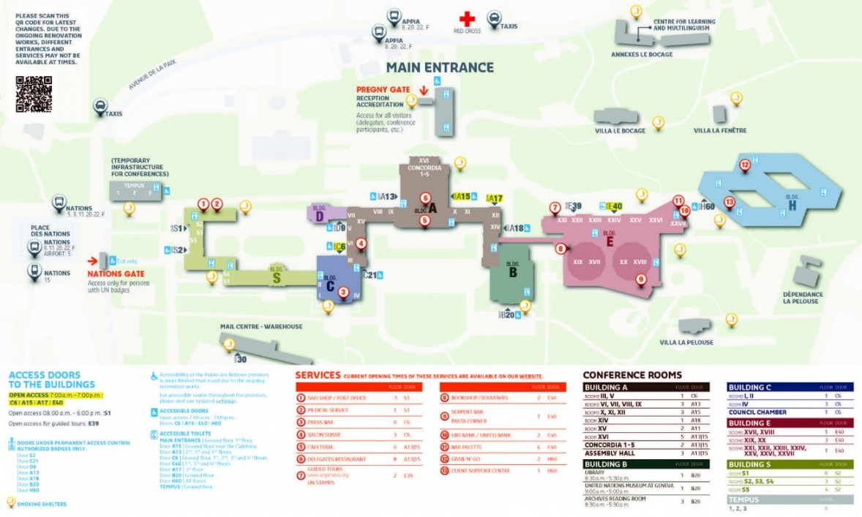

Meeting Times

Meeting – 22 July  9:00 registration  (please come early to ensure entry and finding the correct room)  10:00 – 12:30  Conference room V (Building A)  14:00 – 17:00  WG1: Conference room V  WG2: Concordia 4  WG3: Concordia 5  *Note that Concordia rooms are on the second floor of Building A | Meeting – 23 July  10:00 – 17:00  WG1: Conference room V  WG2: Concordia 4  WG3: Concordia 5 | Meeting – 24 July  10:00 – 11:00  WG1: Conference room V  WG2: Concordia 4  WG3: Concordia 5  11:00-13:00  WG1: Conference room V

Working language

Simultaneous interpretation (Arabic/English) will be provided during the opening and closing sessions. The working groups will be conducted in English.

Documents

The programme of work, agenda, list of participants and other documents will be distributed to participants in due course. Please bring copies of all necessary documents with you to facilitate the discussions. Due to budget restraints, we will unfortunately not be able to make copies for you at the venue.

Travel to Geneva

Travel Visa Requirements

All travellers are required to make their own travel arrangements, including visas if needed to enter Switzerland. You can check whether you will be required to obtain a visa using this link. You can also follow the prompts on the Online Visa System Website to find information on the process and requirements for obtaining a visa depending on your location.

Airport transfer

If you are coming by air, the most direct route to your hotel will be to take a taxi from the airport. Taxis from the airport will cost approximately CHF 50-60. There is also a train to Geneva Cornavin station which takes about 10 minutes, with an additional walk from the station to many hotels. Trains run frequently and cost about CHF 3.

Hotel

Hotel reservations are up to the individual attendees. Many hotels offer special rates for United Nations staff. We recommend enquiring with individual hotels.

UNOG

Public transport to UNOG

Access from Cornavin railway station:
- Bus lines: 5 (“Place des Nations” stop) or 8, 20, 60 (“Appia” stop), then a 5-minute walk to Pregny Gate.
- Tram line: 15 (“Place des Nations” stop), then a 5-minute walk to Pregny Gate.

Access from Cointrin airport:
- Bus lines: 5 (“Place des Nations” stop) then a 5-minute walk to Pregny Gate.

Access from elsewhere in Geneva:
- Bus lines: 11, 22 (“Place des Nations” stop).

Meals

No meals are being provided; however, the cafes at the United Nations in Geneva offer a variety of reasonably priced cuisine for lunch. The main cafeteria is open Monday to Friday from 11:30 to 2 p.m. at Building A, Level 0.

Accessibility

Information about accessibility at UNOG can be found at this link.

Other issues

Further questions

If you have any further questions, please contact Mr. Brian Pozun (pozun@un.org) or Ms. Johnette Mannato (mannato@un.org).

