Create and Manage   
your Indico Account

**V.3**

**April 2025**

Table of Contents

CREATE AN INDICO ACCOUNT 1

PROFILE SETTINGS 4

Personal data 4

eMails 5

Additional email address 5

New primary email address 6

Preferences 7

Favourites 8

Accounts 9

Change password 9

Forgotten password 10

# CREATE AN INDICO ACCOUNT

Go to <https://indico.un.org/login/> and click **create one here**.

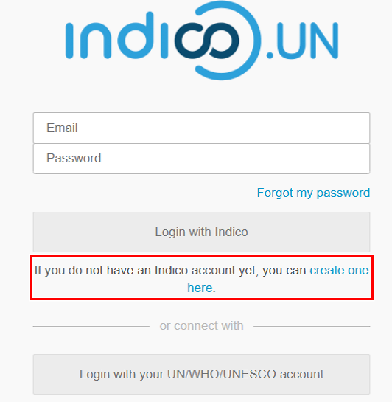

On the **Create a new Indico profile** page enter your email address in the **Email address** field and answer the CAPTCHA. Click **Send me a verification email**.

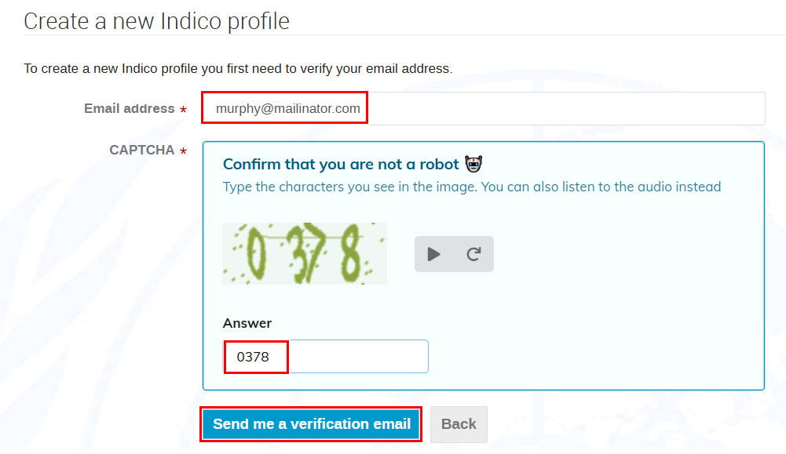

You have **1 HOUR** to go to your email and click the link in the email.

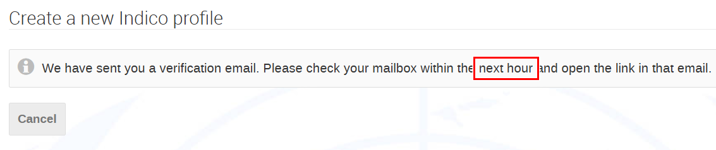

Click the link in the email.

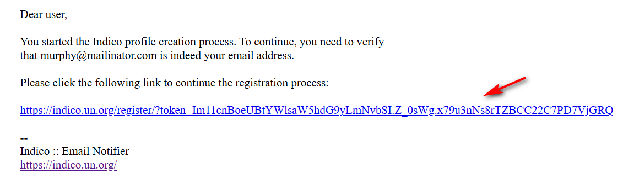

In the **Create a new Indico profile** window:

* Enter your first name and last name.
* Create a password (achieve 6 green check marks  **√** when setting the password).
* All fields marked * are mandatory.
* Click **Create my Indico profile**.

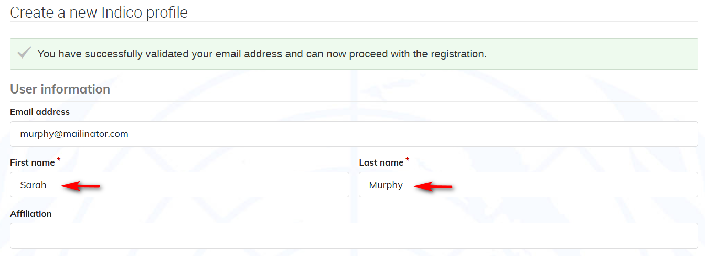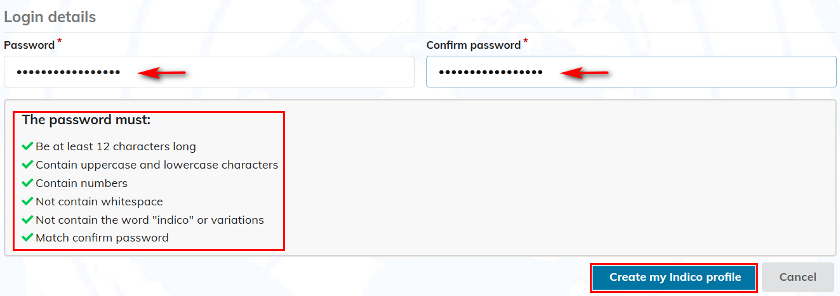

A message appears on-screen.

To add more details to your account click **your profile** in the message.

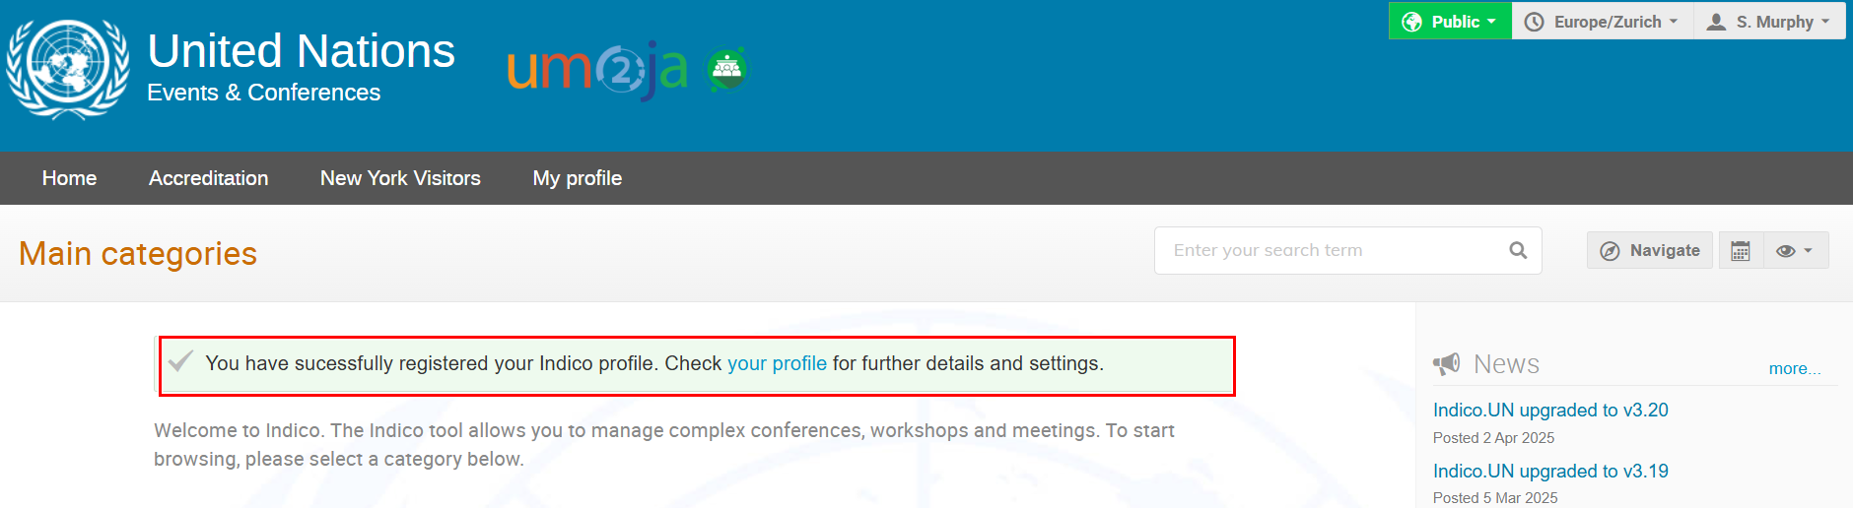

# PROFILE SETTINGS

Log in and click **My profile** in the grey navigation bar.

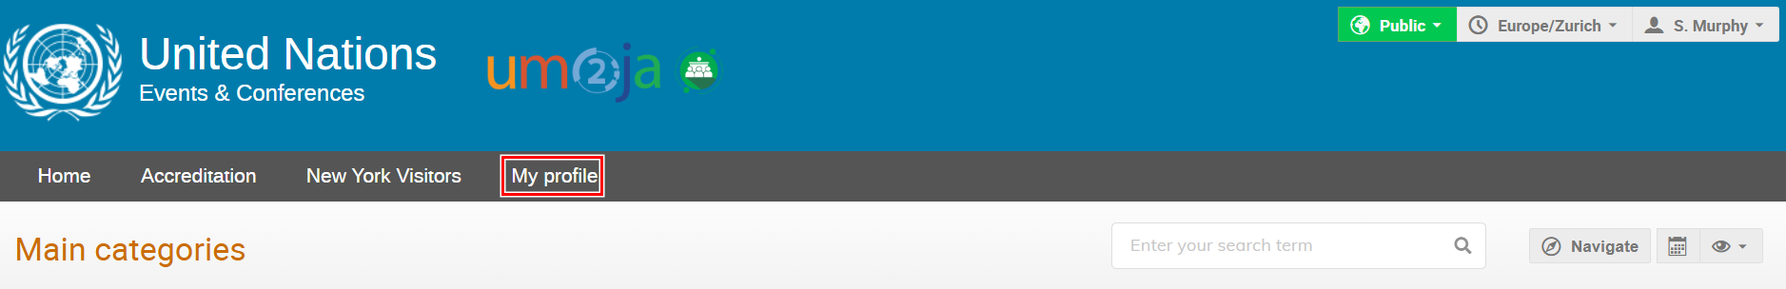

The **Dashboard** opens.

Click **Settings.**

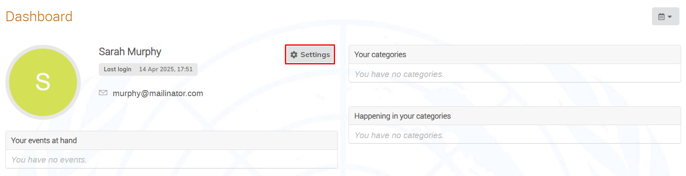

## Personal data

Click **Personal data** on the menu on the left. You can add or modify e.g., your name, DoB, passport details, address, etc.

Click **Save changes**.

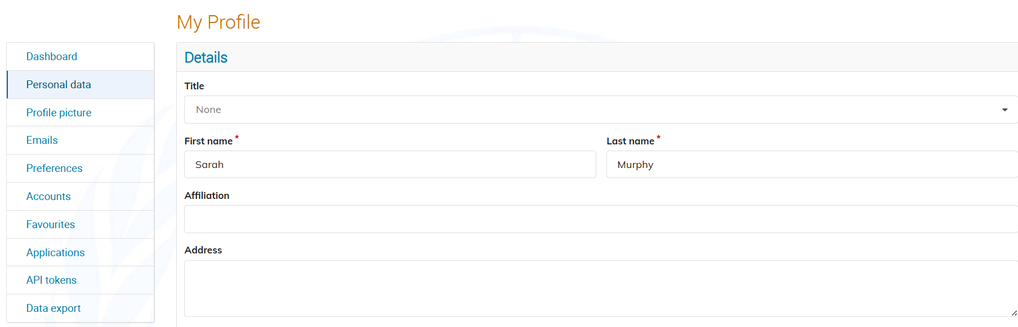

## eMails

The email address used when creating the Indico account is by default the PRIMARY email to which all notifications are sent.

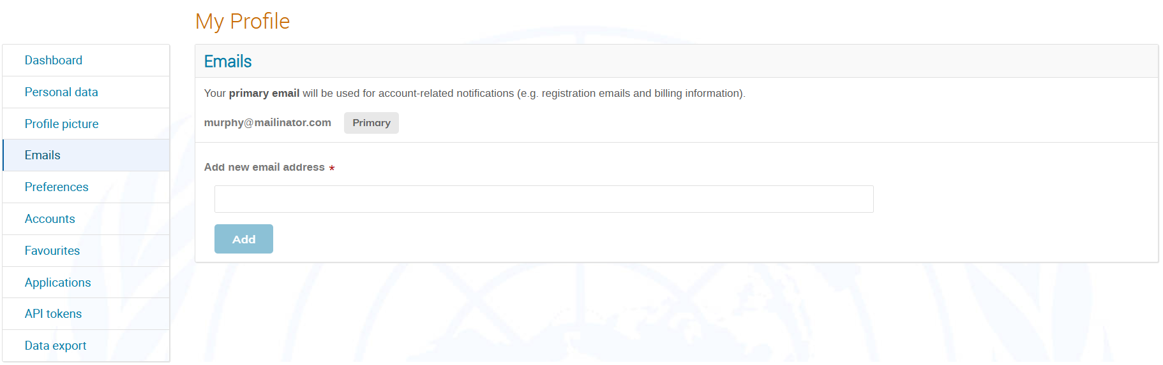

In managing email addresses on your account, you may:

* add other addresses to your account
* reset your primary address (NOTE:  in doing so, the username for log in will also change accordingly)

### Additional email address

Click **Emails** on the menu on the left.

In the **Emails** window enter a new email address in the **Add new email** address field.

Click **Add**.

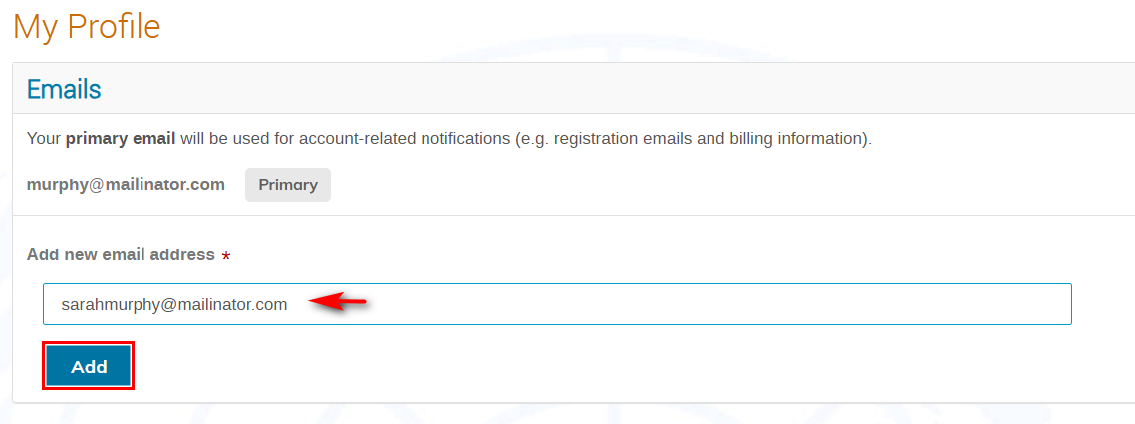

A message appears on-screen.

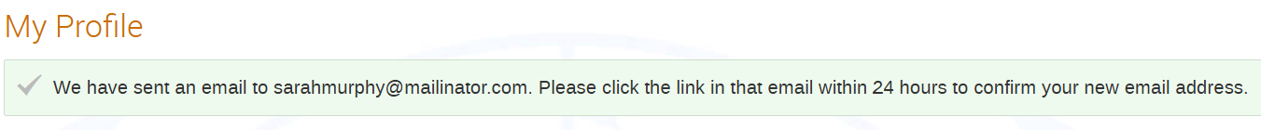

You have **24 HOURS** to click the link in the email.

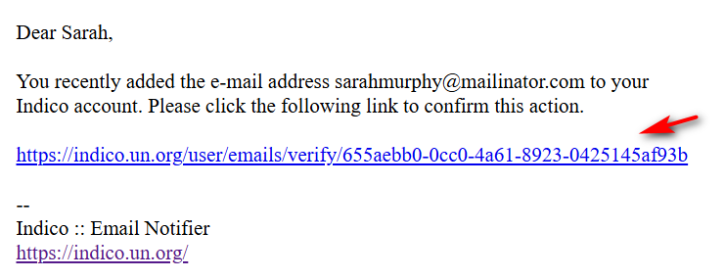

When the link in the email is clicked a message appears on-screen.

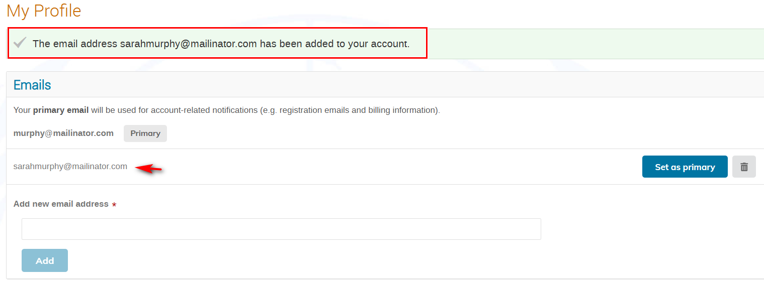

### New primary email address

In the **Emails** window and beside the email you wish to set as the primary, click **Set as primary**.

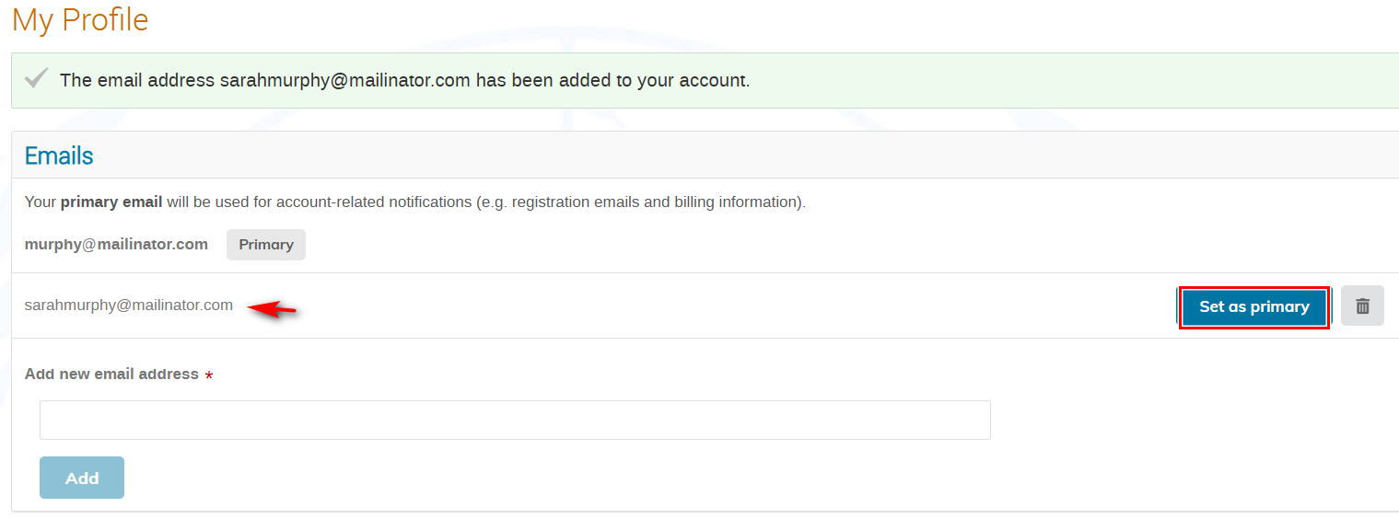

A message appears on-screen.



**The new primary email becomes the new login username.**

Use Screenshot of Indico.UN V2 delete iconto remove unwanted email addresses on your profile.

## 

## Preferences

Click **Preferences** on the menu on the left.

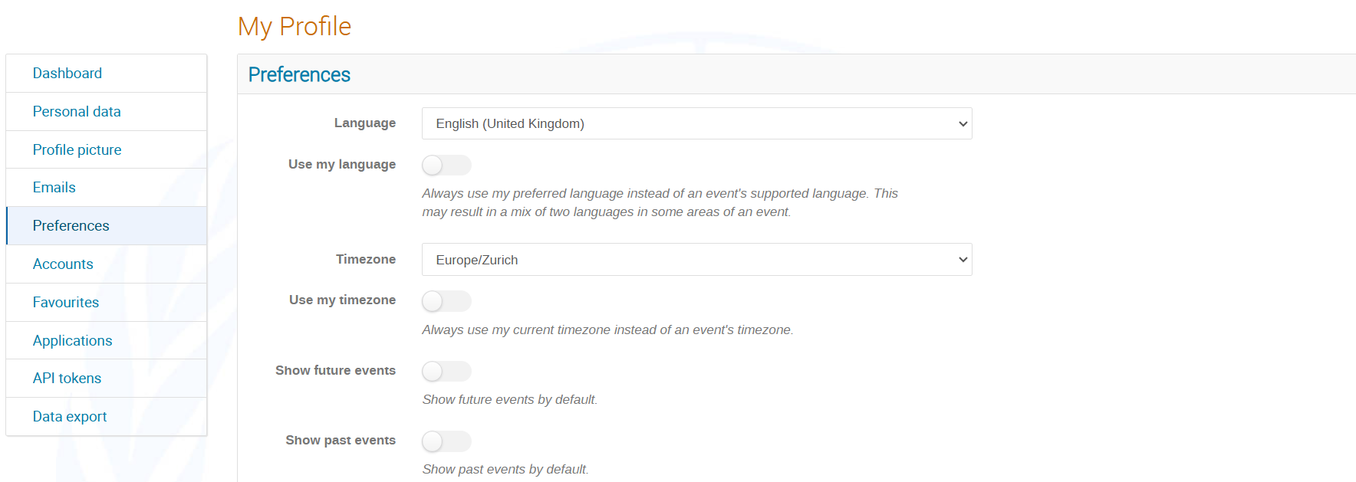

Under **Preferences**, you can:

* Select your display language.
* Set your time zone.
* Elect to have events displayed according to your time zone and not that of the events.
* Elect to have future events displayed by default.
* Elect to have past events displayed by default.
* Determine the format names are displayed of persons.
* Use previewer for PDF.
* Add an event reminder to exported iCal files/URLs.
* Use Markdown editor instead of HTML editor when editing the minutes of a meeting (if applicable to you)

Click **Save** after setting your preferences.

# 

## Favourites

Click **Favourites** on the menu to the left.

Your favourite events and categories are listed here.

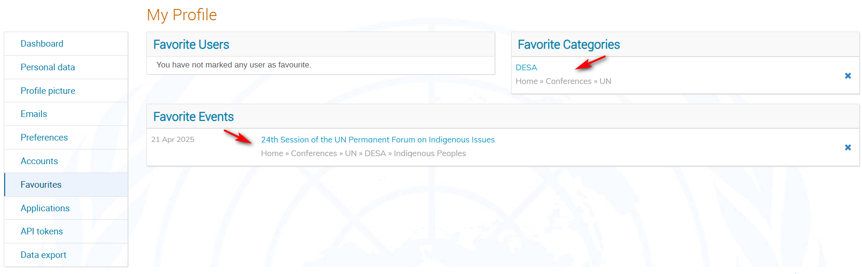

To add a favorite category, do it from within the category itself. Click the star icon.

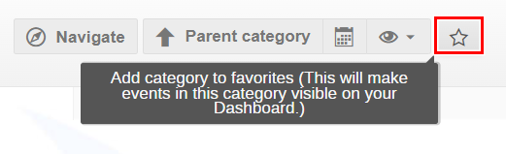

To add a favorite event, do it from the event page. Click the star icon.

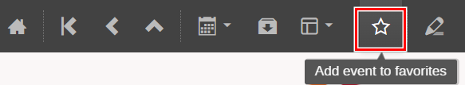

Favorite users: not available to general users

## Accounts

### Change password

Click **Accounts** on the menu to the left.

Enter the current password.

Enter the new password and confirm. Ensure you achieve 6 green check marks √.

Click **Modify credentials**.

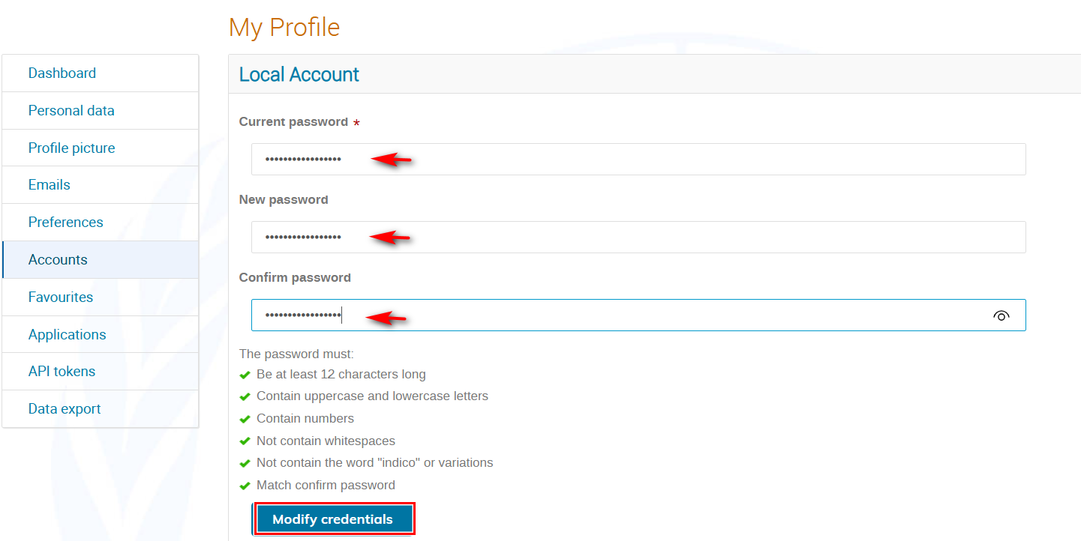

A message appears on-screen.

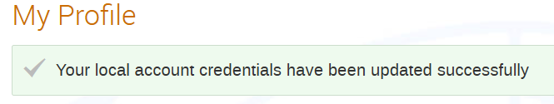

### Forgotten password

Click **Forgot my password** on the Indico log in page.

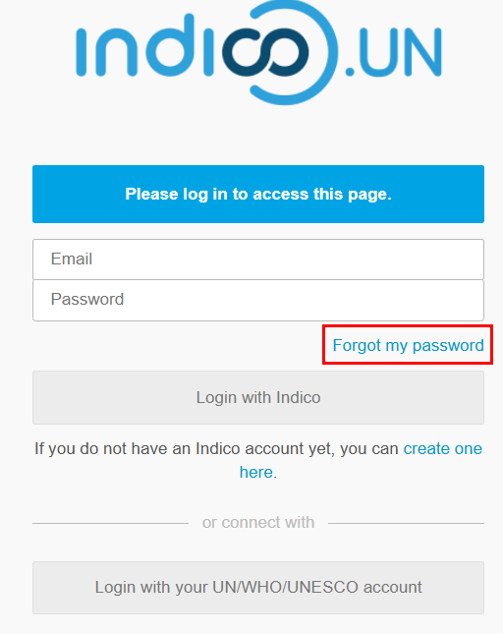

Enter your email address in the **Email address** field.

Click **Submit.**

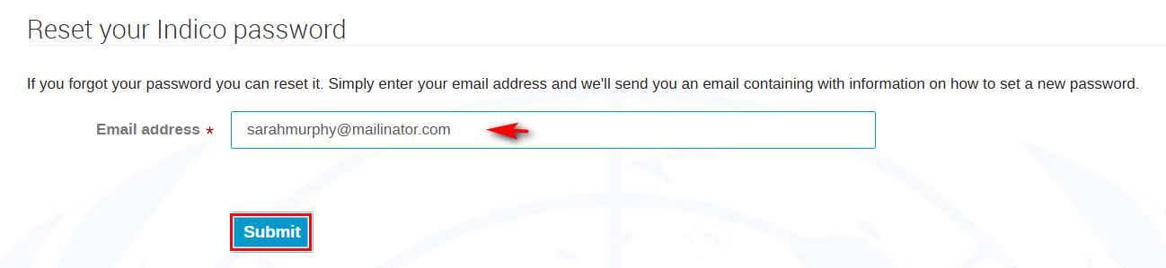

A message appears on-screen. You have **1 HOUR** to click the link in the email.

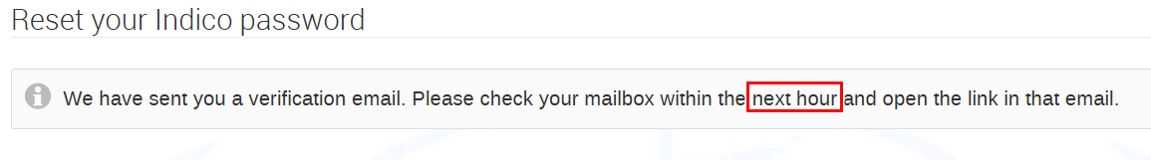

In the email click the link.

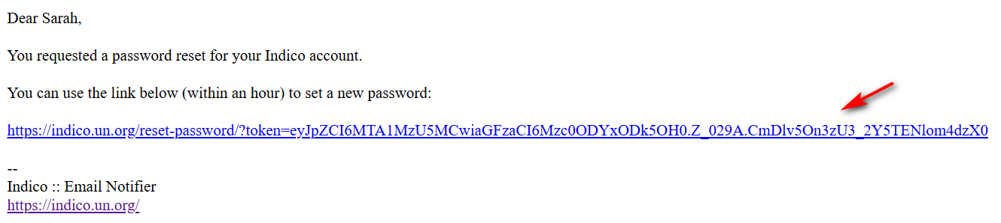

You are redirected back to Indico to a **Reset your Indico password** window where you are required to enter a new password.

Ensure you achieve 6 green check marks √.

Click **Change my password**.

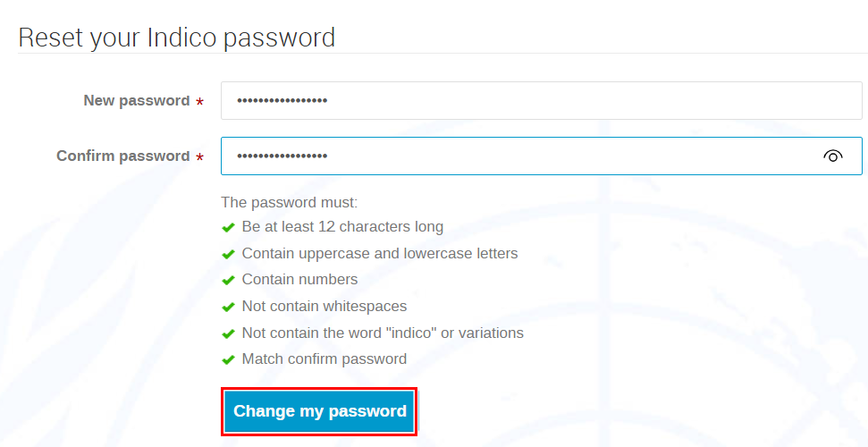

A message appears on-screen.

