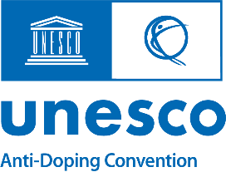
Delegation of Authority Form
Tenth Session of the Conference of Parties (COP10) of the International Convention against Doping in Sport – October 2025
During COP9, States Parties have emphasized the intergovernmental nature of the Convention, as well as the need to strengthen the rule of law and the impact of the Convention as public international law (Res 9CP/23). In view of this, decision-making during COP10 should be carried out by Government representatives, particularly those from the Ministry responsible for the implementation of Convention (Article 3 of the Convention), as depository of the Convention.
In alignment with Rule 1 of the Rules of Procedure of the COP, all individuals from non-Governmental entities making decisions on behalf of a State Party are to submit a Delegation of Authority form, signed by their competent Ministry, to the COP via the Convention’s Secretariat.
Delegation of Authority of ______________ (State Party) for COP10
Section I - Delegated Representative
The depository entity of the Convention confirms that the following is its representative to COP10:
Full Name: _________________________ Position: ___________________________
Entity: _____________________________Email: _____________________________
Phone Number: _____________________
Section II - Scope of Delegation
The representative is authorized to:
☐ Participate in COP10 meetings and consultations
☐ Intervene and contribute on behalf of the State Party for all matters related to the Convention
Section III - Delegating Official
I confirm that the representative in Section I of this form is authorized to act on behalf of ________(State Party) ________ during COP10 in October 2025.

Full Name: ______________________ Position: _______________________
Ministry: ________________________Email: _________________________
Phone Number: _________________

___________________ _________________
Stamp / Signature Date
Please submit the completed and signed form in the registration page.
For any questions or assistance, contact the Secretariat via antidopingteam@unesco.org

