Regional Access and Benefit-Sharing Workshop
11-12 March 2025
Bangkok, Thailand
Logistics Note

Thai visa: | Please check Thailand’s arrival requirements here
DSA/ Terminals | For funded ‘international’ participants, your country office focal point will calculate your ‘actual’ DSA and arrange your air ticket based on these estimates:  Estimated DSA calculation  Arrival date 10 Mar. Meeting Day 1 11 Mar Departure date Meeting Day 2 12 Mar Terminal Allowance Total DSA / person  274 274 - 252 800  DSA = UN DSA rate (as of 1 Feb.2025); No DSA on the departure date  - The itinerary must be approved before issuing an air ticket. Any deviations from this entitlement /approval will be at a personal expense;  - If the participant’s departure flight is only available the next day (13 Mar), no evening flight on 12 Mar, the air ticket and an additional 1-day DSA (for 12 Mar) will be covered by the organizer;  - Participant must arrange & pay for their own accommodation, meals, and transportation while in Bangkok. For UNDP hotel rate, please check here  - AM/PM coffee breaks will be provided during the meeting. Lunch will be at own expenses
For Country office’s Travel Arranger | COA for air tickets and DSA  Please create a Travel Request (TR) in UNALL for the partial DSA and terminal expenses chargeable to the below COA and send it to Thitima:  Travel Processer:  Ms. Thitima Phuavong E: thitima.phuavong@undp.org ,  Please CC: Nittaya Saengow , E: nittaya.saengow@undp.org
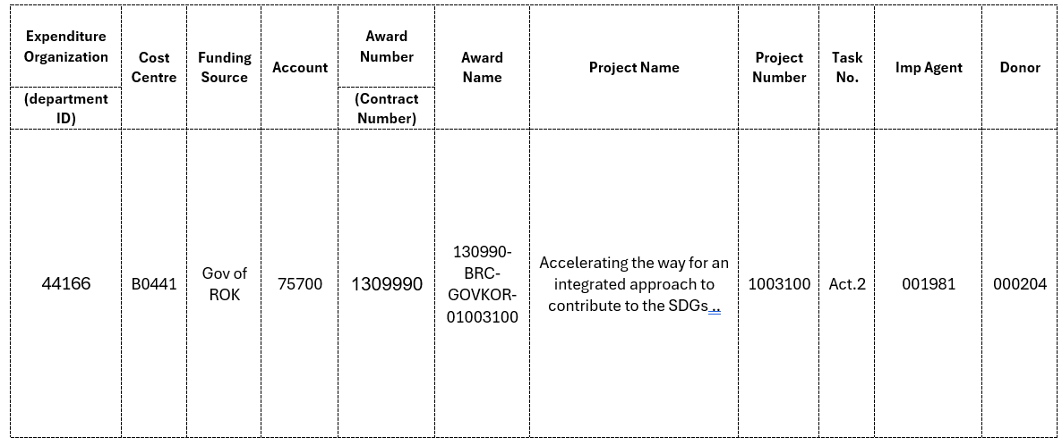
Meeting Venue: | Tues.11-Wed. 12 March 2025 (1.5 days)  Meeting Room G, UN Conference Center  United Nations Economic and Social Commission for Asia & the Pacific (UNESCAP)  Rajadamnern Nok Avenue, Bangkok (Map: here)
Registration required | Online and onsite participants must register at this link: here
Local Currency | Exchange rate USD 1 = approx. THB 34 (link)
Wifi, Power supply and plug type | Participants must bring their own laptops. Wi-Fi internet will be provided at the meeting. Thailand Wall Outlet Voltage: 220V. Thailand power outlets support one of these power plugs: A, B, C, or a modern Thai power outlet (most popular type).  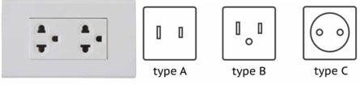
Weather | Please check the updated weather here

