Empowering CRPD Implementation:
Launch of the Practical Guide on Independent Monitoring Mechanisms and Web-Based Repository

Learn more about independent monitoring of the Convention on the Rights of Persons with Disabilities (CRPD)and the experiences of Independent Monitoring Mechanisms (IMMs).

Wednesday 8 May, from 13:30 to 15:00 p.m.
Room XXIII, Palais des Nations
Link to register to follow the event online
https://indico.un.org/event/1011325/
Closed captioning and online International Sign Language available.

Scan the QR code to check out the Practical Guide on Independent Monitoring Mechanisms:

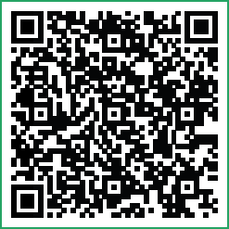

Scan the QR code to check out the repository of IMMs:
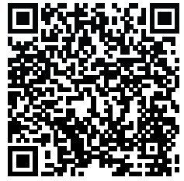

Organized by:




