Grant Category/Sub-Category Manager Role

Step.1: Search for Category/Sub-category
Login to the website with the user credentials of a category manager. Navigate to the category/sub-category of which you want to grant manager rights to another user. Once you navigate please make sure the ‘/category/ ‘ appears in the browser url. (See image below).
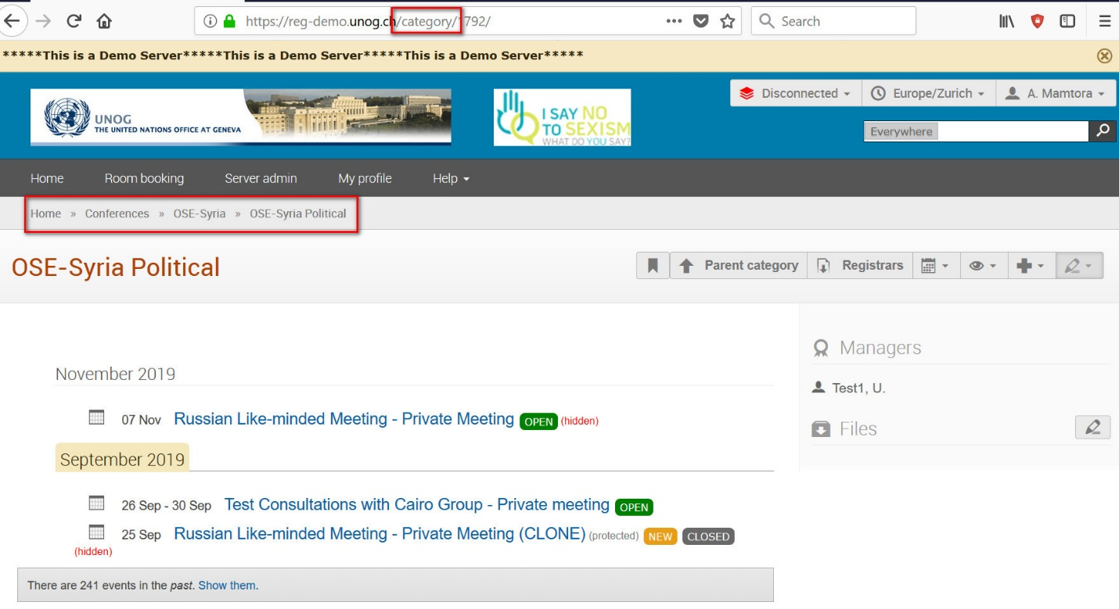

Step.2: Edit Category/Sub-category
Please click on the down arrow next to the pencil icon and then select ‘Edit Category’ as shown in the image below.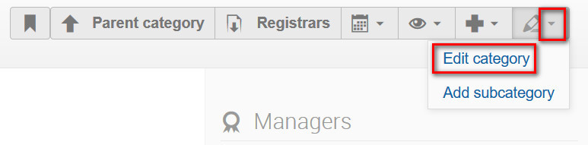

Step.3: Go to Modification control page
Please select ‘Protection’ option on the left-hand side menu and then click on ‘Add manager as shown in the image below.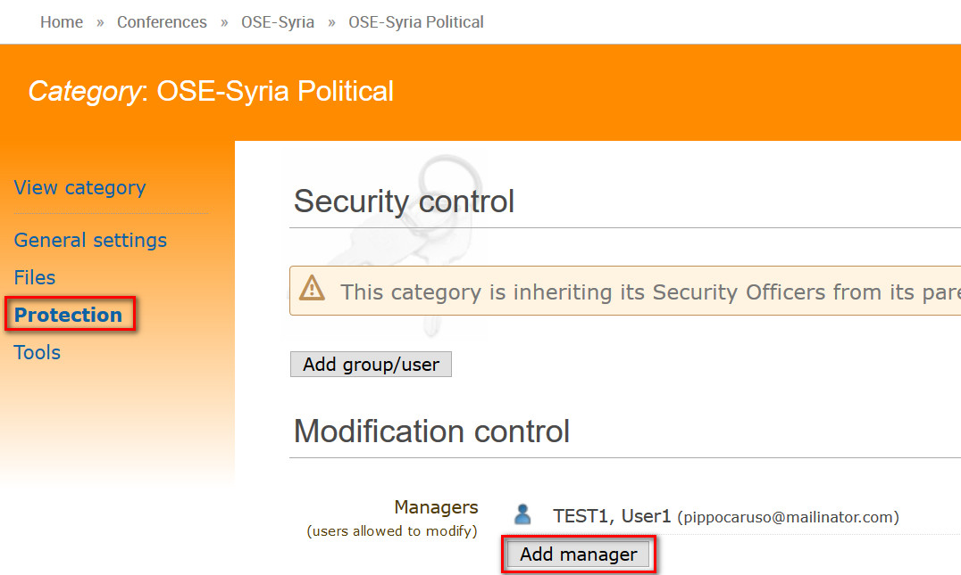
Step.4: Search for existing user to grant additional rights
You can search for the user to be added as manager by any one or combination of following parameters –
- Family Name
- First Name
- Email
- Organization
From the result you could select the user and click on ‘Add’ as shown in the below image.
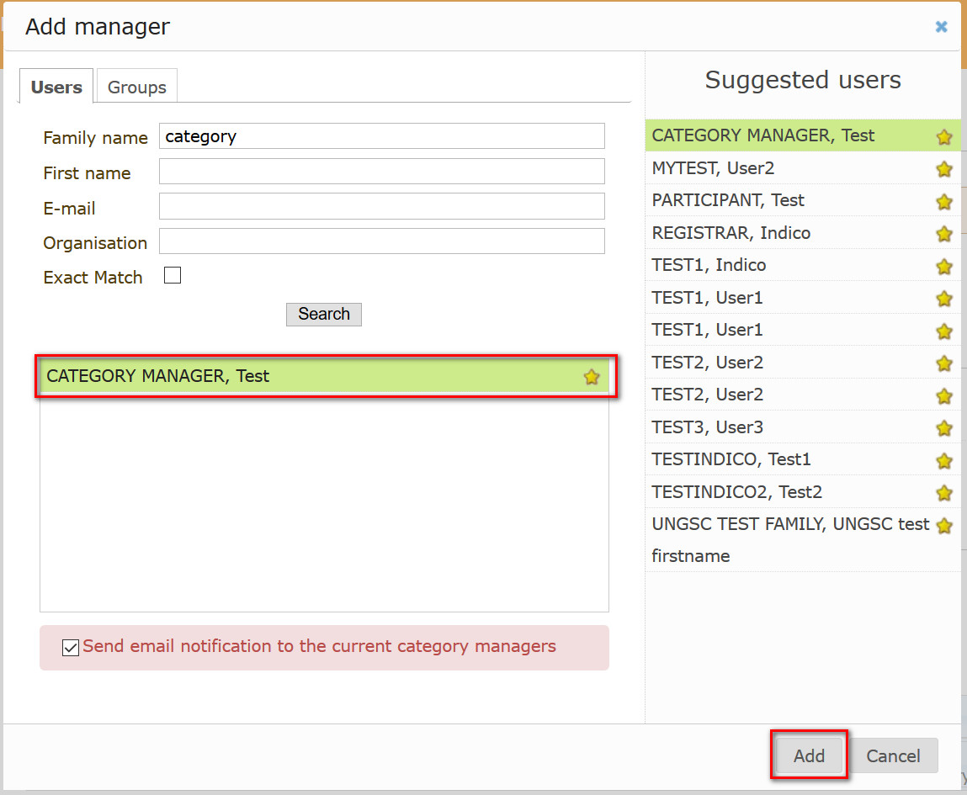

Step.5: Make sure newly added user appears as Manager
Now you should be able to see the newly added user as shown in the below image.