Logistical information to obtain entry badge, access to the Palais and the Meeting Room
Due to renovation works at the Pregny Pavillon effective 5 September 2022 until end of May 2023, please take note of the new location for meeting participants to obtain their access badge to enter the Palais des Nations:
1. When you arrive at the Place des Nations (with the big chair), walk up Avenue de la Paix and collect your entry badge at: VILLA LES FEUILLANTINES on your left as shown below. Please take note that for security reasons, there is no signage to indicate “Villa les Feuillantines” on the building/entrance. Please check carefully the map below.
2. Once you have your badge, enter through the NEW ENTRANCE: PEACE GATE BIS as shown below. This gate is on the opposite side of the road to Villa les Feuillantines.
Picture 1
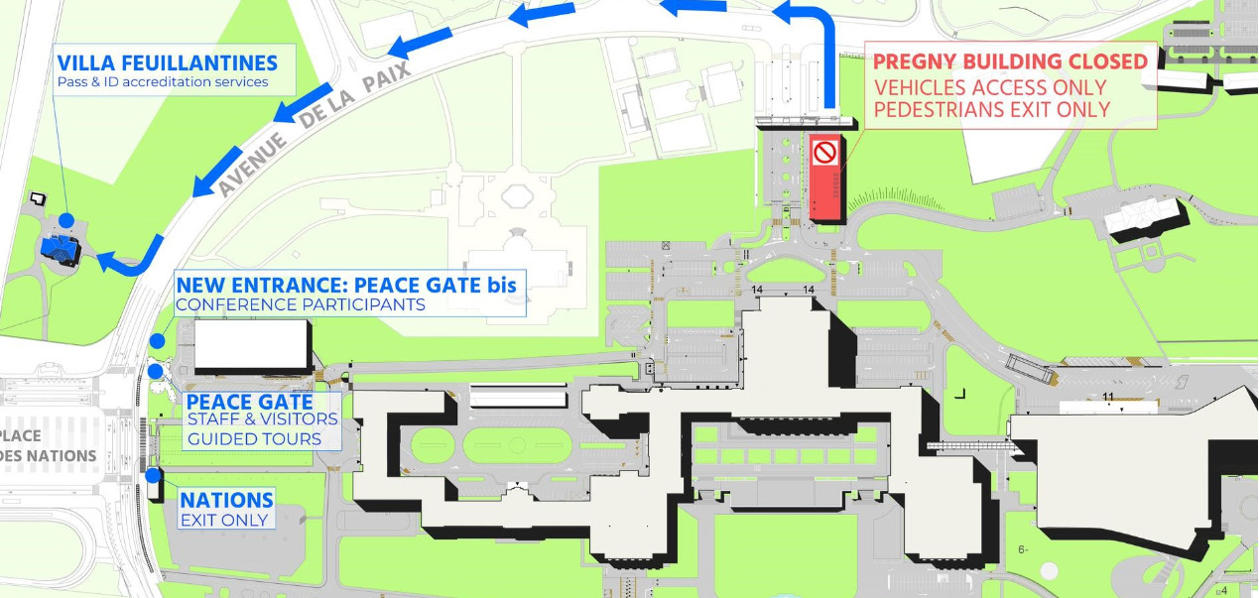
3. Once you have passed security, you will arrive in a parking lot where the TEMPUS building is located. To go to
DOOR 40, cross this parking lot and walk up the road in front of you following the red line as shown below.

4. You will walk past the Pregny Gate on your left, follow the path down in the direction of the E Building (modern building). You will then see a car park and DOOR E40 directly in front of you. Go straight and you will face the H building (where our new offices and meeting rooms are located). Enter the H building and take the elevator to the 3rd floor where Room H-307-1 is located (follow the signs in the building and see the Picture 3 below).

Picture 2
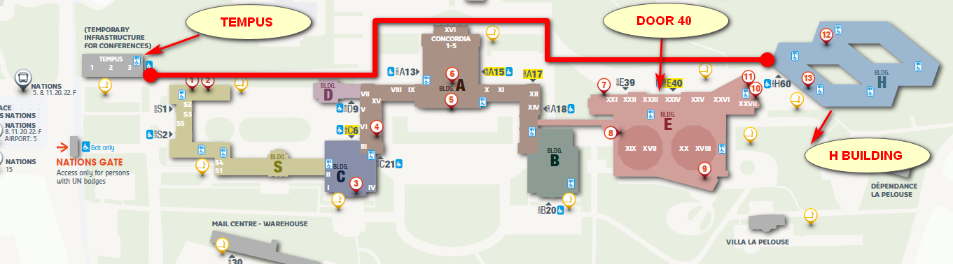
Picture 3
