Logistical information to obtain UN Entry Badge and Directions to the Meeting Room

Due to some ongoing works at the Pregny Gate, effective 5 September 2022 until 31 May 2023, please see below the new location called “Villa Feuillantines” where you will obtain your access badge to the Palais des Nations:
- When you arrive on the Place des Nations (tramway stop), walk up on Avenue de la Paix and on you left you will find the VILLA FEUILLANTINES (as shown on the map below).
- Once you have obtained your entry badge, enter through the NEW ENTRANCE: PEACE GATE BIS (as shown below). This gate is across the road to the Villa les Feuillantines.
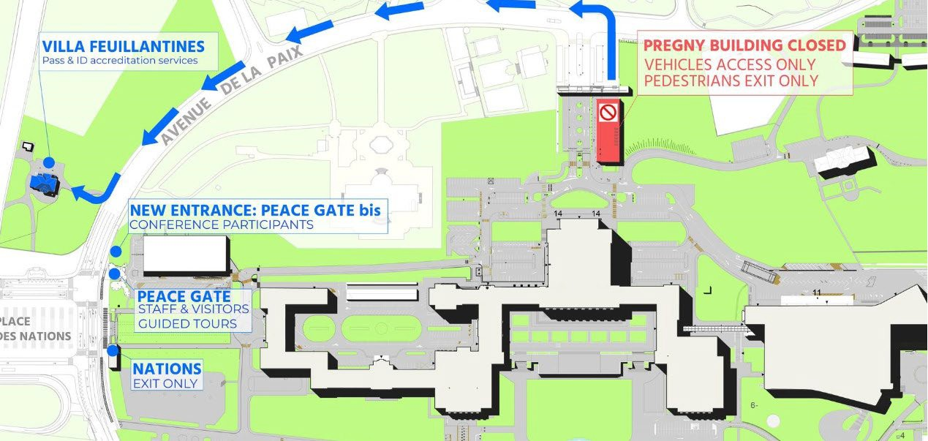

- When you have entered through that gate, you will have to walk across a parking lot and will continue walking up a path following the red line as shown on the map below, in the direction of the E BUILDING.

- Enter through Door E40, (and please make your way to room XXVI (26), on the first floor)

