Guidelines: creating captions using YouTube
The purpose of these guidelines is to explain how to use YouTube to caption video messages. We recommend its use as an example of a quick, simple and free solution to increase the accessibility of Council sessions, but stakeholders are encouraged to use any means of their choosing to add subtitles to video messages.
These guidelines only address how to create subtitles when a transcript of the video is available. YouTube also generates automatic captions, but this falls beyond the scope of these guidelines.
- Go to www.youtube.com and log in or sign up using a Google account.
- In the upper-right corner, click on the camera icon and select “Upload video”.
- Select the video file.
- The following screen appears. As the video will not be made public on YouTube, most details are not relevant. The only required fields are the title and the indication that the video is not meant for children. Complete them and click “Next”.
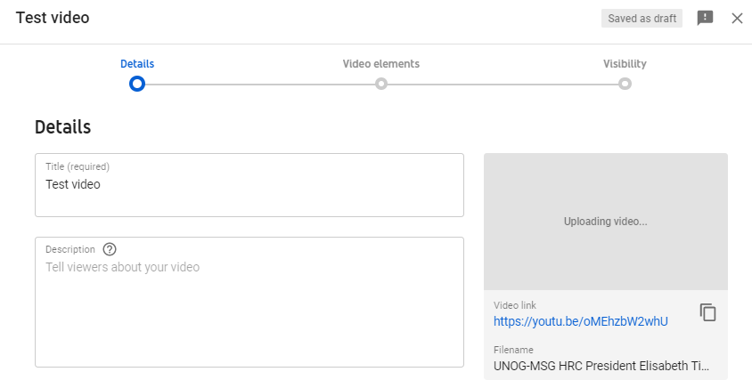
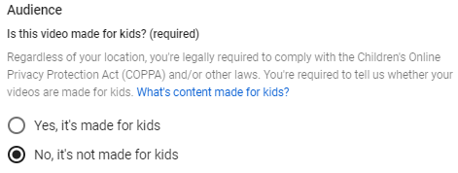
- Click “Next” on the “Video elements” tab. On the “Visibility” tab, select “Private” and click on “Save”.
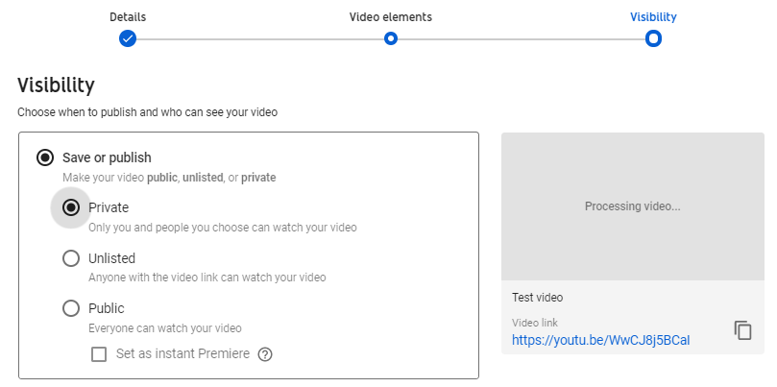
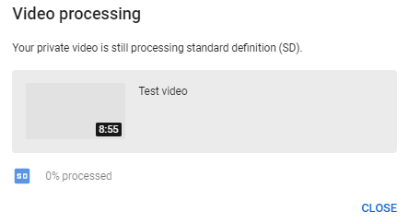
- After the video has finished uploading, it might be necessary to wait some minutes while it is being processed (capture below). Processing time depends on several factors, such as the format and size of the original file, as well as YouTube’s own upload traffic. As a rule of thumb, it can take around one minute of processing for each minute of video – and more than that for higher-resolution video. The progress bar is usually not linear: 0% takes a long time, and from there it jumps to almost completion. A few minutes at 0% does not mean that the processing is frozen.

- Go back to the dashboard by clicking on the icon on the upper-left side. On the left-hand column, select . Click on “Details” next to the video to caption. After that, select “Subtitles”.
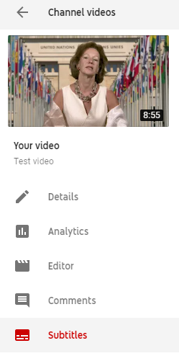

- Select “add” and then “Upload a file”. On the next screen, select “Transcript” as the file type. There might be a warning mentioning that “Uploading a file will overwrite this version of English”. This means that YouTube has already generated automatic captions for this video, which will now be overwritten.
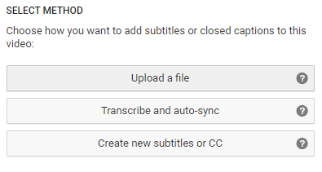

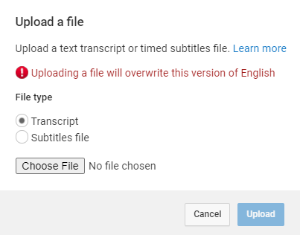

- Upload the transcript as a plain text (.txt) file. Using a Word document will not work properly. Before uploading it, edit the file so as to include only what is actually said in the video, without bullet points, headers or footnotes.
- The transcript will appear in the following box. Click on “Set timings”.
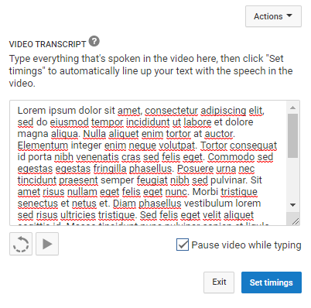
- YouTube will now transform the transcript in timestamped subtitles. For a 7-minute video, this takes 2 to 3 minutes on average. YouTube does not refresh the page automatically when this process has finished; so refresh the page after a few minutes to check whether it is finished (refreshing the page before it is complete does not reset the progress). When it is done, click on the draft.

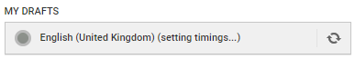
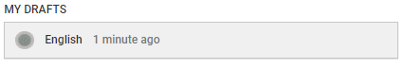
- It is possible to check and edit the subtitles at this stage, changing the wording or timing if needed. After this, click on “Save changes”.

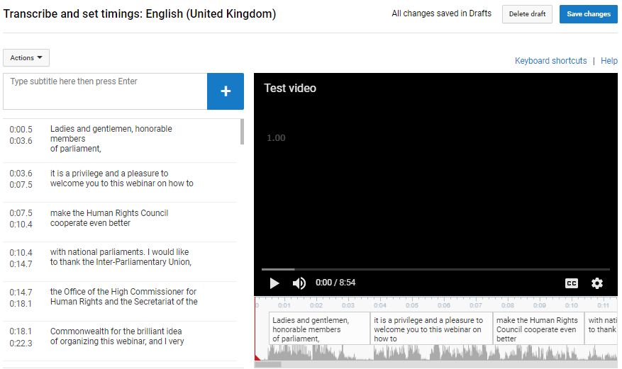

- Select again the edited subtitles. Click on “Actions” and download the captions as a .srt file. Save it with the same file name as the video, as shown in the capture below.

- That is it! To test it, open the video file using a player that supports subtitles, such as VLC Media Player. Provided that both files have the exact same name and are saved on the same folder, captions should be displayed automatically.
- Kindly send the .srt subtitle file when sharing the video file with the Secretariat.

