Registration Management

Audience: Managers and Focal Points

Level: Basic

CONTENT

REGISTRATIONS 1
Access the Registrant List 1
View a Registration 2
The Registration Summary/Profile 3
Approve a Registration 4
Reject a Registration 5
Reset to Pending 6
Add from Existing (on behalf) 7
Add a Registrant 8
Modify a Registration for a Registrant 8
Export Registrants to xls 9
Tags 10
Create a tag 10
Assign a tag 10
Remove a tag 12
Send Email 15
Invitations 17
Send an Invitation to Individuals 18
When Inviting Indico Users 18
When Inviting a New User 19
Receiving an Invitation 21
Send an Invitation to a Large Group using XLS 22
Prepare the xls File 22
Prepare the Text of the Invite 23
Perform the Import 24
THE REGISTRANT LIST FEATURES 25
Buttons Explained 25
Select Columns to Display on the List 25
Reset Column View to Default 26
Move Columns 26
Filters/ Reset Filters 26
Search 26

REGISTRATIONS

Access the Registrant List
- On the event page the pencil icon located in the grey navigation bar at the top.

- On the menu on the left under Organization Registration.

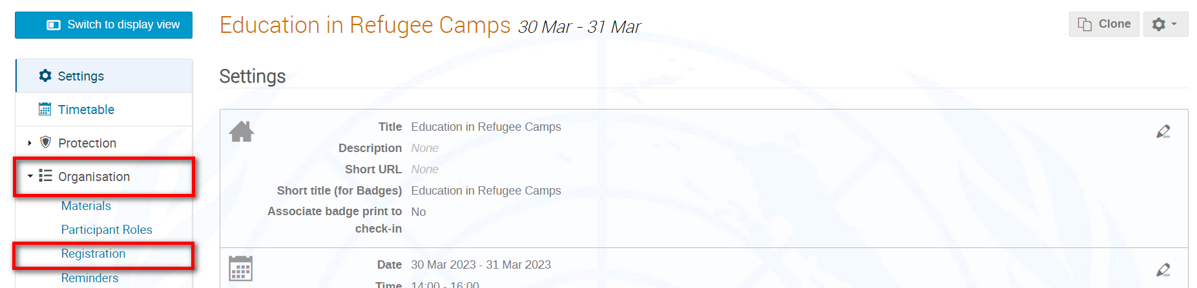

- In the Registration window under List of Registration Forms Registrations.

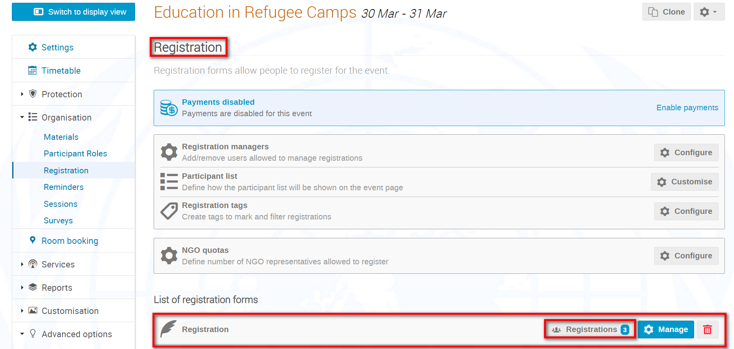

- The list displays.

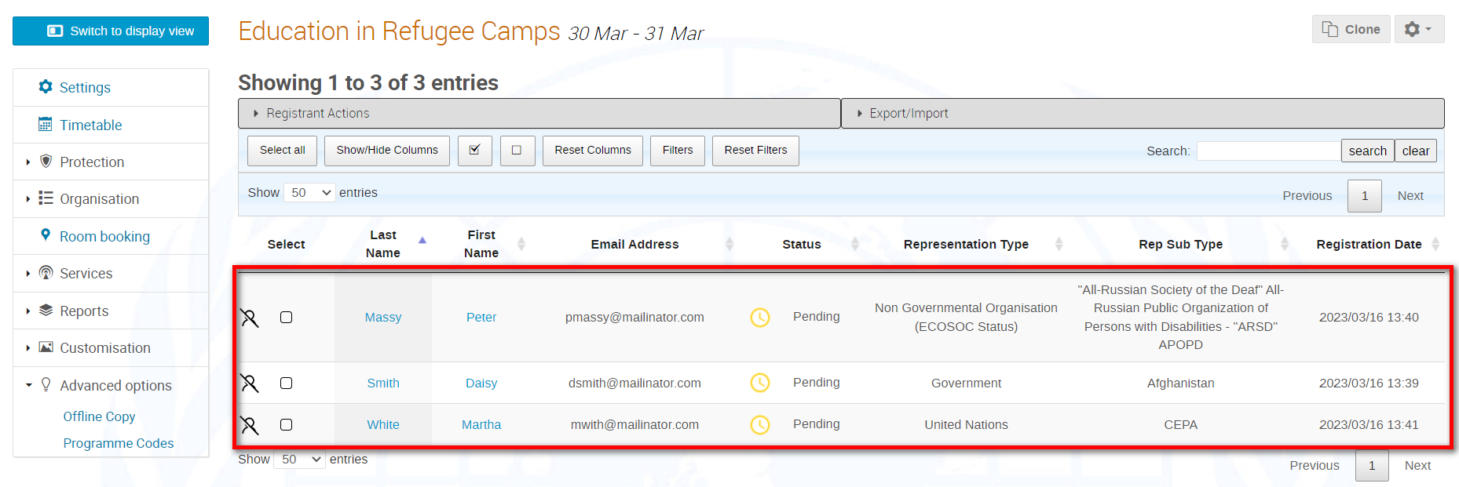

- When using the list, do not forget to expand Registrant Actions and Export/Import as here you will find all the function buttons you need to manage registrations.

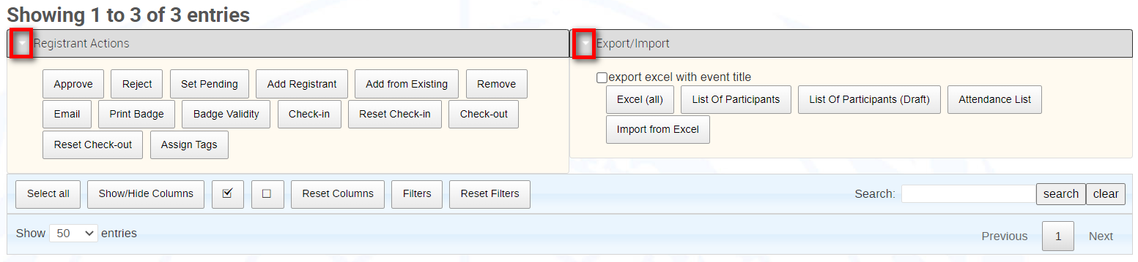

View a Registration
- a name on the list.

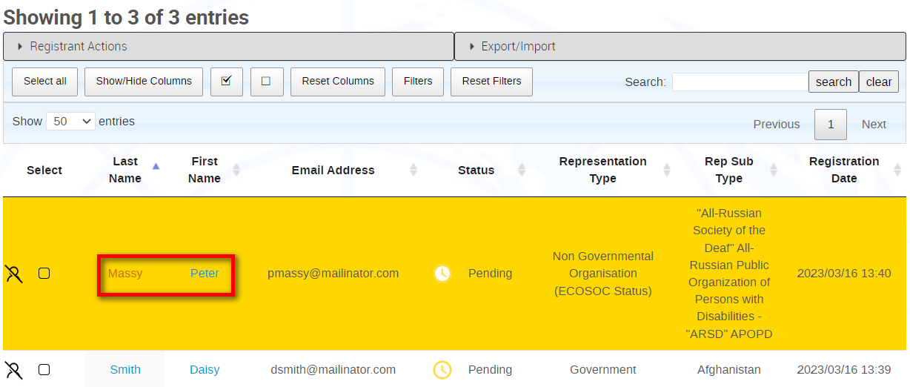

- The registration summary/profile opens.

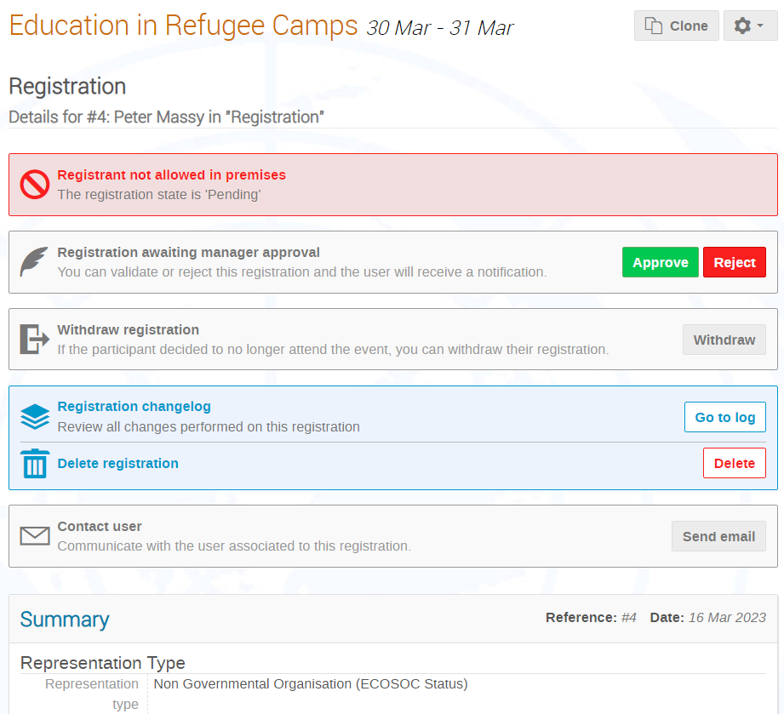

The Registration Summary/Profile
- Depending on the permissions assigned to you, you may perform certain actions from within the registration summary/profile.

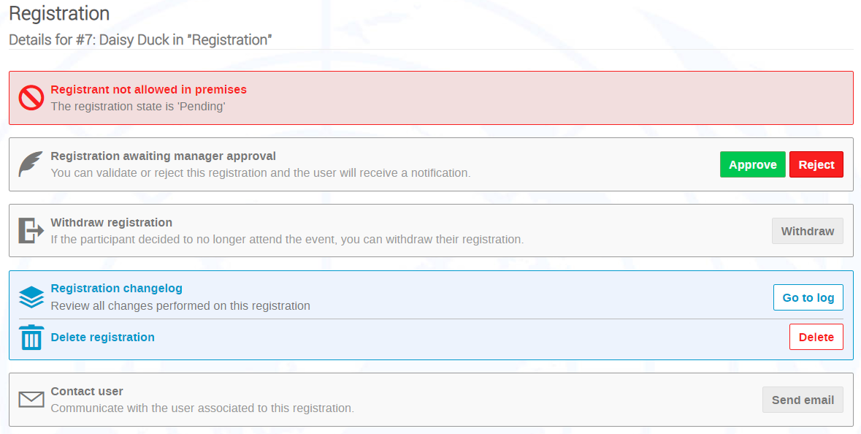

Actions available to take on the registration. 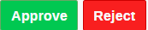

Only displays once the form is completed.
Withdraw the registration on-behalf.
A log of the actions and emails in respect of the registrant.
Delete the registration.
Contact user: Send an email to the registrant.
Indicates if the registrant is on a watch list.
Displays a history of the registrant’s registration history.
Check-in record of the registrant and allows a reset of check in information.
Check-out record the registrant (if being monitored).
Edit or reset badge validity.
The type of badge and option to print a pdf to view.

Approve a Registration
- You may approve a registration either from the list:

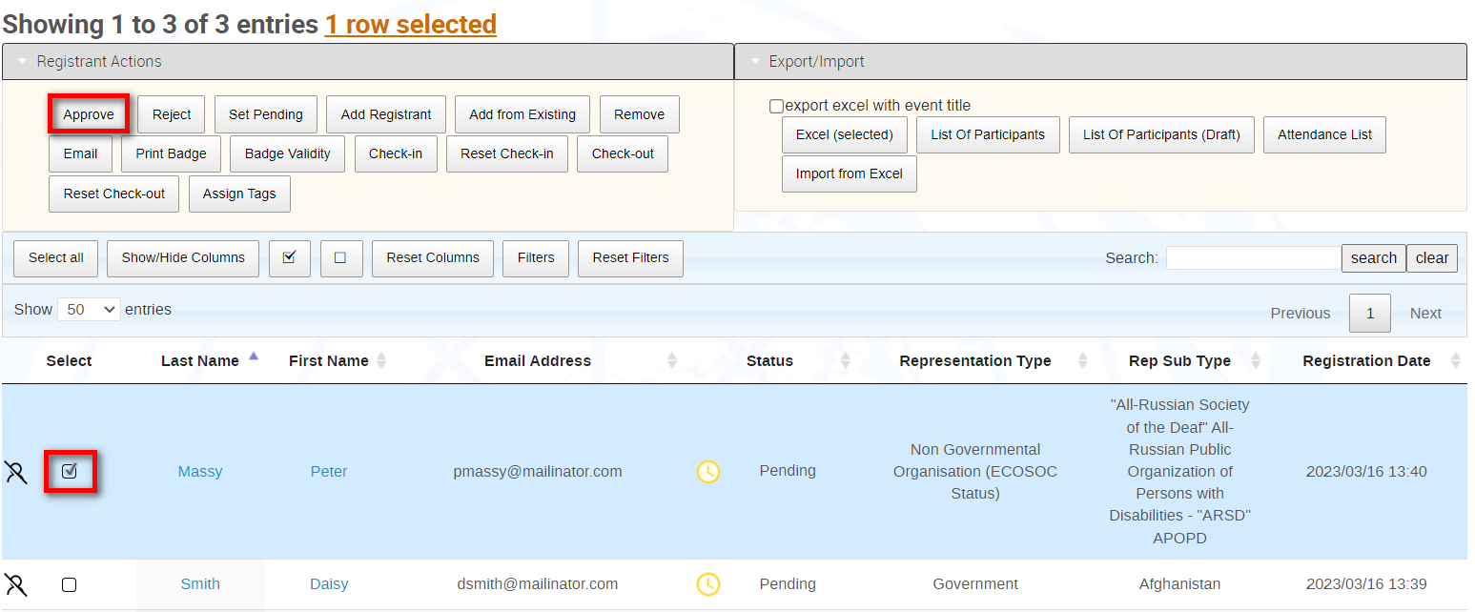

Or from the registration summary/profile.

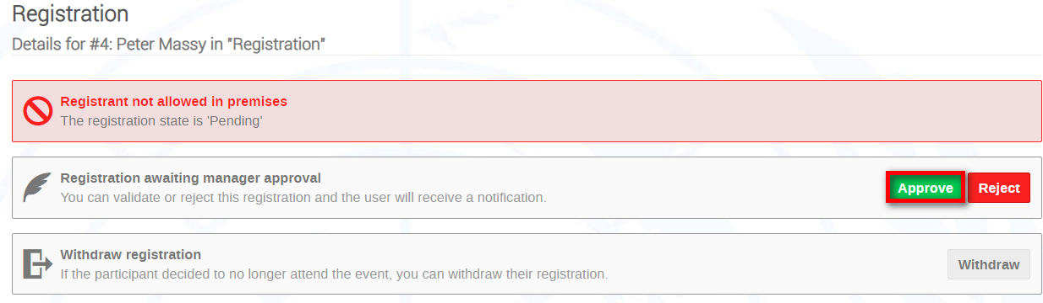

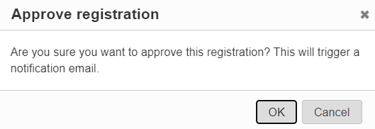
- The action triggers a confirmation message.

- If the event has been set up with email notifications enabled, the registrant receives an approval email.
- The status of the registrant is updated on the list.

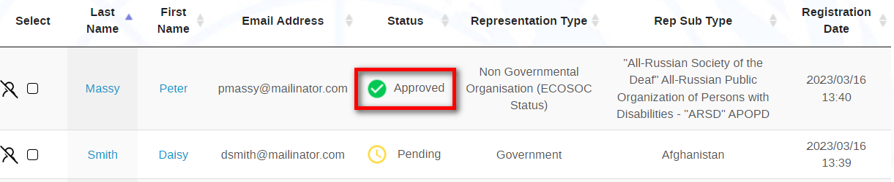

Reject a Registration
- You may reject a registration either from the list:

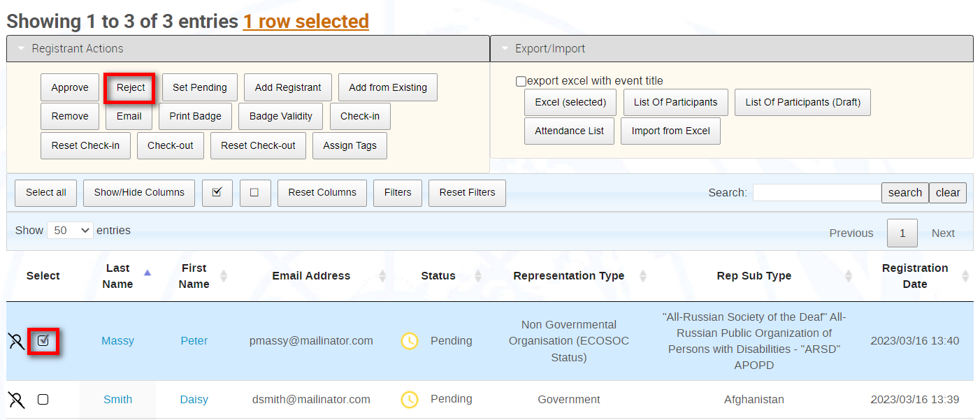

Or from the registration summary/profile.
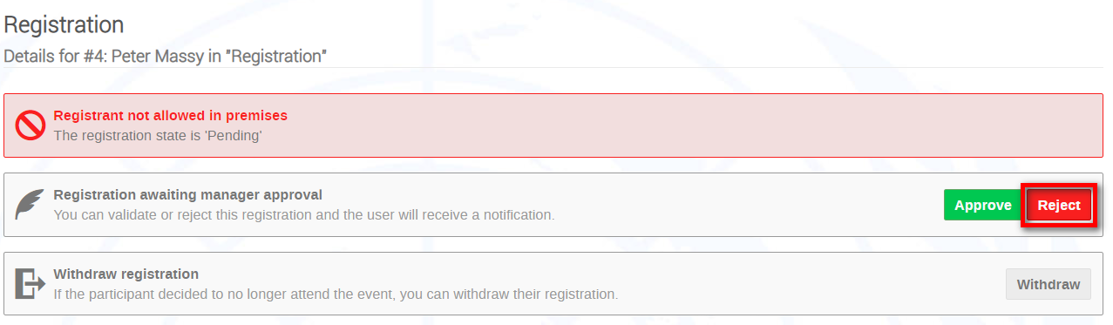

- The action triggers a confirmation message.

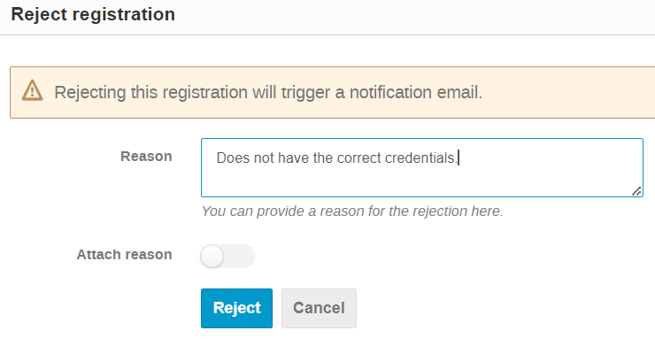

- Give a reason for rejection. If the event has been set up with email notifications enabled the registrant receives a rejection email. You may opt to include the reason for rejection in this email.
- The status of the registrant is updated on the list.

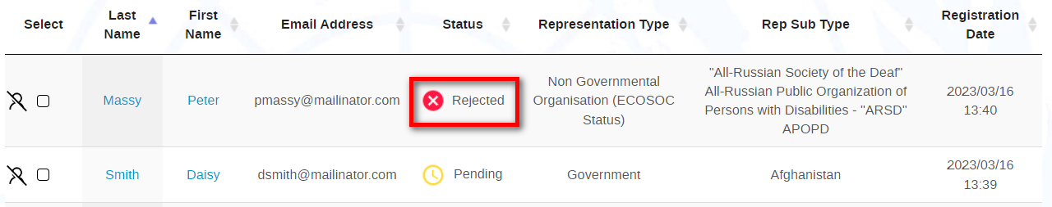

Reset to Pending
- If a registrant has been erroneously approved or rejected, you may reset to pending. Again, you may do this either from the list or the registration profile/summary.

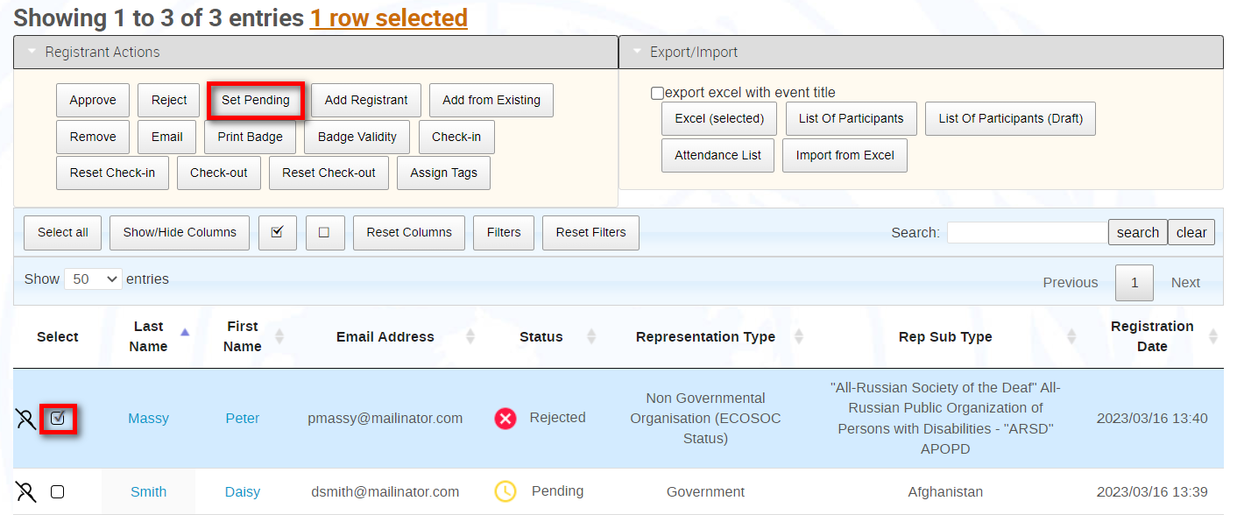

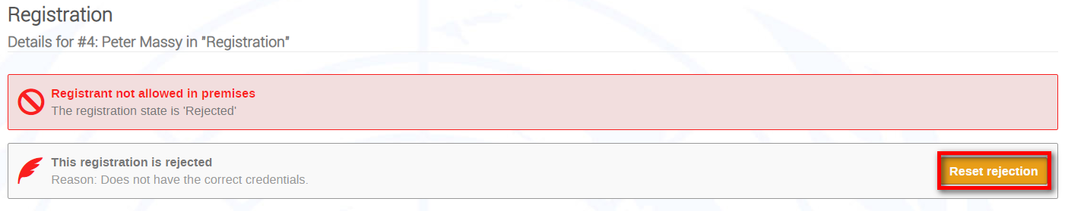

- If the event has been set up with email notifications enabled the registrant receives a notification on the change of status, and the registrant appears on the list as pending again.
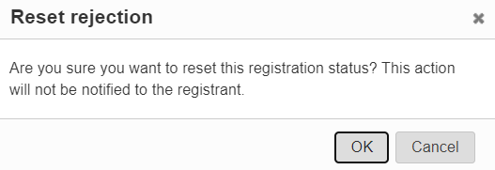

Add from Existing (on behalf)
NOTE: A Focal Point may Add from Existing only if he/she has been granted that right. The right requires a recognized UN domain email address.

- Existing users may be added to the list. It is known as on-behalf. Add from Existing.

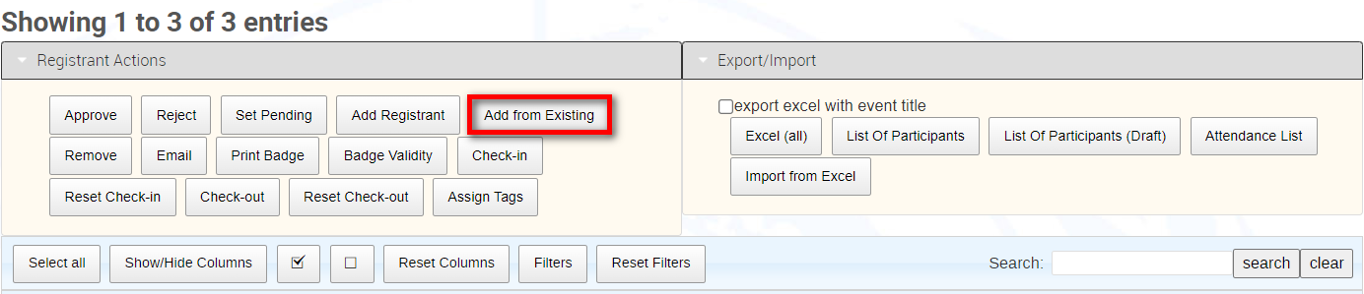

- Perform a search for the user and confirm selection (if you do not find the individual, skip to next section Add registrant). A blank registration form opens. Complete the form. Before submission you may elect to send a notification of the registration to the registrant and to update the profile if new personal information was added (though we do not recommend changing any personal information that a registrant has added to their own profile). Submit. A confirmation message appears on-screen and the registrant is added to the list.

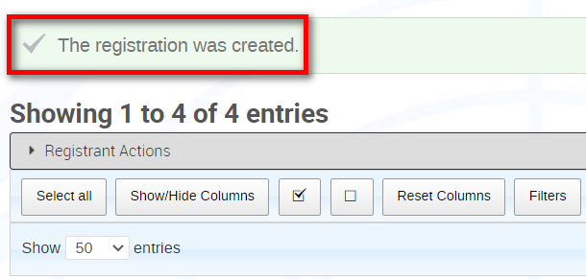

Add a Registrant
- Add Registrant.

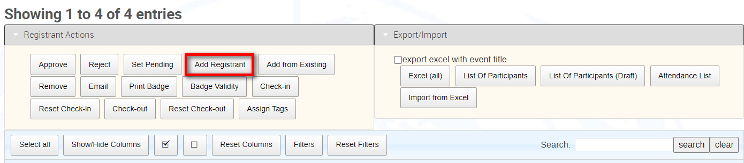

- A blank registration form opens. Complete the form. Before submission you may elect to send a notification of the registration to the registrant. Submit. A confirmation message appears on-screen and the registrant is added to the list.

NOTE: Normally registration for events requires an Indico account. So, when adding registrants on-behalf you may see below the email field one of the following messages.

Registrant does not have an account. A registration may be submitted, and he/she will be indicated on the list with this icon
Registrant exists in the system.

Modify a Registration for a Registrant
A Focal Point may only perform actions on registrations whilst registration is open.

A Focal Point may not modify registrations that are approved.

There may be some instances where a registration received needs to be modified on behalf of a registrant.

- Click the name of a registrant on the list to view the registration summary/profile. Scroll to the bottom of the form and Modify.

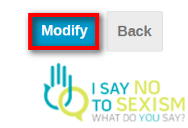

- Make the necessary changes. Before submission you may elect to send a notification to the registrant that changes have been made. You may also opt to update the registrant’s profile with new personal information if changes made to the registration are profile-related. Save.

Can names be modified on behalf of a registrant on a registration form?

- Yes.

Can email addresses be modified on behalf of a registrant on a registration form?

- No.

Export Registrants to xls
- Either make a selection or select all and Excel (all). This will export the selected registrants to an xls file. The xls will display ALL registrant and registration details.

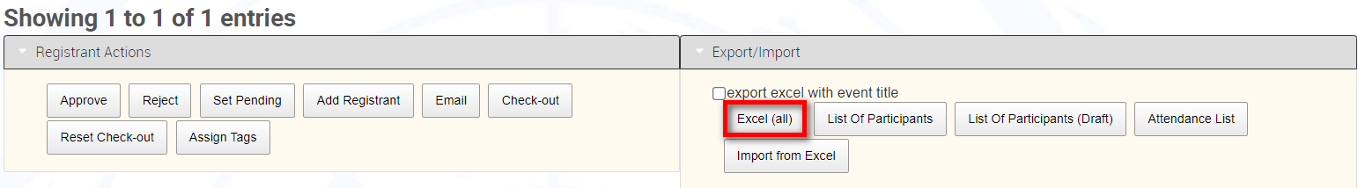

Tags

Create a tag

- In the management area Organisation followed by Registration.
- Beside Registration tags Configure.

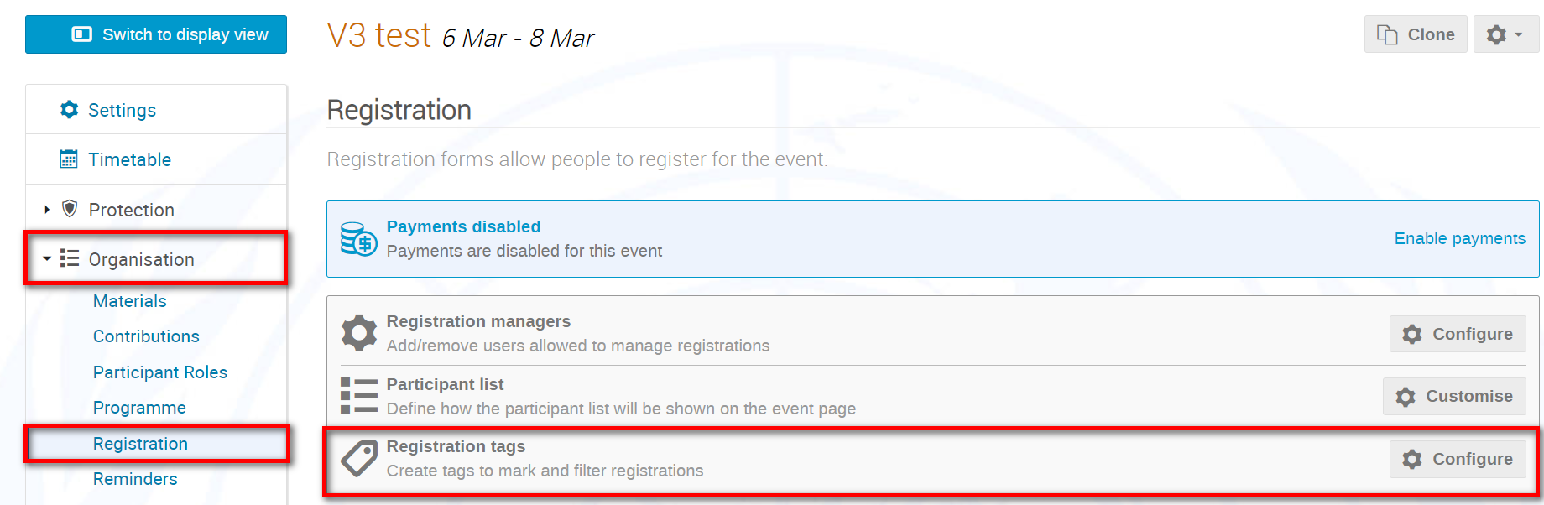

- Add a tag

- In the Title field enter a text for the tag and a display color. Save.

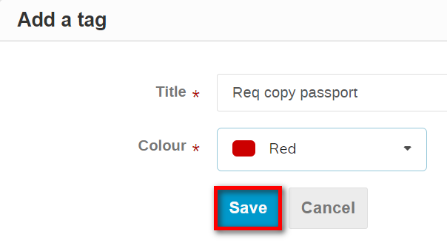

- A confirmation message appears and the tag appears on the list of tags.

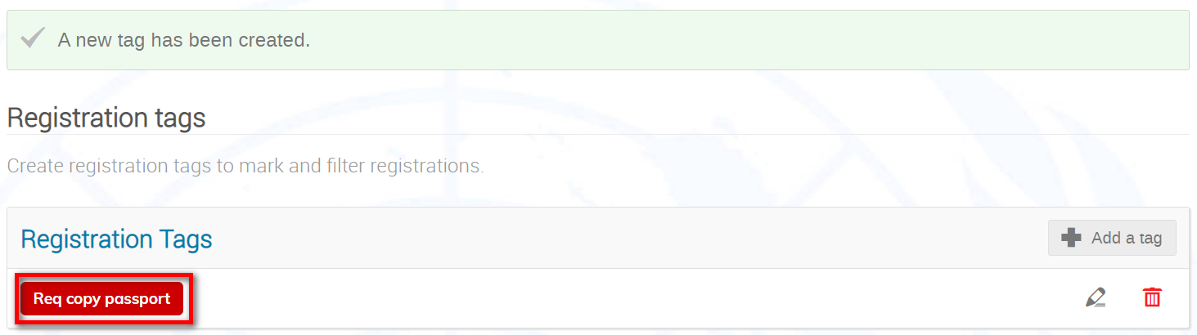

Assign a tag

- If not already visible, display the Tags column on the list.

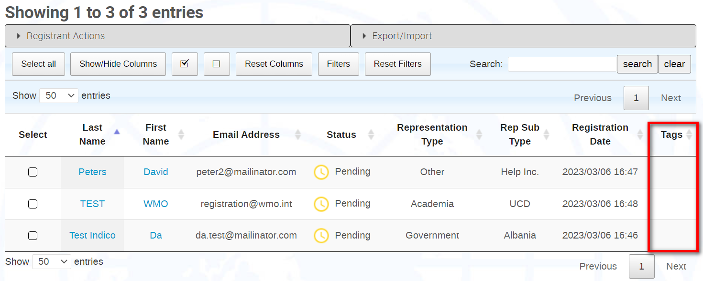

- Select a registrant and, under Registrant Actions, Assign Tags.

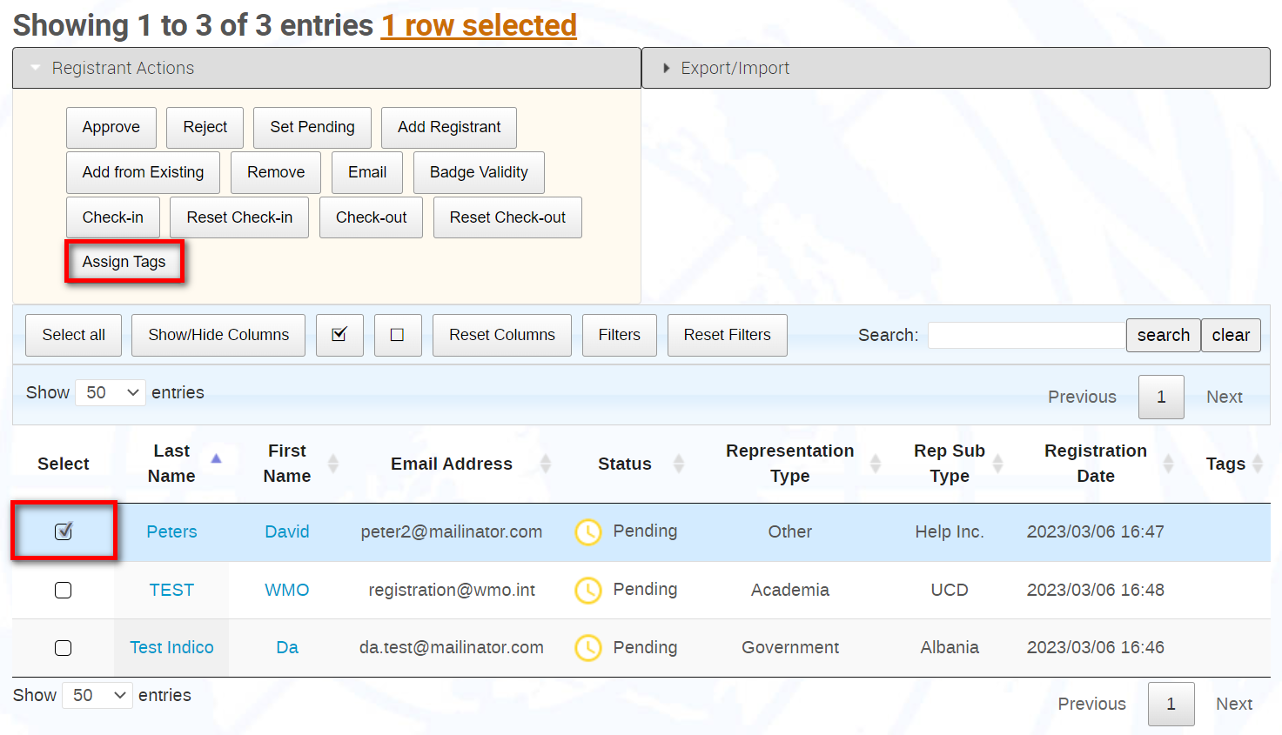

- Expand the Add list, select the tag to assign and Save.

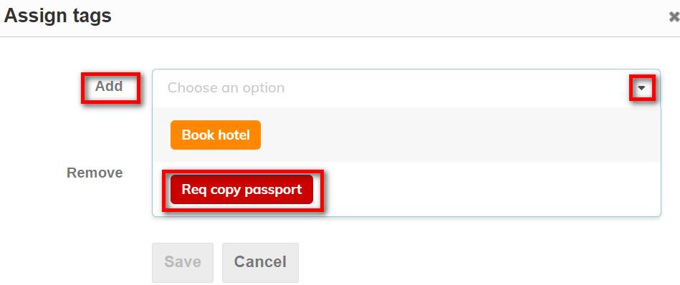

- The tag displays for the selected registrant.

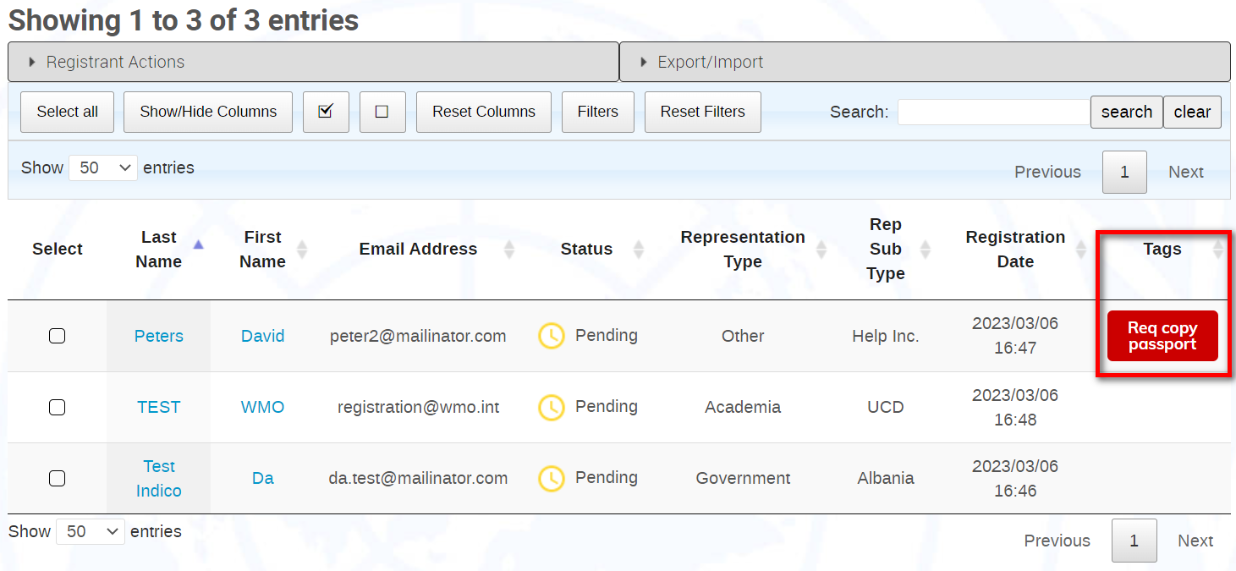

NOTE: You may assign the same tag to more than one registrant at a time.

Remove a tag
- Select a registrant and, under Registrant Actions, Assign Tags.

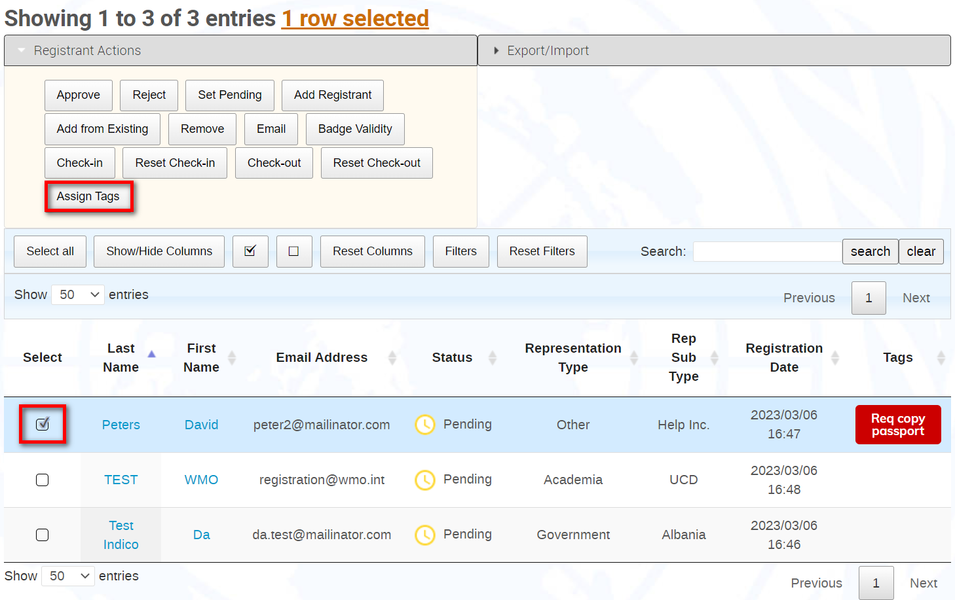

- Expand the Remove list and the tag to remove.

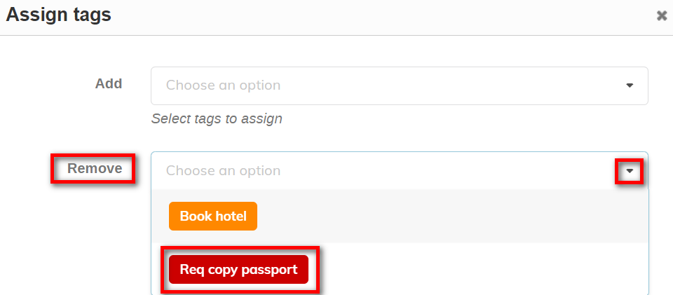

- Save.

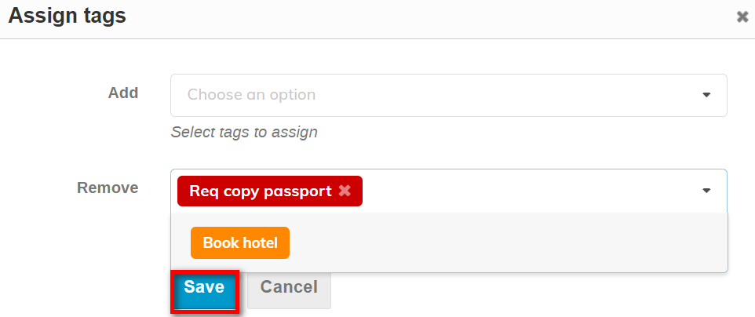

- The tag is removed.

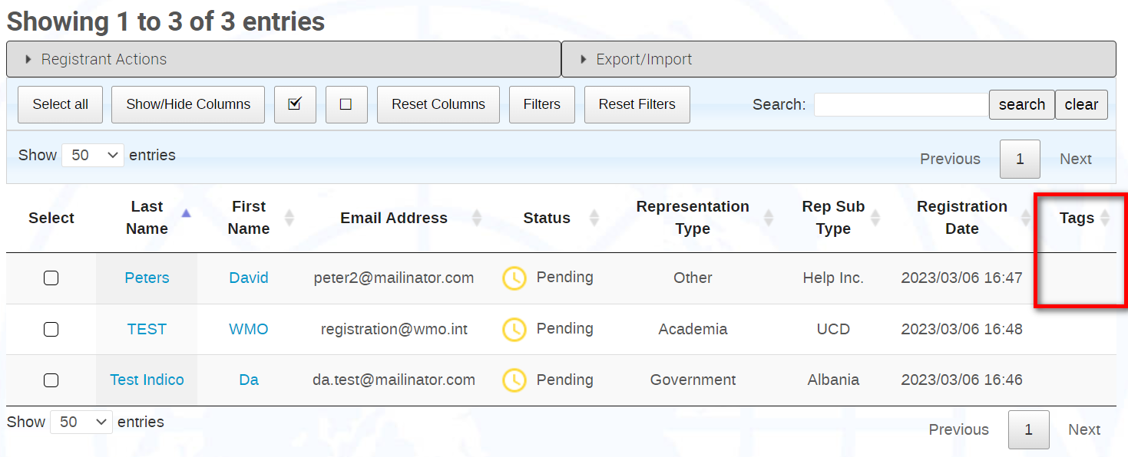

NOTE : You may remove the same tag from more than one registrant at a time, even if the registrants have different/multiple tags assigned. For example, in below screenshot, all registrants have Book hotel as a tag but only one has Req copy passport also assigned. To remove the tag Book hotel from all registrants, select them all, and follow the steps to remove the Book hotel tag.

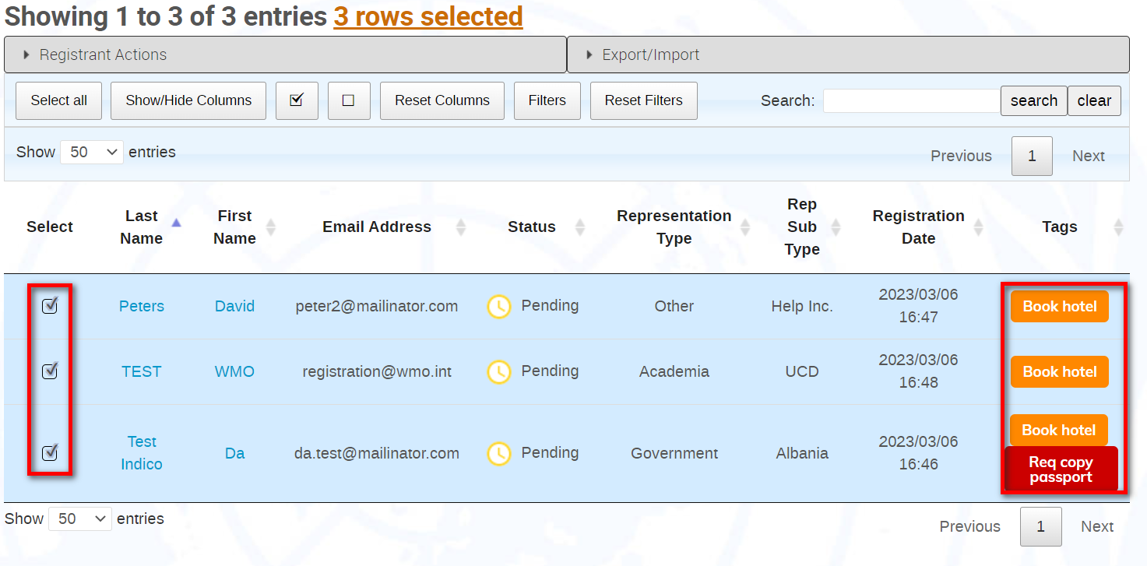

- After removing the tag Book hotel, the tag Req copy of passport is still assigned and unaffected.

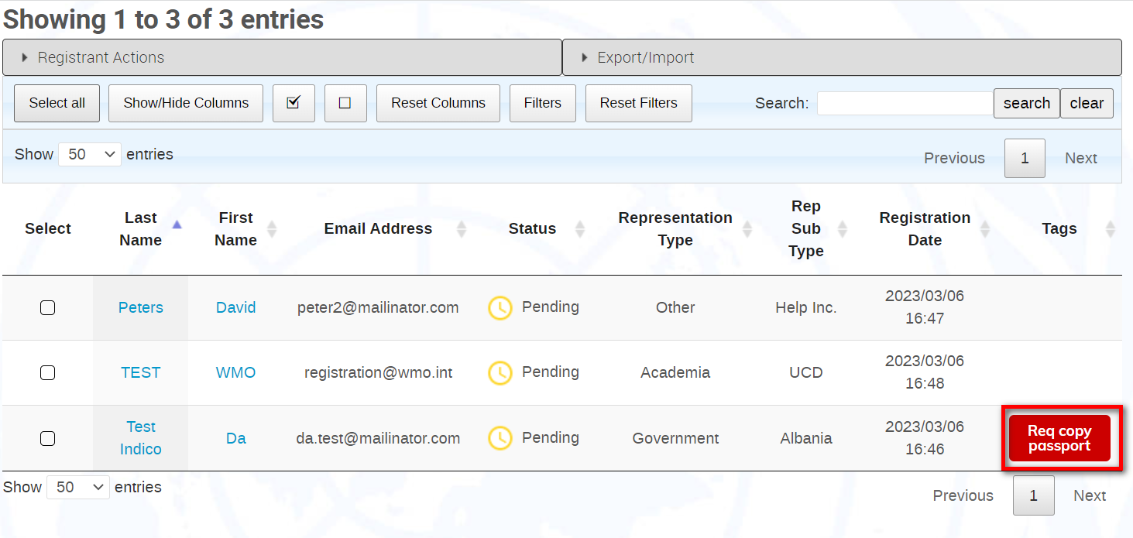

Send Email
- Either make a selection or select all and Email.

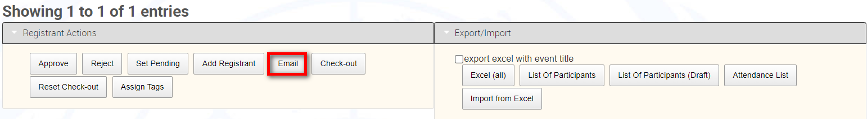

- The Send Email window opens.

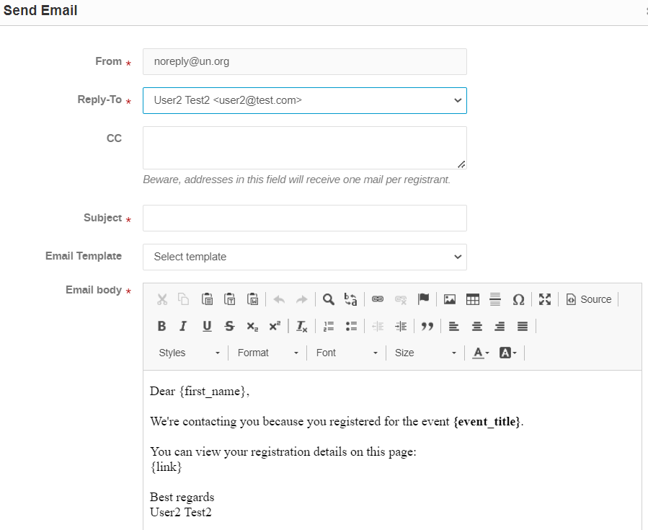
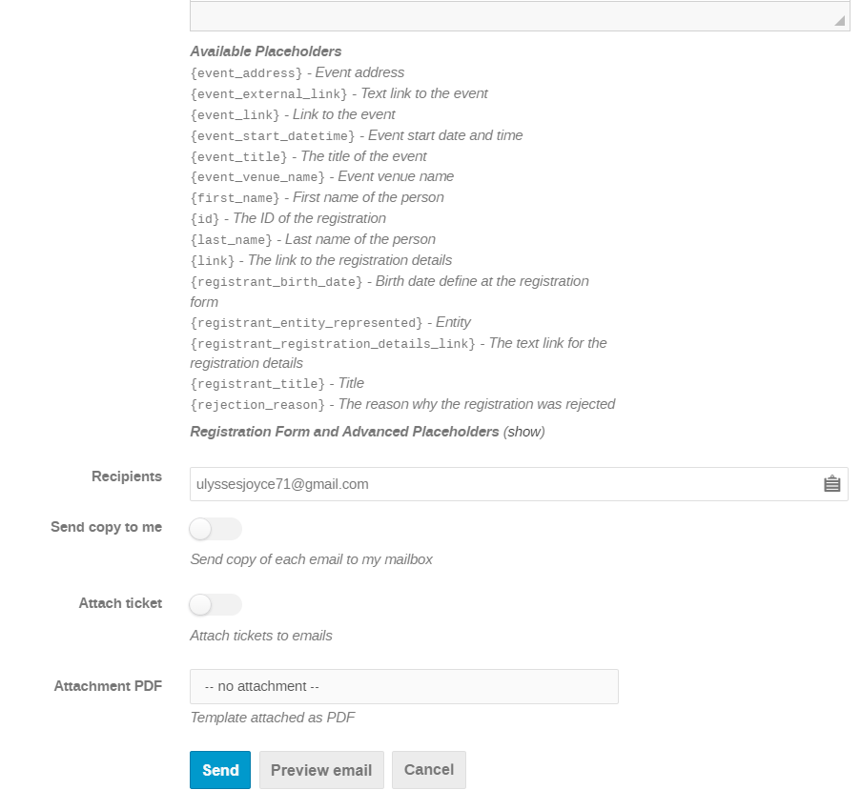

- By defaut the sender is noreply@un.org.
- Any email address added to the event (e.g., contact or that of a manager) is available to select as the Reply to: (i.e., sender).
- If it is an adhoc email, enter a subject. If you elect to use a pre-prepared template, the subject line will autofill.
- Compose the email and copy/paste placeholders if you want to add elements to the email related to the registrant or the event. This pulls the information from the registrant profile or the event (as appropriate) and inserts it at the appropriate placeholder location.
- You may opt to send a copy to yourself but if you are sending the email to more than one person, you will receive a copy of every email sent.
- If the UN Event Pass has been enabled, you may opt to attach it to the email.
- Click Send.
- Refer to the separate guide “Email templates” to understand how to create templates and attachments.

Invitations
A highly useful feature which permits you to send an invitation to your event and a link to the registration form. It also allows you to monitor who received the invitation, who accepted it and who declined it.

- In the management area under Organization - Registration Manage beside the registration form you want invitees to register with.
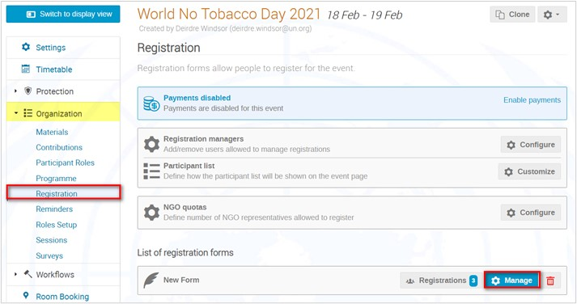

- In the registration form's management area Manage beside Invitations.

Send an Invitation to Individuals
- In the Invitations management area Invite and select from the drop-down menu:
- Indico users (i.e., existing Indico users. You can perform a search and if the user does not appear, opt to use New users instead. You can add several people to the same invitation using this method).
- New users (i.e., non-Indico users. You can only send the invitation to one person at a time).
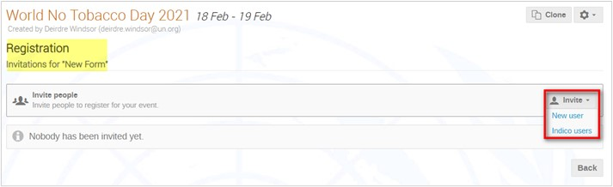

When Inviting Indico Users
- You may invite several existing users at the same time.
- In the Invite user to register window User to identify existing users.
- DO NOT ENABLE "Skip moderation". If you do, once the invitee is registered to the event, he/she will receive automatic approval.
- Identify who the invitation is From: (usually it defaults to that of whomever is logged in sending the invitation. But you can also select one of the event’s conference managers or whatever has been used as the contact on the event page).
- Enter a subject.
- You have the opportunity at this point to modify the body of the email as you see fit. PLEASE ensure that the tag {invitation_link} is included in the email – it inserts a link that directs the invitee directly to the registration form.
- When satisfied, Send.
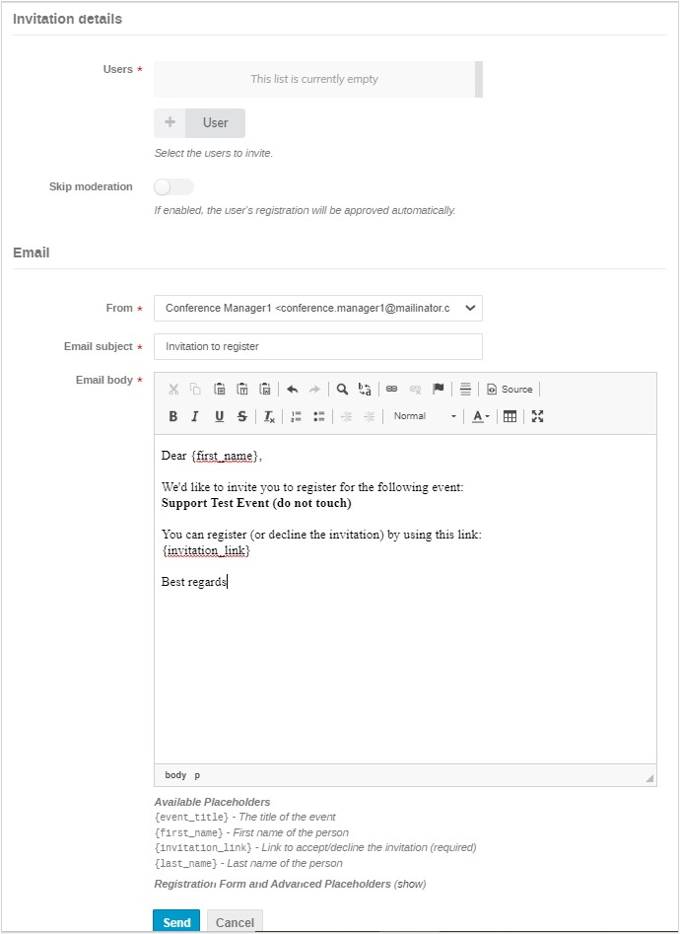

When Inviting a New User
- You may invite only one person at a time.
- In the Invite user to register window enter the name and email of the invitee.
- DO NOT ENABLE "Skip moderation". If you do, once the invitee is registered to the event, he/she will receive automatic approval.
- Identify who the invitation is From: (usually it defaults to that of whomever is logged in sending the invitation. But you can also select one of the event’s conference managers or whatever has been used as the contact on the event page).
- Enter a subject.
- You have the opportunity at this point to modify the body of the email as you see fit. PLEASE ensure that the tag {invitation_link} is in the email – it inserts a link into the email that directs the invitee directly to the registration form.
- When satisfied, Send.
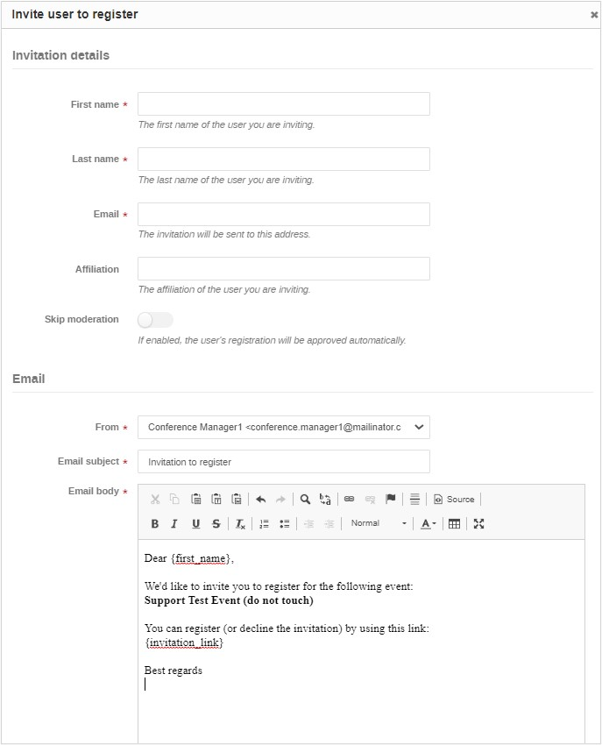

Receiving an Invitation
- If the tag {registration_link} has been included in the invitation, when the corresponding link is clicked in the invite the registration form will open.
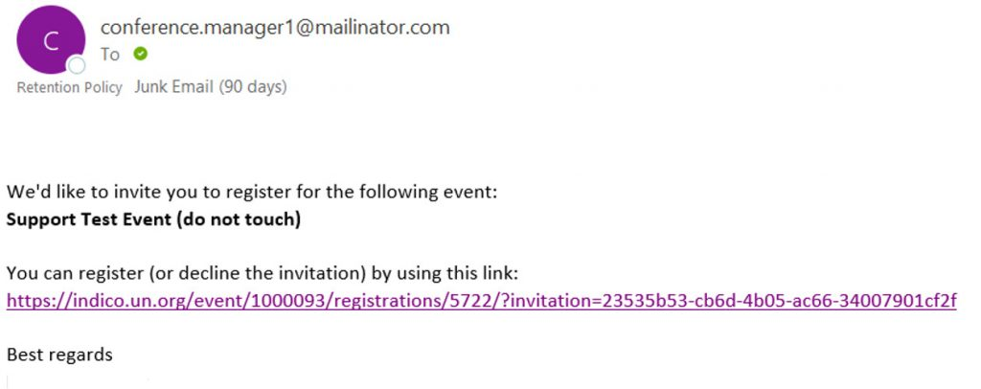
- The invitee has the opportunity to either submit the registration or decline the invitation. If the invitation is declined, the invitee is not prevented from using the link at a later point to submit a registration.
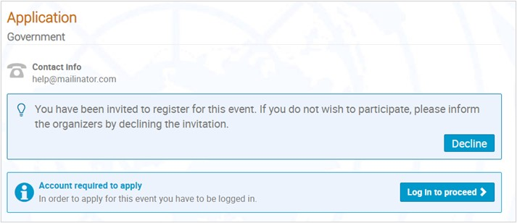
- In the Invitations management area, managers can view the status of invitations sent – those still pending, those accepted and those declined.
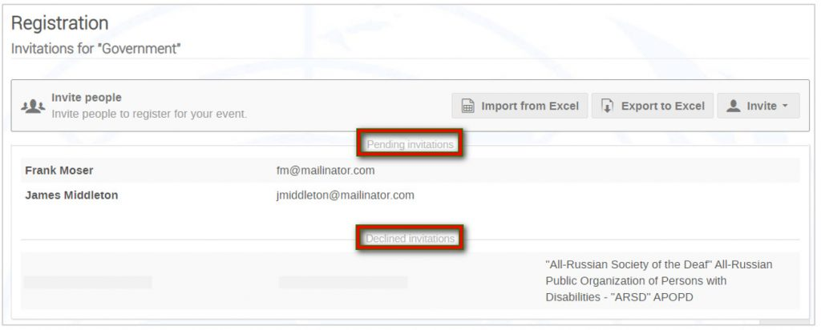

Send an Invitation to a Large Group using XLS
- You can import from xls a large number of invitees. In doing so, the invitation is generated and sent automatically at the time of import (meaning you need to prepare the text of your invitation first if you want it customised).
- The three steps are:
- Prepare the xls
- Prepare the text of the invite
- Perform the import

Prepare the xls File
- In the Invitations management area Export to Excel. This generates a blank xls file into which you add the names and emails of the invitees.
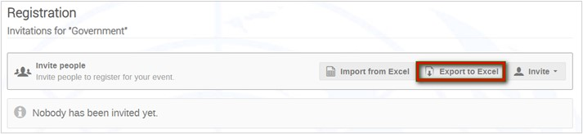

- The mandatory information to be added is:
- First name
- Last name
- Email
- The column Skip moderation MUST contain the value FALSE for each invitee.
- Save the file.

Prepare the Text of the Invite
- In the Email templates module, New to create an invite.
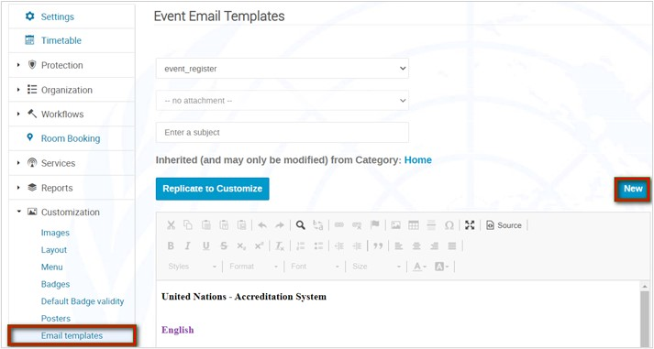
- You must call the invite “invitation”. Give it a subject. Compose the body of the text remembering to include the tag {invitation_link} somewhere. Then Save.
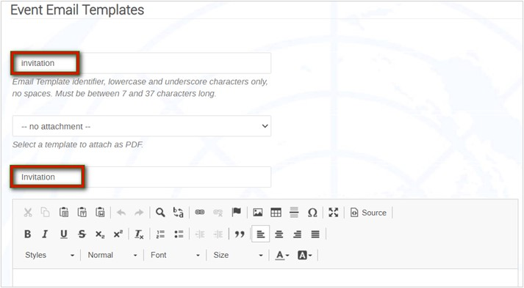

Perform the Import
  - In the Registrations management area Import from Excel.
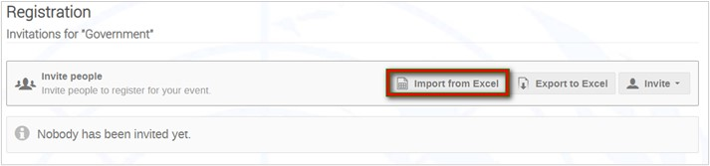
  - Upload the xls file of invitees and follow the steps for the import.
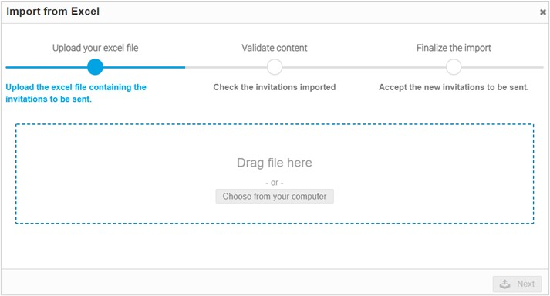
  - If the import notices some errors with the xls it will tell you e.g. if there is an invitee in xls already registered to the event. In this case, abort the import, remove the invitee from the xls and initiate the import again.
  - Once the import has been completed, a confirmation message displays.
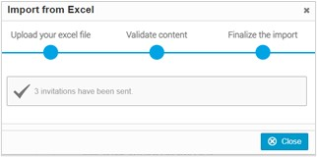

THE REGISTRANT LIST FEATURES

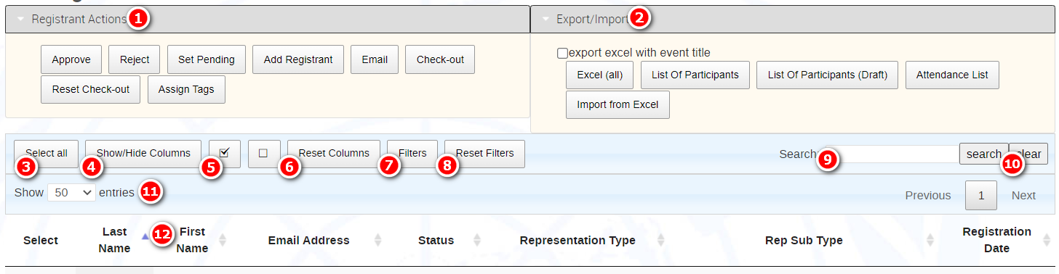

Buttons Explained
1 | 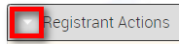 | Expand to view action buttons
2 | 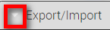 | Expand to view LoP, import, and export functions
3 | Select all | Select all records displayed on the list.
4 | Show/Hide Columns* | Customize the columns on display on the list.  HIGHLY USEFUL TOOL
5 | 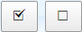 | Select/deselect records displayed
6 | Reset Columns | Restore the columns on display to the default setting
7 | Filters | Apply filters to sort or search through records
8 | Reset Filters | Restore the view to all records and remove the filter
9 | Search | Enter keywords to search for registrants
10 | Clear | Clear the search results
11 | Show xx entries | Select the number of records on display on the list:  10, 50 100, 200, 300, 500 or All
12 |  | Click this arrowhead in any column header to display records either ascending or descending

Select Columns to Display on the List

- For example, display the column “Passport expiration” on the list.

- Show/Hide Columns.
- A menu of the sections on the registration form displays. Since passport information is listed under Personal Data on the registration form, select Personal Data.
- A menu of fields that appear in the Personal Data section displays. Select “Passport expiration” (It turns a darker shade of grey when selected). The column displays on the registrant list.

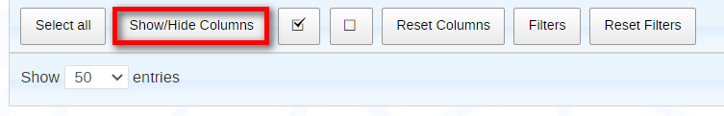
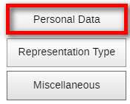
ç These are the sections on the registration form

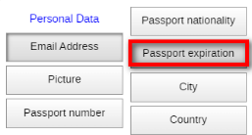
ç These are the fields in the chosen section

- To hide a column, repeat the same steps. When you select the column no longer needed it turns from dark grey to light grey and disappears from the list.

Reset Column View to Default

- To return column view to the default setting Reset Columns.

Move Columns
- Columns may be moved across the list to another location – just click into a column header, drag, and drop the column at a new location.

Filters/ Reset Filters

- Use the filters function to filter out registrants based on a variety of parameters. To clear filter results, Reset Filters.

Search

- Use the search function to find registrants using a variety of values. Search to launch the search and Clear to remove search results.

