Enhance an Event Page

Audience: Managers

Level: Advanced

CONTENT

Insert an Image on an Event Page 1
Add a Logo to an Event Page Header and Remove 2
Add Material to an Event Page 3
Add a File Directly to an Event Page 3
Edit the Name of a File on an Event Page 4
Remove a File from an Event Page 5
Protect a File 5
Create a Folder for Material on an Event Page 6
Add a File to a Folder 7
Protect a Folder 8
Links 9
Customize the Menu on an Event Page 10
Add a New Item to the Menu 11
Add a URL to the Menu 12
Create a Timetable 14
Step 1: Create Sessions 14
Step 2: Add Session Blocks (agenda items) 15
Modify Timetable 16
Event Page Layout 17
Layout options explained 18
Enable the UN Event Pass 19
Reminders 21

Insert an Image on an Event Page
- Under Customization select Images. Drag or upload the image file and then Upload. The file is added under Existing Images and a confirmation message appears.
- the link icon in the bottom-right corner of the image. A URL link to the image is copied to the clipboard.

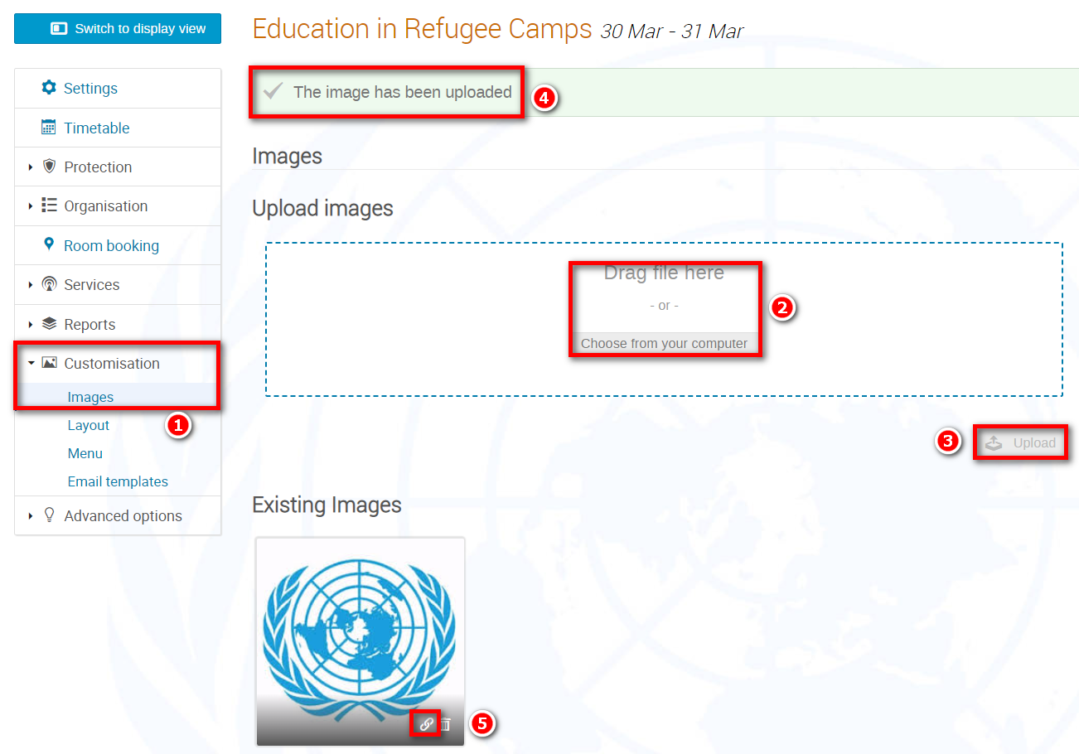

- Go to the Settings module. In the home page section the pencil. In the Description window the image icon.

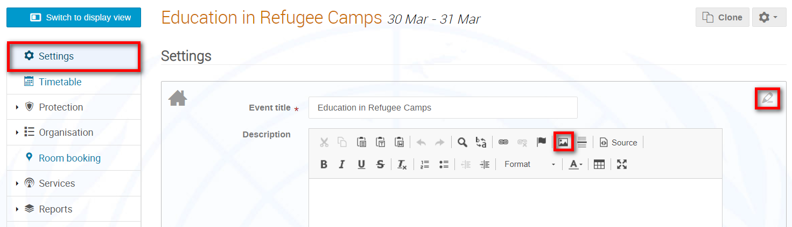

- The Image Properties window opens. Right- into the URL field and select paste. The URL link to the image is pasted into the field. Adjust the width and height if need be to resize the image. OK and then Save.
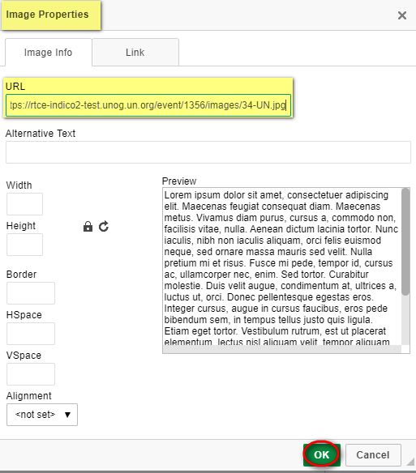

- Check the event page to ensure the image appears correctly.

Add a Logo to an Event Page Header and Remove
- Under Customization select Layout and scroll to bottom of the Layout window to the section Event Logo.
- Choose an image and Upload logo. A message appears on-screen to confirm the new logo. Go back to the event page and check the logo appears in the header correctly.
- To remove the logo Delete.
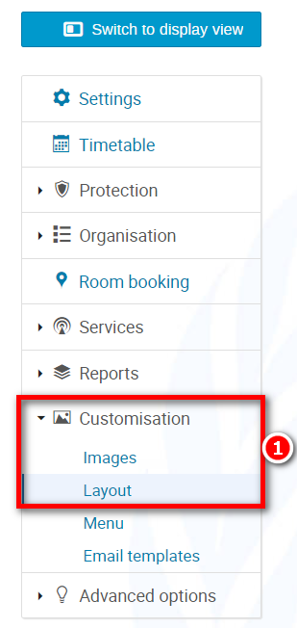
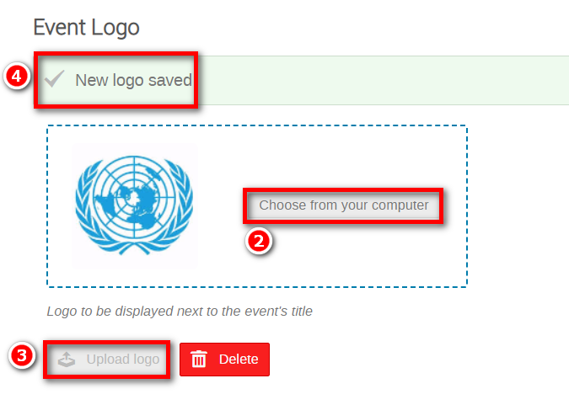

Add Material to an Event Page

Add a File Directly to an Event Page
- In the event management area select Materials and in the Materials window Upload files.

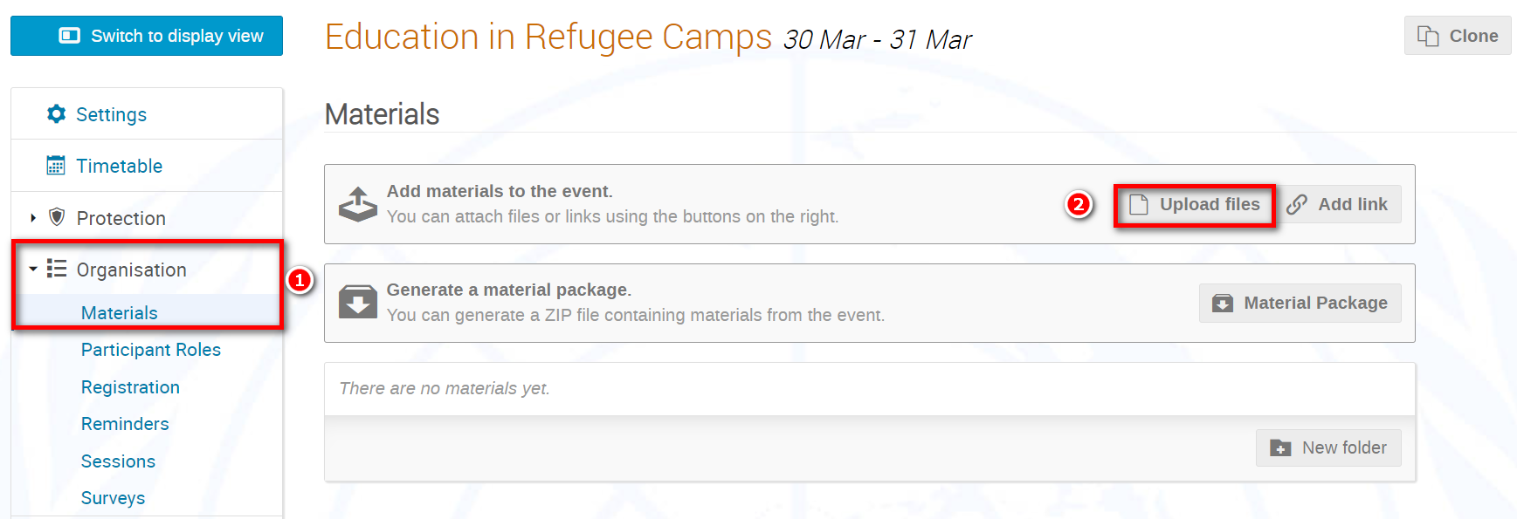

- In the Upload files window, select the material and Upload.

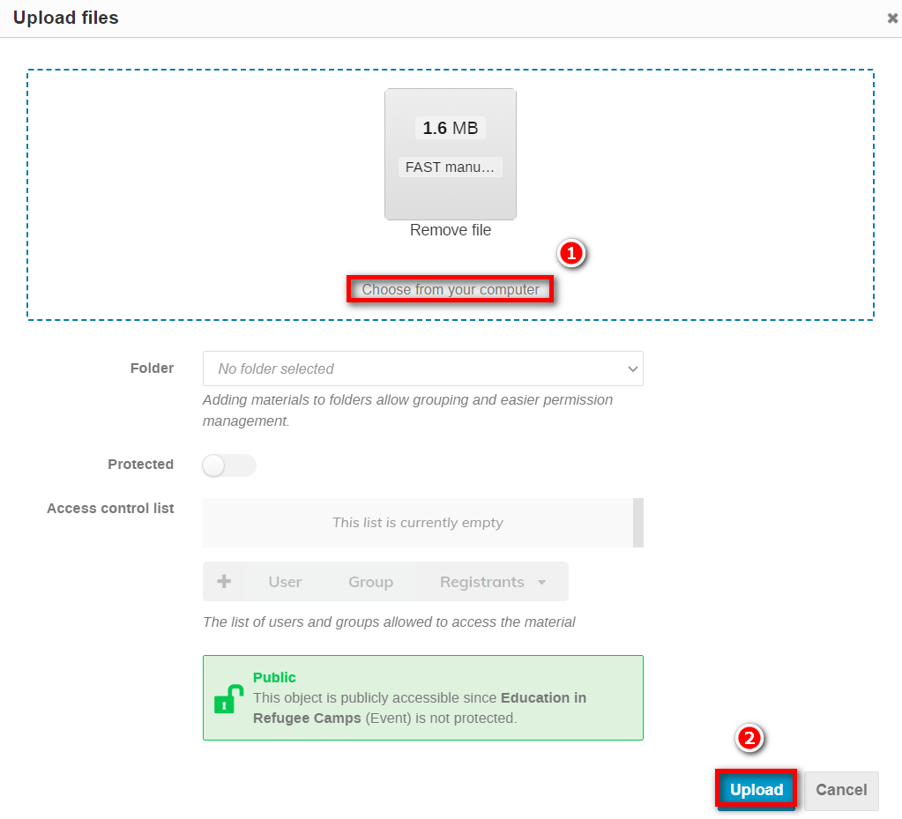

- A message appears on-screen confirming that the file has been uploaded.

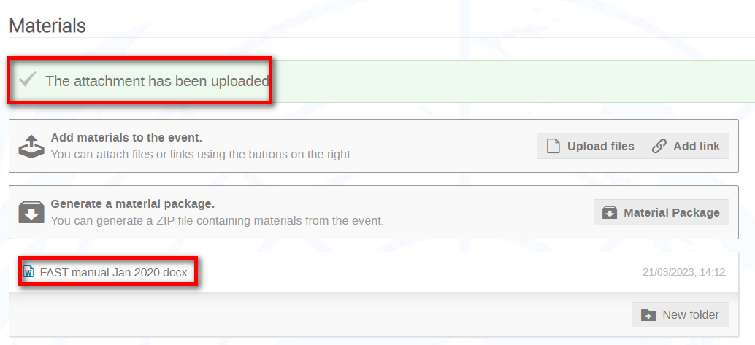

- Switch to the event page to check the file is present.

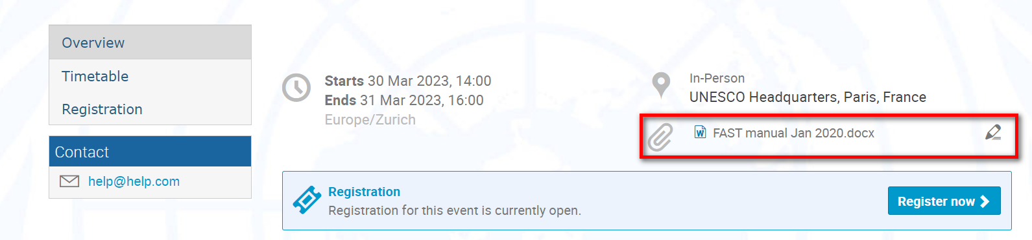

Edit the Name of a File on an Event Page
- In the event management area and in the Materials window, to change a material’s name from e.g., “FAST manual Jan 2020.docx” to “FAST manual Jan 2020” on an event page, the pencil icon.

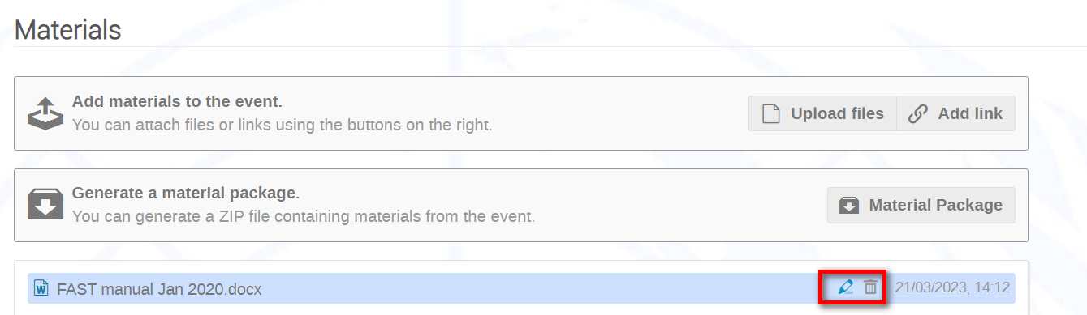

- In the Edit window modify the Title field. Save the change. A message appears on-screen confirming the change.

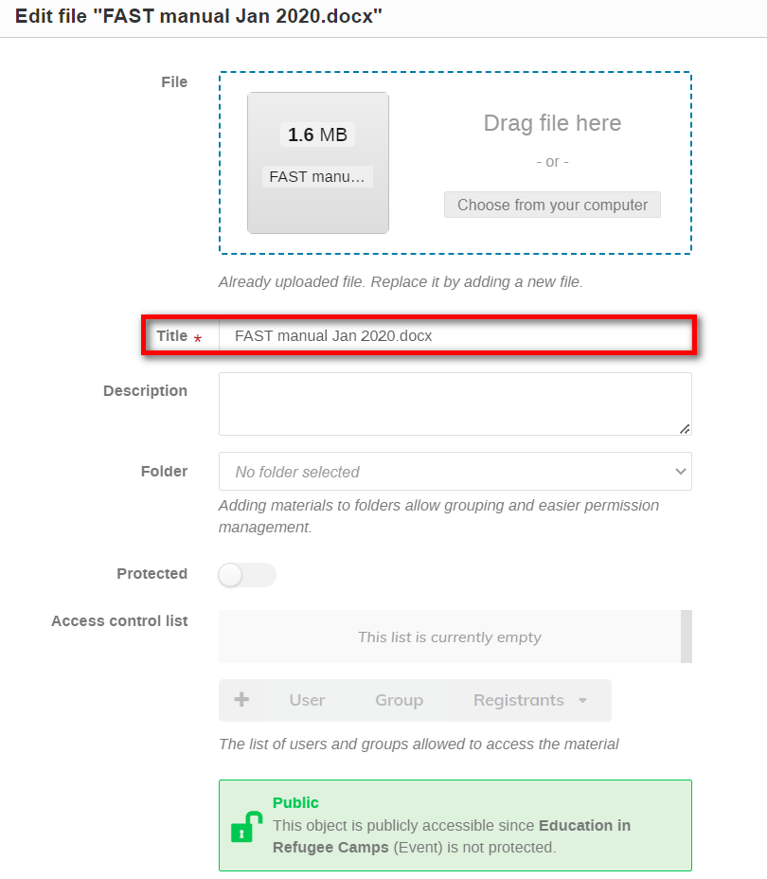

Remove a File from an Event Page
- In the event management area and in the Materials window the trashcan icon beside the file to remove form the event page. You will be asked to confirm the removal.

Protect a File
- If a file posted directly to a page (or in a folder) is to be accessed by only certain persons, then set it as Protected (either at the moment of upload or, if already uploaded, edit it).
- Search for and place users on an access control list. Only these persons will have access to the file.
- Protected items are indicated by a padlock
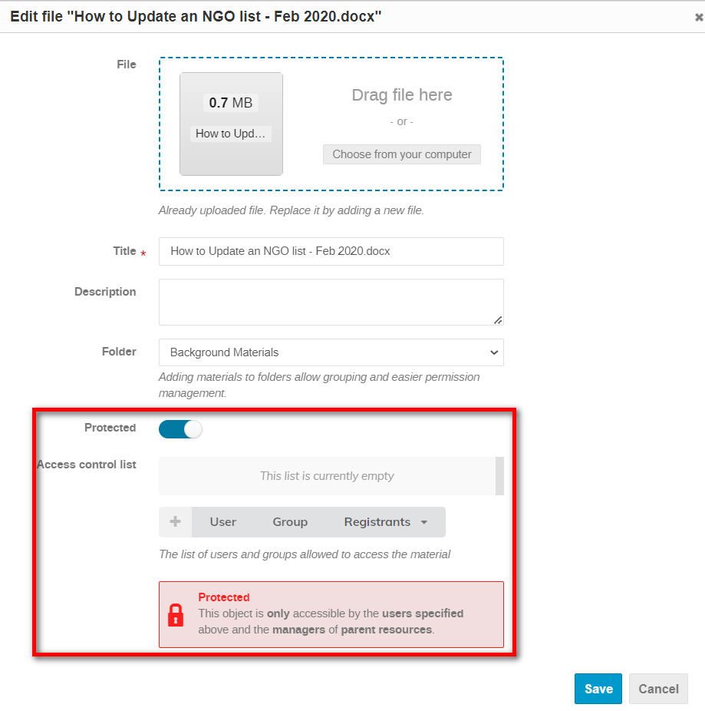

Create a Folder for Material on an Event Page
- In the event management area and in the Materials window, New folder.

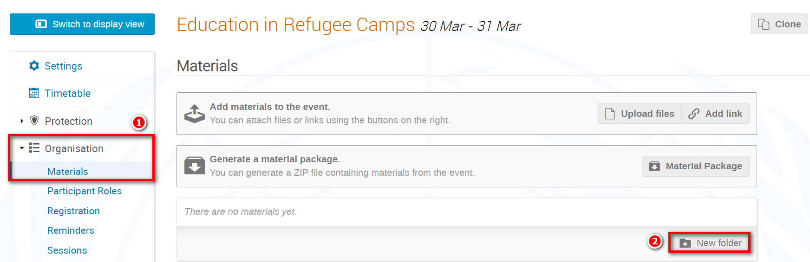

- In the Create a new folder window, enter a name for the folder and Submit.

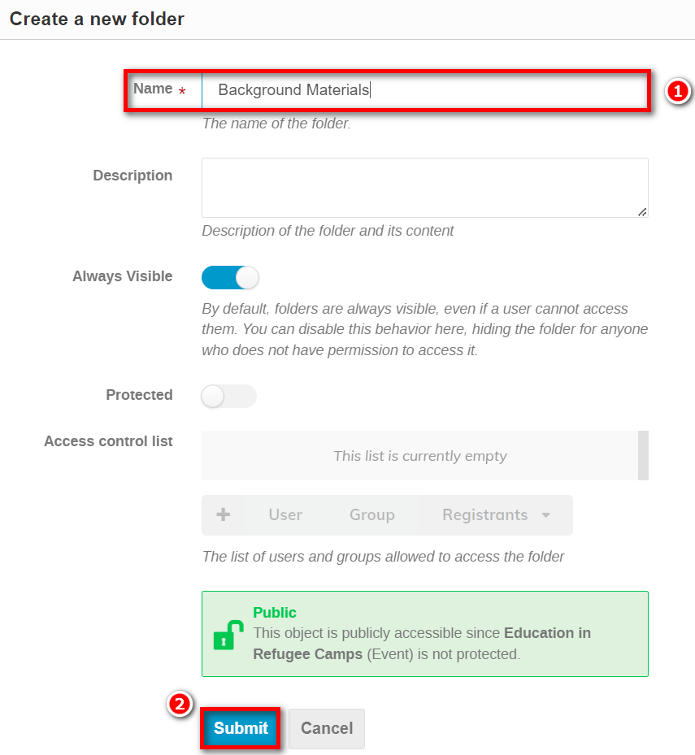

- A message appears on-screen to confirm that the folder has been created. As soon as you add material to the folder it will appear on the event page.

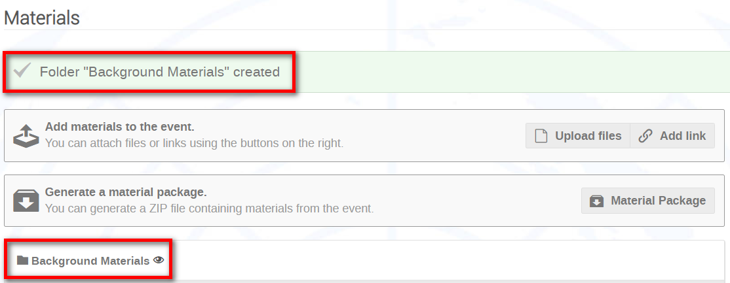

Add a File to a Folder
- At the point of upload, expand the Folder menu and select the folder the file is to be placed into. Upload.

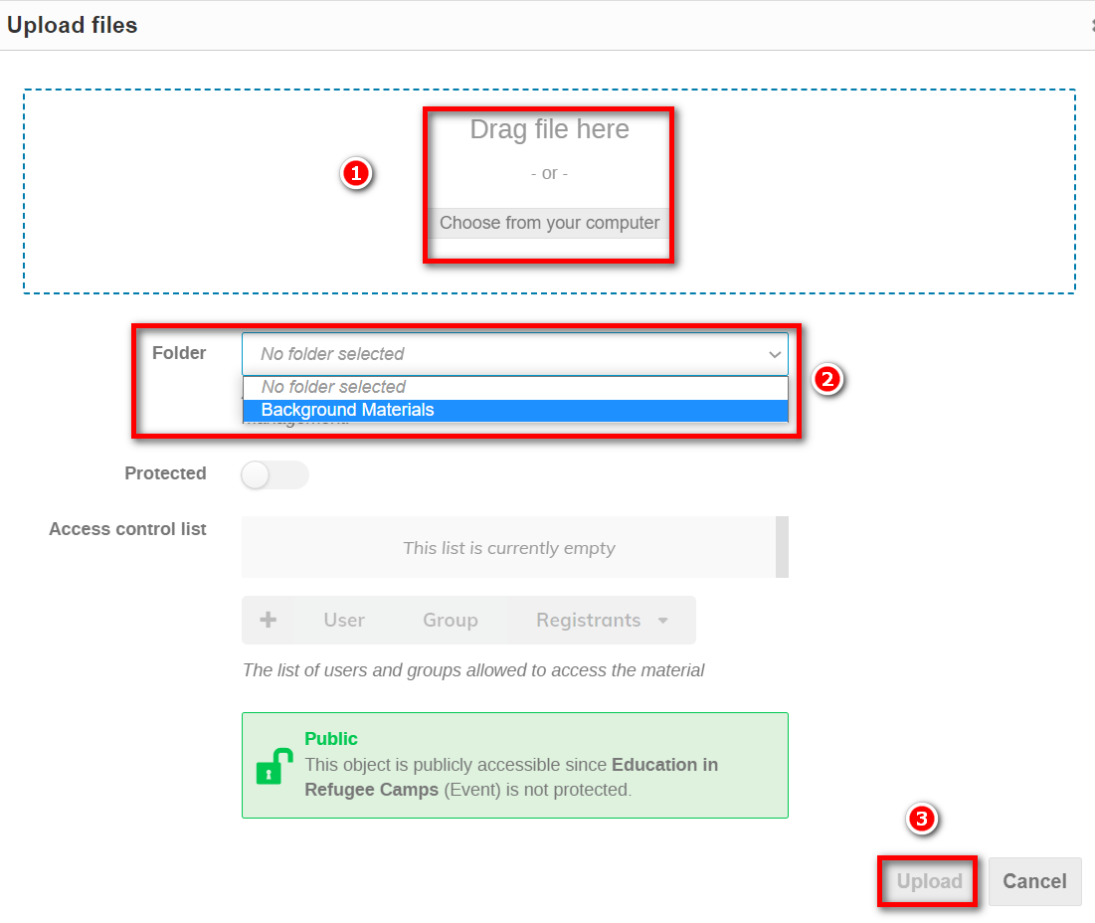

- A message appears on-screen confirming that the file has been uploaded and is listed in the selected folder.

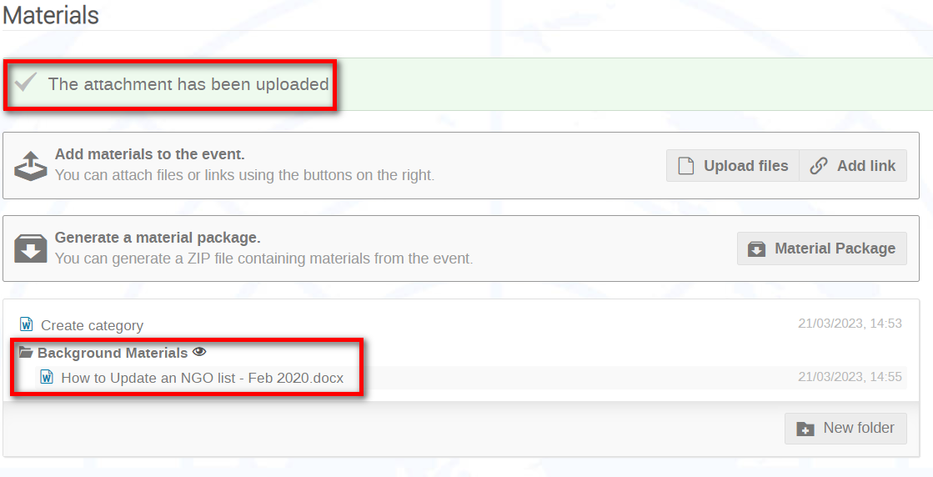

Protect a Folder
- If a folder is to be accessed by specific persons only, then set it as Protected (either at the moment of creation or, if already created, edit it).
- Search for and place users on an access control list. Only these persons will have access to the folder and its content.
- Protected items are indicated by a padlock.

NOTE:
- When a folder is protected, ALL its content inherits the protection too.
- If you do not want ALL a folder’s content to be protected, then do not apply protection at the level of the folder but rather at file level.

Links
- You manage links in the same way as files - they may be posted directly to a page or added to a folder and protected if necessary.
- In the Materials window click Add link.

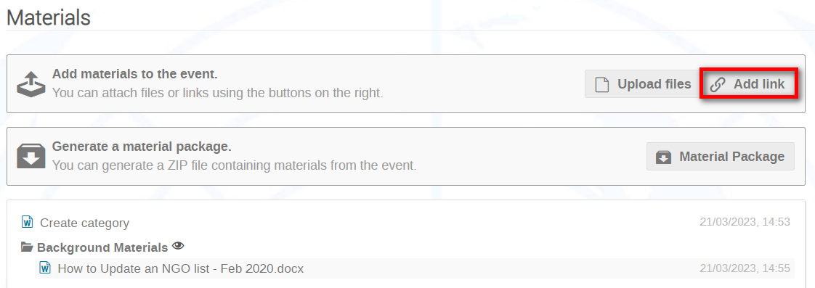

- In the Add link window enter the URL of the link and the title of the link as you want it to appear. If the link is being placed in a folder, select the folder. Add protection (if necessary) in the same way as for files. Submit. A message appears on-screen to confirm that the link has been added in the same way as for files.

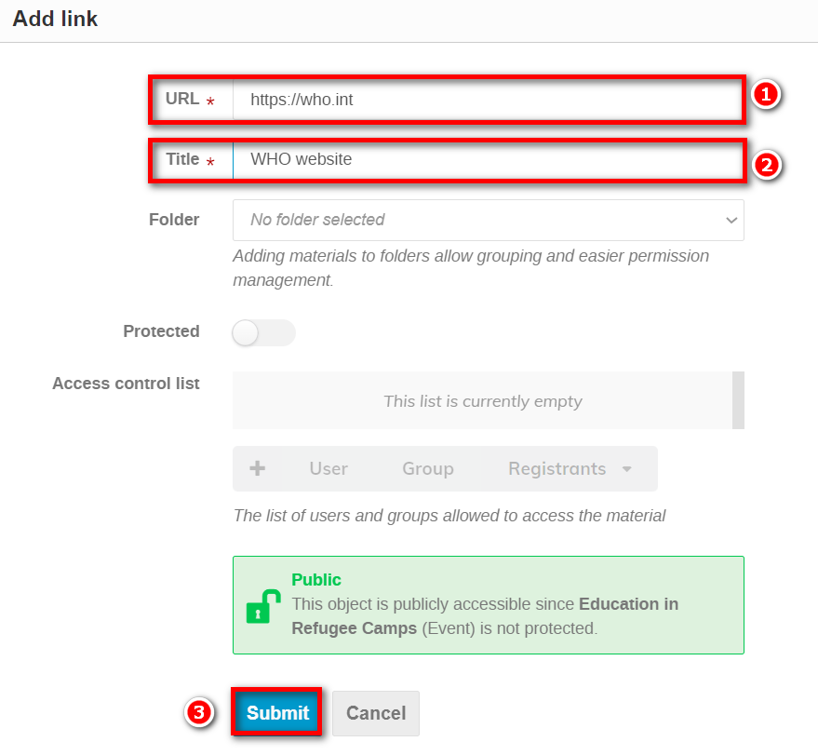

Customize the Menu on an Event Page
- Under Customization select Menu. Enable menu customization by toggling the button to the ON position.

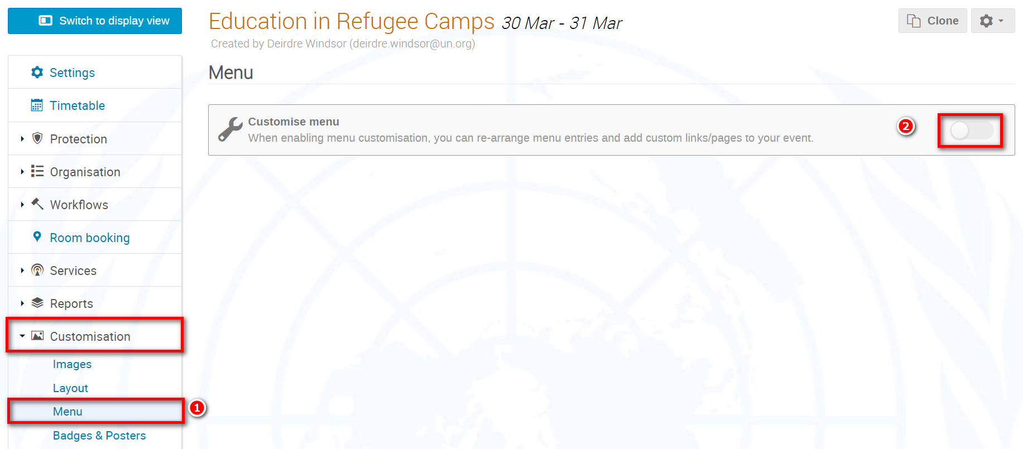

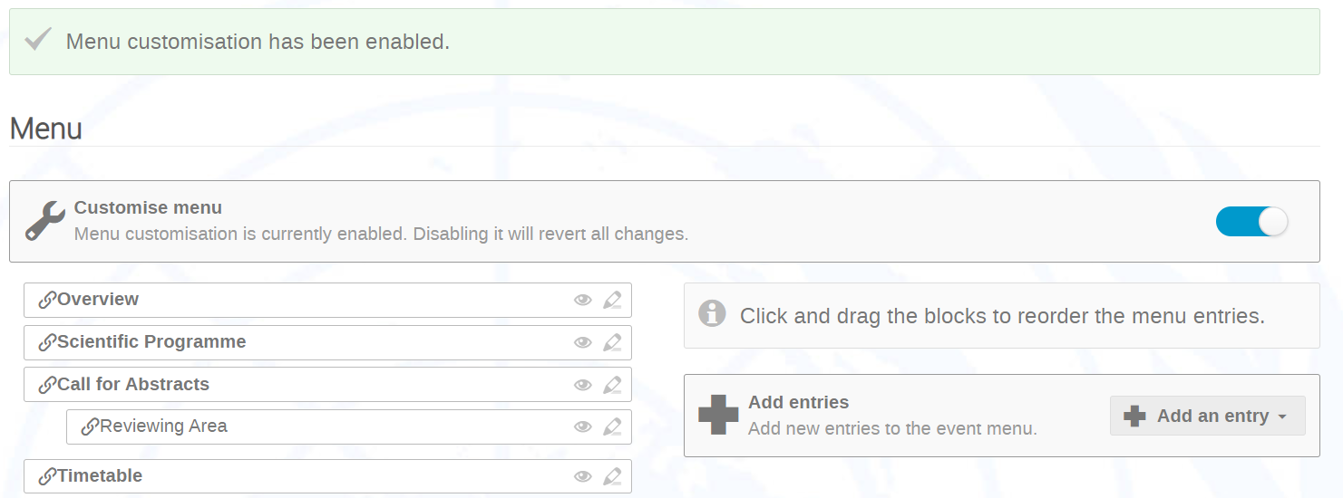

Icons Explained

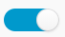 | Enabling this button permits customization. If disabled, the menu reverts to the default setting and will PERMANENTLY DELETE all menu customizations you have made including custom pages.
 | Indicates that a menu entry is enabled on the menu. to disable the entry
 | Indicates that a menu entry is disabled on the menu. to enable the entry.
 | Edit the title of a menu entry on the menu
 | Add a new link, a page, or a spacer to the menu

- You may click, drag, and drop a menu option on the list to re-arrange the order.

Add a New Item to the Menu
- Add an entry and select from the drop-down menu Add page.

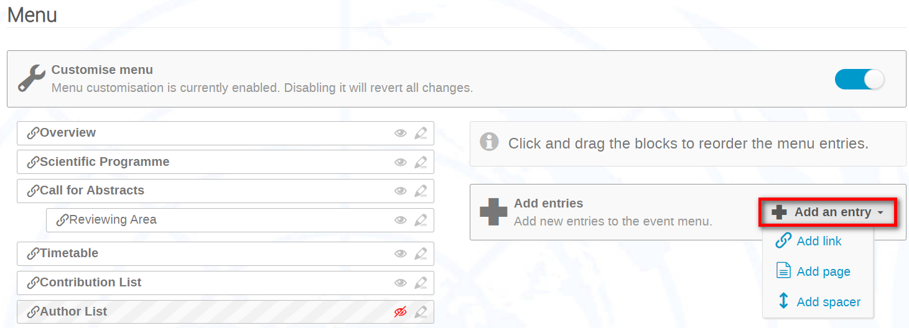

- In the New Page window, give the page a title and add content.

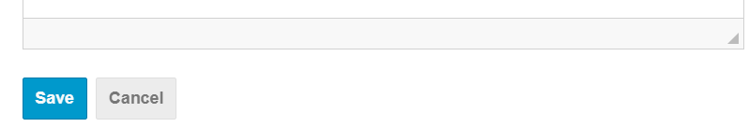
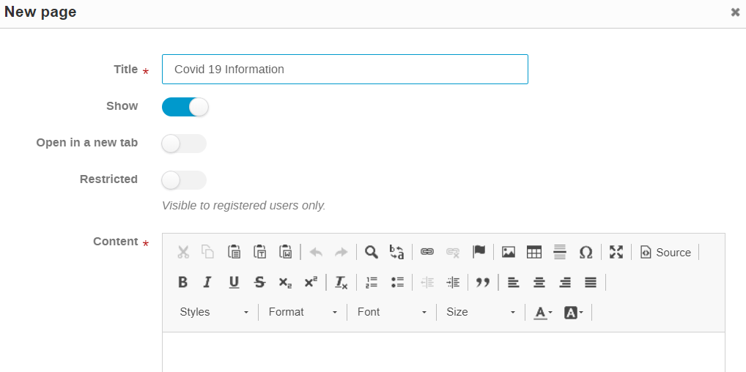

- Enabling Show will display the new page on the menu. Disabling it will conceal it from the menu only, it won’t delete it.

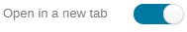
- Enabling Open in a new tab will open the new page in a new tab in your browser when it is clicked in the menu. If left disabled, the new page will open in the same tab in your browser you are currently in.

- 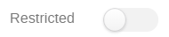 Enabling Restricted limits access to the page to persons registered to the event only.

- Save when you are finished configuring the new page.
- The new page displays on the menu. Check that it displays also on the menu on the event page.

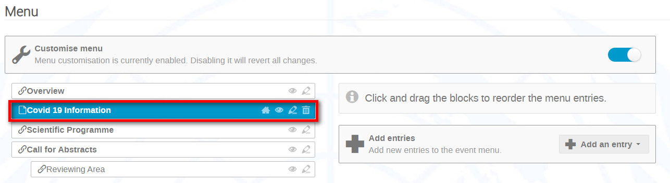

Add a URL to the Menu
- Add an entry and select from the drop-down menu Add link.

- In the New link window, give the link a title.

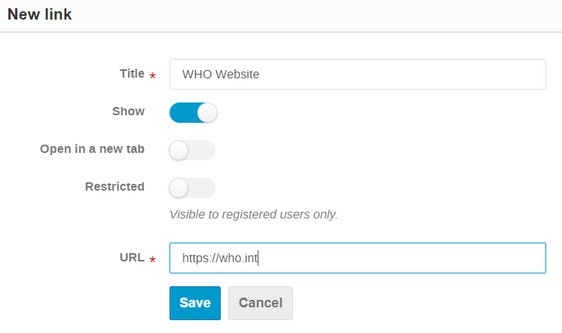
- Enabling Show will display the new link on the menu. Disabling it will conceal it from the menu only, it won’t delete it.

- Enabling Open in a new tab will open the new link in a new tab in your browser when it is clicked in the menu. If left disabled, the new link will open in the same tab in your browser you are currently in.

- Enabling Restricted limits access to the link to persons registered to the event only.

- URL: enter the URL of the site that the link directs the user to.

- Save when you are finished configuring the new link.

- The new link displays on the menu. Check that it displays also on the menu on the event page.
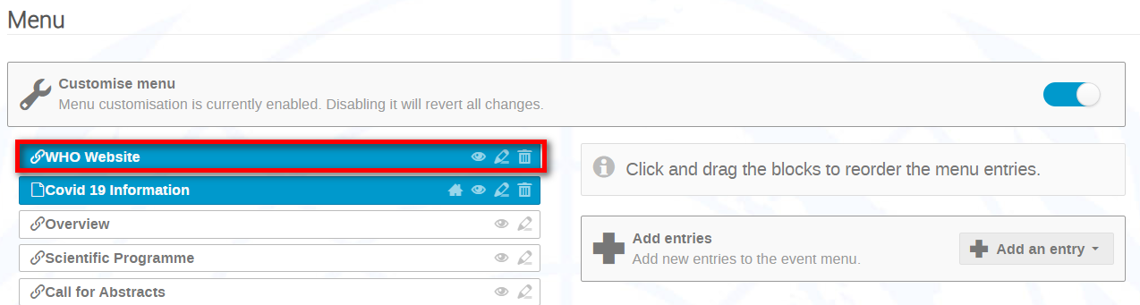

Create a Timetable
The following demonstrates how to set up a timetable for a given day.

Step 1: Create Sessions
- Under Organization select Sessions. In the Sessions window Add new session.

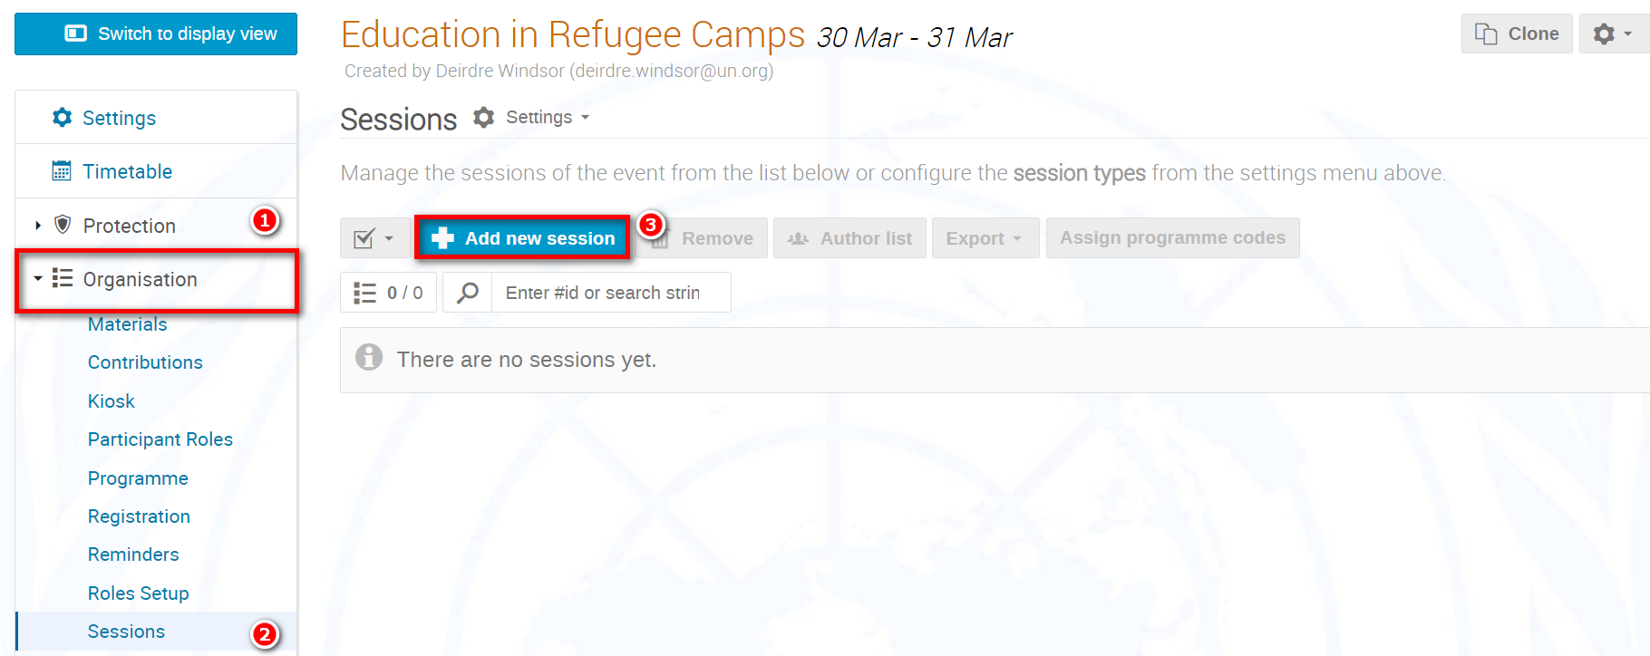

- In the Add new session dialogue box enter a name for the session i.e., Morning and Save.
- Repeat the same to create an Afternoon session.

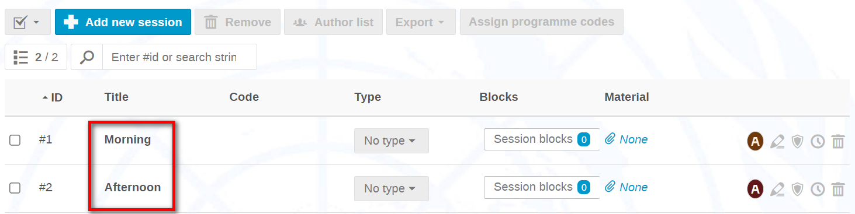

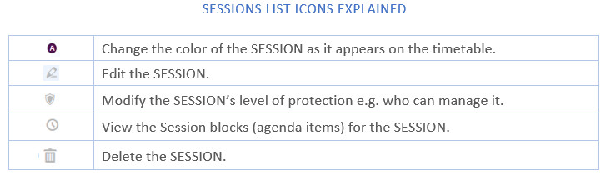

Return to Timetable.

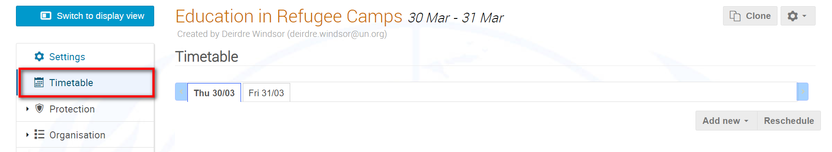

Step 2: Add Session Blocks (agenda items)
- Timetable and in the Timetable window select the day you are creating a timetable for.
- Add new and select Session block.

- Select Morning (because you want to add timetable items for the morning).

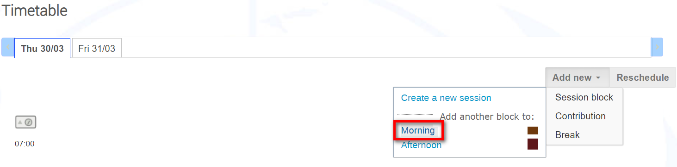

- In the Add session block window, enter a title for the item, the start time, and the duration. Save.

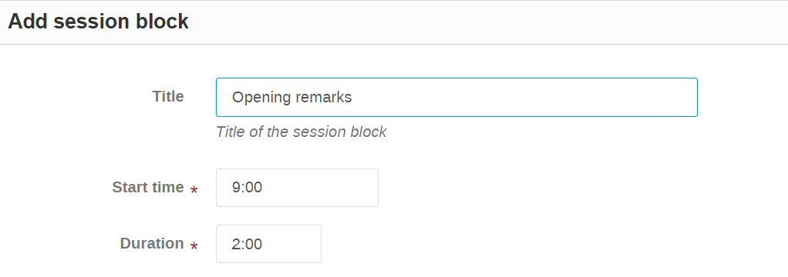

- Repeat each item taking place during the Morning session.
- For breaks e.g., Lunch, use the Add New – Break option.
- For the afternoon’s timetable, repeat paras.2 to 4 but this time selecting the session Afternoon.
- The following screenshot demonstrates a timetable where agenda items have been added for a morning and an afternoon session.

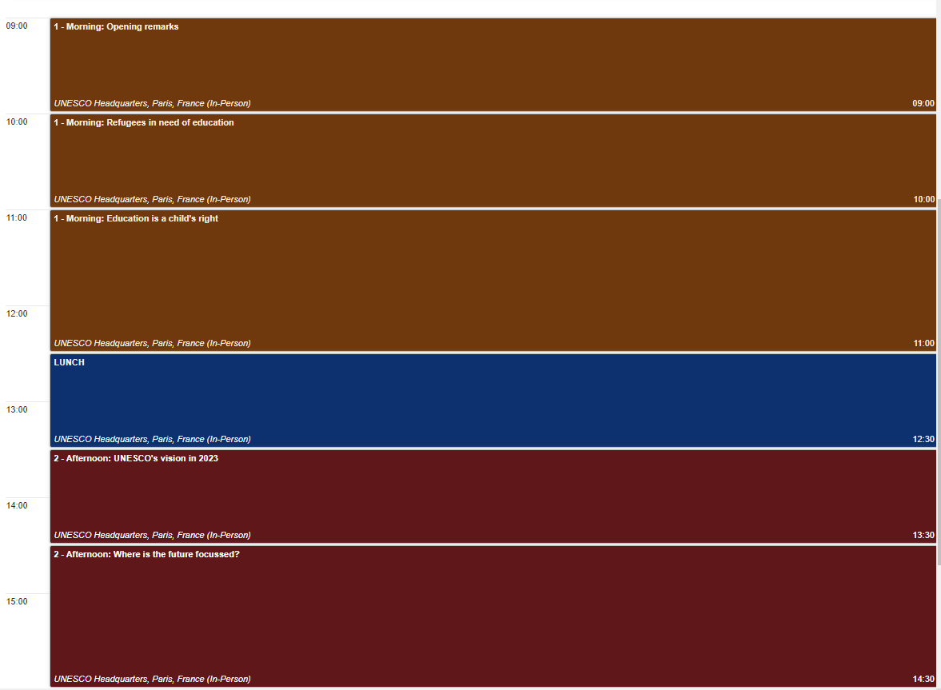

Modify Timetable
- Click into a timetable entry.

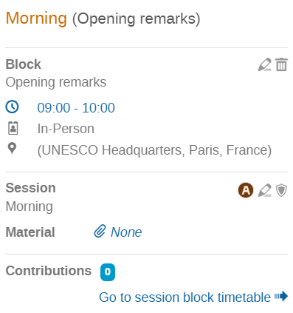
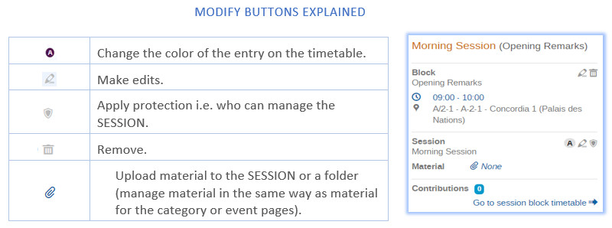

Event Page Layout
- Use the Layout module to modify the look of an event page.
- In the management area under Customizaton select Layout.

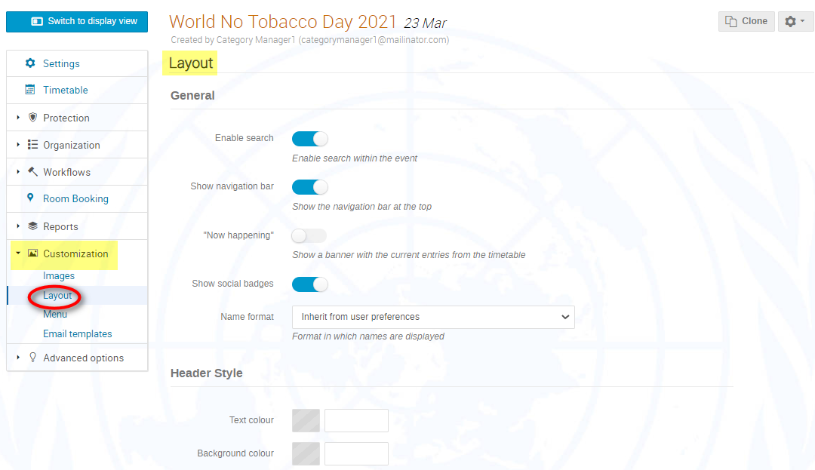
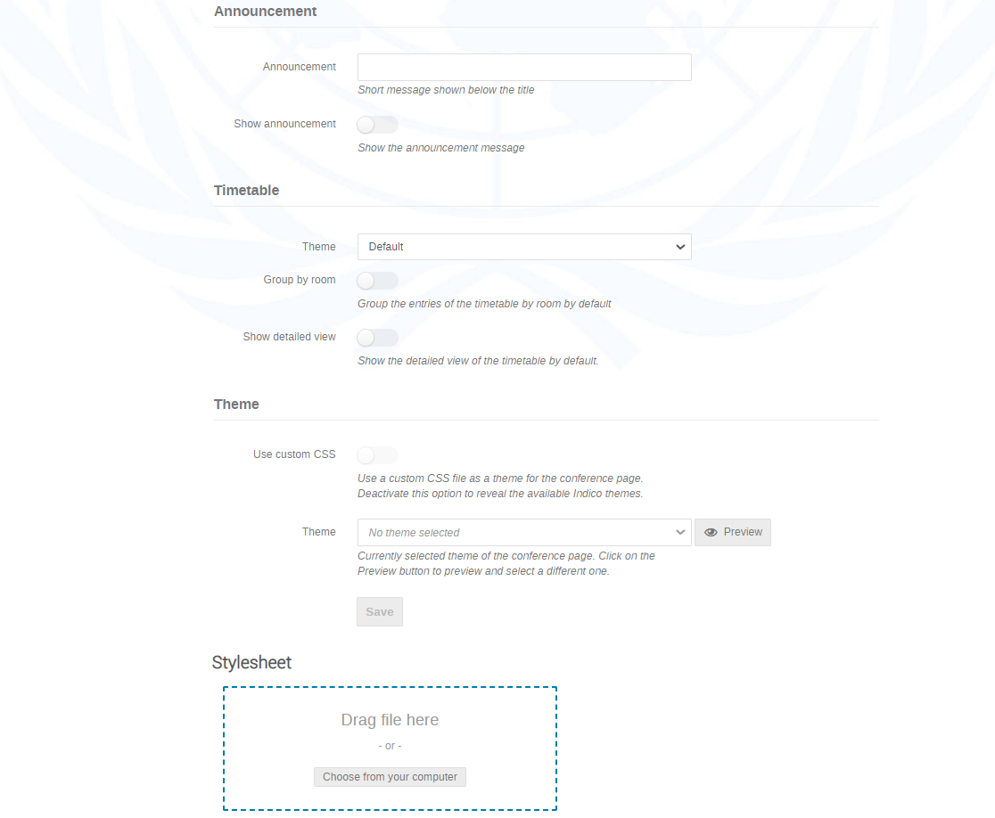

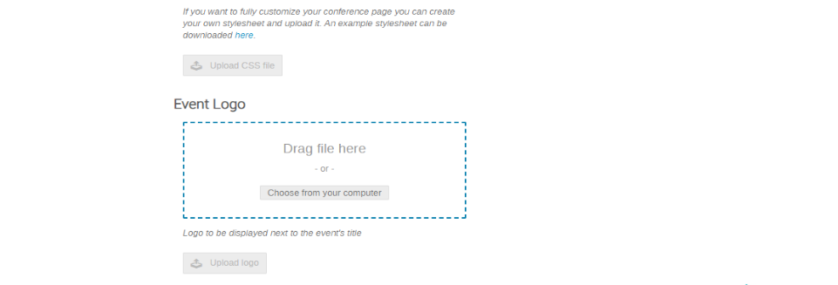

- If you make any modifications, don’t forget to look for the message on-screen Do not forget to save your changes! and click SAVE NOW.

Layout options explained

GENERAL
Enable Search | Enable a search field for use within an event.
Show Navigation bar | Display the navigation bar at the top of an event page.
Now Happening | Display current events.
Show social badges | NA
Name format | Format in which names are displayed.
HEADER STYLE
Text color | Change text color in the event page header.
Background color | Change background color of the event page header.
ANNOUNCEMENT
Announcement | Enter a short message to display on the event page under the header.
Show announcement | Toggle on or off the announcement text.
TIMETABLE
Theme | Select a theme for the timetable.
Group by room | Display the timetable by room.
Show detailed view | Toggle on or off a detailed view of the timetable.
THEME
Use custom CSS | Toggle on to use your own custom CSS for the event page or off to revert to the default Indico style.
Theme | Option to select a theme for the event page.
STYLESHEET | Upload here a stylesheet for the event page.
EVENT LOGO | Upload here a logo that appears in the heading on the event page.
LIST OF PARTICIPANTS TEMPLATE | If you want to customize the List of Participants you can create your own template and upload it. The default template can be downloaded from here.
EXCEL IMPORT DEFAULT PICTURE | If you are using the import from excel functionality to add individuals to the registrant list, you may upload a generic picture here that will be added to each of the imported registrant profiles.

Enable the UN Event Pass
- In the management area under Organization select Registration.
- In the Registration window click Manage beside the registration form to manage.

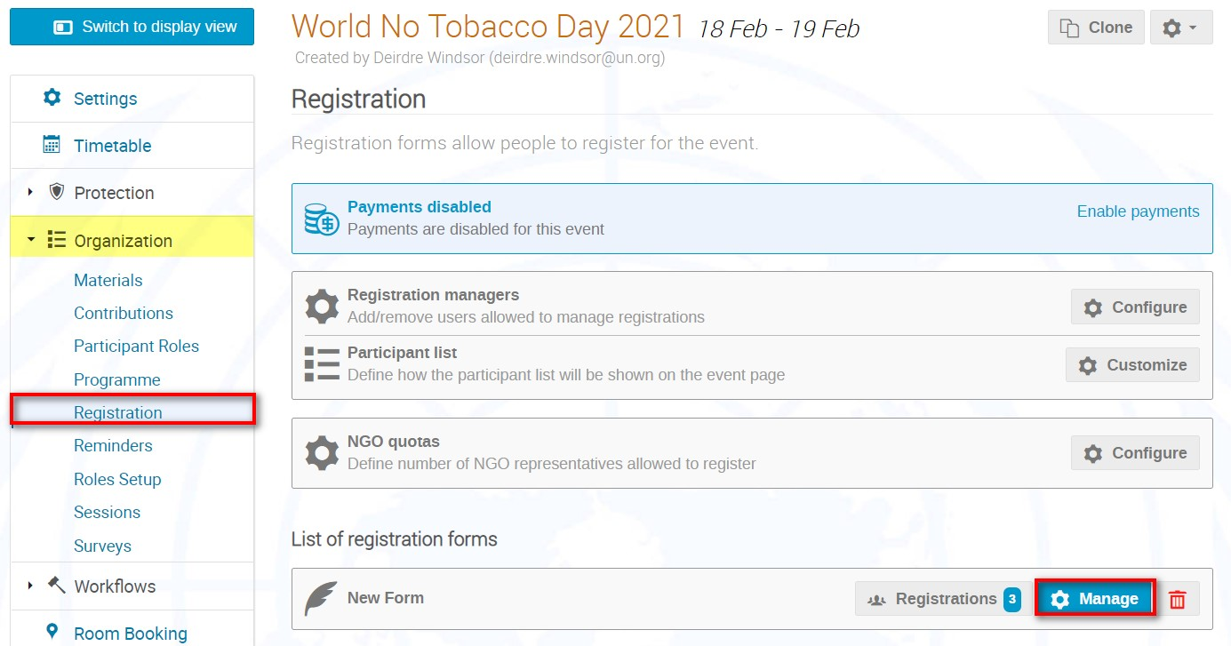

- In the management area of the registration form beside UN Event Passes click Configure.

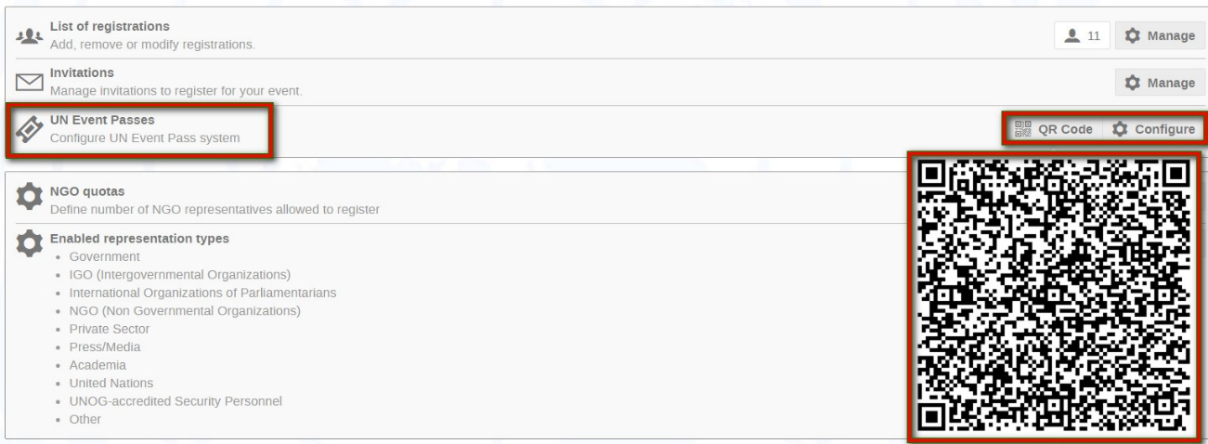

- In the Configure UN Event Passes window toggle Enable UN Event Passes to the ON position which will generate a UN Event Pass for your event. Then toggle whichever option you would like the UN Event Pass to be obtained – attached to an email, downloadable from the event page or downloadable from the registration summary.
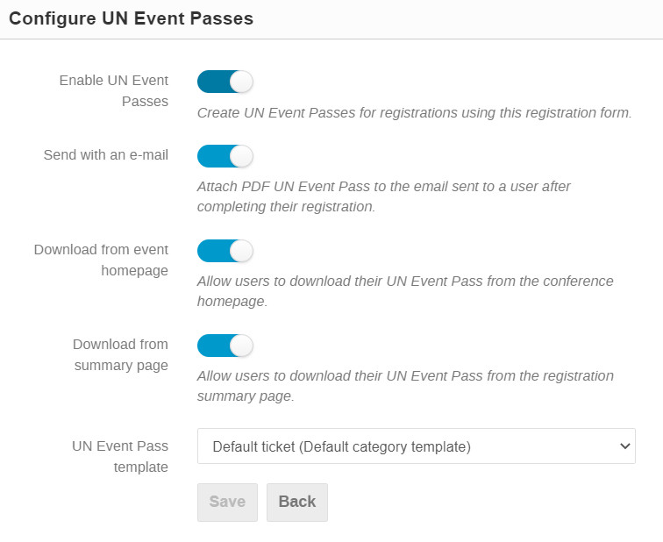

Reminders
- You may send a reminder concerning the start of the event either relative to the event start time, on a fixed date/time or immediately.
- Under Organization – Reminders Add Reminder.
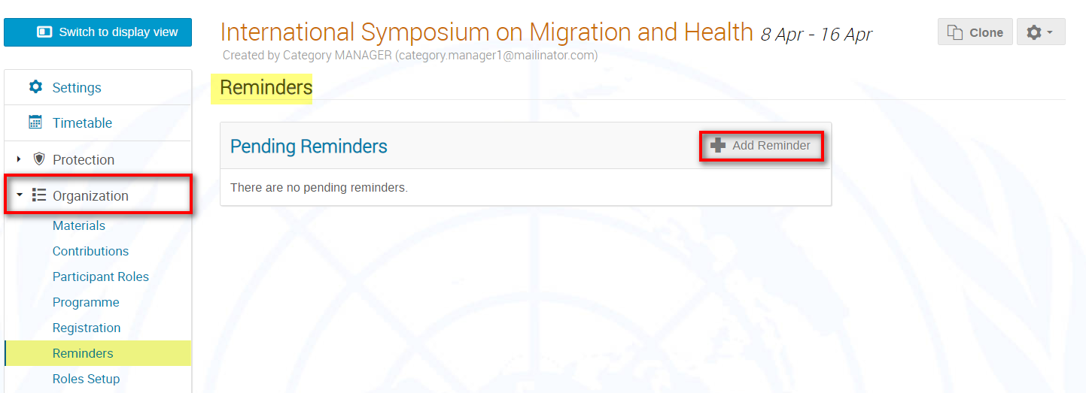

- Check the box Participants if the reminder is destined for all participants of the event.
- You may also type emails in the relevant box - enter one email address per line, no separators are allowed.
- Select who the sender is. Use the Note box if you would like to add some information for the participants. You may decide to include the event’s agenda by checking Include Agenda or an iCalendar file.
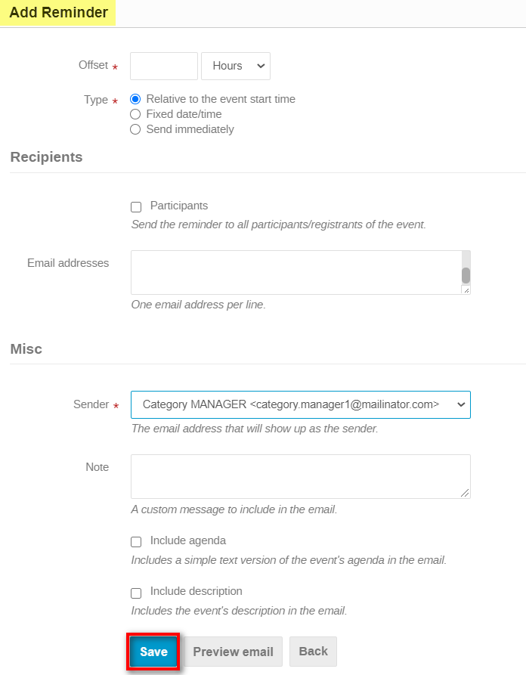
- Preview email to view the email and if happy Save.
