Email Templates

Audience: Managers

Level: Advanced

CONTENT

Create an Email Template 1
Customize a System Email e.g., Approval for an Event 2
Revert to a System Email 3
Prepare an Email with Accompanying Attachment 4
Step 1: Create the attachment 4
Step 2: Create the cover email and marry the attachment to it 5

You may create your own email templates at either the category or event level. If created at category level, events within the category will inherit them.

Create an Email Template
- Under Customization Email templates and then New.
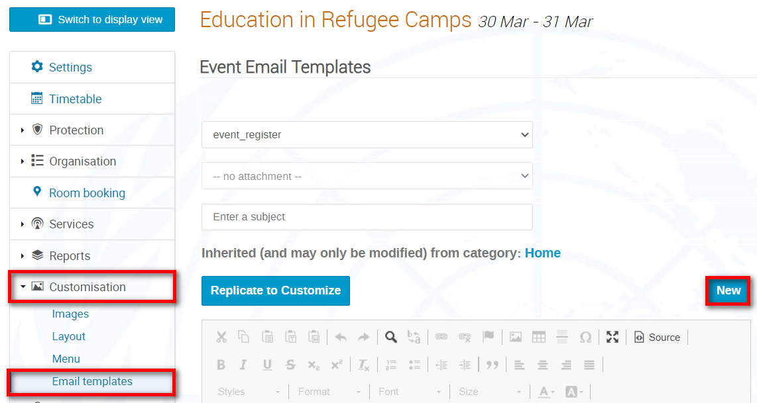
- Give the email a name (lowercase and underscore only). Compose it in the email window. Use placeholder tags (copy and paste) as appropriate to help personalize the email and pull information on registrants and/or the event you want to feature in the email.
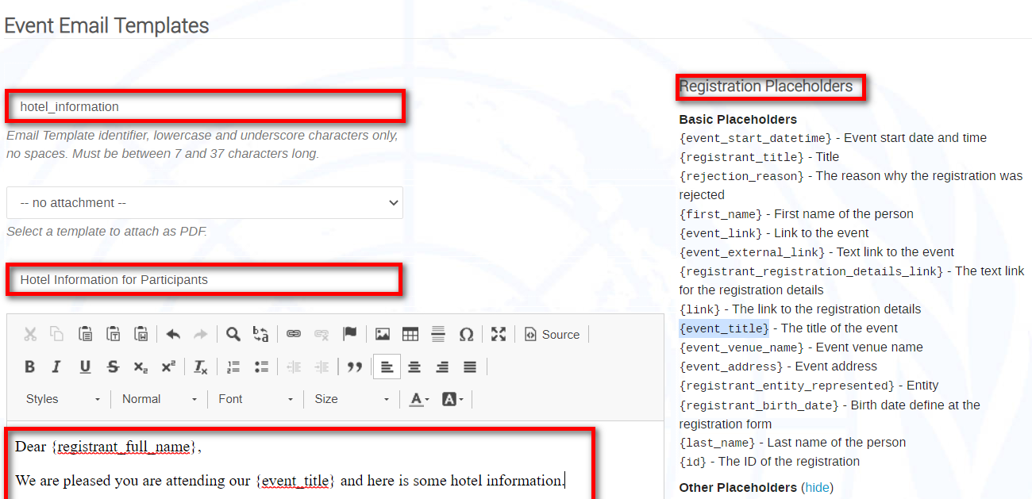
- When finished Save at the bottom of the email. A message appears on-screen that the template has been created successfully and the template is added to the list available for use.

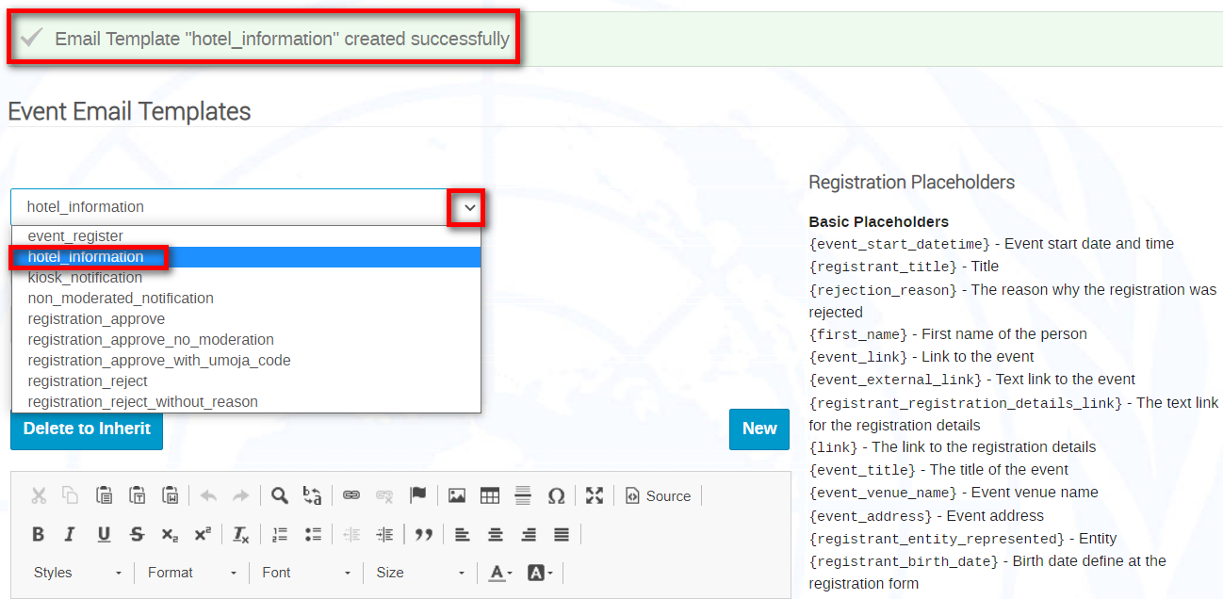

Customize a System Email e.g., Approval for an Event
- Select from the drop-down menu the system email to customize and Replicate to Customize.
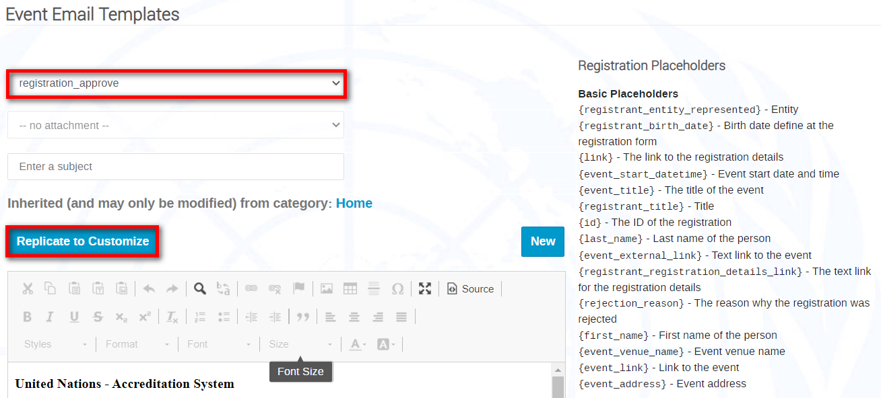
- A message appears on-screen that the template has been replicated successfully.
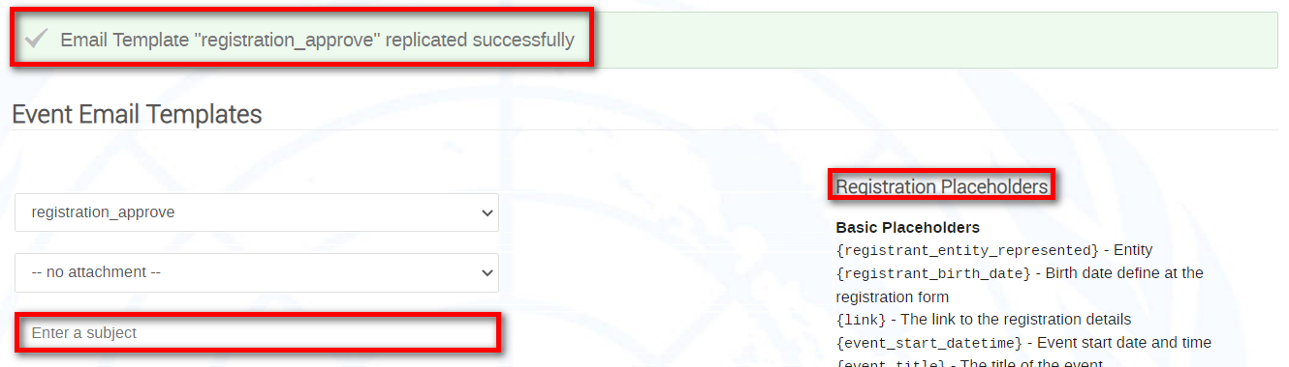
- Proceed to make your customizations. When finished Save at the bottom of the email. A message appears on-screen that the template has been saved successfully. It now replaces the system Approval email.
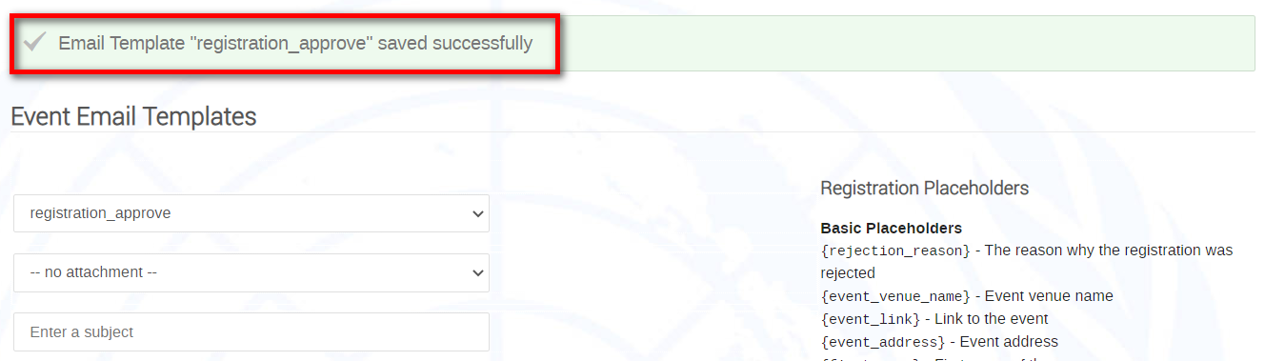

Revert to a System Email
- Should you wish to reinstate a system email, from the drop-down list select the customized email you no longer wish to use and Delete to Inherit.
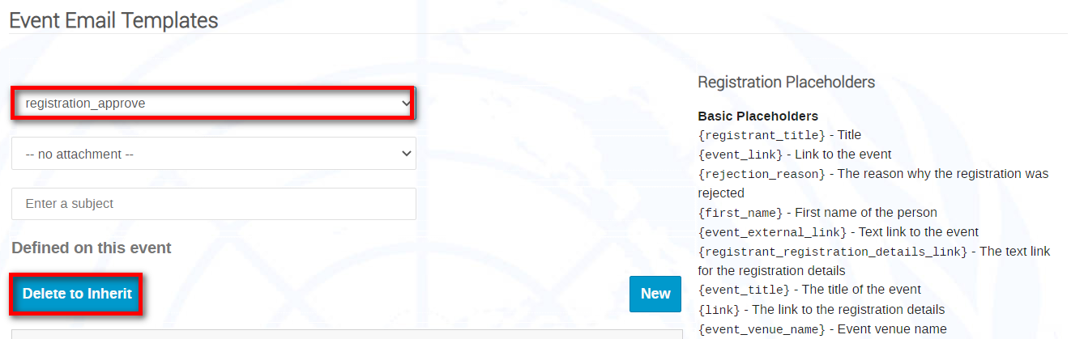
- A message appears on-screen to confirm the deletion. Ok.
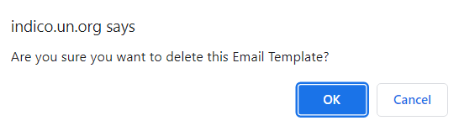
- Another message appears on-screen to confirm the deletion.
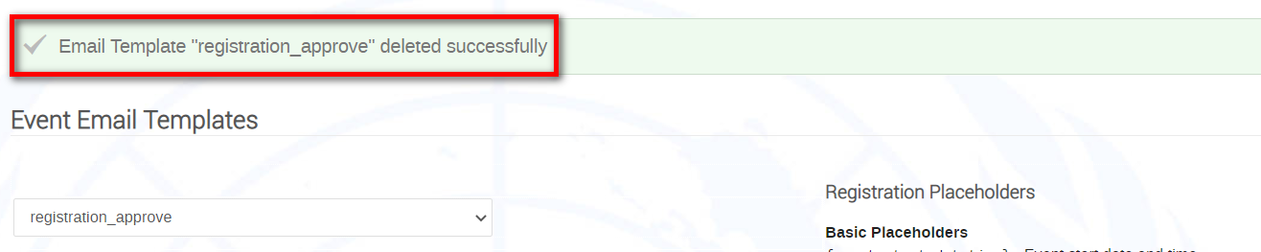

Prepare an Email with Accompanying Attachment

Steps are:
- Create the attachment (i.e., what is to be sent as a PDF attachment to an email).
- Create the cover email …. then marry the attachment to it.

Go to the management area of the category. Click Email templates.
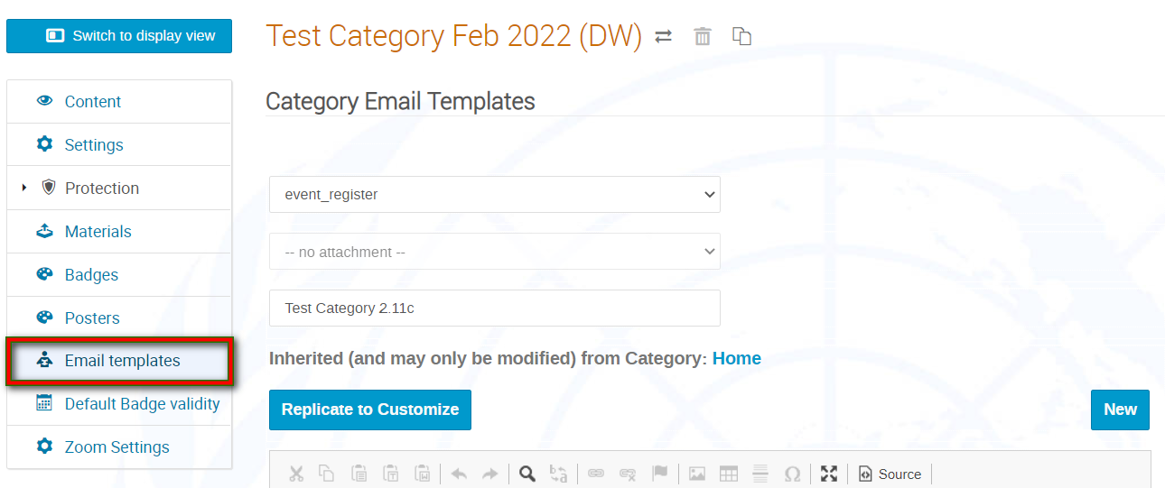

Step 1: Create the attachment
- Under Customization Email templates and then New.

- Give the attachment a name, a subject and proceed to compose it. When naming it, it is advised to include “attachment” or “att” e.g., “logistics_information_att” so that it is clear it’s an attachment. The same applies when giving it a subject. Feel free to copy and paste placeholders into the body of the text.

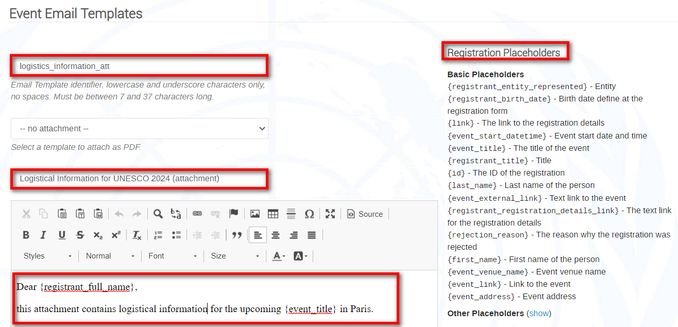

- After composing, Save. A message appears on-screen confirming creation of the attachment.

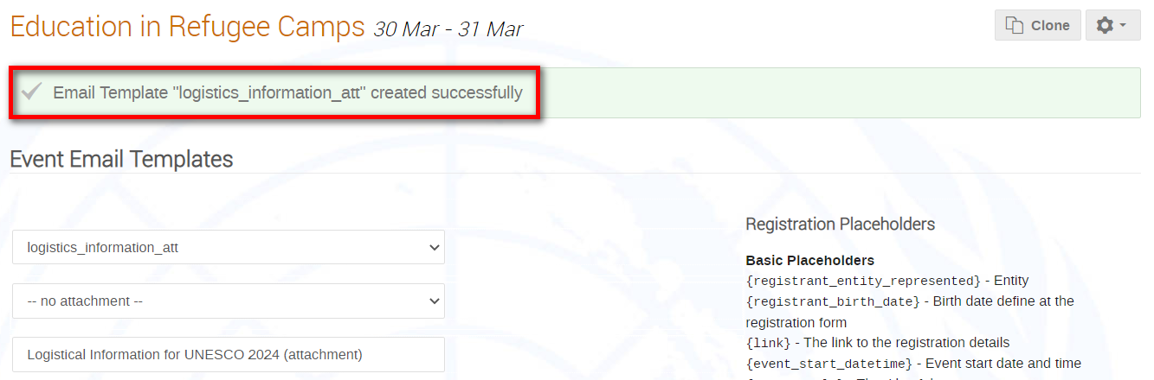

Step 2: Create the cover email and marry the attachment to it
- Again, in the email Templates work area New.
- Give the cover a name; it is advised to include a word e.g., “cover” so that it is clear it’s a covering email e.g., logistics_cover. The same applies when giving it a subject.
- In the -- no attachment -- field, open the drop-down menu and select the correct attachment created earlier to marry with the cover email.

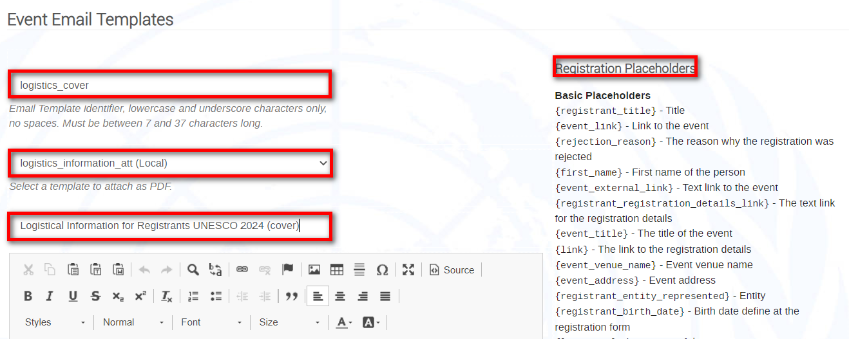

- After composing the cover email, Save. A message appears on-screen confirming creation of the cover.

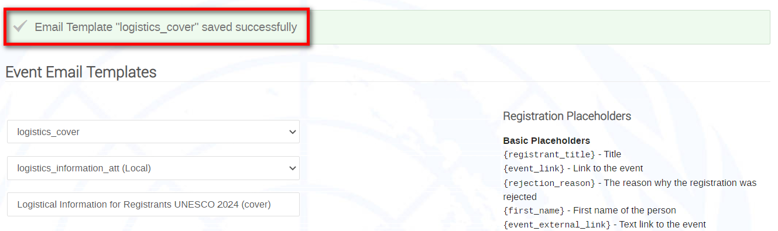

- Now, any time you select the “cover” template to send, the attachment will be loaded automatically to it (this is indicated at the bottom of the mail). See next screenshot.

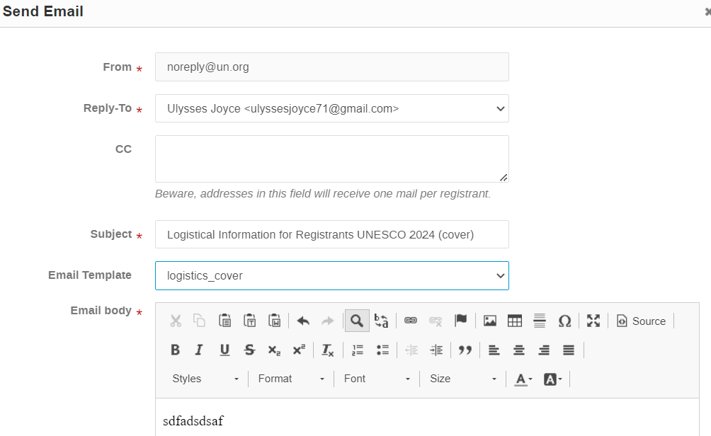
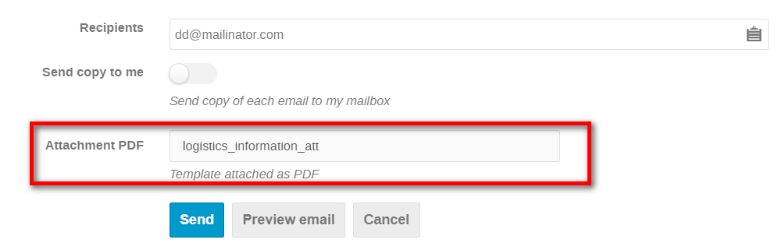

If ever you see the word “Local” after a template name, it means that the template was created at the level you are in. “Inherited” indicates it was created at a category level.

