Create a Simple Event Page, Registration Form and
Open Registration

Audience: Managers

Level: Basic

CONTENT

Create an Event Page 1
Event Page Settings 2
Registration Form 3
Copy a Registration Form From one Event to Another 3
Create a Registration Form 4
Configure a Registration Form 6
Open Registration 7
Clone an Event Page (incl. Registration Form) 9

Create an Event Page
- On the category page, New conference.

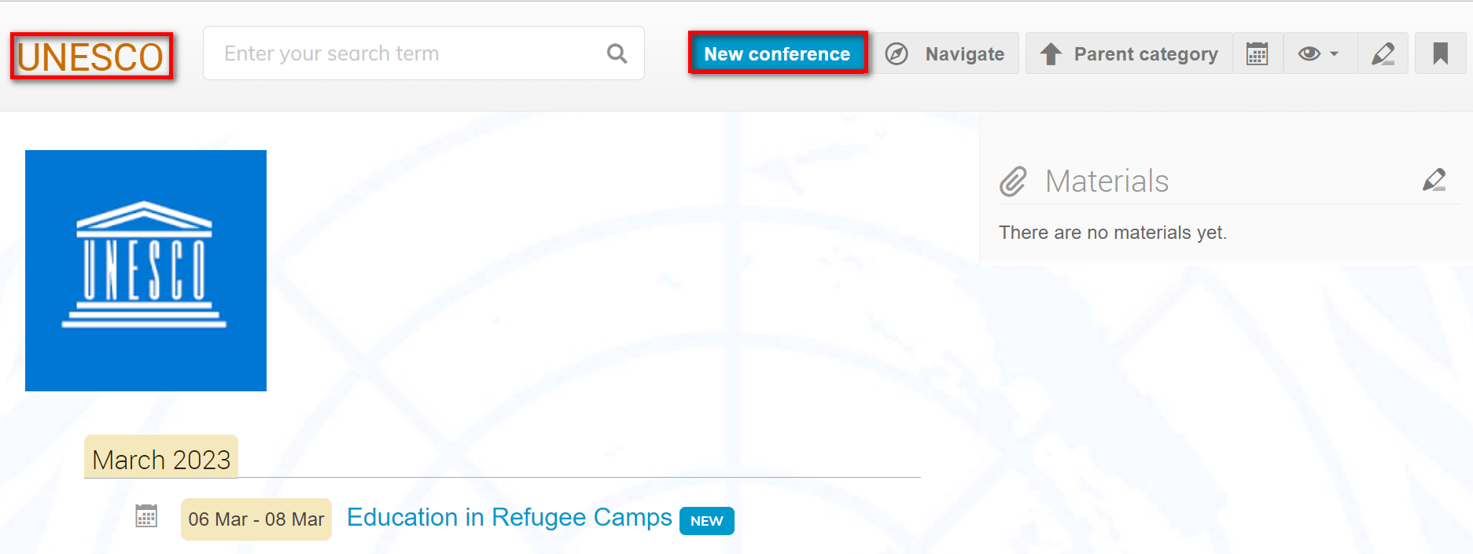

- Enter event details. Create event.

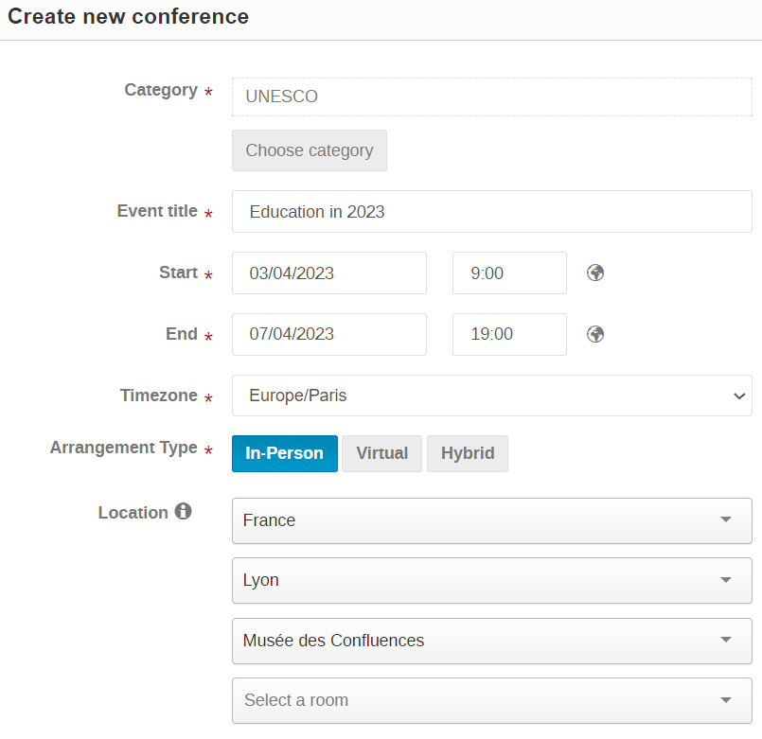
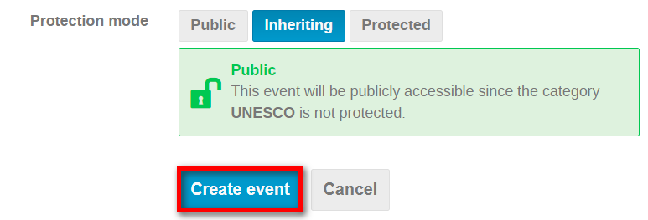

- The event is created and you land in Settings. Here, you apply some settings for the event. Note the unique URL and event number.

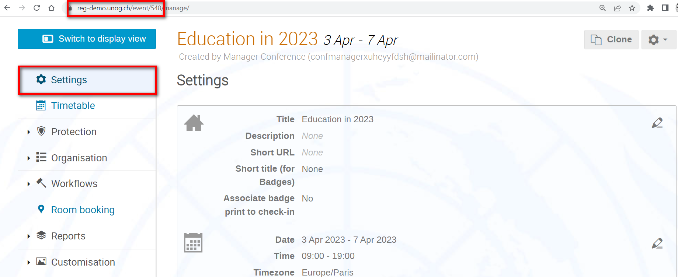

Event Page Settings
- Click to make edits to any of sections on the Settings page. Those marked * are mandatory and the minimum required to open registration.

 | Title* | Title of the event.
 | Description | Enter a text to serve as background on the event.
 | Short URL | Instead of https://reg.unog.ch/event/20121/ you may change the event URL by adding UPR15 e.g., https://reg.unog.ch/e/UPR2015.
 | Short title (for badge)* | Title of the event as it is to appear on badges. Max.30 characters.
 | Associate badge print to check-in | If enabled (by Admin), a record is kept of when the badge is printed.
 | Date | Start and end date of the event.
 | Time | Start and end times of the event.
 | Time zone | Self-explanatory.
 | Screen dates | Dates that will appear on the Indico.UN event page.
 | Arrangement type | Select an option: in person, virtual or hybrid.
 | Location* | Self-explanatory.
 | Room | Self-explanatory.
 | Venue | Self-explanatory.
 | Address | Self-explanatory.
 | Map URL | Upload a map to the event page.
 | Chairpersons | Identify chairperson(s) to be listed on the event page.
 | Additional Info | Enter a text that will serve as additional info for registrants.
 | Contact title | Enter a caption e.g., Support, Help, Contact, etc.
 | Email* | At least one email address as a contact point for registrants.
 | Phone | A telephone number as a contact point for registrants.
 | Keywords | Keywords to assist people to find the event through a search on Indico.
 | Label | A caption that appears in the event header to draw registrant’s attention e.g., Cancelled, Postponed, Virtual, etc.

Registration Form

Copy a Registration Form From one Event to Another
To save time it is possible to copy a registration form from one event to another.
Example: copy the registration form from event #546 to event #548

- Go to the management area of the event you are setting up i.e., #548. Expand the gear icon and Import.

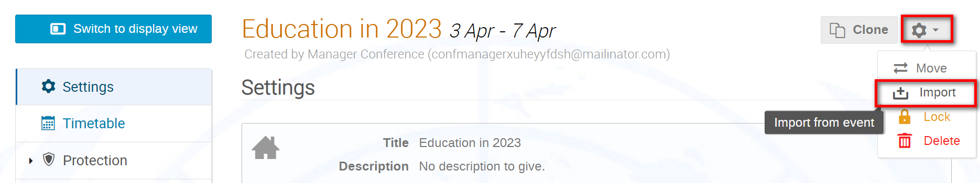

- Enter the URL of the event you are importing FROM i.e., #546 in the Event URL field. Next.

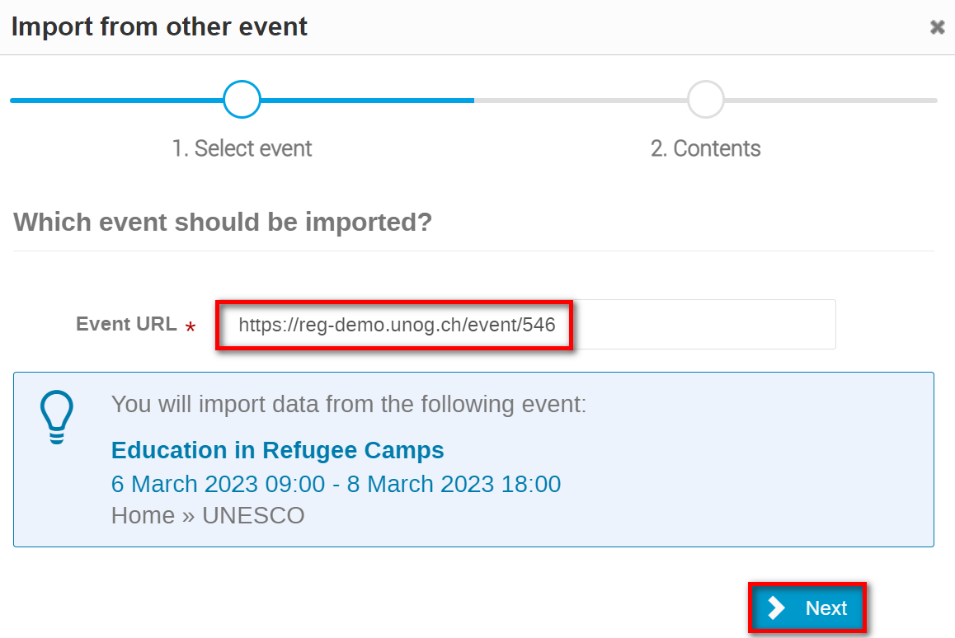
- From the list of items to import select Registration forms. The icon indicates that either there is nothing to export or that it already exists in the target event.

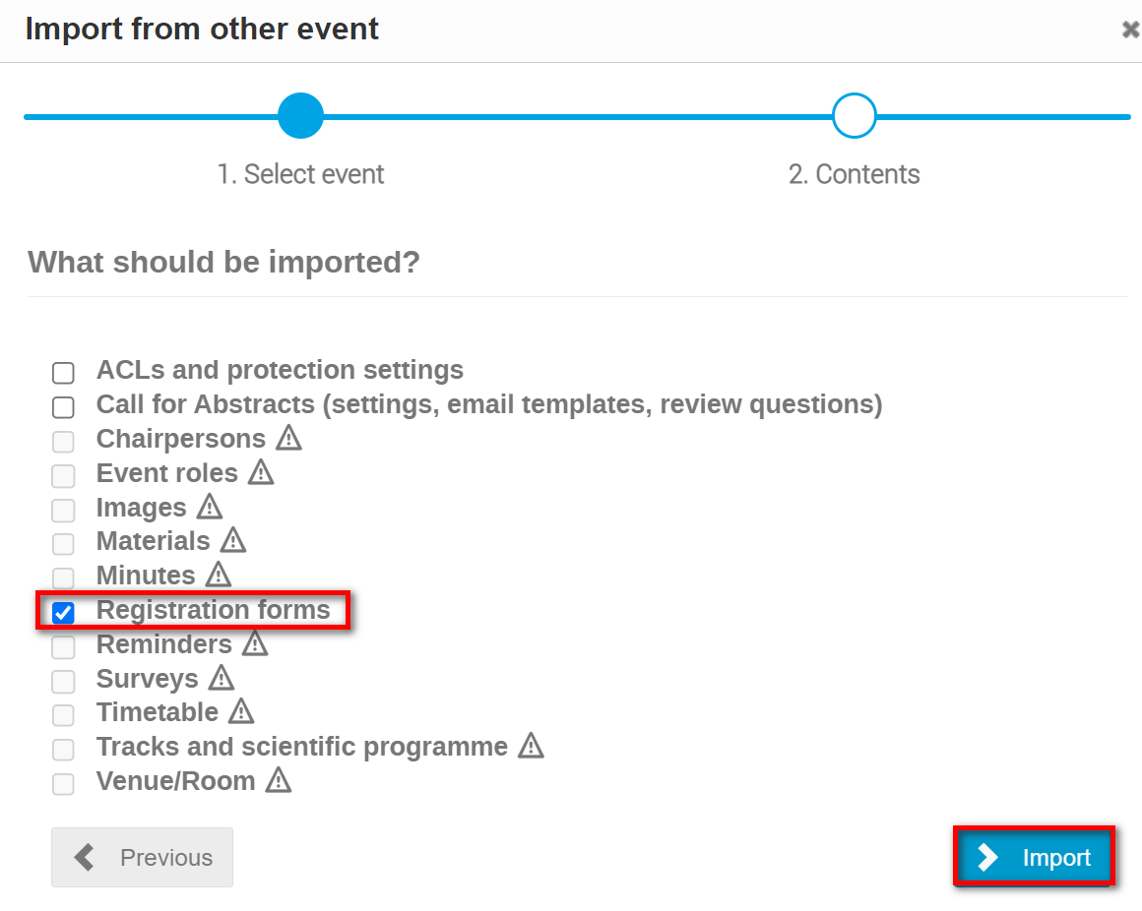
- Next. A message displays that the import is successful. Go to the Registration module and check the registration form.

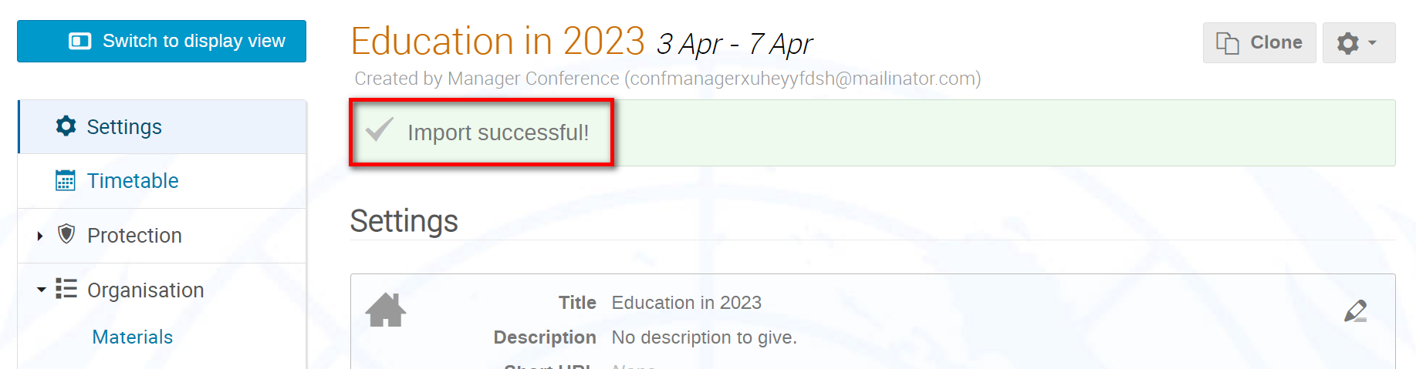

Create a Registration Form
- Under Organisation, Registration then Create form.

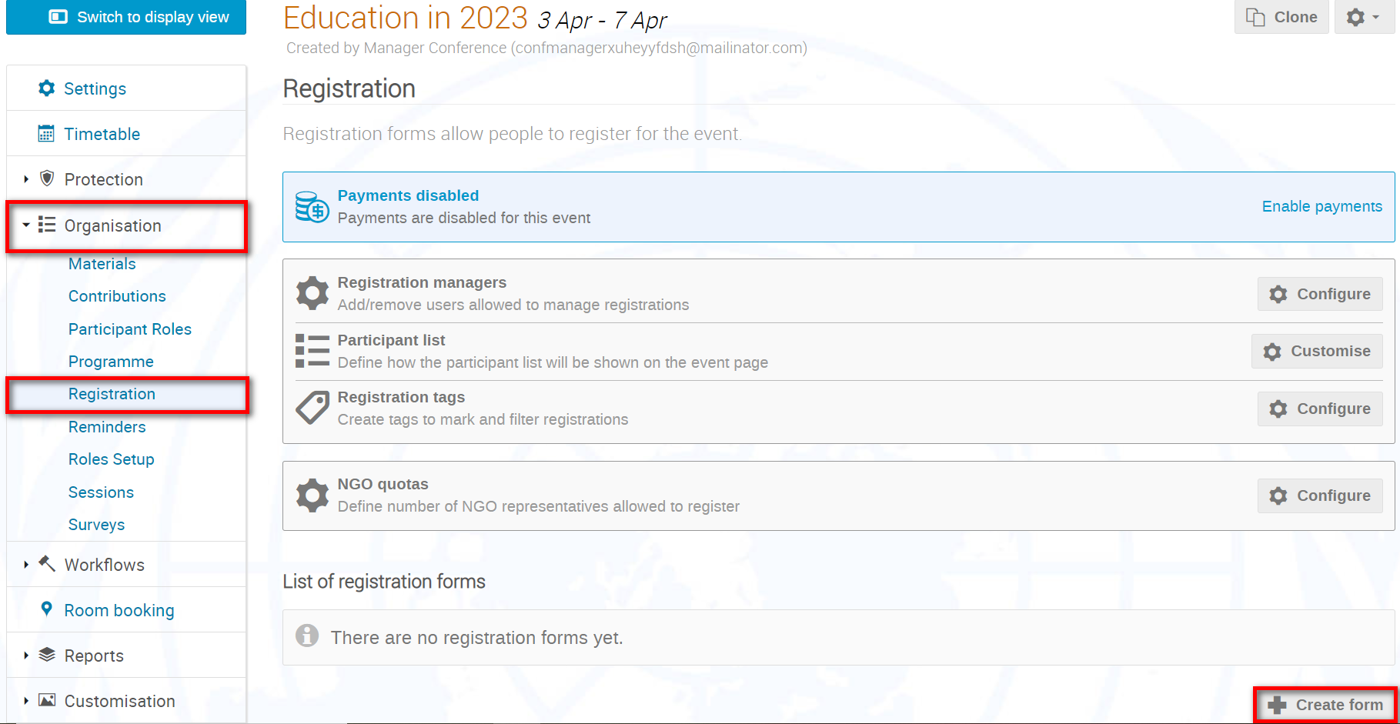

- Create the form according to the following parameters and don’t forget to Save once finished.

Title | Name of the registration form.
Introduction | A brief text or instructions for registrants.
Contact info | An email or tel. number where registrants can contact the organizer.
Moderated | If disabled, registrations are approved automatically. If enabled, registrations are reviewed before being approved.
Only logged in users | Only logged in users can register.
Registrant must have an account | Only those with an account may register.
Limit registrations | Place a ceiling on the number of registrations.
Modification allowed | If NEVER is selected, registrants are unable to make any modifications to their registration.  If UNTIL APPROVED is selected, registrants may make changes until they are approved.  If MODIFICATION DEADLINE is selected, they may make changes to their registrations up to a given point, even if approved (see article Registration Period).
Publish registrations | Do not use
Publish number of registrations | Do not use
Publish check in status | Do not use
Attach iCalendar file | Attach an iCalendar file to the approval email.
Hide representation type section | Do not use - this will hide the representation type section on the registration form and users will be unable to indicate their representation type (which is mandatory)
NOTIFICATIONS FOR REGISTRANTS | By default, registrants will always receive an acknowledgement of their registration.  If you disable this feature, they will not receive a notification when they are approved, rejected, or set to pending.
Notification reply to address | Email address set as the reply-to of all notifications sent to users. If empty, then noreply@unog.ch is used.
Send copy to addresses | A copy of every email sent to registrants will be sent to the addresses listed as BCC:.
Message for unpaid registrations | NA
NOTIFICATIONS FOR MANAGERS | If enabled, managers will receive notifications when registrations are submitted.  If you permit modifications to registrations, you may enable “Also on modifications” which will generate notifications each time a registration is modified (whether it be by the registrant, manager, or focal point). The persons you place on the list will receive the notification.  Bear in mind that the persons on the list will receive notifications for ALL registrations modified.

- When the form is saved, a message appears.

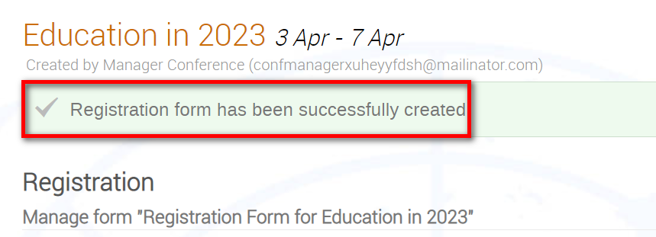

Configure a Registration Form
- Under Organisation, Registration then beside the registration form Manage.

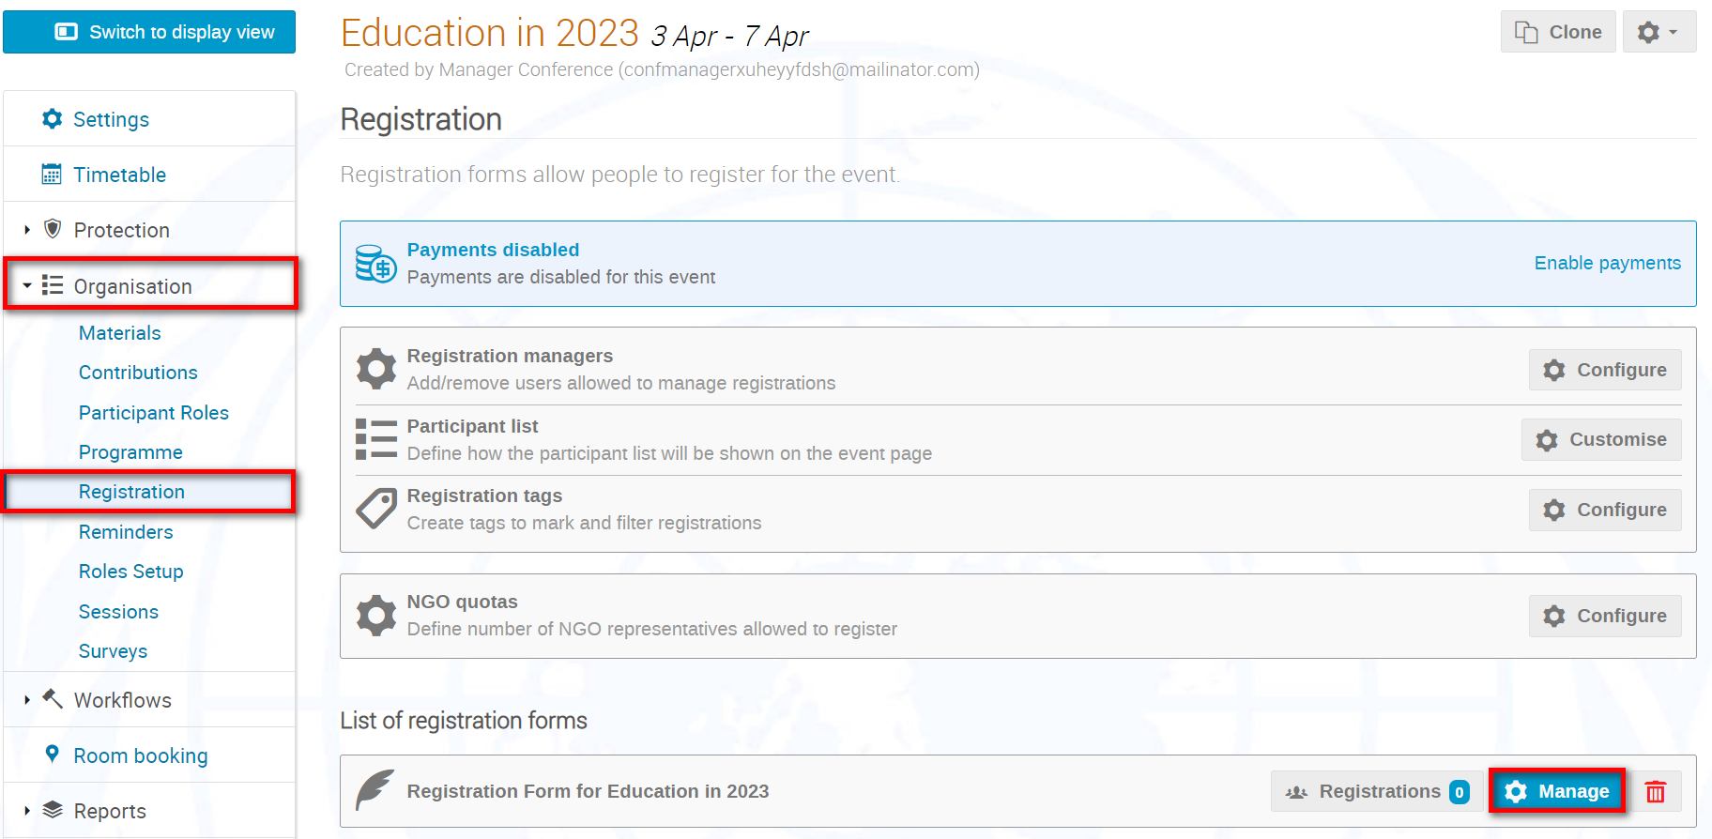

- The management area of the form opens. Beside Registration Form Configure.

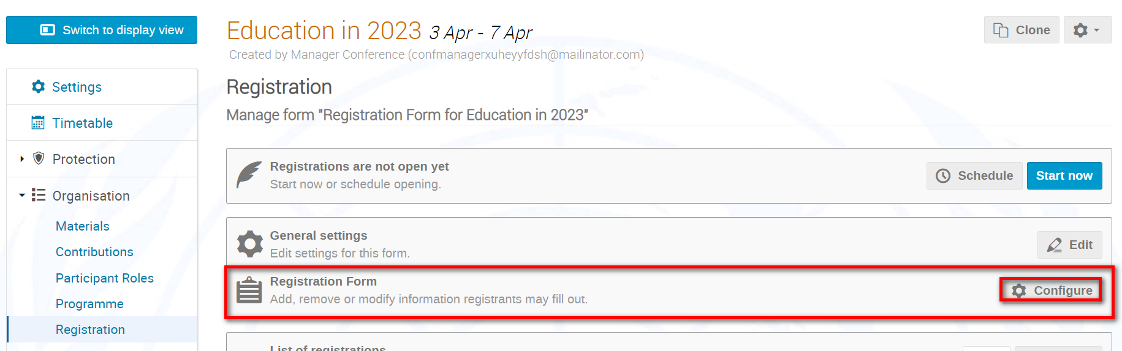

- Set up the registration form (sections, fields, etc.) to capture the information you need on your registrants.

Open Registration
- Under Organisation, Registration then beside the registration form Manage.

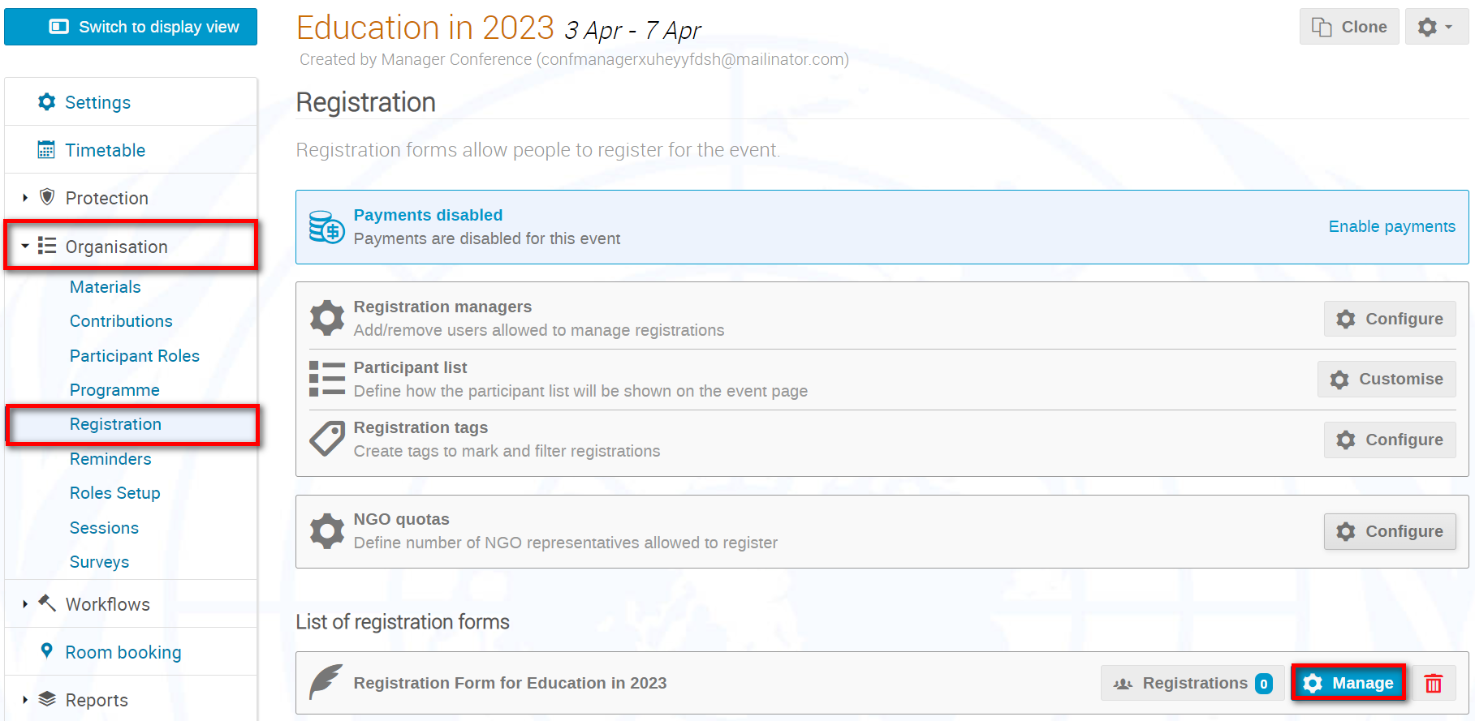

- To begin registration immediately, Start now. No closing date is set so you will have to remember to manually close the registration period at some later date.
To schedule an opening and closing date, Schedule and enter the dates.

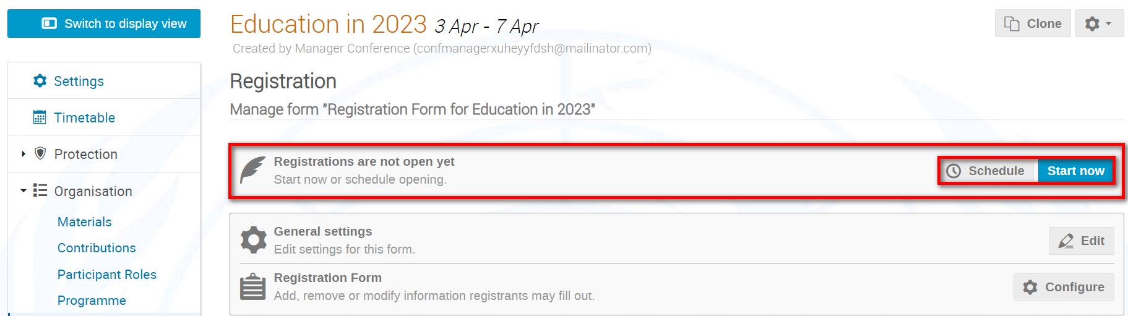

- When registration is opened, a message appears.

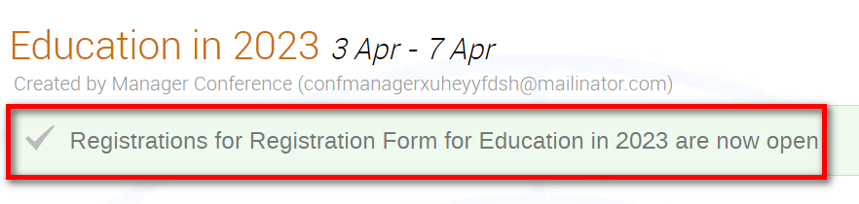

- The event page displays the Register now button.

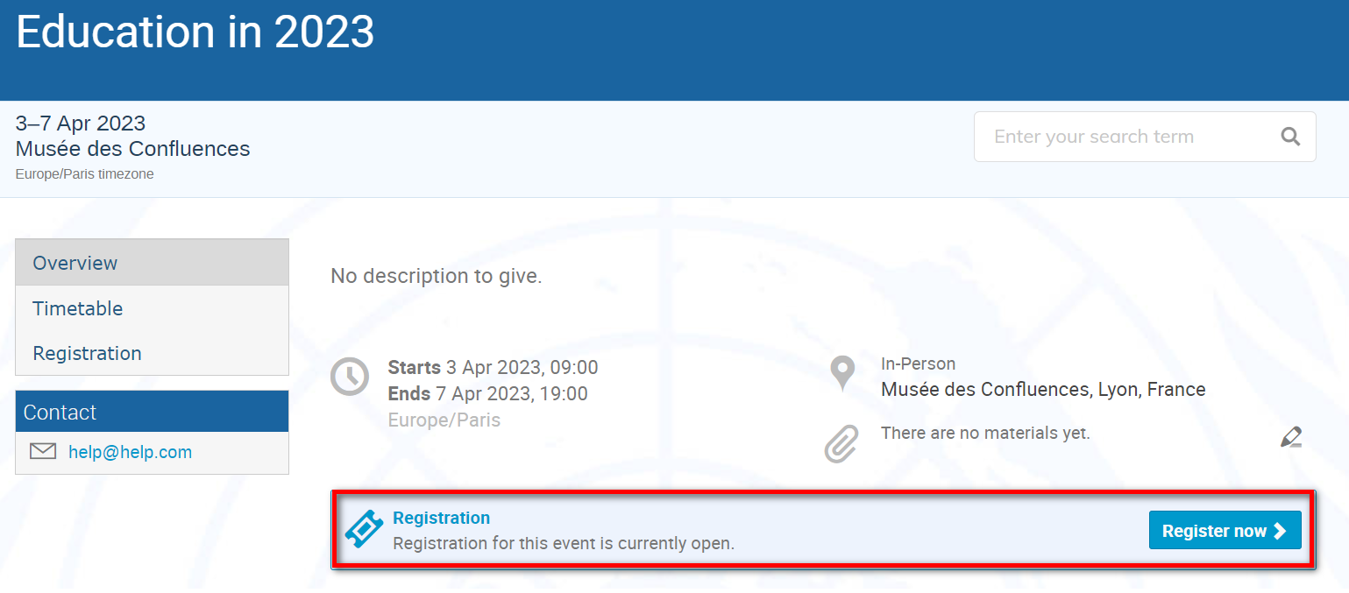

Clone an Event Page (incl. Registration Form)
- In the event management area of the event to be cloned, Clone.

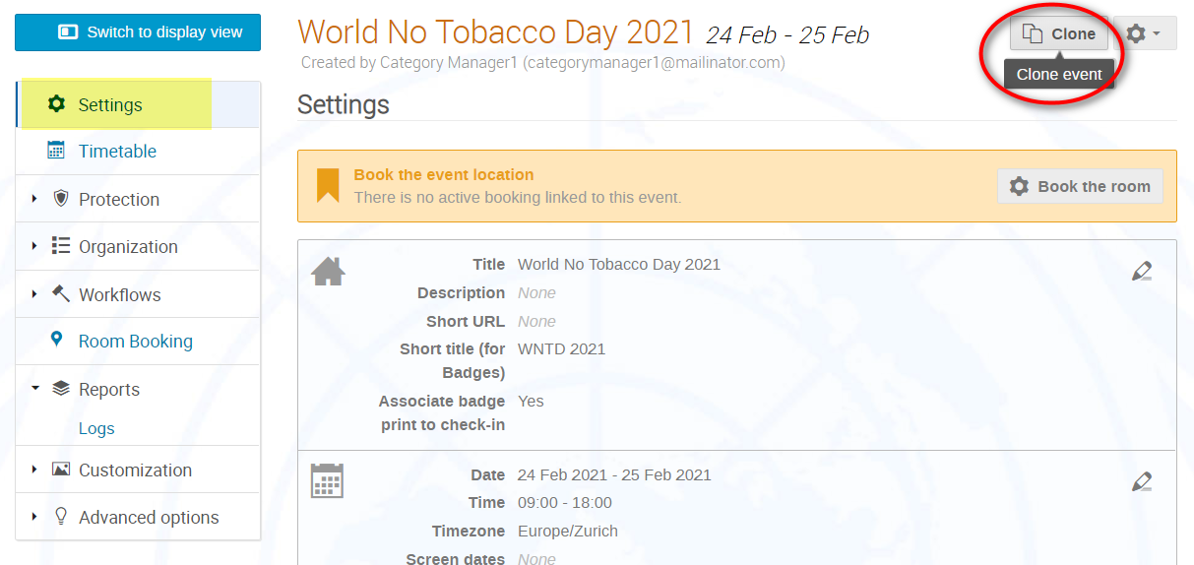

- In the Clone Event pane, follow the process step-by-step.

Step 1: Select the interval at which the event is to be cloned i.e., once, with a fixed interval or repeatedly in a pattern (see step 4). Next.

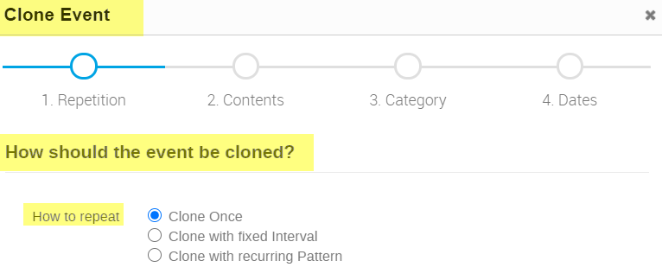

Step 2: Select what elements of the event are to be cloned to the new event. Elements that are greyed out are those that are not available in the event being cloned. Next.

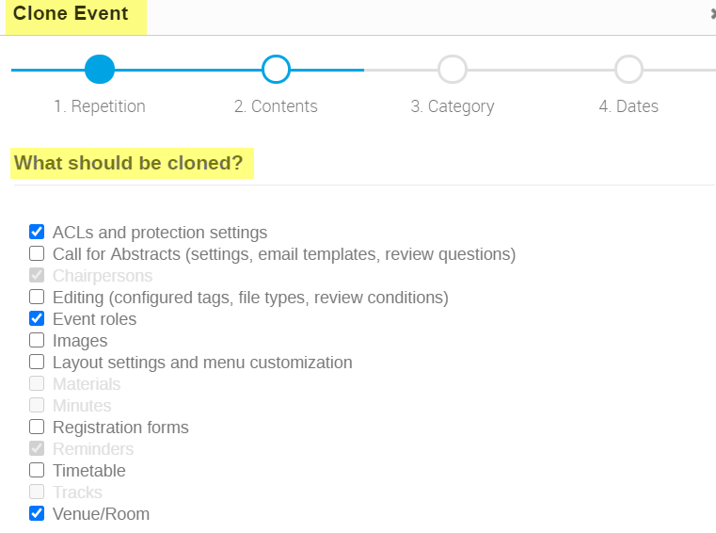

Step 3: Select the destination category or sub-category for the event. Close then Next.
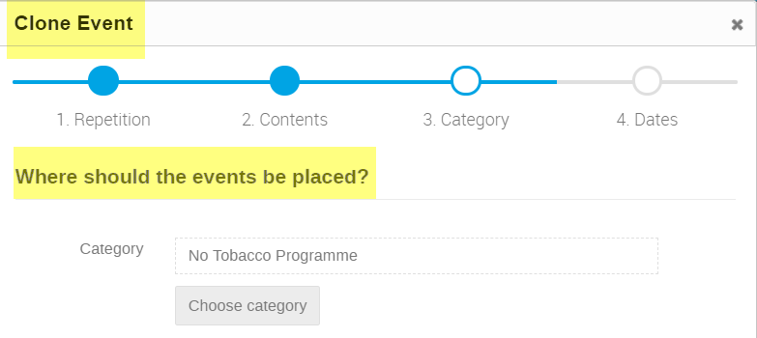

Step 4: If cloning only one instance of the event, enter the opening date and time of the event and Clone.
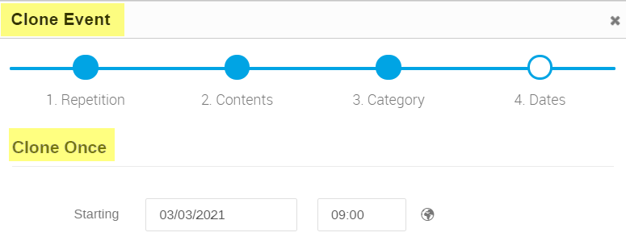

If cloning more than one instance of the event at fixed intervals, indicate the duration of the interval between instances, the start date and time of the first instance and the number of instances (or enter an end date).

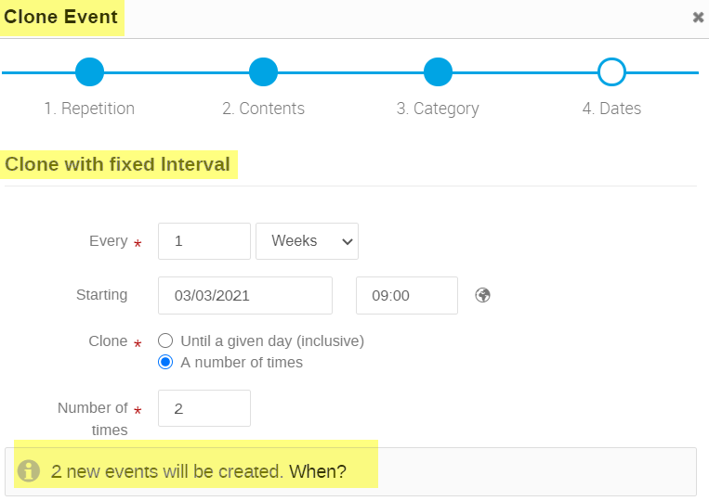

If cloning more than one instance of the event following a recurring pattern, indicate the start date and time of the first instance, the number of months between instances and the number of times (or enter an end date).

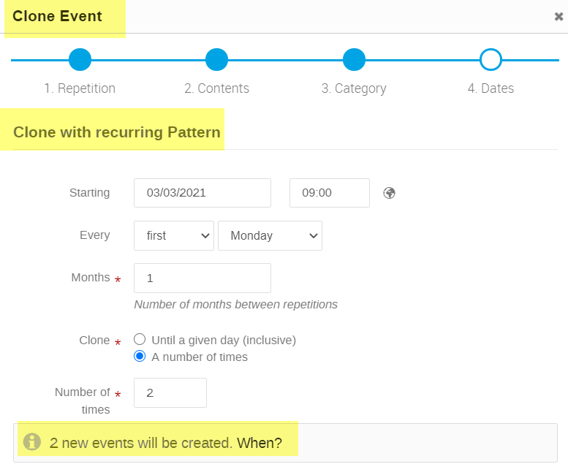

- The event management area of the new event opens. A message appears on-screen welcoming you to the cloned event. It indicates the date of the event and the dates of the event it has been cloned from. Remember to take note of its event number. Check to make sure that the cloned event has all the elements you required and make edits as necessary.

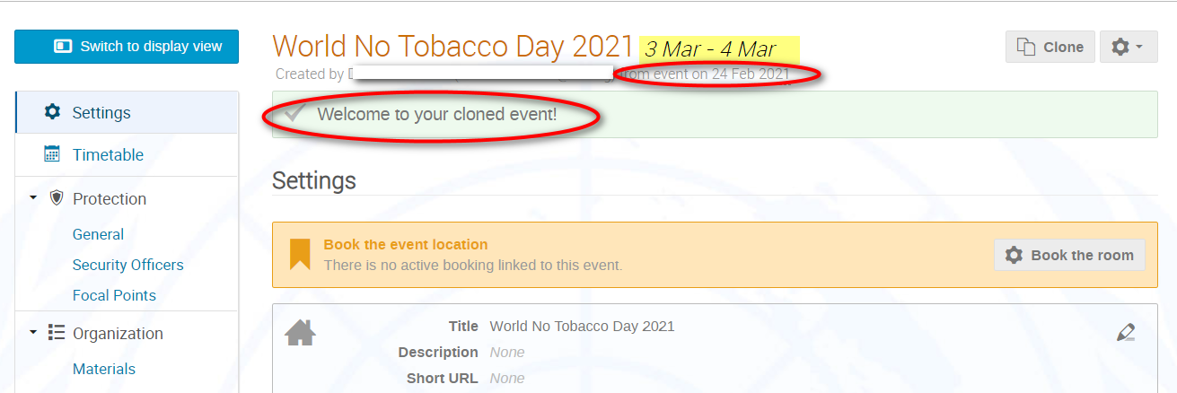

For registration management, assigning permissions, and enhancing an event page refer to the separate guides.

