Add Focal Points

Audience: Managers

Level: Advanced

CONTENT

Add a Focal Point to a Specific Event 1
Add a Focal Point with Access to All Registrations 1
Add a Focal Point with Restricted Access to Registrations 2
Restrict a Focal Point to e.g., a specific entity, organization. 2
Restrict a Focal Point to a specific representation type 2
Restrict a Focal Point to a specific Government/Member State 3
Focal Points at the Category Level and Inheriting 4
Icons on the Focal Point List Explained 4

Add a Focal Point to a Specific Event
A Focal Point assigned to an event has access to the registrant list of that event only and may only perform actions whilst the registration period is open.

NOTE: the permission “Add existing” may not be assigned to users who do not hold a UN domain email address.

Add a Focal Point with Access to All Registrations
- In the event management menu, under Protection, select Focal Points.
- In the Focal Points Events window New Focal Point.

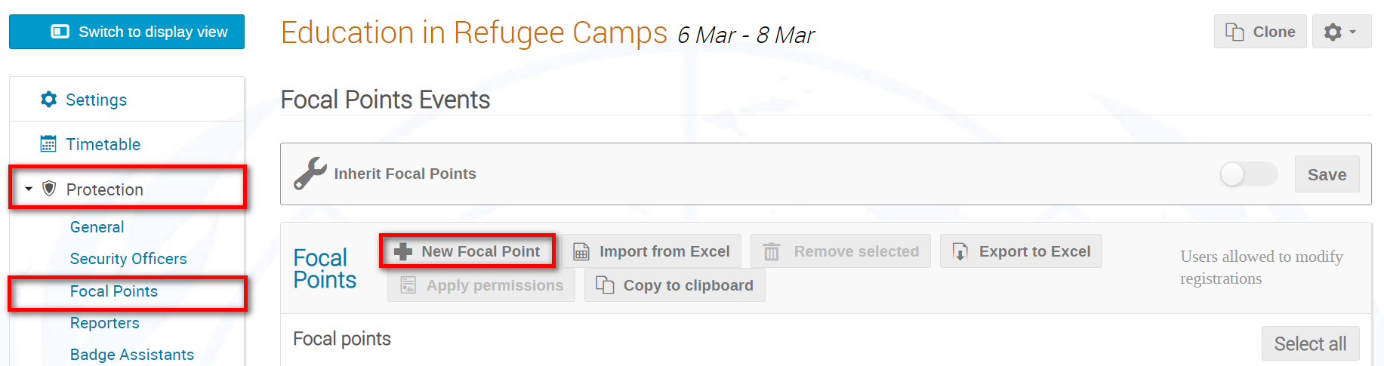

- Search for and add a user as a Focal Point. Also, assign the appropriate rights. Leave the values for Representation Type and Representation Class as they are.

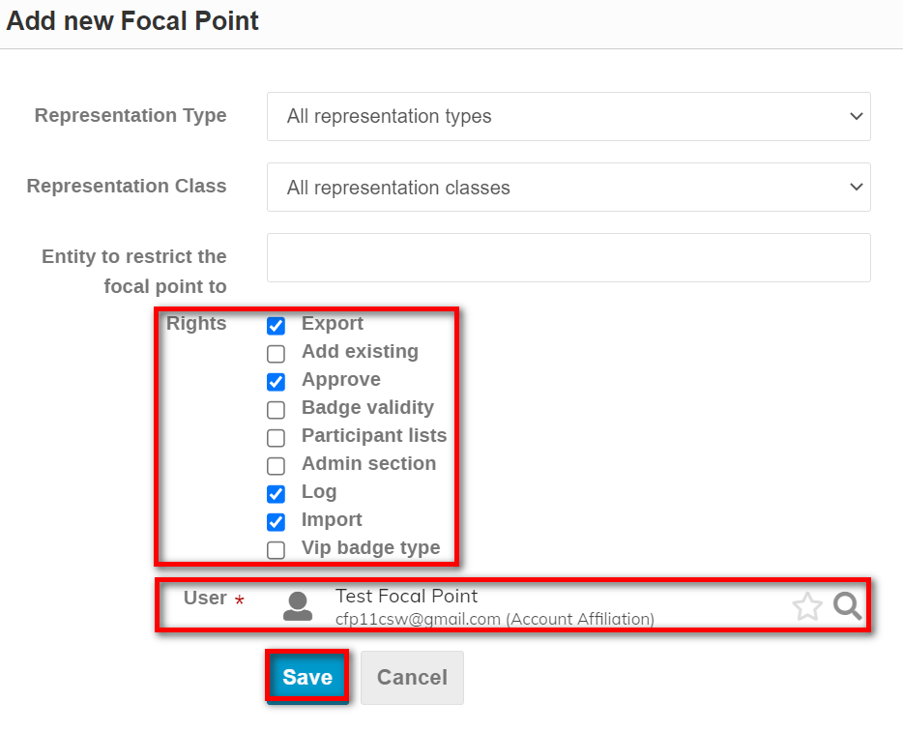

- The Focal Point appears on the list together with an indication of the permissions assigned. (The columns RepType, Organisation and Organization_type are empty. If a Focal Point is assigned to specific entities or rep types then it will be indicated in one of these columns.)

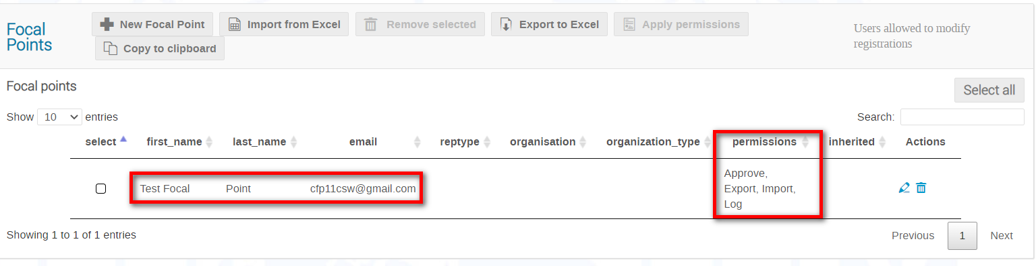

Add a Focal Point with Restricted Access to Registrations

Restrict a Focal Point to e.g., a specific entity, organization.
- Add the Focal Point. Assign the appropriate rights. In the Entity to restrict the focal point to field, identify the entity. Save.

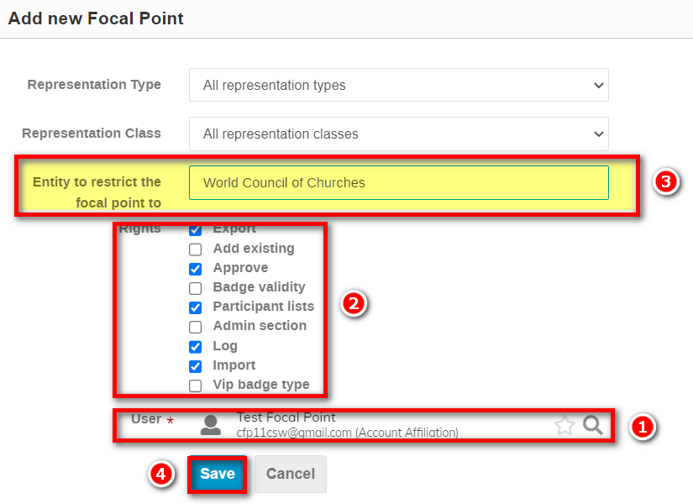

- The restriction and permissions will display on the focal point list as below.

Restrict a Focal Point to a specific representation type
- Add the Focal Point. Assign the appropriate rights. In the Representation Type field, Select the rep type e.g., IGO. Save.

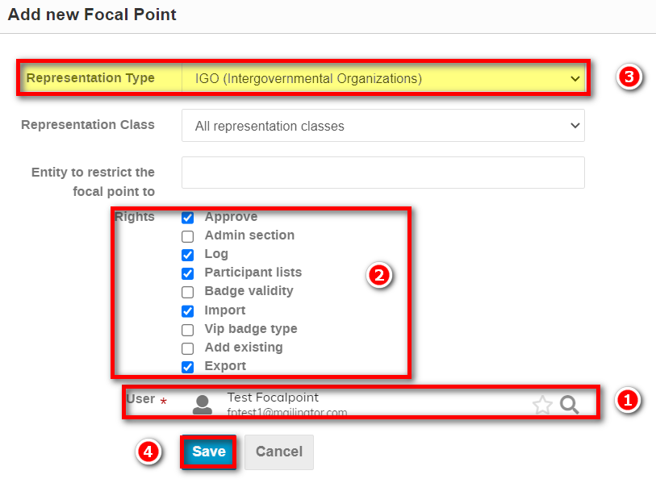

- The restriction and permissions will display on the focal point list as below. The Focal Pint has access to all registrations that are of type IGO.

Restrict a Focal Point to a specific Government/Member State
- Add the Focal Point. Assign the appropriate rights. In the Entity to restrict the focal point to field, enter a country value e.g., Albania. Save.

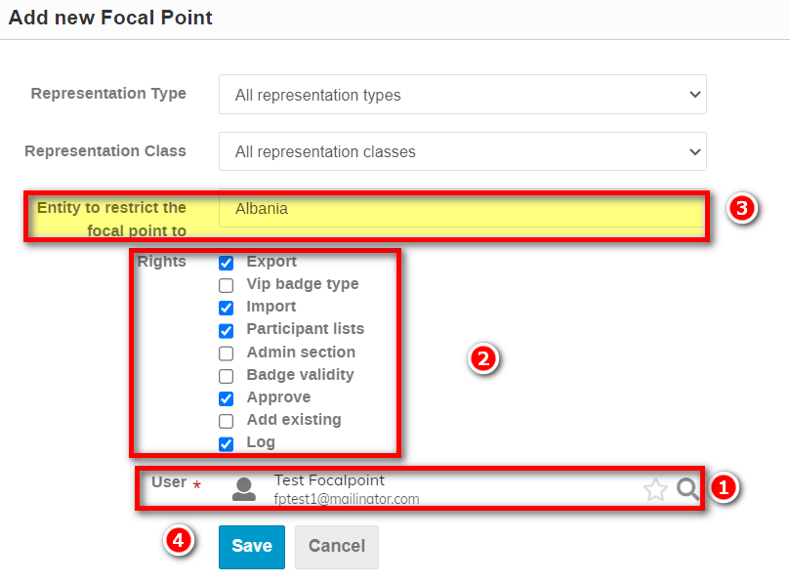

- The restriction and permissions will display on the focal point list as below. The Focal Point has access to all registrations that are of country type and the specific country is indicated.

Focal Points at the Category Level and Inheriting
- If you use a core group of persons as Focal Points event after event, then you may assign them at the category level. Then, in the focal point window of an event you simply enable the option Inherit Focal Points and Save. The Focal Points are imported from the category level to the event together with the permissions originally assigned. It saves time. Inherited Focal Points are always highlighted in grey. Additional Focal Points added at the event level are not highlighted grey so you may see the distinction..

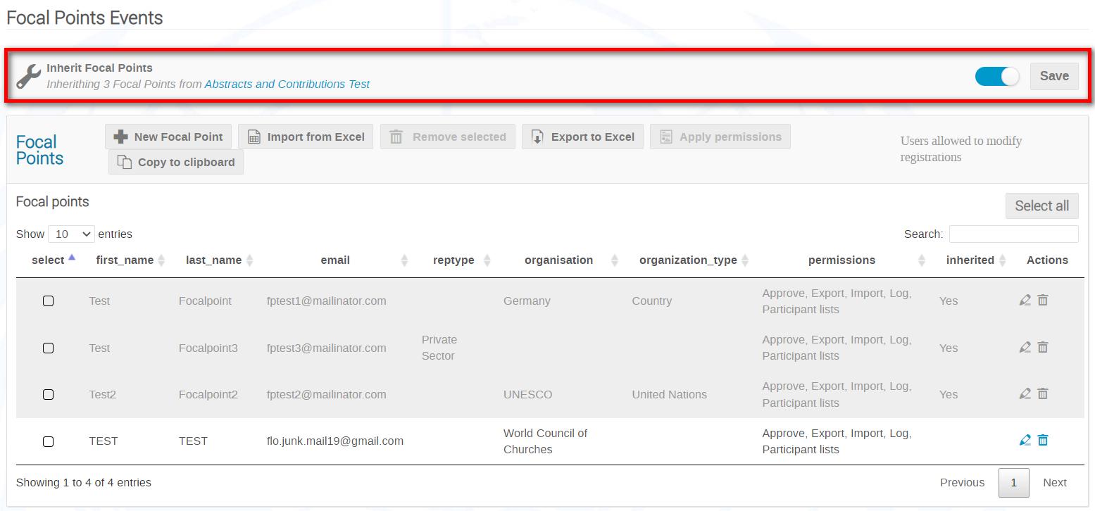

Icons on the Focal Point List Explained

Edit a Focal Point’s permissions.
Delete a Focal Point.
Add a Focal Point.
Export a list of Focal Points, their assigned representation types, and associated rights to xls.
Import from xls a list of Focal Point (export to excel a blank list, add the required data and then import it).
Copy all email addresses of Focal Points to the clipboard.
________

